Table 1：Demographics informations of patients with anterior circulation ischemic stroke.
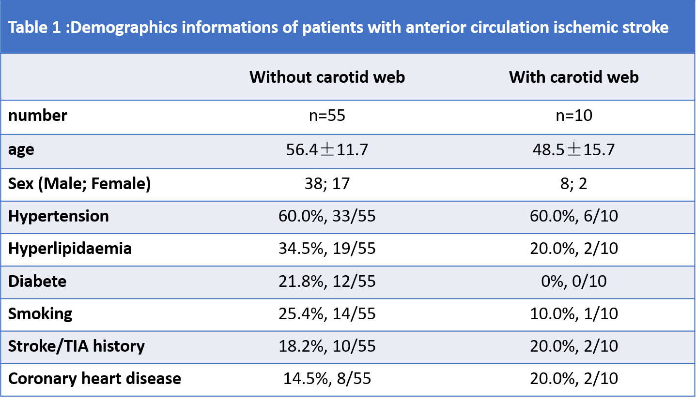
Table 2：Sensitivity, specificity, and area under the curve (AUC) of each diagnostic features at CTA and MRI
