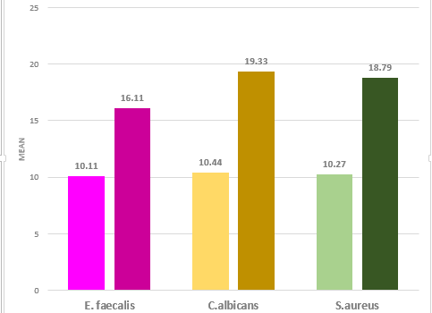
Table 1: Comparison of mean microbial count of Endosequence BC after 1 hour and 24 hours
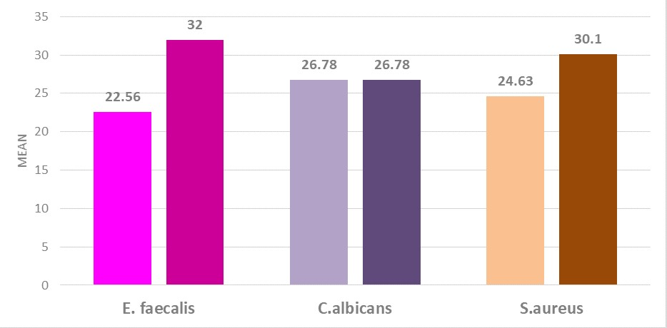
Table 2: Comparison of mean microbial count of AH Plus after 1 hour and 24 hours
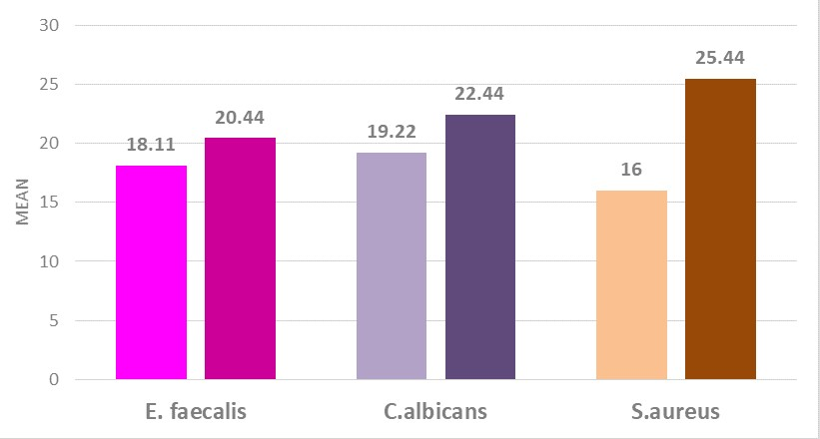
Table 3: Comparison of mean microbial count of MTA Fillapex after 1 hour and 24 hours

