Table S1. Statistics for data collection and refinement.
- CrmE10
Items | CrmE10 | CrmE10-D178A
Data collection
Wavelength | 0.97923 | 0.9778
Resolutions (Å) | 50.00-1.9 (1.96-1.9)ª | 50.00-2.18 (2.22-2.18)
Space group | C 2 | P 2₁ 2₁ 2
Unit cell (Å, °) | a=116.655, b=37.019, c=99.747  α=90, β=99.055, γ=90 | a=65.012, b=70.041, c=80.572  α=β=γ=90
Unique reflections | 33196 (3319) | 18262 (1807)
Completeness (%) | 98 (99) | 100 (100)
R_{merge} (%)^{b} | 7.4 (66.9) | 18.7 (44.8)
I/σ (I) | 16.81 (5.93) | 12.33 (6.91)
Refinement statistics
Resolutions (Å) | 34.82-1.9 (1.96-1.9) | 47.65-2.24 (2.32-2.24)
Reflection used in refinement | 33183 (3319) | 18244 (1807)
R_{work} (%)^{c} | 17.54(18.44) | 17.00 (17.10)
R_{free} (%)^{d} | 21.13 (19.61) | 22.80(26.99)
Number of non-hydrogen atoms | 3360 | 3311
Number of imidazole | 2 | 0
Number of acetate | 3 | 2
Number of water | 378 | 377
Number of protein residues | 388 | 378
RMSD
Bond lengths (Å) | 0.025 | 0.017
Bond angles (°) | 2.41 | 2.09
Average B-facor (Å²) | 27.79 | 23.74
Ramachandran favored (%) | 98.40 | 98.10
Ramachandran allowed (%) | 1.60 | 1.90
Ramachandran outliers (%) | 0 | 0
PDB code | 6IQ7 | 6IQ8

- AlinE4
Items | AlinE4 | AlinE4-D162A | AlinE4-S13A
Data collection
Wavelength | 0.97931 | 1.06881 | 0.97915
Resolutions (Å) | 79.78-1.18 (1.21-1.18)ª | 79.81-1.55 (1.64-1.55) | 40.00-1.75 (1.84-1.75)
Space group | P 4₂ 2₁ 2 | P 4₂ 2₁ 2 | P 4₂ 2₁ 2
Unit cell (Å, °) | a=79.783, b=79.783, c=61.010  α=β=γ=90 | a=79.810 b=79.810, c=60.920  α=β=γ=90 | a=79.810, b=79.810, c=60.820  α=β=γ=90
Unique reflections | 64670 (4370) | 29082 (4174) | 20419 (2929)
Completeness (%) | 99.2 (92.7) | 100 (100) | 100 (100)
R_{merge} (%)^{b} | 7.3 (64.5) | 9.6 (26.2) | 21.6 (76.7)
I/σ (I) | 20.0 (3.2) | 32.71 (12.73) | 12.9 (7.6)
Refinement statistics
Resolutions (Å) | 48.46-1.18 (1.22-1.18) | 48.42-1.55 (1.61-1.55) | 39.90-1.75 (1.81-1.75
Reflection used in refinement | 64618 (5974) | 29037 (2859) | 20382 (1988)
R_{work} (%)^{c} | 17.75(25.08) | 16.61 (16.63) | 16.90 (19.53)
R_{free} (%)^{d} | 18.94 (25.32) | 19.90 (20.94) | 20.22 (25.99)
Number of non-hydrogen atoms | 1778 | 1712 | 1665
Number of Cd²⁺ | 3 | 4 | 5
Number of acetate | 4 | 2 | 1
Number of glycerol | 0 | 1 | 3
Number of water | 217 | 179 | 132
Number of protein residues | 189 | 189 | 189
RMSD
Bond lengths (Å) | 0.006 | 0.006 | 0.006
Bond angles (°) | 0.88 | 0.83 | 0.80
Average B-facor (Å²) | 15.90 | 15.18 | 14.36
Ramachandran favored (%) | 98.40 | 98.93 | 98.40
Ramachandran allowed (%) | 1.60 | 1.07 | 1.60
Ramachandran outliers (%) | 0 | 0 | 0
PDB code | 6IQ9 | 6IQA | 6IQB
ª Statistics for the highest-resolution shell are shown in parentheses.
^{b} R_{merge}=Σ |Ii − < I> |/Σ |I|, where I_{i} is the intensity of an individual reflection and I is the average
^{c} R_{work}=Σ ||F_{o}| − |F_{c}||/Σ |F_{o}|, where F_{o} and F_{c} are the observed and calculated structure factors for reflections, respectively.
^{d} R_{free} was calculated as R_{work} using the 5% of reflections that were selected randomly and omitted from refinement.

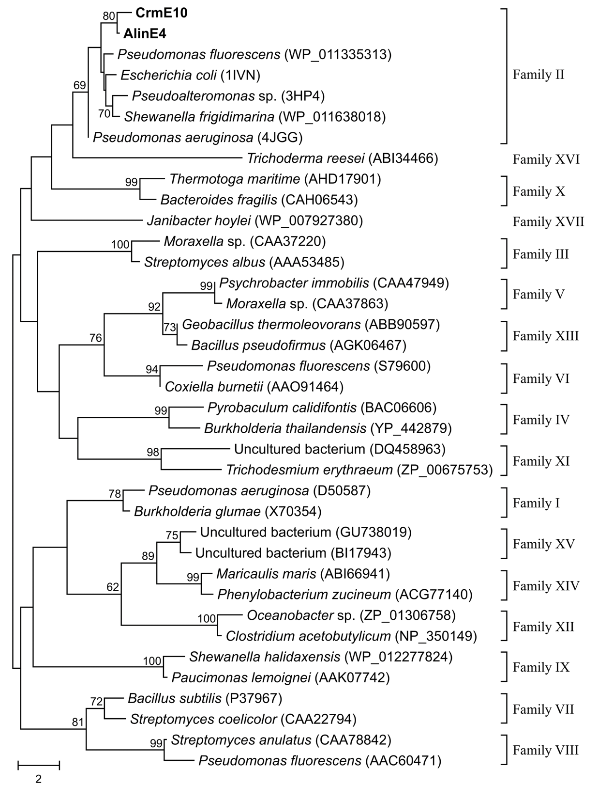

Fig. S1 Neighbor-joining phylogenetic tree of CrmE10 and AlinE4. The tree was constructed using MEGA software. Bootstrap values are based on 1000 replicates and only values >50% are shown. The scale bar indicates the number of amino acid substitutions per site.

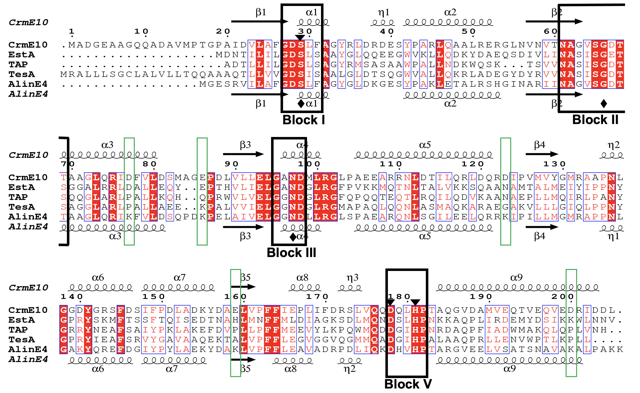

Fig. S2 Structure-based sequences alignment of CrmE10, AlinE4 and other esterases. The enzymes are shown below: EstA (PDB code: 3HP4, from Pseudoalteromonas sp.), TAP (PDB code: 1IVN, from Escherichia coli), and TesA (PDB code: 4JGG, from Pseudomonas aeruginosa). Sequence alignment was performed using the ClustalX and ESpript v.3.0 programs. Identical and similar residues are shown in white text on a red background and in red text on a white background, respectively. The secondary structure elements including α-helix, β-strand, and 3₁₀-helix are denoted as α, β, and η, respectively. Consensus blocks, I, II, III and V, related to the catalytic reaction, are marked by black boxes. Five key residues related to the catalytic activity are marked by green box. The triangles and diamonds indicate the residues in the catalytic triad (Ser-Asp-His) and oxyanion hole (Ser-Gly-Asn), respectively.

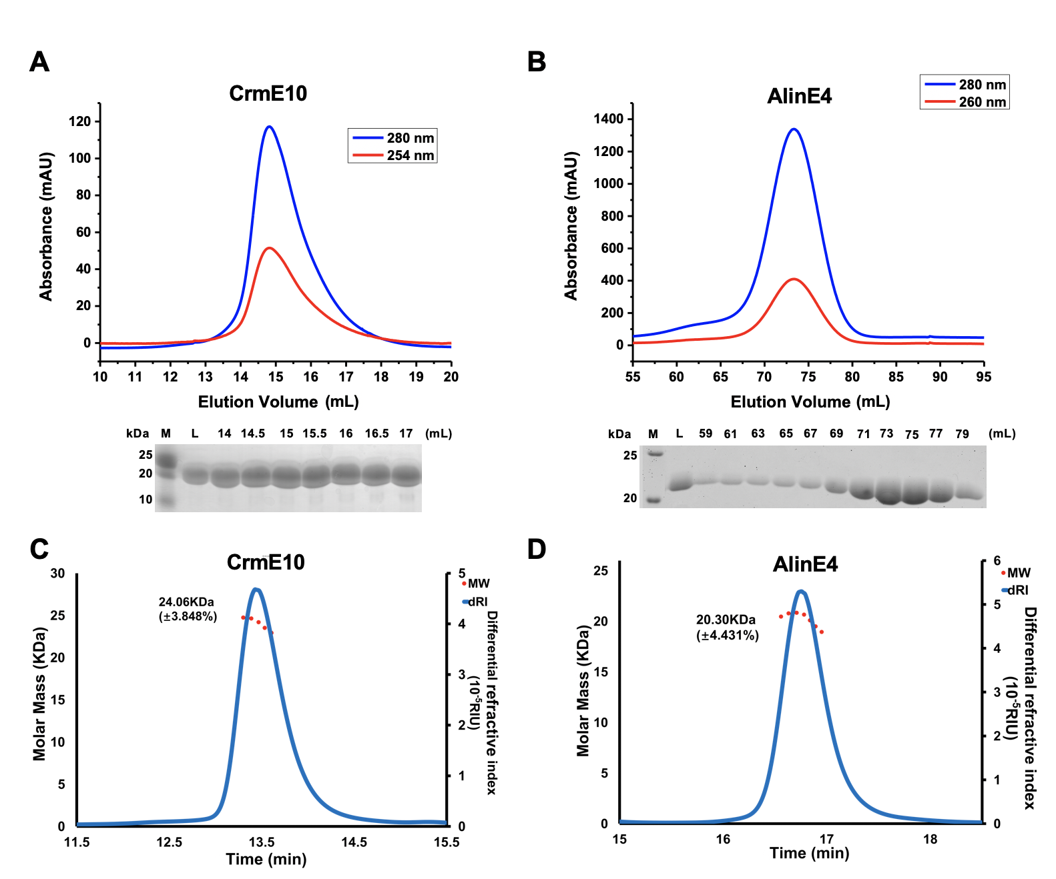

Fig. S3 Gel-filtration and MALS profiles of CrmE10 and AlinE4. (A) and (B) are gel filtration profiles (Top) and SDS-PAGE (Bottom) of CrmE10 and AlinE4, respectively. (C) and (D) are MALS results of CrmE10 and AlinE4, respectively. The calculated molecular weight by MALS showed both CrmE10 and AlinE4 are monomer in solution.

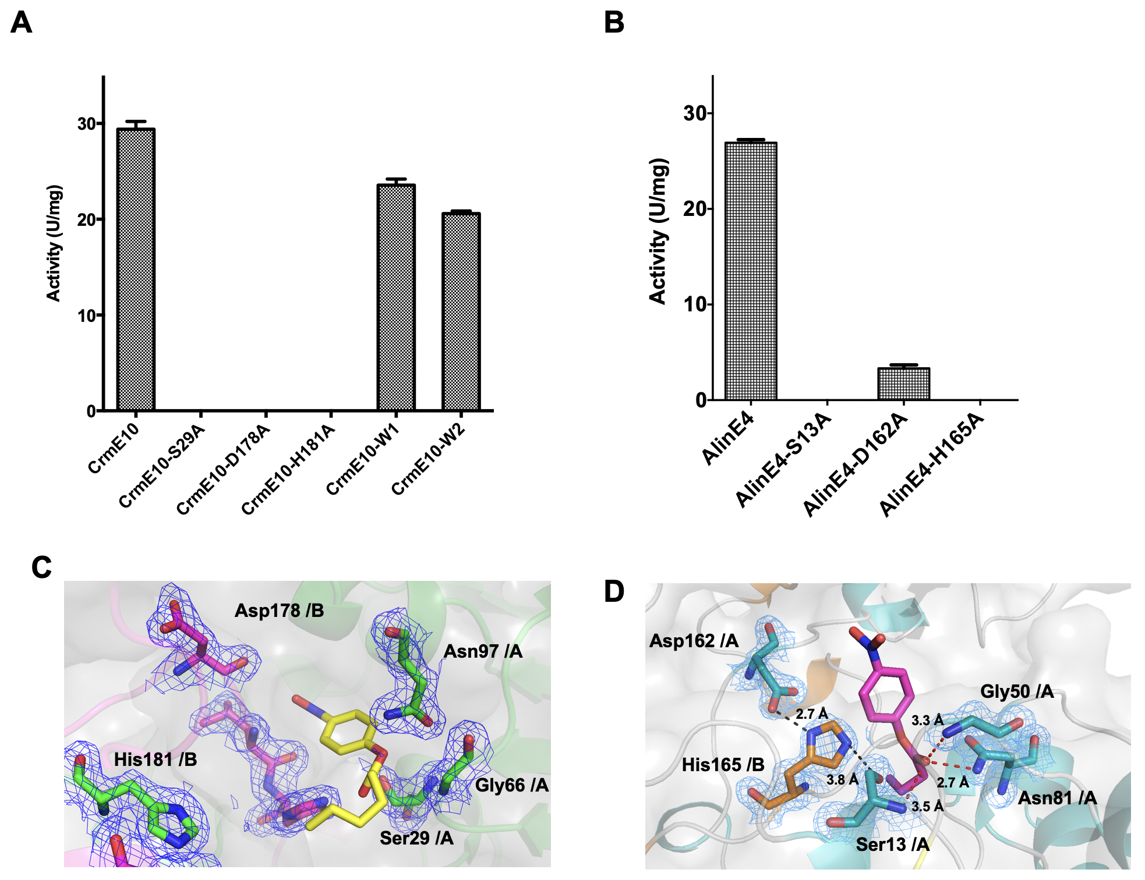
Fig. S4 Dimerization contributes to the enzymatic activities of CrmE10 and AlinE4. (A) Enzymatic activity of WT CrmE10 and its mutants. (B) Enzymatic activity of WT AlinE4 and its mutants. (C) The structural model of CrmE10 and its auto-docked substrate p-NP hexanoate (yellow sticks). (D) The structural model of AlinE4 and its auto-docked substrate p-NP butyrate (magenta sticks). Residue His165 of chain B forms hydrogen bonds with Ser13 and Asp162 of chain A (black dotted lines). The substrate molecule forms hydrogen bonds with Gly50 and Asn81 of chain A (red dotted lines). The electronic map is contoured to 1.0 σ at the 2Fo-Fc map

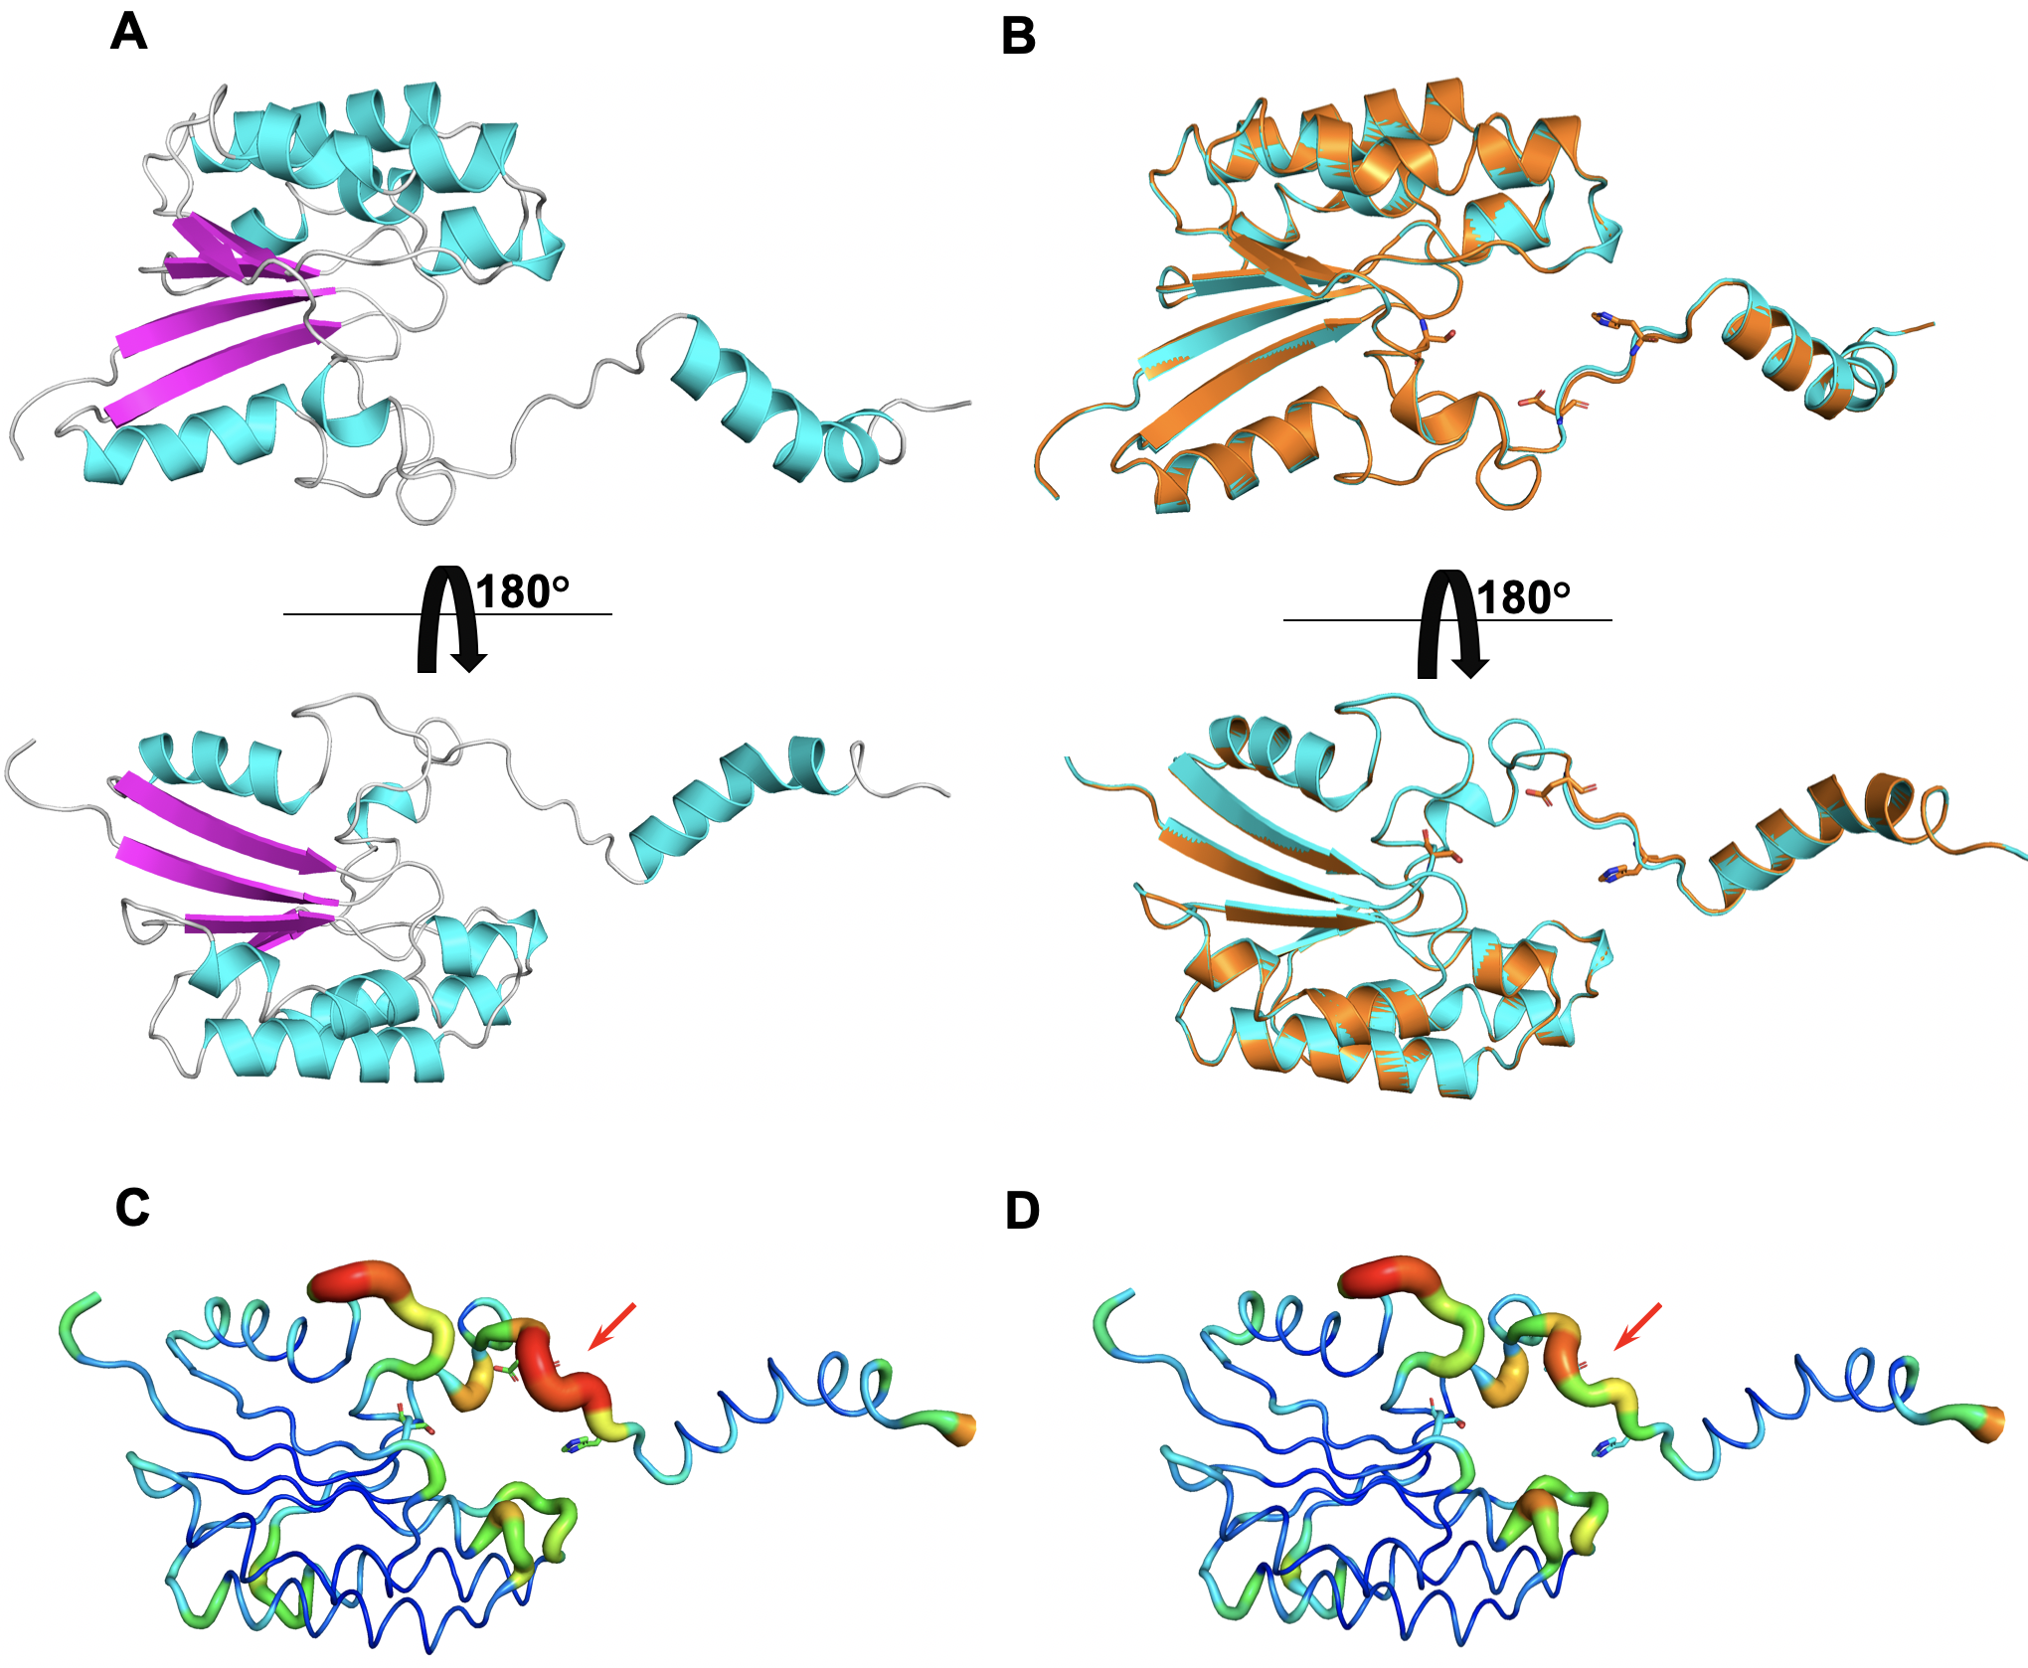.
Fig. S5 Structural comparison of AlinE4 and its mutant AlinE4-D162A. (A) Cartoon representation of AlinE4-D162A. The α-helices and β-strands of AlinE4-D162A are depicted in cyan and magenta, respectively. (B) The structural superposition of AlinE4 (green) and AlinE4-D162A (cyan). The B-factor distributions of AlinE4 and AlinE4-D162A are shown in (C) and (D) with tubing model. Wider and redder tubing corresponds to higher B-factor. Red arrows indicate the flexible loops between 3₁₀-helix η3 and α-helix α9 of AlinE4.

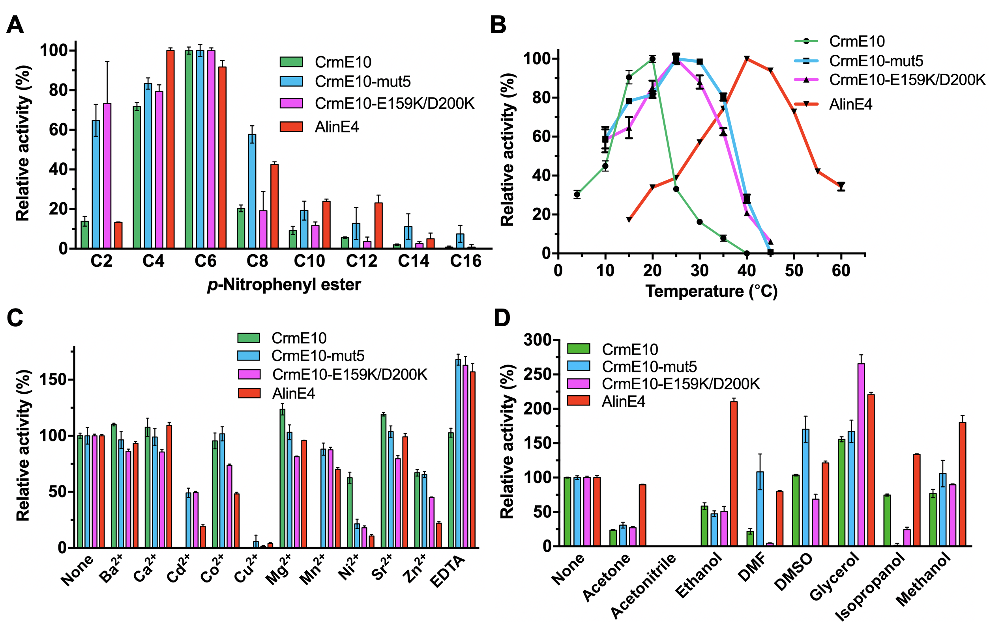
Fig. S6 Enzymatic Characterizations of Structure-based CrmE10 mutants. (A) Enzymatic activities toward substrates with various chain lengths of p-nitrophenyl (p-NP) esters. The value toward p-NP hexanoate (CrmE10 and its mutants) and p-NP butyrate (AlinE4) were taken as 100%. (B) Effects of temperature on enzyme activities. Enzymatic activity was determined with a series of temperatures. The values obtained at 20 °C (CrmE10), 25 °C (CrmE10 mutants) and 40 °C (AlinE4) were taken as 100%. (C) Effects of different metal ions on the activities. The values obtained without ions in the reaction mixture were taken as 100%. (D) Effects of organic solvents on the activities. The values obtained without organic solvent were taken as 100%.

