Table 1. Demographic and clinical characteristics of study cohorts at the index date.
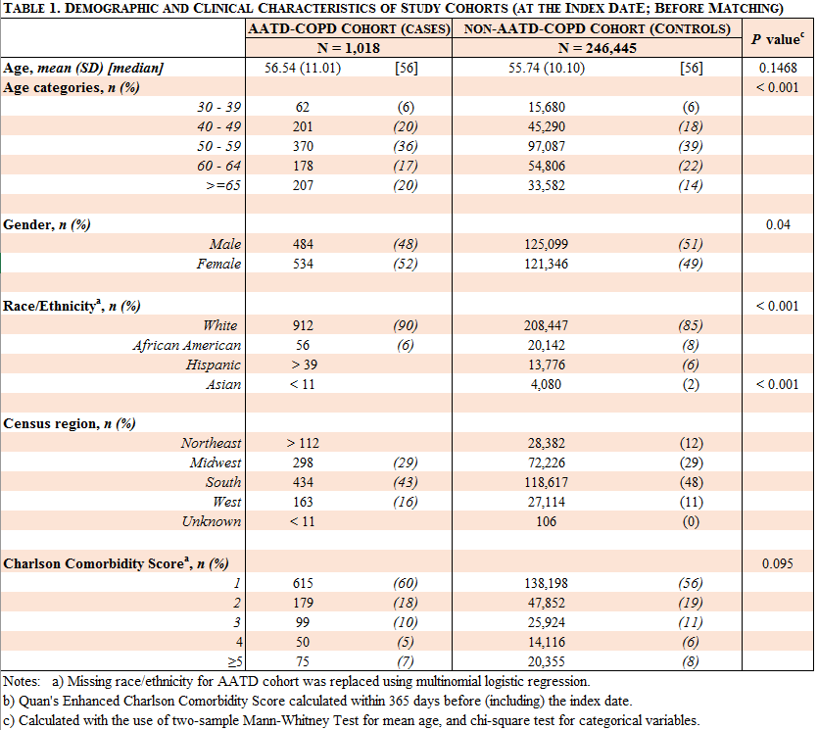

Table 2. Timing between AATD and COPD diagnoses stratified by time horizons analyzed.
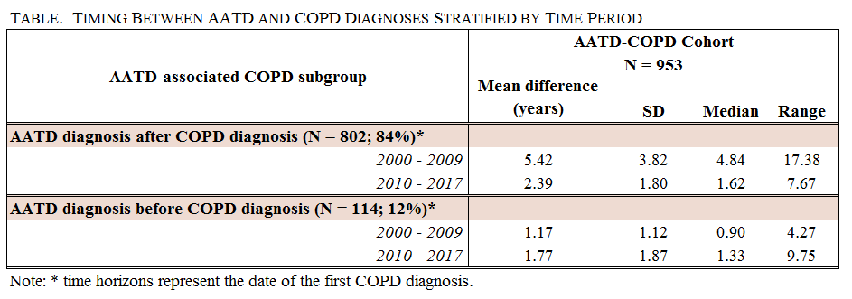

Table 3. Adjusted healthcare resource utilization before and after the index date.
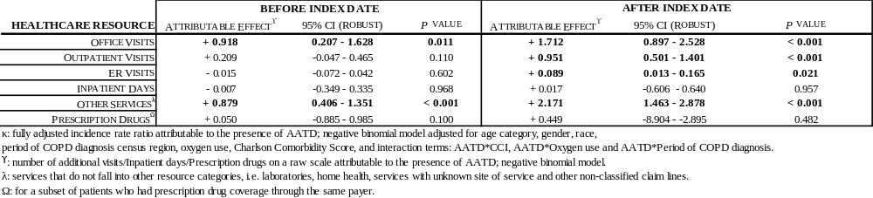

Table 4. Adjusted cost ratios before and after the index date.
