Supplementary Figure of the paper “Effects of enhanced insect feeding on the fecal microbiome and transcriptome of a family of captive common marmosets (Callithrix jacchus)” by Yumiko Yamazaki, Shigeharu Moriya, Shinpei Kawarai, Hidetoshi Morita, Takefumi Kikusui, and Atsushi Iriki
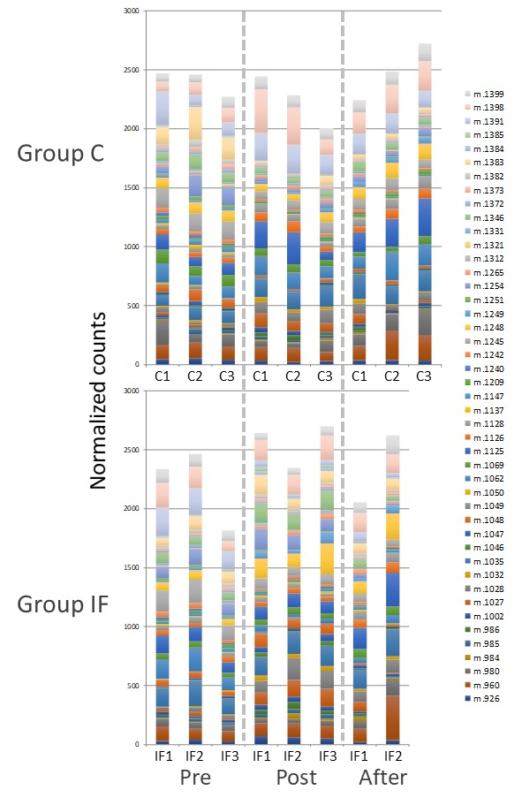
Figure S1. Normalized counts of the significant transcripts in the Pre, Post, and After periods for Groups C (upper panel) and IF (lower panel).

