Independent and reproducible hippocampal radiomic biomarkers for multisite Alzheimer’s disease: diagnosis, longitudinal progress and biological basis

Outline
Quantitative hippocampal radiomic biomarkers for multisite Alzheimer’s disease: diagnosis, longitudinal progress and biological basis 1
Outline 1
S01: Data description 3
PL_G and PL_S 3
HH_Z 4
QL_W 5
XW_H 5
XW_Z 7
ADNI 8
MRI scanner and image acquisition protocol information. 9
Funding 9
S02: Supplementary method for cross-validation: pseudocodes for classification methods based on support vector machine (SVM) 10
Pseudocode for the inter-site cross-validation (CV1). 11
Pseudocode for the intrasite cross-validation (CV2). 11
Pseudocode for CV3. 12
Pseudocode for CV4. 12
S03: Supplementary results classification 13
AUCs for each site with inter-site cross-validation 13
Results of MCI classification 14
S04: Supplementary analysis of cross-validation between each pair of centers with in-house data 15
S06: Supplementary experiments to elucidate the effects of the APOE genotype, Aβ and Tau 16
Radiomic features of APOE ε4+/APOE ε4- 16
Radiomic features of Aβ+/Aβ- and Tau+/Tau- 17
Radiomic features of Aβ+&Tau+, Aβ+&Tau-/Aβ-&Tau+, and Aβ-&Tau- 18
Correlation between radiomic features and Aβ/Tau scores 20
S06: Correlation between radiomic features and the polygenic risk score 21
Genotype processing 21
Computation of the polygenic risk score 22
S07: Supplementary experiment for radiomics alterations in longitudinal PMCI and SMCI subjects 24
S08: Radiomic features can be used to predict whether MCI converts to AD 27
Fitting 27
Classification baseline 27
S09: Summary of radiomic features 28
S10: Association between the radiomics features and Aβ in the hippocampus 30
S11: Definitions of the radiomics features 31
1. Intensity features 31
2. Shape features 33
3. Textural features 34
4. Wavelet features 37
References 38

S01: Data description
Supporting material can be found at GitHub (www.github.com/YongLiuLab).

PL_G and PL_S
This study was approved by the Medical Ethics Committee of PLA General Hospital, Beijing, China. Written informed consent was obtained from each enrolled subject or his/her authorized guardian. All participants were recruited by an advertisement (Chinese version). Written consent forms were obtained from all subjects or their legal guardians under protocols approved by the ethics committee of Chinese PLA General Hospital. Prior to selection for this study, all participants were given free physical, psychological and laboratory examinations, and all patients received professional suggestions for further treatment.
All of the subjects were right-handed and underwent a battery of neuropsychological tests, including subjection to the Mini-Mental State Examination (MMSE), Auditory Verbal Learning Test (AVLT), Geriatric Depression Scale (GDS) [1], Clinical Dementia Rating (CDR) [2] and Activities of Daily Living (ADL) Scale. The AVLT consisted of 1 learning trial in which a list of 10 Chinese double-character words was read, and the subject was asked to immediately recall as many items as possible. The trial was repeated twice, and the immediate recall score was the average of 3 accurate recalls. After a 5-minute delay, each subject was asked to recall the words from the initial list (AVLT-delayed recall). The subjects were then told to identify the 10 studied words that were intermixed with 10 new words (AVLT recognition).
The recruited AD patients fulfilled the following inclusion criteria: (1) diagnosed using the criteria of the National Institute of Neurological and Communicative Disorders and Stroke and the Alzheimer’s Disease and Related Disorders Association for probable AD; (2) CDR=1 or 2; (3) currently receiving no nootropic drugs, such as cholinesterase inhibitors; and (4) able to perform the neuropsychological test and tolerate magnetic resonance (MR) scanning.
The diagnostic criteria for mild cognitive impairment (MCI) were determined as previously described [3] and included the following: (1) memory complaints lasting at least 6 months; (2) CDR=0.5; (3) intact functional status and ADL< 26; and (4) lack of dementia. The criteria for the NCs included the following: (1) normal physical status; (2) CDR=0; and (3) no memory complaints.
The exclusion criteria for the participants in this study included the following: (1) metabolic conditions, such as hypothyroidism and vitamin B12/folic acid deficiencies; (2) psychiatric disorders, such as schizophrenia and depression; (3) infarction or brain hemorrhaging, as indicated by MR/computed tomography (CT) imaging; and (4) Parkinsonian syndrome, epilepsy or other nervous system diseases that can influence cognitive function. In addition, patients with a metallic foreign body, such as a cochlear implant, heart stent or other relevant MR scanning contraindications, were excluded from the study.
MR images for PL_S were acquired on a 3.0 T MR scanner (Siemens Skyra, Siemens, Germany). T1-weighted MR images were acquired using a magnetization-prepared rapid acquisition gradient echo (MP-RAGE) sequence (repetition time (TR)=2530 ms; echo time (TE)=3.43 ms; flip angle (FA)=7°; field of view (FOV)=256 mm×256 mm; matrix=256×256; inversion time=1100 ms; slice thickness=1 mm, no gap; 192 slices).
MR images for PL_G were acquired on a 3.0 T MR scanner (GE Signa HDx, GE, USA). T1-FSPGR anatomical scans were acquired with the following parameters: TR=7 ms; TE=2.9 ms; FA=8°; FOV=240 mm×240 mm; matrix=256×256; inversion time=450 ms; slice thickness=1.2 mm, no gap; 166 slices.
Further details are available in previously published studies [4-14].

HH_Z
This dataset follows the protocol of PL_G and PL_S. This study was approved by the Medical Ethics Committee of Tianjin Huanhu Hospital, Tianjin China. The patients were recruited from the memory clinic of the neurology department of Tianjin Huanhu Hospital. The control subjects were recruited from the local community using advertisements. Written informed consent was obtained from each enrolled subject or his/her authorized guardian. The participants underwent general physical, psychological and laboratory examinations prior to enrollment in the formal study. The participants did not take medications that might have influenced their cognition during the scans, and all patients received professional suggestions for further treatment.
MR images were acquired on a 3.0 T MR scanner (Magnetom Trio, Siemens, Germany). T1-weighted MR images were acquired using an MP-RAGE sequence (TR=2000 ms; TE=2.3 ms; FA=9°; FOV=232 mm×256 mm; matrix=232×256; inversion time=900 ms; slice thickness=1 mm, no gap; 192 slices; one subject with FOV=222 mm×208 mm and matrix=256×240; one subject with FOV=216 mm×256 mm and matrix=216×256).

QL_W
This dataset follows the protocol of PL_G and PL_S. This study was approved by the Medical Ethics Committee of Qilu Hospital of Shandong University, Jinan, China. The patients were recruited from the memory clinic of the Department of Neurology and Radiology, Qilu Hospital of Shandong University. The control subjects were recruited from the local community using advertisements. Written informed consent was obtained from each enrolled subject or his/her authorized guardian. The participants underwent general physical, psychological and laboratory examinations prior to enrollment in the formal study. The participants did not take medications that might have influenced their cognition during the scans, and all patients received professional suggestions for further treatment.
MR images were acquired on a 3.0 T MR scanner (Siemens Verio, Siemens, Germany). T1-weighted MR images were acquired using an MP-RAGE sequence (TR=1900 or 2000 ms; TE=2.3 ms; FA=9°; FOV=256 mm×256 mm; matrix=256×256; inversion time=900 ms; slice thickness=1 mm, no gap; 176 slices).
Related publications can be found elsewhere [15].

XW_H
The study was approved by the Medical Research Ethics Committee and Institutional Review Board of Xuanwu Hospital, Beijing, China (ClinicalTrials.gov identifiers: NCT02353884 and NCT02225964). Some of the data have been used in previous studies, and detailed information can be found elsewhere [16, 17].
All subjects underwent a series of standardized clinical evaluations, including a medical history interview, a neurological examination, and a battery of neuropsychological tests. The neuropsychological tests included the Chinese version of the MMSE, the Beijing version of the Montreal Cognitive Assessment (MoCA) [18], the CDR Scale [2], the AVLT [19], an ADL assessment, the Hachinski Ischemic Scale, the Hamilton Depression Rating (HAMD) Scale [20], and the Center for Epidemiologic Studies Depression scale [21]. Confirmation of diagnosis for all subjects was made by the consensus of at least two experienced neurologists at the Neurology Department of Xuanwu Hospital. The diagnoses were based on the available data from the neuropsychological assessment evaluation, a battery of general neurological examinations, collateral and subject symptoms and functional capacity reports.
Inclusion criteria for an MCI diagnosis included the following [22]: (a) memory complaints confirmed by an informant; (b) objectively impaired memory confirmed by neuropsychological tests; (c) definitive history of cognitive decline; (d) not meeting the criteria for dementia according to the Diagnostic and Statistical Manual of Mental Disorders, Fourth Edition, Revised (DSM-IV-R); and (e) a CDR score of 0.5.
AD subjects were diagnosed according to the National Institute of Aging-Alzheimer’s Association (NIA-AA) criteria for clinically probable AD as follows [23, 24]: (a) meeting the criteria for dementia; (b) insidious and gradual onset (not sudden) over more than 6 months; (c) definitive history of declining cognition; (d) initial and most prominent cognitive deficits evident in amnestic or nonamnestic performance; and (e) hippocampal atrophy confirmed by structural magnetic resonance imaging (MRI).
The NC subjects were required to meet the following research criteria: (a) no memory concerns; (b) MMSE and MoCA scores within the normal ranges (adjusted for age, sex, and education); and (c) a CDR score of 0.
The exclusion criteria applied to all subjects, and a history of stroke included the following: (a) vascular cognitive impairment (Hachinski Ischemic Scale score > 4 points); (b) severe depression (HAMD score > 24 points or Center for Epidemiological Studies Depression Scale score > 21 points); (c) other central nervous system diseases that could cause cognitive decline (e.g., epilepsy, brain tumors, Parkinson’s disease, and encephalitis); (d) systemic diseases that could cause cognitive impairments (e.g., anthracemia, syphilis, thyroid dysfunctions, severe anemia, and HIV); (e) history of psychosis or congenital mental growth retardation; (f) severe hypopsia or dysacusis; (g) cognitive decline caused by traumatic brain injury; (h) severe end-stage disease or severe diseases in acute stages; or (i) unable to complete neuropsychological tests or contraindication with MRI.
MR images were acquired on a 3.0 T MR scanner (Magnetom Trio, Siemens, Germany). T1-weighted MR images were acquired using an MP-RAGE sequence (TR=1900 ms; TE=2.2 ms; FA=9°; FOV=256 mm×224 mm; matrix=512×448; inversion time=900 ms; slice thickness=1 mm, no gap; 176 slices).

XW_Z
All participants were recruited by advertisements and supported throughout the testing procedures at a specialized neuropsychological research facility at Xuanwu Hospital in Beijing, China. Patients and informants (usually a family member) were interviewed clinically by a senior psychiatrist (X. Zhang). Written consent forms were obtained from all subjects or their legal guardians (usually a family member). The study was approved by the ethics committee of Xuanwu Hospital. AD subjects were diagnosed using standard operationalized criteria (DSM-IVR [American Psychiatric Association, 1994] and NINCDS-ADRDA [23]]).
Patients with a diagnosis of AD and a CDR score of 1 were classified as having mild AD, while patients with a CDR score of 2 or 3 were diagnosed with severe AD.
MCI was diagnosed according to standard criteria [3, 25, 26], including subjective memory loss with objective evidence of memory impairment in the context of normal or near-normal performance on other domains of cognitive functioning, minimal impairment of daily living activities, and a CDR score of 0.5. Normal volunteers had a CDR score of 0.
All participants satisfied the following inclusion criteria: (1) no history of an affective disorder within one month prior to assessment; (2) normal vision and audition; (3) able to cooperate with cognitive testing; (4) aged between 50 and 90 years; (5) no clinical history of stroke or other severe cerebrovascular disease; and (6) no more than one lacunar infarction, without patchy or diffuse leukoaraiosis, on neuroradiological assessment of conventional MR images.
The exclusion criteria included the following: (1) severe general medical disorders of the cardiovascular, endocrine, renal or hepatic systems; neurological disorders associated with potential cognitive dysfunction, including local brain lesions, traumatic brain injury with loss of consciousness or confusion, and dementia associated with neurosyphilis, Parkinsonism or Lewy body disease; psychiatric disorders, including depression, alcohol and drug abuse; (2) concomitant use of psychotropic medication; and (3) insufficient cognitive capacity to understand and cooperate with the study procedures.
All patients underwent a complete physical and neurological examination, an extensive battery of neuropsychological assessments, and standard laboratory tests. Healthy volunteers underwent a brief clinical interview and the MMSE to confirm that they satisfied the exclusion criteria for cognitive deficits, psychoactive drug use, and clinical disorders. Detailed information can be found in our previous studies [27-31].
MR images were acquired on a 3.0 T MR scanner (Magnetom Trio, Siemens, Germany). T1-weighted MR images were acquired using an MP-RAGE sequence (TR=2000 ms; TE=2.6 ms; FA=9°; FOV=256 mm×224 mm; matrix=256×224; inversion time=900 ms; slice thickness=1 mm, no gap; 176 slices).

ADNI
Additional information about the Alzheimer's Disease Neuroimaging Initiative (ADNI) dataset can be found in http://adni.loni.usc.edu/wp-content/uploads/how_to_apply/ADNI_Acknowledgement_List.pdf.
The number of subjects from each site is shown below.
Figure S1. Distribution of the number of subjects in the ADNI dataset

MRI scanner and image acquisition protocol information.
Table S1. MRI scanner and image
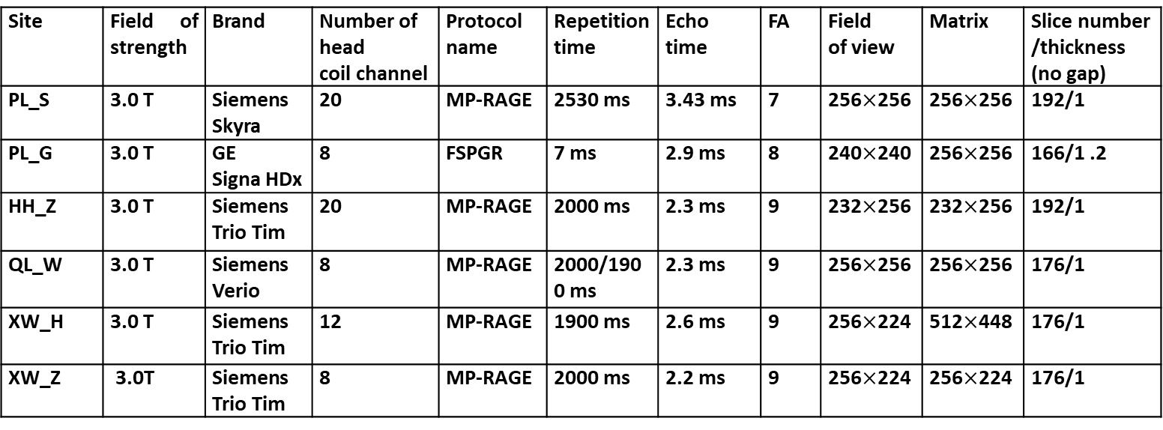
One subject in HH_Z had FOV=222 mm×208 mm and matrix=256×240; one subject had FOV=216 mm×256 mm and matrix=216×256.

Funding
This work was partially supported by the National Key Research and Development Program of China (grant no. 2016YFC1305904), the Strategic Priority Research Program (B) of the Chinese Academy of Sciences (grant no. XDB32020200), and the National Natural Science Foundation of China (grant nos. 81871438, 61633018, 81571062, 81400890, 81471120 and 61431012).

S02: Supplementary method for cross-validation: pseudocodes for classification methods based on support vector machine (SVM)
This section briefly presents the inter-site cross-validation.
CV1 consisted of leaving one center out as the testing set while using the data from other centers as the training data (Figure 1d, Figure S2). In addition, the model trained on the complete pooled data was applied to each pair of independent validation cohorts (S04).
The intrasite cross-validation (CV2) consisted of randomly splitting the participants into training sets (approximately 90% of the data) and a testing set (10% of the data). This procedure was resampled and performed 1000 times (Figure 1d, Figure S3).
CV3: In-house data were used as the training set, and ADNI data were applied as the testing set with the SVM-recursive feature elimination (SVM-RFE) feature selection method using the default parameters (Figure S4).
CV4: Conversely, the ADNI data were used as the training set, and in-house data were used as the testing set (Figure S5).

Pseudocode for the inter-site cross-validation (CV1).
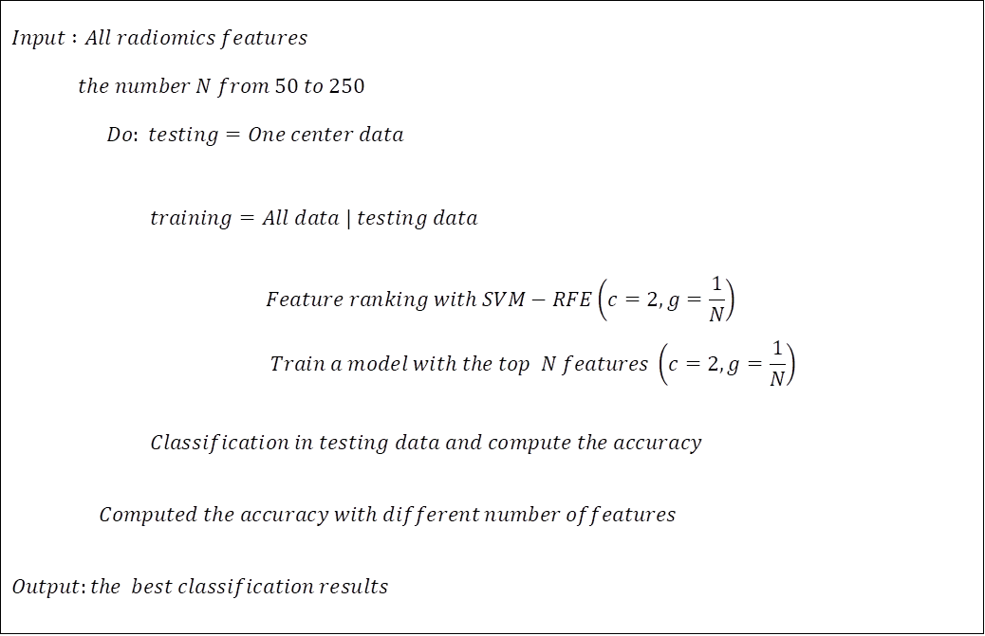
Figure S2. Pseudocode for the inter-site cross-validation (CV1).

Pseudocode for the intrasite cross-validation (CV2).
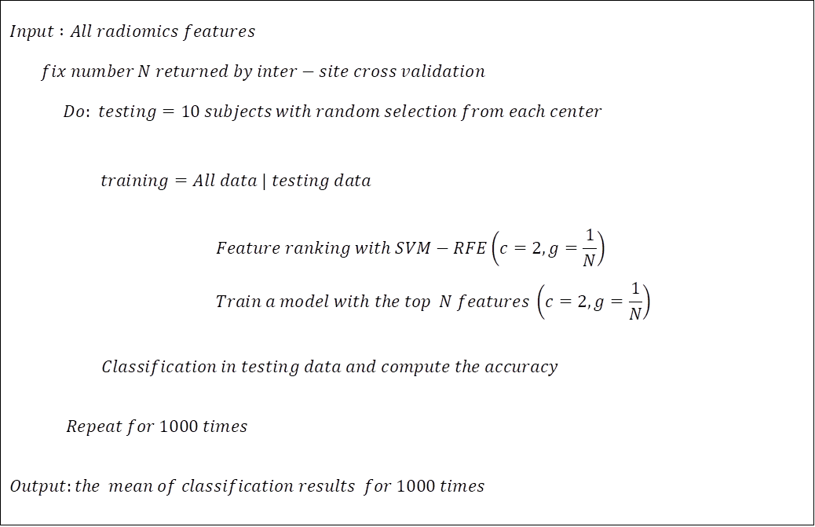
Figure S3. Pseudocode for the intrasite cross-validation (CV2).

Pseudocode for CV3.
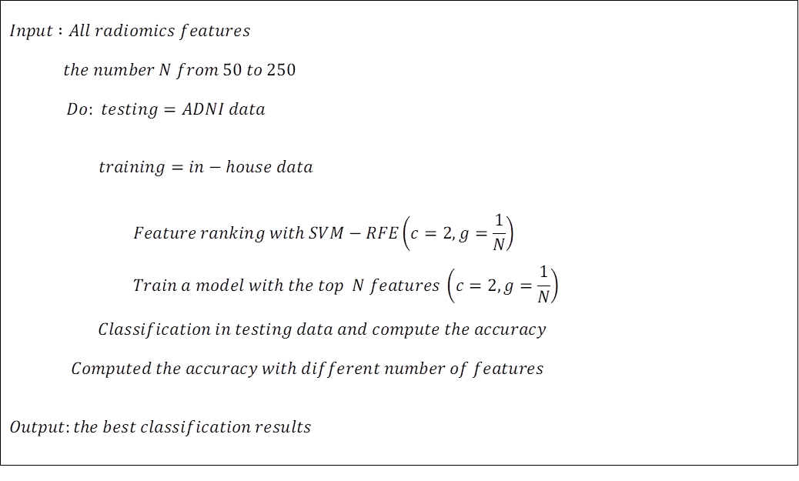
Figure S4. Pseudocode for CV3.

Pseudocode for CV4.
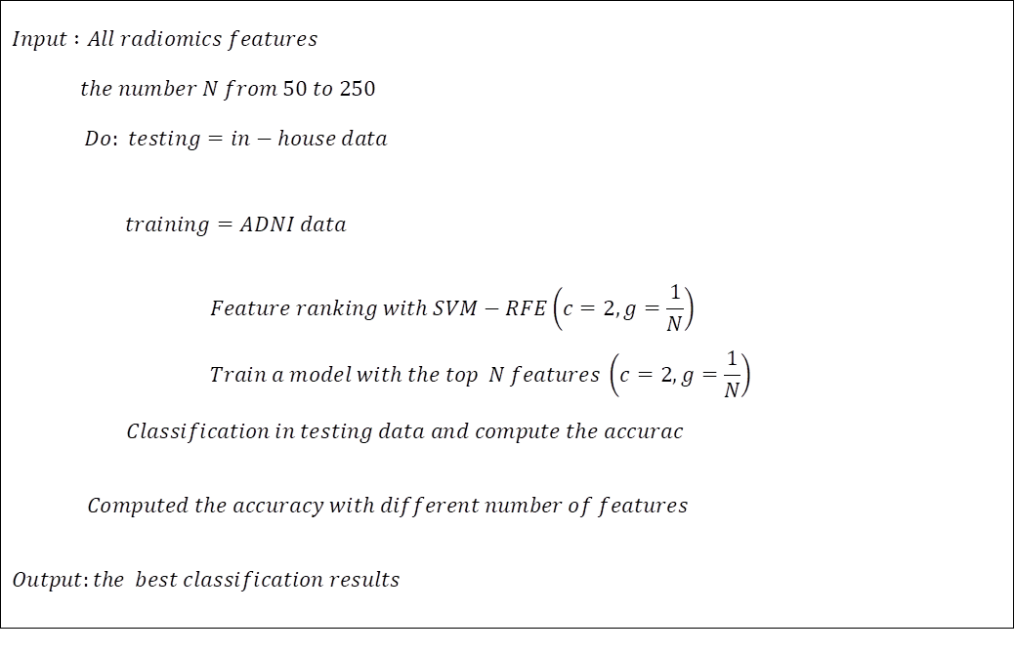
Figure S5. Pseudocode for CV4.

S03: Supplementary results classification

AUCs for each site with inter-site cross-validation
To explore the performance of the classification at each center, the areas under the curve (AUCs) of single centers were obtained by inter-site cross-validation at each site.
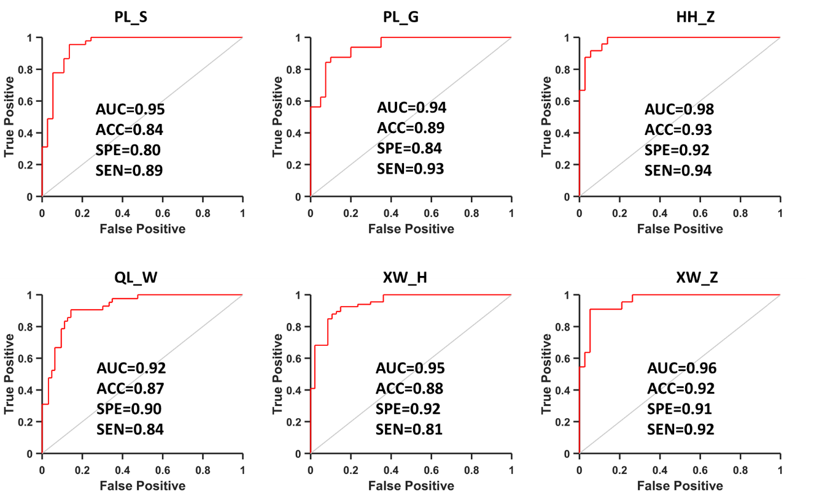
Figure S6. ROC curves of each center with inter-site cross-validation of the in-house data.
With the inter-site cross-validation, we computed the accuracy (ACC) and AUC for each site. The AUCs for all sites were higher than 0.9.

Results of MCI classification
To further explore the performances of the classifications between the MCI and NC groups and between the MCI and AD groups, inter-site cross-validations were evaluated using the same method.
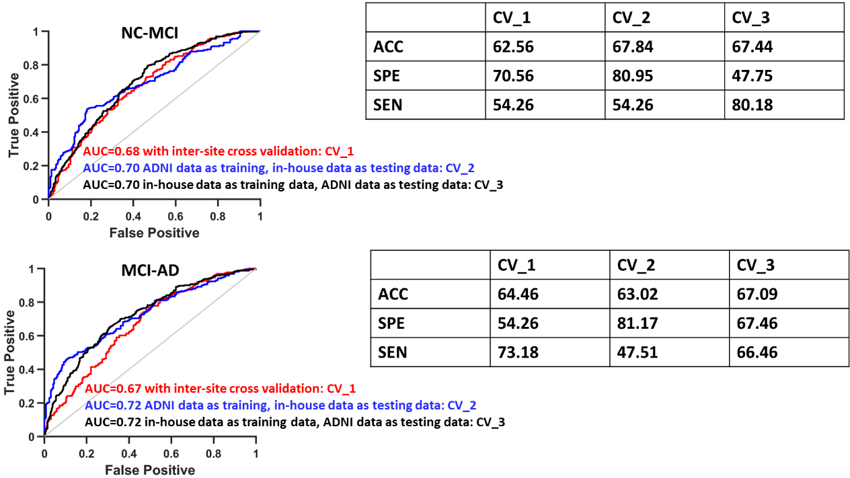
Figure S7. Results of the classifications among the MCI and AD/NC groups.

Because the results show that the classification among the MCI group was comparable with that reported previously [32], the lower ACC might have been due to the high heterogeneity of the MCI groups in the data from different centers. Hence, a better model is needed to reduce the heterogeneity of the MRI images and the individual variances in the future.

S04: Supplementary analysis of cross-validation between each pair of centers with in-house data
To determine the accuracy for each pair of centers, we used the same method as that used with CV1 to validate the robustness of the radiomic features, as shown below.
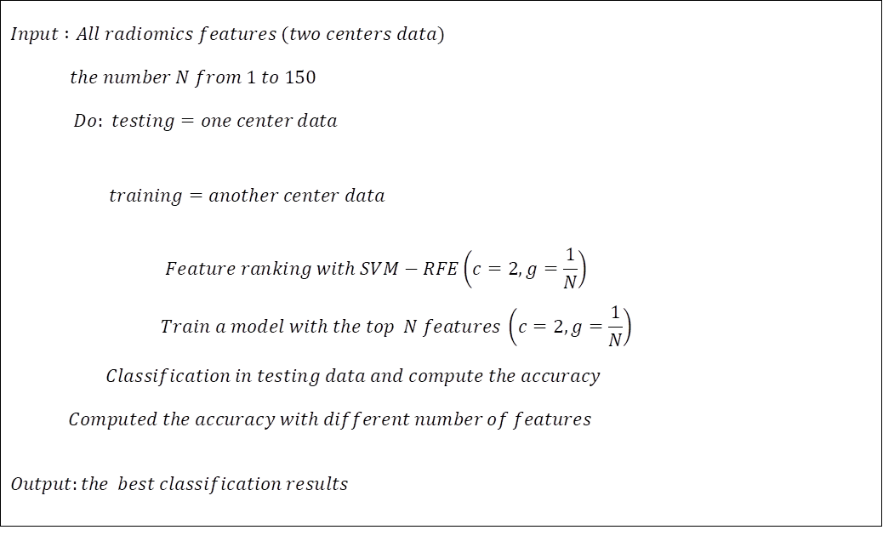
Figure S8. Pseudocode for cross-validation between each pair of centers with in-house data.
The results showed that the mean accuracy was higher than 84% (Table S2), comparable to the CV1-CV4 cross-validation results in the main text (Figure 3).

Table S2. The accuracy (%) for each pair of centers; the rows are training data, and the columns are testing data.
 | PL_S | PL_G | HH_Z | QL_W | XW_H | XW_Z
PL_S |  | 84.72 | 90 | 68.57 | 85.84 | 85
PL_G | 90.24 |  | 88.33 | 83.81 | 87.61 | 88.33
HH_Z | 86.56 | 76.39 |  | 64.76 | 77.88 | 83.33
QL_W | 87.80 | 84.72 | 96.67 |  | 87.61 | 88.33
XW_H | 90.24 | 81.94 | 86.67 | 76.19 |  | 88.33
XW_Z | 80.49 | 84.72 | 91.67 | 87.62 | 87.61

S06: Supplementary experiments to elucidate the effects of the APOE genotype, Aβ and Tau
For the ADNI data, we obtained 1228 subjects, including 356 NCs (age: 73.90±5.87; gender (M/F): 171/185; MMSE: 29.06±1.16), 550 MCI patients (age: 73.25±7.49; gender (M/F): 324/226; MMSE: 27.61±1.78) and 322 AD patients (age: 74.78±7.40; gender (M/F): 183/139; MMSE: 23.89±2.43). In classifying the AD patients from the NCs, all NC and AD data were used for the CV3 and CV4 steps (356 NCs, 322 AD patients). To elucidate the relationships between the classification output and the MMSE scores and between the subset of ‘coincident’’ features and MMSE scores, all MCI subjects were included.
In addition, to explore the relationships between coincidental radiomic features and the APOE genotype and Aβ and Tau pathology, 708 subjects (182 NCs, 328 MCI patients and 198 AD patients) with known information about their APOE genotype and Aβ and Tau status were further selected from the 1228 ADNI subjects; see Table S3.
Table S3. Demographic, APOE genotype, Aβ and Tau characteristics of the target sample.
 | NCs (n=182) | MCI patients (n=328) | AD patients (n=198)
Age (years) | 73.1±5.8 | 72.3±7.3 | 74.4±7.7
Gender (M/F) | 86/96 | 191/137 | 122/76
MMSE | 29.1±1.1 | 27.8±1.8 | 24.1±2.3
APOE ε4+/ε4- | 68/114 | 177/151 | 141/57
Aβ | 1036.3±373.8 | 846.3±342.4 | 623.3±236.4
Tau | 226.7±90.3 | 285.2±128.1 | 364.3±146.2
APOE ε4+ included subjects with one or two copies of the ε4 allele at the APOE locus.

Radiomic features of APOE ε4+/APOE ε4-
To investigate the potential effect of the APOE genotype, we evaluated the differences in radiomic features in the 328 selected MCI subjects (Table S3). As shown in Figure 5 of the main text, 8 of the 33 coincidental features were significantly different between the APOE ε4+ subjects (N=177) and the APOE ε4- subjects (N=151) in the MCI group (P<0.05) (Figure 5, Table S5).

Radiomic features of Aβ+/Aβ- and Tau+/Tau-
As shown in Figure S9, there are large overlaps of Aβ and Tau among the NC, MCI and AD groups
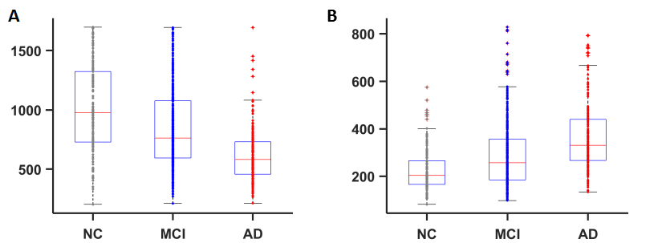
Figure S9. Boxplots of Aβ (A) and Tau (B) values in the selected samples.
To study the effects of Aβ and Tau, we studied the radiomic alterations in the subgroups (Aβ+/Aβ-) and (Tau+/Tau-) in the MCI groups according to the following steps. To estimate the categorical differences between the high and low values, the cutoffs were defined by the mean value±0.5× standard deviation of the Aβ and Tau values. In that manner, 115 subjects with low Aβ values (Aβ<675, Aβ+), 86 subjects with high Aβ values (Aβ>1017, Aβ-), 88 subjects with high Tau values (Tau>349 Tau+) and 116 subjects with low Tau values (Tau<221, Tau-) were obtained from the MCI groups (Table S4). It is worth noting that the results only reflect higher Aβ or Tau compared with lower Aβ or Tau, so the thresholds used mean±0.5*std.
Table S4. Demographic and Aβ/Tau characteristics of the target MCI subgroups.
 | High Aβ (Aβ-) | Low Aβ (Aβ+) | High Tau (Tau+) | Low Tau (Tau-)
Age | 72.43±8.35 | 72.98±7.11 | 72.99±7.09 | 72.14±7.74
Gender (M/F) | 45/41 | 83/46 | 38/50 | 77/39
Aβ/Tau | 1327.30±209.07 | 537.47±102.81 | 454.45±95.37 | 162.29±33.86
Next, two-sample two-sided t-tests were used to evaluate the differences in the radiomic features of any two MCI subgroups. The results show that 19 features were significantly different between the subjects with high Aβ (Aβ-) values and low Aβ (Aβ+) values at p<0.05, while 19 of the 33 coincidental features were significantly different between the subjects with high Tau (Tau+) values and low Tau (Tau-) values (Table S5).

Table S5. Differential features between APOE ε4+ and ε4-, high Aβ and low Aβ, and high Tau and low Tau.
 |  |  | P value | P value
 | Feature | ε4+/ε4- | Higher $Aβ$/Lower $Aβ$ | Higher Tau/Lower Tau
Left | size | 0.013 | 0.005 | 0.003
 | minimum | 0.137 | 0.083 | 0.474
 | skewness | 0.507 | 0.242 | 0.568
 | Compactness1 | 0.057 | 0.007 | 0.001
 | Surf2VolRatio | 0.002 | 0.002 | 0.364
 | Autocorrelation | 0.285 | 0.133 | 0.143
 | SumAverage | 0.324 | 0.267 | 0.282
 | SumVariance | 0.268 | 0.123 | 0.138
 | Variance | 0.262 | 0.145 | 0.153
 | GLN | 0.006 | 0.003 | 0.006
 | GLN-LLL | 0.006 | 0.008 | 0.003
 | RLN-LLH | 0.058 | 0.022 | 0.009
 | median-LHL | 0.108 | 0.023 | 0.108
 | RLN-LHH | 0.091 | 0.007 | 0.013
 | RLN-HLH | 0.067 | 0.022 | 0.033
 | LRE-HHL | 0.084 | 0.159 | 0.104
 | RLN-HHH | 0.093 | 0.065 | 0.027
Right | mad | 0.183 | 0.049 | 0.444
 | skewness | 0.295 | 0.982 | 0.211
 | Compactness1 | 0.199 | 0.036 | 0.001
 | SumVariance | 0.098 | 0.719 | 0.981
 | GLN | 0.024 | 0.001 | 3.44x10⁻⁴
 | skewness-LLL | 0.396 | 2.89x10⁻⁴ | 0.005
 | LRE-LLL | 0.484 | 0.070 | 0.007
 | GLN-LLL | 0.041 | 0.015 | 0.001
 | LRHGLE-LLL | 0.346 | 0.002 | 0.041
 | SRE-LHL | 0.321 | 0.437 | 0.162
 | GLN-LHL | 0.105 | 0.002 | 1.37x10⁻⁴
 | GLN-HLH | 0.047 | 0.020 | 0.006
 | RLN-HLH | 0.218 | 0.076 | 9.61x10⁻⁵
 | entropy-HHL | 0.248 | 0.809 | 0.143
 | GLN-HHL | 0.048 | 0.017 | 2.21x10⁻⁴
 | GLN-HHH | 0.051 | 0.007 | 0.001

Radiomic features of Aβ+&Tau+, Aβ+&Tau-/Aβ-&Tau+, and Aβ-&Tau-
Aβ and Tau occasionally coexist, which substantially increases the risk of AD [33-35]. Hence, we also evaluated the difference in the identified features in three subgroups (Aβ+&Tau+, Aβ-&Tau+ or Aβ+&Tau-, and Aβ-&Tau-) of the MCI subjects. For the subjects with Aβ and Tau information, we extracted 43 subjects with Aβ+&Tau+, 36 subjects with Aβ-&Tau+ or Aβ+&Tau-, and 52 subjects with Aβ-&Tau- for further analysis (Table S6).
Table S6. Demographic characteristics of the target MCI subgroups.
 | Aβ+&Tau+ (N=43) | Aβ+&Tau-/Aβ-&Tau+ (N=36) | Aβ-&Tau- (N=52)
Age | 72.34±6.61 | 74.30±8.63 | 70.51±7.69
Gender (M/F) | 17/26 | 27/9 | 28/24
A comparison of the subjects with Aβ+&Tau+ (N=43) and Aβ-&Tau- (N=52) showed that 21 of the 33 coincidental features were significantly different, and the scores of these features in the Aβ+ &Tau- (Aβ-&Tau+) subgroup fell in the middle of those of the other two subgroups (Table S7).
Table S7. Statistical differences among different subgroups of the target MCI sample.
 |  | Left |  |  |  |  | Right
Feature | P  (ANOVA) | P  (++/--) | P  (--/+-) | P  (++/+-) | Feature | P  (ANOVA) | P  (++/--) | P  (--/+-) | P  (++/+-)
size | 0.042 | 0.019 | 0.619 | 0.097 | mad | 0.080 | 0.028 | 0.790 | 0.088
minimum | 0.038 | 0.006 | 0.607 | 0.076 | skewness | 0.388 | 0.501 | 0.491 | 0.164
skewness | 0.103 | 0.414 | 0.187 | 0.037 | Compactness1 | 0.011 | 0.003 | 0.474 | 0.065
compactness1 | 0.020 | 0.009 | 0.657 | 0.060 | SumVariance | 0.638 | 0.484 | 0.851 | 0.351
surf2volratio | 0.830 | 0.554 | 0.662 | 0.986 | GLN | 0.002 | 0.001 | 0.092 | 0.076
autocorrelation | 0.387 | 0.142 | 0.615 | 0.469 | skewness-LLL | 0.007 | 0.003 | 0.597 | 0.022
sumaverage | 0.577 | 0.294 | 0.442 | 0.911 | LRE-LLL | 0.031 | 0.023 | 0.896 | 0.039
sumvariance | 0.384 | 0.143 | 0.661 | 0.432 | GLN-LLL | 0.011 | 0.004 | 0.491 | 0.054
variance | 0.435 | 0.166 | 0.599 | 0.531 | LRHGLE-LLL | 0.004 | 0.010 | 0.672 | 0.005
GLN | 0.051 | 0.019 | 0.386 | 0.166 | SRE-LHL | 0.379 | 0.327 | 0.657 | 0.204
GLN-LLL | 0.037 | 0.030 | 0.966 | 0.046 | GLN-LHL | 0.001 | 2.3x10⁻⁴ | 0.116 | 0.053
RLN-LLH | 0.039 | 0.022 | 0.816 | 0.067 | GLN-HLH | 0.013 | 0.004 | 0.530 | 0.054
median-LHL | 0.057 | 0.014 | 0.472 | 0.150 | RLN-HLH | 0.014 | 0.003 | 0.171 | 0.176
RLN-LHH | 0.035 | 0.018 | 0.696 | 0.074 | entropy-HHL | 0.231 | 0.107 | 0.964 | 0.191
RLN-HLH | 0.096 | 0.043 | 0.634 | 0.154 | GLN-HHL | 0.012 | 0.004 | 0.371 | 0.074
LRE-HHL | 0.073 | 0.297 | 0.172 | 0.032 | GLN-HHH | 0.005 | 0.002 | 0.288 | 0.062
RLN-HHH | 0.160 | 0.064 | 0.608 | 0.236
++ indicates that Aβ is positive and Tau is positive.
+- indicates that Aβ is positive and Tau is negative or Aβ is negative and Tau is positive.
-- indicates that Aβ is negative and Tau is negative.

Correlation between radiomic features and Aβ/Tau scores
As shown in Figure 5, 20 features showed significant correlations with the Aβ scores, and 22 features had significant correlations with the Tau scores in the MCI subjects (N=328, P<0.05) (Figure 5, Table S8).
Table S8. Correlation results in the MCI group with the Aβ and Tau data.
 | Feature | R (Aβ) | P (Aβ) | R (Tau) | P (Tau)
Left | size | 0.164 | 0.003 | -0.170 | 0.002
 | minimum | -0.083 | 0.135 | 0.080 | 0.150
 | skewness | 0.069 | 0.211 | -0.054 | 0.329
 | compactness1 | 0.160 | 0.004 | -0.197 | 3.21x10⁻⁴
 | surf2volratio | -0.162 | 0.003 | 0.020 | 0.720
 | autocorrelation | -0.065 | 0.239 | 0.028 | 0.616
 | sumaverage | -0.042 | 0.448 | -0.003 | 0.963
 | sumvariance | -0.067 | 0.224 | 0.030 | 0.588
 | variance | -0.062 | 0.259 | 0.025 | 0.657
 | GLN | 0.153 | 0.005 | -0.181 | 0.001
 | GLN-LLL | 0.154 | 0.005 | -0.178 | 0.001
 | RLN-LLH | 0.113 | 0.041 | -0.149 | 0.007
 | median-LHL | -0.123 | 0.026 | 0.128 | 0.021
 | RLN-LHH | 0.153 | 0.005 | -0.145 | 0.008
 | RLN-HLH | 0.139 | 0.012 | -0.138 | 0.012
 | LRE-HHL | 0.083 | 0.133 | -0.123 | 0.026
 | RLN-HHH | 0.107 | 0.053 | -0.128 | 0.021
Right | mad | -0.105 | 0.057 | 0.060 | 0.280
 | skewness | 0.019 | 0.734 | -0.074 | 0.181
 | compactness1 | 0.140 | 0.011 | -0.207 | 1.59x10⁻⁴
 | sumvariance | 0.010 | 0.855 | -0.007 | 0.905
 | GLN | 0.200 | 2.75x10⁻⁴ | -0.210 | 1.24x10⁻⁴
 | skewness-LLL | -0.197 | 3.29x10⁻⁴ | 0.160 | 0.004
 | LRE-LLL | 0.125 | 0.023 | -0.193 | 4.50x10⁻⁴
 | GLN-LLL | 0.157 | 0.004 | -0.196 | 3.61x10⁻⁴
 | LRHGLE-LLL | 0.193 | 4.36x10⁻⁴ | -0.139 | 0.012
 | SRE-LHL | -0.036 | 0.510 | -0.122 | 0.028
 | GLN-LHL | 0.192 | 4.66x10⁻⁴ | -0.210 | 1.27x10⁻⁴
 | GLN-HLH | 0.132 | 0.017 | -0.160 | 0.004
 | RLN-HLH | 0.127 | 0.021 | -0.211 | 1.18x10⁻⁴
 | entropy-HHL | -0.002 | 0.972 | -0.105 | 0.058
 | GLN-HHL | 0.148 | 0.007 | -0.214 | 9.45x10⁻⁵
 | GLN-HHH | 0.181 | 0.001 | -0.197 | 3.23x10⁻⁴
R represents the correlation coefficient, P represents the statistical significance, and R (PMCI) indicates the R value of the correlation of radiomic features with changes in cognitive ability.

S06: Correlation between radiomic features and the polygenic risk score
To explore the influence of genetic risk on the identified radiomics features, we performed a correlation analysis of the radiomic features and polygenic risk scores in the AD and MCI groups.

Genotype processing
We obtained whole-genome sequencing (WGS) data from 812 participants in the ADNI dataset and then performed genotype quality control (QC) analysis using PLINK version 1.07 [36]. First, we removed individuals with missing genotype rates greater than 0.05. In addition, we estimated the pairwise identity-by-descent (IBD) value to identify the individuals with possible relative relationships. These identified pairs of individuals had more similar genotypes than expected by chance in a random sample. In each pair, the individual with more missing genotype information was removed. We then applied single nucleotide polymorphism (SNP)-level filtering, removing SNPs with a minor allele frequency less than 0.01, SNPs missing rates greater than 0.05, and SNPs that significantly departed from Hardy-Weinberg equilibrium (P < 0.001). To control for population stratification, we carried out principal component analysis (PCA) using GCTA version 1.91.4beta [37] on a linkage disequilibrium (LD) pruned set of autosomal SNPs obtained by carrying out LD pruning with PLINK and removing 5 long-range LD regions with the HapMap phase 3 reference dataset [38]. We obtained 10 principal components and excluded the outliers of the samples based on an SD >6 from the mean. Finally, we used SHAPEIT v2 (r790) [39] and IMPUTE2 [40] to impute ungenotyped SNPs from the 1000 Genomes Phase 1 reference dataset. Further analyses focused on autosomal SNPs with imputation quality scores greater than 0.8.
Table S9. Demographic characteristics of the target sample with polygenic data.
 | NCs (N=195) | MCI subjects (N=277) | AD subjects (N=61)
Age | 73.88±5.49 | 72.43±7.31 | 73.39±7.81
Gender (M/F) | 98/97 | 161/116 | 38/23
MMSE | 29.09±1.10 | 27.97±1.59 | 24.62±2.63
After the QC procedures, 792 ADNI subjects with more than 7 million SNPs were retained for the subsequent analysis. After interleaving with the MRI image data, 533 subjects were used in this study (Table S9).

Computation of the polygenic risk score
We used the “score” utility in PLINK and recent summary statistics for AD [41] to compute the polygenic AD risk score. The polygenic risk score computing method was developed by Purcell and colleagues [42] as described by Holmes and colleagues [43]. Eighteen PGRSs for each subject were obtained using different SNP inclusion thresholds as follows: P_{T} < 1; P_{T} < 0.5; P_{T} < 0.4; P_{T} < 0.3; P_{T} < 0.2; P_{T} < 0.1; P_{T} < 0.05; P_{T} < 0.01; P_{T} < 0.005; P_{T} < 0.001; P_{T} < 5×10⁻⁴; P_{T} < 1×10⁻⁴; P_{T} < 1×10⁻⁵; P_{T} < 1×10⁻⁶; P_{T} < 1×10⁻⁷; P_{T} < 1×10⁻⁸; P_{T} < 1×10⁻⁹; and P_{T} < 1×10⁻¹⁰.
Choosing the PGRS under the appropriate SNP inclusion threshold is an important step. Specifically, we compared the polygenic risk scores for AD between AD patients and controls and found that the difference was most significant when the threshold was equal to 1×10⁻⁶, suggesting that this PGRS could best explain the patient-control difference in genetic structure. Therefore, the polygenic risk score with a threshold of 1×10⁻⁶ was used for further analysis.
Table S10. Correlation between the radiomic features and the polygenic risk score.
Feature (left) | R | P |  | Feature (right) |  |  | R |  | P
size | -0.113 | 0.004 |  | mad |  | 0.002 |  | 0.960
minimum | -0.002 | 0.968 |  | skewness |  | 0.024 |  | 0.541
skewness | -0.023 | 0.568 |  | compactness1 |  | -0.125 |  | 0.001
compactness1 | -0.112 | 0.005 |  | sumvariance |  | -0.017 |  | 0.672
surf2volratio | -0.052 | 0.187 |  | GLN |  | -0.145 |  | 2.25x10-4
autocorrelation | -0.015 | 0.707 |  | skewness-LLL |  | 0.074 |  | 0.062
sumaverage | -0.029 | 0.466 |  | LRE-LLL |  | -0.107 |  | 0.007
sumvariance | -0.013 | 0.743 |  | GLN-LLL |  | -0.135 |  | 0.001
variance | -0.015 | 0.697 |  | LRHGLE-LLL |  | -0.101 |  | 0.011
GLN | -0.105 | 0.007 |  | SRE-LHL |  | -0.084 |  | 0.033
GLN-LLL | -0.125 | 0.001 |  | GLN-LHL |  | -0.127 |  | 0.001
RLN-LLH | -0.102 | 0.010 |  | GLN-HLH |  | -0.137 |  | 4.72x10-4
median-LHL | 0.006 | 0.878 |  | RLN-HLH |  | -0.127 |  | 0.001
RLN-LHH | -0.104 | 0.008 |  | entropy-HHL |  | -0.081 |  | 0.040
RLN-HLH | -0.109 | 0.005 |  | GLN-HHL |  | -0.127 |  | 0.001
LRE-HHL | -0.093 | 0.018 |  | GLN-HHH |  | -0.131 |  | 0.001
RLN-HHH | -0.105 | 0.008
Next, Spearman’s correlations between the radiomic features and polygenic risk scores were evaluated after accounting for the regression group and the influence of race. The results demonstrated that 21 of the 33 coincidental features were highly correlated with the polygenic risk score after accounting for the regression group and the influence of race using Spearman’s correlation analysis (P<0.05) (Table S10).

S07: Supplementary experiment for radiomics alterations in longitudinal PMCI and SMCI subjects
To investigate the existence of disease progression-associated alterations, 168 PMCI subjects and 134 SMCI subjects scanned on two instruments were also included. We further selected the brain images of the progressive MCI (PMCI) subjects and stable MCI (SMCI) subjects from the ADNI (www.loni.ucla.edu/ADNI). In total, 336 PMCI images (168 PMCI subjects x 2 visits; interval time of 33.01±24.57 months) and 268 SMCI images (134 SMCI subjects x 2 visits; interval time of 38.61±29.22 months) were obtained (Table S11).
Table S11. Demographic information, duration, MMSE and changed MMSE in the target sample.
 | PMCI subjects (n=168) | SMCI subjects (n=134)
Age (years) | 74.42±7.02 | 73.90±7.79
Gender (M/F) | 101/67 | 84/50
MMSE¹ | 25.80±2.68 | 27.90±1.88
MMSE² | 23.02±5.10 | 27.01±2.56
MMSE¹ is the MMSE score at the first visit, and MMSE² is the MMSE score at the second visit.
For the 168 PMCI subjects, 24 features had high correlations between the changes in feature scores and changes in cognitive ability (MMSE) (Spearman correlation, P<0.05). For the 134 SMCI subjects, 25 features had high correlations between the changes in feature scores and changes in cognitive ability (MMSE) (Spearman correlation, P<0.05), but the relevance was substantially weaker than that for the PMCI group (Figure 5 and Table S12).

Table S12. Correlation results of changes in cognitive ability in the PMCI and SMCI groups.
 | Feature | R (PMCI) | P (PMCI) | R (SMCI) | P (SMCI)
Left | size | 0.524 | 8.604x10⁻¹⁴ | 0.225 | 0.009
 | minimum | 0.178 | 0.013 | 0.075 | 0.390
 | skewness | 0.316 | 1.790x10⁻⁵ | 0.211 | 0.015
 | compactness1 | 0.483 | 1.023x10⁻¹¹ | 0.257 | 0.003
 | surf2volratio | -0.311 | 2.590x10⁻⁵ | -0.224 | 0.009
 | autocorrelation | -0.012 | 0.697 | -0.184 | 0.034
 | sumaverage | -0.034 | 0.868 | -0.179 | 0.039
 | sumvariance | -0.023 | 0.647 | -0.185 | 0.032
 | variance | -0.013 | 0.736 | -0.185 | 0.033
 | GLN | 0.338 | 4.203x10⁻⁶ | 0.205 | 0.018
 | GLN-LLL | 0.462 | 9.363x10⁻¹¹ | 0.240 | 0.005
 | RLN-LLH | 0.445 | 4.951x10⁻¹⁰ | 0.253 | 0.003
 | median-LHL | -0.048 | 0.529 | -0.049 | 0.575
 | RLN-LHH | 0.296 | 6.216x10⁻⁶ | 0.254 | 0.003
 | RLN-HLH | 0.374 | 2.940x10⁻⁷ | 0.241 | 0.005
 | LRE-HHL | 0.220 | 0.003 | 0.163 | 0.060
 | RLN-HHH | 0.344 | 2.849x10⁻⁶ | 0.286 | 0.001
Right | mad | -0.062 | 0.409 | -0.091 | 0.295
 | skewness | 0.411 | 1.341x10⁻⁸ | 0.216 | 0.012
 | compactness1 | 0.556 | 8.882x10⁻¹⁶ | 0.363 | 1.599x10⁻⁵
 | sumvariance | -0.046 | 0.541 | 0.015 | 0.867
 | GLN | 0.458 | 1.491x10⁻¹⁰ | 0.287 | 0.001
 | skewness-LLL | -0.150 | 0.046 | -0.093 | 0.287
 | LRE-LLL | 0.342 | 3.249x10⁻⁶ | 0.175 | 0.043
 | GLN-LLL | 0.528 | 4.086x10⁻¹⁴ | 0.243 | 0.005
 | LRHGLE-LLL | 0.091 | 0.227 | -0.02 | 0.819
 | SRE-LHL | -0.276 | 2.057x10⁻⁴ | -0.323 | 7.591x10⁻⁴
 | GLN-LHL | 0.442 | 7.462x10⁻¹⁰ | 0.378 | 6.655x10⁻⁵
 | GLN-HLH | 0.375 | 2.789x10⁻⁷ | 0.234 | 0.007
 | RLN-HLH | 0.410 | 1.399x10⁻⁸ | 0.178 | 0.040
 | entropy-HHL | -0.085 | 0.260 | -0.033 | 0.706
 | GLN-HHL | 0.380 | 1.8540x10⁻⁷ | 0.254 | 0.003
 | GLN-HHH | 0.356 | 1.178x10⁻⁶ | 0.206 | 0.017
R represents the correlation coefficient, P represents the statistical significance, and R (PMCI) represents the R value of the correlation of the radiomics features with changes in cognitive ability.

To further explore whether the radiomic features can serve as biomarkers to track the course of disease development in the conversion of MCI to AD, PMCI (N=35) and SMCI (N=29) subjects were used in this study (Table S13).
Table S13. Demographic information, MMSE and changed MMSEs in the sample over 5 visits.
 | PMCI subjects (n=35) | SMCI subjects (n=29)
Age (years) | 73.75±5.87 | 73.05±8.08
Gender (M/F) | 24/11 | 20/9
MMSE¹ | 26.71±2.52 | 28.52±1.15
MMSE² | 25.03±4.15 | 28.66±1.32
MMSE³ | 23.40±5.11 | 28.10±1.97
MMSE⁴ | 21.29±6.47 | 27.41±1.86
MMSE⁵ | 18.74±6.60 | 27.17±2.41
MMSE¹⁻⁵ are the MMSE scores for visits 1-5, respectively.
In this study, changes in more than 2/3 of the radiomic features were highly consistent with changes in cognitive ability in the MCI subjects (Figure S10).
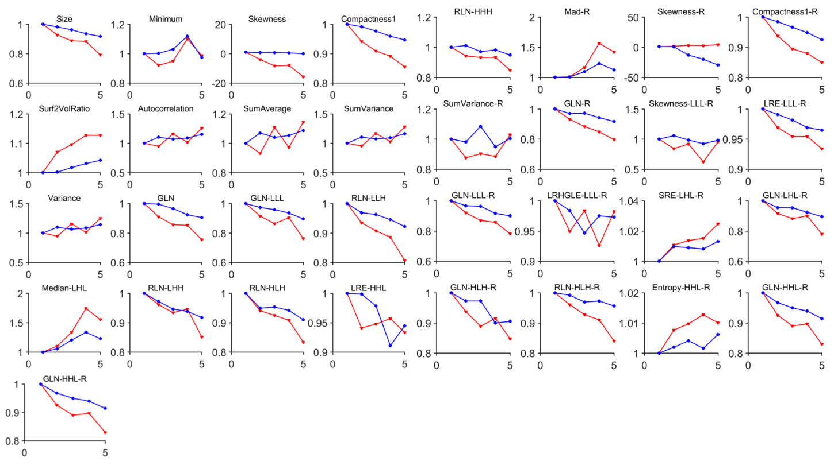
Figure S10. Trends in feature changes over 5 visits (red: PMCI, Blue: SMCI).

S08: Radiomic features can be used to predict whether MCI converts to AD

Fitting
To evaluate whether the features fit the data, the logistical regression results were computed as follows. First, we fit the data with only age, gender and APOE ε4, and the AUC was computed. We then added the radiomic features one by one with the rule that the most significant radiomic features were selected first until the AUC did not increase.
The AUC was equal to 0.65 when only the basic subject information was used, and this value increased slowly as the number of features used increased, peaking at 0.82 (Figure 5c in the main text). The selected features are: size, minimum, skewness, Compactness1, Autocorrelation, Sum Average, Sum Variance, Variance, GLN, RLN-LLH, median-LHL, RLN-HLH, LRE-HHL, mad-R, Compactness1-R, Sum Variance-R, skewness-LLL-R, LRE-LLL-R, SRE-LHL-R, GLN-HLH-R, entropy-HHL-R, GLN-HHH-R, Surf2VolRatio, GLN-LLL, skewness-R, GLN-R, GLN-LLL-R, RLN-HLH-R, RLN-LHH, and LRHGLE-LLL-R, up to 30 features.

Classification baseline
To assess the multivariate performances of the radiomic features to classify the subjects, the classification model using logistical regression was tested. With leave-one-out cross-validation (LOOCV), AUC=0.62 when only the basic subject information was used, and AUC=0.70 when the identified radiomic features were included. The lack of substantial difference in this value suggests that features from other brain regions or other model features need to be used in combination in future studies.

S09: Summary of radiomic features
Using the two-sample t-test to compare each center between the AD and NC groups, 8 features in the left hippocampus were significantly different between each center, and 22 features in the right hippocampus were significantly different; most of these features were textures, some were shapes, and no intensity features were observed (Table S14).
Table S14. Features with significant differences among centers in the left hippocampus.
Type of features | Feature details
Intensity features
Shape features | Size  Compactness1
Texture features | Gray Level Nonuniformity (HLL)  Run Length Nonuniformity (LLL, LLH, LHL, LHH, HLH)

Table S15. Features with significant differences among centers in the right hippocampus.
Type of features | Feature details
Intensity features
Shape features | Size  Area  Compactness1  Surf2VolRatio
Texture features | Gray Level Nonuniformity (Original feature, LLL, LLH, LHL, LHH, HLH, HHL, HHH)  Run Length Nonuniformity (LLL, LLH, LHL, LHH, HLL, HLH, HHH)  RunPercentage-LLL  LongRunEmphasis-LLL

S10: Association between the radiomics features and Aβ in the hippocampus
To confirm whether the important features can reflect microstructural changes in the brain, such as NFTs and Aβ plaques, 812 corresponding PET images (NC=254, MCI=382 and AD=176) were included and registered to the Montreal Neurological Institute (MNI) space, and the mean PET value in the hippocampus was computed. The Pearson correlation coefficients were used to evaluate the relationships between these identified features and the Aβ values in the hippocampus.
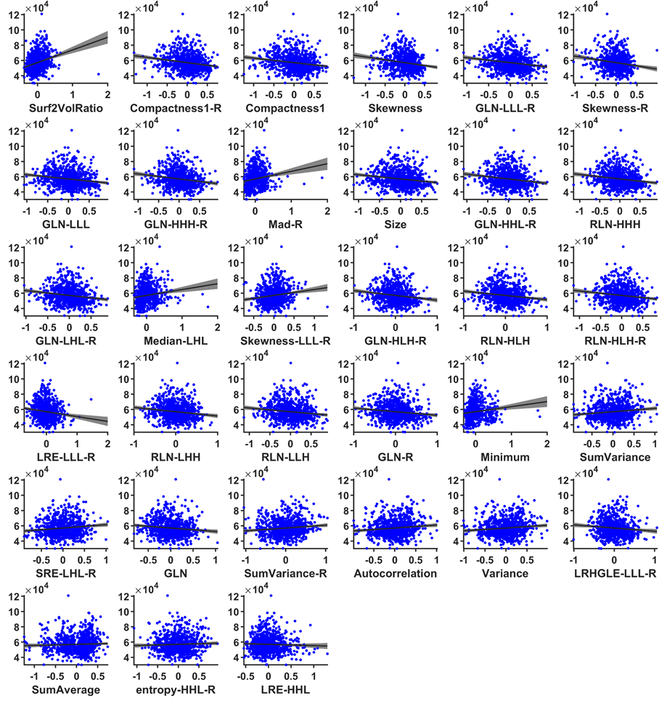
Figure S11. Correlations between 33 important features and the PET Aβ values; 27 features have high correlations with PET Aβ values P<0.05.

S11: Definitions of the radiomics features
A total of 431 MRI imaging features, including intensity, textural and wavelet groups, were extracted in this study [44]. We provided this information in a previous study [4]. To maintain the integrity of this study, we include it in the supplemental material here.

1. Intensity features
Table S16. Intensity features describe the distribution of voxel intensities within an MRI image through commonly used and basic metrics. Because some intensity features have a close relationship with the voxel intensity, such as the maximum and mean, we first normalized those features by the image intensity using the min-max method in each center.
 | Image feature | Equation | Definition
Intensity features (14) | Energy | $$\sum_{i}^{N}{{X(i)}^{2}}$$ | Measure of the randomness of the intensity values in an image
Intensity features (14) | Entropy | $$\sum_{i=1}^{N_{l}}{P\left(i\right)\log_{2}}P\left(i\right)$$ | Represents the irregularity of the intensity value distribution
Intensity features (14) | Kurtosis | $$\frac{\frac{1}{N}\sum_{i=1}^{N}{{\left(X\left(i\right)-\overline{X}\right)}^{4}}}{{\left(\sqrt{\frac{1}{N}\sum_{i=1}^{N}{{\left(X\left(i\right)-\overline{X}\right)}^{2}}}\right)}^{2}}$$ | The peakedness of the histogram or indication of histogram flatness
Intensity features (14) | Maximum | Maximum intensity value of X
Intensity features (14) | Mean | $$\frac{1}{N}\sum_{i}^{N}{X(i)}$$ | Average intensity value of the pixels within the region of interest
Intensity features (14) | Mean Absolute Deviation (mad) | Mean of the absolute deviations of all voxel intensities around the mean intensity value | A measure of how much the gray levels differ from the mean
Intensity features (14) | Median | Median intensity value of X
Intensity features (14) | Minimum | Minimum intensity value of X
Intensity features (14) | Range | Range of intensity values of X
Intensity features (14) | Root Mean Square (rms) | $$\sqrt{\frac{{\sum_{i}^{N}{X(i)}}^{2}}{N}}$$
 | Skewness | $$\frac{\frac{1}{N}\sum_{i=1}^{N}{{(X\left(i\right)-\overline{X})}^{3}}}{{\left(\sqrt{\frac{1}{N}\sum_{i=1}^{N}{{(X\left(i\right)-\overline{X})}^{2}}}\right)}^{3}}$$ | Symmetry of intensity values in an image
 | Standard Deviation | $${\left(\frac{1}{N-1}\sum_{i=1}^{N}{{\left(X\left(i\right)-\overline{X}\right)}^{2}}\right)}^{1/2}$$ | A measure of how much variation or dispersion exists
 | Uniformity | $$\sum_{i=1}^{N_{l}}{{P(i)}^{2}}$$ | Measures the homogeneity of the intensity value distribution in an image
 | Variance | $$\frac{1}{N-1}\sum_{i=1}^{N}{{\left(X\left(i\right)-\overline{X}\right)}^{2}}$$ | The spread or variation around the mean (sum of squares)
X denotes the three-dimensional image matrix. N is the number of voxels. P is the first-order histogram with N_{l} discrete intensity levels. $\overline{ X}$ is the mean of X. The number of histogram bins is 100.

2. Shape features
Table S17. Shape features describe the shape of the hippocampus
 | Image Features | Equation | Definition
Shape features(8) | Compactness1 | Compactness 1=$\frac{V}{\sqrt{π}A^{\frac{2}{3}}}$ | The density of the hippocampus
Shape features(8) | Compactness2 | Compactness 2=36$π\frac{V^{2}}{A^{3}}$ | The density of the hippocampus
Shape features(8) | Max3dDiam | The maximum three-dimensional diameter is measured as the largest  pairwise Euclidean distance between voxels on the surface of the hippocampus volume. | The maximum three-dimensional diameter
Shape features(8) | Spherical Disprop | Spherical Disprop=$\frac{A}{4πR^{2}}$
Shape features(8) | Sphericity | Sphericity=$\frac{π^{\frac{1}{3}{(6V)}^{\frac{2}{3}}}}{A}$ | The degree of similarity with a sphere.
Shape features(8) | Area | Area=$\sum_{i=1}^{N}{\frac{1}{2}|a_{i}b_{i}×a_{i}c_{i}|}$ | The area of the hippocampus
Shape features(8) | Volume | The volume of the hippocampus is determined by counting the number of pixels in the hippocampus region and multiplying this value by the voxel size | The volume of the hippocampus
Shape features(8) | Surf2VolRatio | Surf2VolRatio=$\frac{Area}{Volume}$ | The ratio of surface area to volume
N is the total number of triangles covering the surface and edge vectors of the triangles, R is the radius of the sphere of the hippocampus, and the dimensional values are voxel dimensions (1 mm).

3. Textural features
Table S18. Textural features describe the patterns or spatial distribution of voxel intensities.
 | Image feature | Equation | Definition
Textural features (33) | Autocorrelation | $$\sum_{i=1}^{N_{g}}{\sum_{j=1}^{N_{g}}{ijP(i,j)}}$$
Textural features (33) | Cluster Prominence (CP) | $$\sum_{i=1}^{N_{g}}{\sum_{j=1}^{N_{g}}{{\left[i+j-μ_{x}\left(i\right)-μ_{y}\left(j\right)\right]}^{4}P(i,j)}}$$
Textural features (33) | Cluster Shade | $$\sum_{i=1}^{N_{g}}{\sum_{j=1}^{N_{g}}{{\left[i+j-μ_{x}\left(i\right)-μ_{y}\left(j\right)\right]}^{3}P(i,j)}}$$
Textural features (33) | Cluster Tendency | $$\sum_{i=1}^{N_{g}}{\sum_{j=1}^{N_{g}}{{\left[i+j-μ_{x}\left(i\right)-μ_{y}\left(j\right)\right]}^{2}P(i,j)}}$$
Textural features (33) | Contrast | $$\sum_{i=1}^{N_{g}}{\sum_{j=1}^{N_{g}}{{\left|i-j\right|}^{2}}}P(i,j)$$ | Measures the local variation in intensity values
Textural features (33) | Correlation | $$\frac{\sum_{i=1}^{N_{g}}{\sum_{j=1}^{N_{g}}{ijP\left(i,j\right)-μ_{i}(i)μ_{j}(j)}}}{σ_{x}\left(i\right)σ_{y}(j)}$$ | Measures the linear dependencies of intensity values in an image
Textural features (33) | Difference Entropy | $$\sum_{i=0}^{N_{g}-1}{P_{x-y}\left(i\right)\log_{2}\left[P_{x-y}(i)\right]}$$
Textural features (33) | Dissimilarity | $$\sum_{i=1}^{N_{g}}{\sum_{j=1}^{N_{g}}{\left|i-j\right|}}P(i,j)$$
Textural features (33) | Energy | $$\sum_{i=1}^{N_{g}}{\sum_{j=1}^{N_{g}}{{\left[P(i,j)\right]}^{2}}}$$
Textural features (33) | Entropy | $$-\sum_{i=1}^{N_{g}}{\sum_{j=1}^{N_{g}}{P\left(i,j\right)}}\log_{2}\left[P\left(i,j\right)\right]$$
Textural features (33) | Homogeneity1 | $$\sum_{i=1}^{N_{g}}{\sum_{j=1}^{N_{g}}{\frac{P\left(i,j\right)}{1+\left|i-j\right|}}}$$ | Measures the homogeneity of the intensity values
 | Homogeneity2 | $$\sum_{i=1}^{N_{g}}{\sum_{j=1}^{N_{g}}{\frac{P\left(i,j\right)}{1+{\left|i-j\right|}^{2}}}}$$ | Measures the homogeneity of the intensity values of the pixel pair
 | Informational Measure of Correlation 1 (IMC1) | $$\frac{HXY-HXY1}{max\left\{HX,HY\right\}}$$
 | Informational Measure of Correlation 2 (IMC2) | $$\sqrt{1-e^{-2\left(HXY2-HXY\right)}}$$
 | Inverse Difference Moment Normalized (IDMN) | $$\sum_{i=1}^{N_{g}}{\sum_{j=1}^{N_{g}}{\frac{P\left(i,j\right)}{1+\left(\frac{{\left|i-j\right|}^{2}}{N^{2}}\right)}}}$$
 | Inverse Difference Normalized (IDN) | $$\sum_{i=1}^{N_{g}}{\sum_{j=1}^{N_{g}}{\frac{P\left(i,j\right)}{1+\left(\frac{\left|i-j\right|}{N}\right)}}}$$
 | Inverse Variance | $$\sum_{i=1}^{N_{g}}{\sum_{j=1}^{N_{g}}{\frac{P\left(i,j\right)}{{\left|i-j\right|}^{2}}}}, i≠j$$
 | Maximum Probability | max$\left\{P\left(i,j\right)\right\}$
 | Sum Average | $$\sum_{i=2}^{{2N}_{g}}{\left[iP_{x+y}(i)\right]}$$
 | Sum Entropy | $$-\sum_{i=2}^{{2N}_{g}}{P_{x+y}(i)\log_{2}\left[P_{x+y}(i)\right]}$$
 | Sum Variance | $$\sum_{i=2}^{{2N}_{g}}{{\left(i-SE\right)}^{2}}P_{x+y}(i)$$
 | Variance | $$\sum_{i=1}^{N_{g}}{\sum_{j=1}^{N_{g}}{{\left(i-μ\right)}^{2}}}P(i,j)$$
 | Short Run Emphasis (SRE) | $$\frac{\sum_{i=1}^{N_{g}}{\sum_{j=1}^{N_{r}}{\left[\frac{p\left(i,j | θ\right)}{j^{2}}\right]}}}{\sum_{i=1}^{N_{g}}{\sum_{j=1}^{N_{r}}{p\left(i,j | θ\right)}}}$$
 | Long Run Emphasis (LRE) | $$\frac{\sum_{i=1}^{N_{g}}{\sum_{j=1}^{N_{r}}{j^{2}}}p\left(i,j | θ\right)}{\sum_{i=1}^{N_{g}}{\sum_{j=1}^{N_{r}}{p\left(i,j | θ\right)}}}$$
 | Gray Level Nonuniformity (GLN) | $$\frac{\sum_{i=1}^{N_{g}}{{\left[\sum_{j=1}^{N_{r}}{p\left(i,j | θ\right)}\right]}^{2}}}{\sum_{i=1}^{N_{g}}{\sum_{j=1}^{N_{r}}{p\left(i,j | θ\right)}}}$$ | Represents the similarity of intensity values in an image

 | Run Length Nonuniformity (RLN) | $$\frac{\sum_{j=1}^{N_{r}}{{\left[\sum_{i=1}^{N_{g}}{p\left(i,j | θ\right)}\right]}^{2}}}{\sum_{i=1}^{N_{g}}{\sum_{j=1}^{N_{r}}{p\left(i,j | θ\right)}}}$$ | Measures the run length similarity
 | Run Percentage (RP) | $$\sum_{i=1}^{N_{g}}{\sum_{j=1}^{N_{r}}{\frac{p\left(i,j | θ\right)}{N_{p}}}}$$ | Ratio of the total number of runs to the total number of possible runs measuring the homogeneity of the runs.
 | Low Gray Level Run Emphasis (LGLRE) | $$\frac{\sum_{i=1}^{N_{g}}{\sum_{j=1}^{N_{r}}{\left[\frac{p\left(i,j | θ\right)}{i^{2}}\right]}}}{\sum_{i=1}^{N_{g}}{\sum_{j=1}^{N_{r}}{p\left(i,j | θ\right)}}}$$
 | High Gray Level Run Emphasis (HGLRE) | $$\frac{\sum_{i=1}^{N_{g}}{\sum_{j=1}^{N_{r}}{i^{2}}}p\left(i,j | θ\right)}{\sum_{i=1}^{N_{g}}{\sum_{j=1}^{N_{r}}{p\left(i,j | θ\right)}}}$$
 | Short Run Low Gray Level Emphasis (SRLGLE) | $$\frac{\sum_{i=1}^{N_{g}}{\sum_{j=1}^{N_{r}}{\left[\frac{p\left(i,j | θ\right)}{i^{2}j^{2}}\right]}}}{\sum_{i=1}^{N_{g}}{\sum_{j=1}^{N_{r}}{p\left(i,j | θ\right)}}}$$
 | Short Run High Gray Level Emphasis (SRHGLE) | $$\frac{\sum_{i=1}^{N_{g}}{\sum_{j=1}^{N_{r}}{\left[\frac{p\left(i,j | θ\right)i^{2}}{j^{2}}\right]}}}{\sum_{i=1}^{N_{g}}{\sum_{j=1}^{N_{r}}{p\left(i,j | θ\right)}}}$$
 | Long Run Low Gray Level Emphasis (LRLGLE) | $$\frac{\sum_{i=1}^{N_{g}}{\sum_{j=1}^{N_{r}}{\left[\frac{p\left(i,j | θ\right)j^{2}}{i^{2}}\right]}}}{\sum_{i=1}^{N_{g}}{\sum_{j=1}^{N_{r}}{p\left(i,j | θ\right)}}}$$
 | Long Run High Gray Level Emphasis (LRHGLE) | $$\frac{\sum_{i=1}^{N_{g}}{\sum_{j=1}^{N_{r}}{p\left(i,j | θ\right)i^{2}j^{2}}}}{\sum_{i=1}^{N_{g}}{\sum_{j=1}^{N_{r}}{p\left(i,j | θ\right)}}}$$
$P(i,j)$ is the co-occurrence matrix for an arbitrary $δ$ and$α$
$N_{g}$is the number of discrete intensity levels in the image
$p\left(i,j | θ\right)$ is the $\left(i,j\right)$th entry in the given run-length matrix $p$ for a direction $θ$
N_{g} is the number of discrete intensity values in the image
N_{r} is the number of different run lengths
N_{p} is the number of voxels in the image
u is the mean of $P(i,j)$
$p_{x}(i)$=$\sum_{j=1}^{N_{g}}{P\left(i,j\right)}$ is the marginal row probabilities
$p_{y}(i)$=$\sum_{i=1}^{N_{g}}{P\left(i,j\right)}$ is the marginal column probabilities
$μ_{x}$ is the mean of${ p}_{x}$
$μ_{y}$ is the mean of${ p}_{y}$
$σ_{x}$is the standard deviation of${ p}_{x}$
$σ_{y}$is the standard deviation of${ p}_{y}$
$p_{x+y}\left(k\right)$=$\sum_{i=1}^{N_{g}}{\sum_{j=1}^{N_{g}}{P\left(i,j\right)}}$, i$+$j=k, k=2,3,…,2*$N_{g}$
$P_{x-y}\left(k\right)$=$\sum_{i=1}^{N_{g}}{\sum_{j=1}^{N_{g}}{P\left(i,j\right)}}$,$\left|i-j\right|$=k, k=0,1,…,$N_{g}-$1
HX=$-\sum_{i=1}^{N_{g}}{p_{x}}\left(i\right)\log_{2}\left[p_{x}\left(i\right)\right]$ is the entropy of $p_{x}$
HY=$-\sum_{i=1}^{N_{g}}{p_{y}}\left(i\right)\log_{2}\left[p_{y}\left(i\right)\right]$ is the entropy of $p_{y}$
H=$-\sum_{i=1}^{N_{g}}{\sum_{j=1}^{N_{g}}{P\left(i,j\right)}}\log_{2}\left[P\left(i,j\right)\right]$ is the entropy of P$\left(i,j\right)$
HXY1=$-\sum_{i=1}^{N_{g}}{\sum_{j=1}^{N_{g}}{P\left(i,j\right)log\left(p_{x}\left(i\right)p_{y}\left(j\right)\right)}}$
HXY2=$-\sum_{i=1}^{N_{g}}{\sum_{j=1}^{N_{g}}{p_{x}\left(i\right)p_{y}\left(j\right)log\left(p_{x}\left(i\right)p_{y}\left(j\right)\right)}}$

4. Wavelet features
Wavelet transformation was performed in each hippocampal subregion image in eight directions (LLL, LLH, LHL, LHH, HLL, HLH, HHL, and HHH, where L means low, and H means high), which resulted in 376 wavelet features on the basis of the 14 intensity features and 33 textural features described above [44].

References
1. Yesavage JA, Brink TL, Rose TL, Lum O, Huang V, Adey M, et al. Development and validation of a geriatric depression screening scale: a preliminary report. J Psychiatr Res. 1982;17(1):37-49.
2. Morris JC. The Clinical Dementia Rating (CDR): current version and scoring rules. Neurology. 1993;43(11):2412-4.
3. Petersen RC, Smith GE, Waring SC, Ivnik RJ, Tangalos EG, Kokmen E. Mild cognitive impairment: clinical characterization and outcome. Arch Neurol. 1999;56(3):303-8.
4. Feng F, Wang P, Zhao K, Zhou B, Yao H, Meng Q, et al. Radiomic Features of Hippocampal Subregions in Alzheimer's Disease and Amnestic Mild Cognitive Impairment. Front Aging Neurosci. 2018;10:290.
5. Alpert K, Kogan A, Parrish T, Marcus D, Wang L. The Northwestern University Neuroimaging Data Archive (NUNDA). Neuroimage. 2016;124(Pt B):1131-6.
6. Zhou B, Yao H, Wang P, Zhang Z, Zhan Y, Ma J, et al. Aberrant Functional Connectivity Architecture in Alzheimer's Disease and Mild Cognitive Impairment: A Whole-Brain, Data-Driven Analysis. Biomed Res Int. 2015;2015:495375.
7. Wang P, Zhou B, Yao H, Zhan Y, Zhang Z, Cui Y, et al. Aberrant intra- and inter-network connectivity architectures in Alzheimer's disease and mild cognitive impairment. Sci Rep. 2015;5:14824.
8. Zhang Z, Liu Y, Zhou B, Zheng J, Yao H, An N, et al. Altered functional connectivity of the marginal division in Alzheimer's disease. Current Alzheimer research. 2014;11(2):145-55.
9. Yao H, Zhou B, Zhang Z, Wang P, Guo Y, Shang Y, et al. Longitudinal alteration of amygdalar functional connectivity in mild cognitive impairment subjects revealed by resting-state FMRI. Brain Connect. 2014;4(5):361-70.
10. Guo Y, Zhang Z, Zhou B, Wang P, Yao H, Yuan M, et al. Grey-matter volume as a potential feature for the classification of Alzheimer's disease and mild cognitive impairment: an exploratory study. Neurosci Bull. 2014;30(3):477-89.
11. Zhou B, Liu Y, Zhang Z, An N, Yao H, Wang P, et al. Impaired functional connectivity of the thalamus in alzheimer' s disease and mild cognitive impairment: a resting-state FMRI study. Curr Alzheimer Res. 2013;10(7):754-66.
12. Yao H, Liu Y, Zhou B, Zhang Z, An N, Wang P, et al. Decreased functional connectivity of the amygdala in Alzheimer's disease revealed by resting-state fMRI. Eur J Radiol. 2013;82(9):1531-8.
13. Wang P, Zhang X, Liu Y, Liu S, Zhou B, Zhang Z, et al. Perceptual and response interference in Alzheimer's disease and mild cognitive impairment. Clin Neurophysiol. 2013;124(12):2389-96.
14. Zhang Z, Liu Y, Jiang T, Zhou B, An N, Dai H, et al. Altered spontaneous activity in Alzheimer's disease and mild cognitive impairment revealed by Regional Homogeneity. Neuroimage. 2012;59(2):1429-40.
15. Wang D, Hu L, Xu X, Ma X, Li Y, Liu Y, et al. KIBRA and APOE gene variants affect brain functional network connectivity in healthy older people. J Gerontol A Biol Sci Med Sci. 2019.
16. Yan T, Wang W, Yang L, Chen K, Chen R, Han Y. Rich club disturbances of the human connectome from subjective cognitive decline to Alzheimer's disease. Theranostics. 2018;8(12):3237-55.
17. Li S, Yuan X, Pu F, Li D, Fan Y, Wu L, et al. Abnormal changes of multidimensional surface features using multivariate pattern classification in amnestic mild cognitive impairment patients. J Neurosci. 2014;34(32):10541-53.
18. Lu J, Li D, Li F, Zhou A, Wang F, Zuo X, et al. Montreal cognitive assessment in detecting cognitive impairment in Chinese elderly individuals: a population-based study. J Geriatr Psychiatry Neurol. 2011;24(4):184-90.
19. Guo Q, Sun Y, Yu P, Hong Z, Lu C. Norm of Auditory Verbal Learning Test in the Normal Aged in China Community. Chinese Journal of Clinical Psychology. 2007;15(2):132-4.
20. Hamilton M. A rating scale for depression. J Neurol Neurosurg Psychiatry. 1960;23:56-62.
21. Dozeman E, van Schaik DJ, van Marwijk HW, Stek ML, van der Horst HE, Beekman AT. The center for epidemiological studies depression scale (CES-D) is an adequate screening instrument for depressive and anxiety disorders in a very old population living in residential homes. Int J Geriatr Psychiatry. 2011;26(3):239-46.
22. Petersen RC. Mild cognitive impairment as a diagnostic entity. Journal of internal medicine. 2004;256(3):183-94.
23. McKhann G, Drachman D, Folstein M, Katzman R, Price D, Stadlan EM. Clinical diagnosis of Alzheimer's disease: report of the NINCDS-ADRDA Work Group under the auspices of Department of Health and Human Services Task Force on Alzheimer's Disease. Neurology. 1984;34(7):939-44.
24. McKhann GM, Knopman DS, Chertkow H, Hyman BT, Jack CR, Jr., Kawas CH, et al. The diagnosis of dementia due to Alzheimer's disease: recommendations from the National Institute on Aging-Alzheimer's Association workgroups on diagnostic guidelines for Alzheimer's disease. Alzheimers Dement. 2011;7(3):263-9.
25. Petersen RC, Doody R, Kurz A, Mohs RC, Morris JC, Rabins PV, et al. Current concepts in mild cognitive impairment. Arch Neurol. 2001;58(12):1985-92.
26. Choo IH, Lee DY, Youn JC, Jhoo JH, Kim KW, Lee DS, et al. Topographic patterns of brain functional impairment progression according to clinical severity staging in 116 Alzheimer disease patients: FDG-PET study. Alzheimer Dis Assoc Disord. 2007;21(2):77-84.
27. Wu Y, Zhang Y, Liu Y, Liu J, Duan Y, Wei X, et al. Distinct Changes in Functional Connectivity in Posteromedial Cortex Subregions during the Progress of Alzheimer's Disease. Frontiers in neuroanatomy. 2016;10:41.
28. Liu J, Zhang X, Yu C, Duan Y, Zhuo J, Cui Y, et al. Impaired Parahippocampus Connectivity in Mild Cognitive Impairment and Alzheimer's Disease. J Alzheimers Dis. 2016;49(4):1051-64.
29. Liu Y, Yu C, Zhang X, Liu J, Duan Y, Alexander-Bloch AF, et al. Impaired long distance functional connectivity and weighted network architecture in Alzheimer's disease. Cereb Cortex. 2014;24(6):1422-35.
30. He X, Qin W, Liu Y, Zhang X, Duan Y, Song J, et al. Abnormal salience network in normal aging and in amnestic mild cognitive impairment and Alzheimer's disease. Hum Brain Mapp. 2014;35(7):3446-64.
31. Song J, Qin W, Liu Y, Duan Y, Liu J, He X, et al. Aberrant functional organization within and between resting-state networks in AD. PLoS One. 2013;8(5):e63727.
32. Rathore S, Habes M, Iftikhar MA, Shacklett A, Davatzikos C. A review on neuroimaging-based classification studies and associated feature extraction methods for Alzheimer's disease and its prodromal stages. Neuroimage. 2017;155:530-48.
33. Sepulcre J, Grothe MJ, d'Oleire Uquillas F, Ortiz-Teran L, Diez I, Yang HS, et al. Neurogenetic contributions to amyloid beta and tau spreading in the human cortex. Nat Med. 2018;24(12):1910-8.
34. Bennett DA, Schneider JA, Wilson RS, Bienias JL, Arnold SE. Neurofibrillary tangles mediate the association of amyloid load with clinical Alzheimer disease and level of cognitive function. Arch Neurol. 2004;61(3):378-84.
35. Schneider JA, Arvanitakis Z, Bang W, Bennett DA. Mixed brain pathologies account for most dementia cases in community-dwelling older persons. Neurology. 2007;69(24):2197-204.
36. Purcell S, Neale B, Todd-Brown K, Thomas L, Ferreira MA, Bender D, et al. PLINK: a tool set for whole-genome association and population-based linkage analyses. Am J Hum Genet. 2007;81(3):559-75.
37. Yang J, Lee SH, Goddard ME, Visscher PM. GCTA: a tool for genome-wide complex trait analysis. Am J Hum Genet. 2011;88(1):76-82.
38. Thorisson GA, Smith AV, Krishnan L, Stein LD. The International HapMap Project Web site. Genome Res. 2005;15(11):1592-3.
39. Delaneau O, Marchini J, Zagury JF. A linear complexity phasing method for thousands of genomes. Nat Methods. 2011;9(2):179-81.
40. Howie BN, Donnelly P, Marchini J. A flexible and accurate genotype imputation method for the next generation of genome-wide association studies. PLoS Genet. 2009;5(6):e1000529.
41. Jansen I, Savage J, Watanabe K, Bryois J, Williams D, Steinberg S, et al. Genetic meta-analysis identifies 10 novel loci and functional pathways for Alzheimer's disease risk. bioRxiv. 2018:258533.
42. International Schizophrenia Consortium, Purcell SM, Wray NR, Stone JL, Visscher PM, O'Donovan MC, et al. Common polygenic variation contributes to risk of schizophrenia and bipolar disorder. Nature. 2009;460(7256):748-52.
43. Holmes AJ, Lee PH, Hollinshead MO, Bakst L, Roffman JL, Smoller JW, et al. Individual differences in amygdala-medial prefrontal anatomy link negative affect, impaired social functioning, and polygenic depression risk. J Neurosci. 2012;32(50):18087-100.
44. Aerts HJ, Velazquez ER, Leijenaar RT, Parmar C, Grossmann P, Carvalho S, et al. Decoding tumour phenotype by noninvasive imaging using a quantitative radiomics approach. Nat Commun. 2014;5:4006.

