Supplementary Information

High-resolution imaging of autophagosome formation by LC3 and ATG12 in cells using scanning electron-assisted dielectric microscopy

Tomoko Okada & Toshihiko Ogura*

Biomedical Research Institute, National Institute of Advanced Industrial Science and Technology (AIST), Central 6, Tsukuba, Ibaraki 305-8566, Japan

*Corresponding author: Toshihiko Ogura
Biomedical Research Institute, National Institute of Advanced Industrial Science and Technology (AIST),
Highashi 1-1-1, Tsukuba, Ibaraki 305-8566, Japan
Tel.: +81-29-861-3408, Fax: +81-29-861-2677
E-mail: t-ogura@aist.go.jp

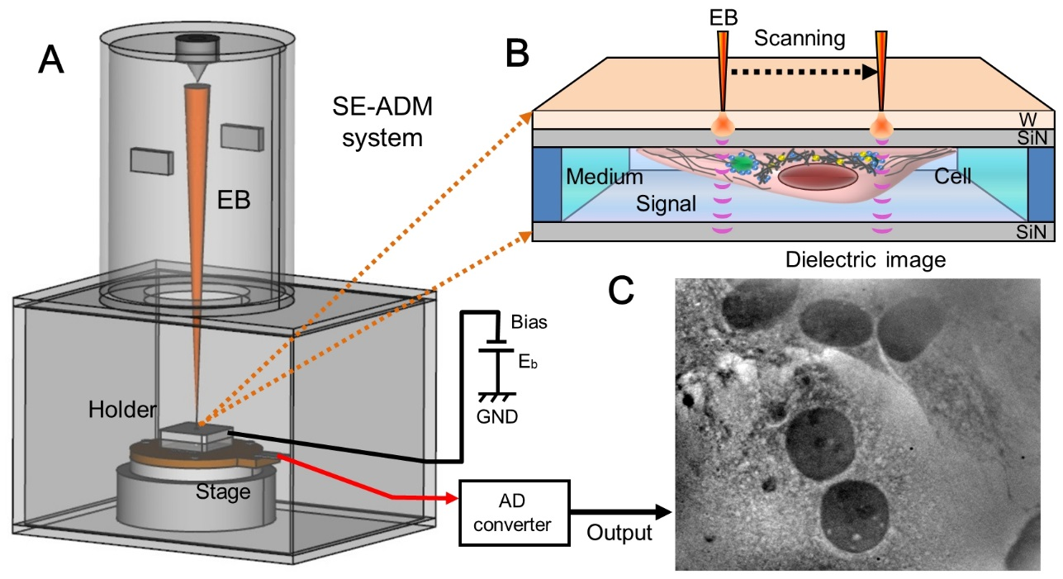

Supplementary Fig. S1
Overview of autophagosome observations in cells using the SE-ADM system. (A) Schematic of the SE-ADM system based on FE-SEM with a liquid sample holder. The sample holder containing the cultured cells is mounted on the stage attached to the pre-amplifier. This whole apparatus is introduced to the SEM chamber. (B) Schematic of the liquid holder containing the cells and 60-nm gold colloids bound to LC3 or Atg12. The W-coated SiN film is scanned by the electron beam. The measurement terminal under the holder detects the electrical signal through the cells in the liquid medium. (C) Typical SE-ADM image of REF cells in the liquid holder.

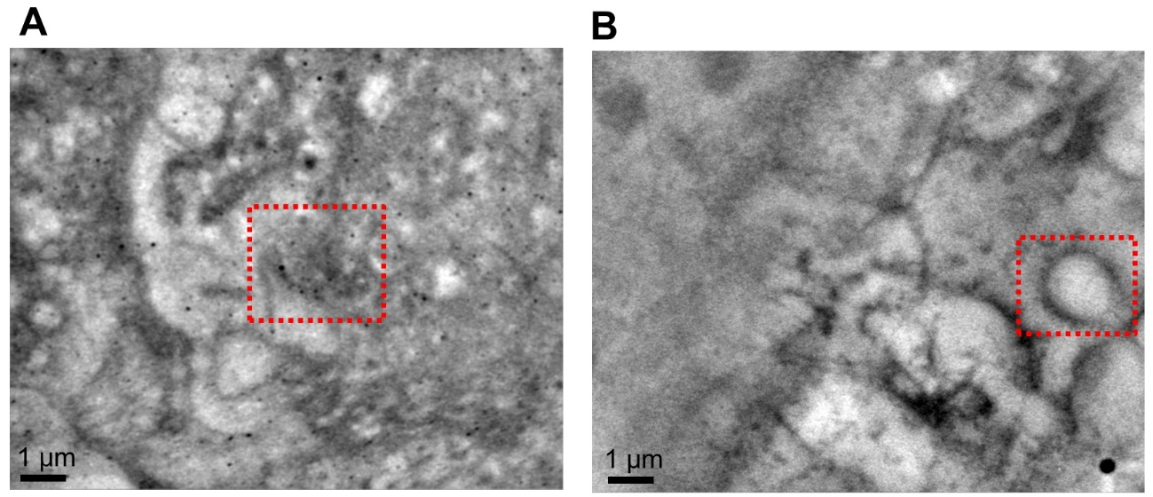

Supplementary Fig. S2
SE-ADM images of EM3 cells stained with anti-LC3 antibody conjugated with 60-nm gold colloids. (A–B) Images of cell regions stained with anti-LC3 antibody and 60-nm gold colloids after paraformaldehyde fixation and 0.1% Tween-20 permeabilisation. Images were taken at 10,000× magnification under a 6-kV electron beam. (E, H) Enlarged images of the red boxed areas in (A) and (B), respectively. Scale bars are 1 μm.

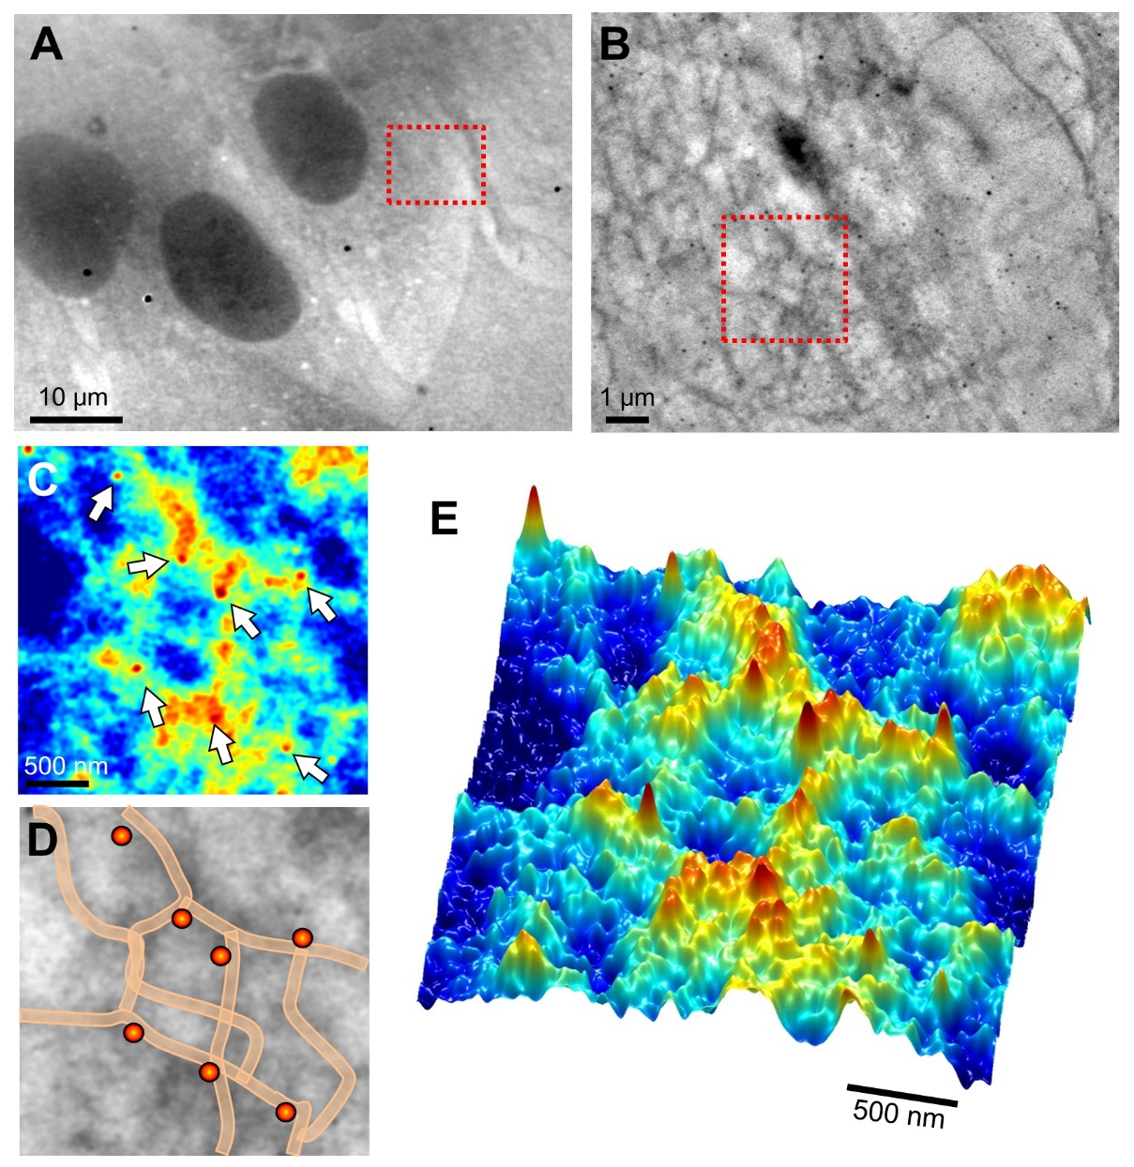

Supplementary Fig. S3
SE-ADM images of REF cells stained with anti-Atg12 antibody conjugated with 60-nm gold colloids. (A) Another low-magnification dielectric image of REF cells stained with anti-Atg12 antibody and 60-nm gold colloids after paraformaldehyde fixation and permeabilisation (1,000× magnification, 6-kV electron beam). (B) High-magnification image (10,000×) of the red boxed area in (A), showing Atg12 bound with 60-nm gold colloids. The Atg12 is dispersed over the whole area near the nucleus. (C) Enlarged pseudo-colour map of the red boxed area in (B). The Atg12 is localised along the mesh-like structures. (D) Schematic diagram of mesh-like structures and gold colloids superimposed on a dielectric image of (C). (E) 3D colour map of (D). Scale bars: 10 μm in (A), 1 μm in (B), 500 nm in (C, E).

