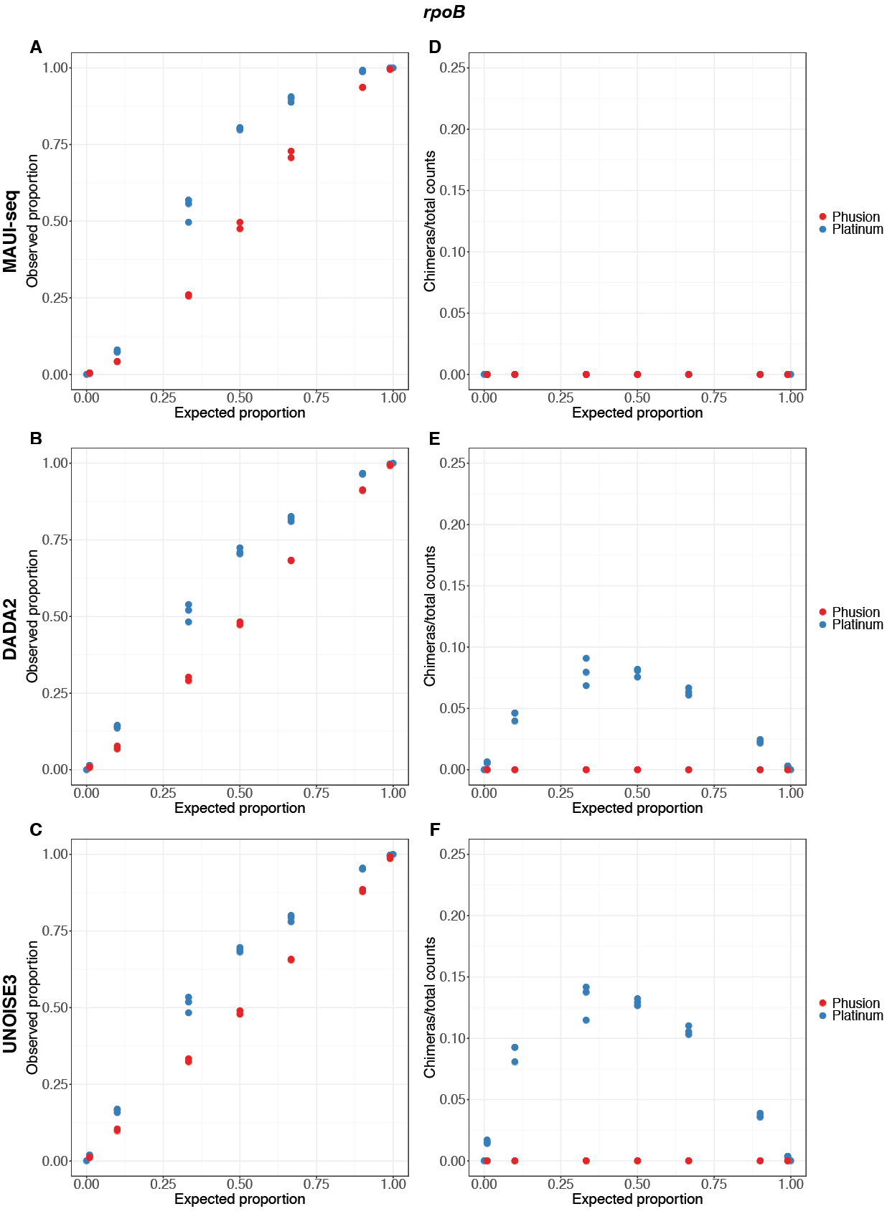
Supplementary Figure 1. Performance on DNA mixtures for rpoB. A and D: MAUI-seq. A: Observed proportion of SM170C rpoB reads versus the expected proportion. Pearson correlation for Phusion=0.996 and Platinum=0.956. D: Proportion of chimeras compared to total reads. B and E: DADA2. B: Observed proportion of SM170C rpoB reads versus the expected proportion. Pearson correlation for Phusion=0.999 and Platinum=0.977. E: Proportion of chimeras compared to total counts. C and F: UNOISE3. C: Observed proportion of SM170C rpoB reads versus the expected proportion. Pearson correlation for Phusion=0.9998 and Platinum=0.981. F: Proportion of chimeras compared to total counts.
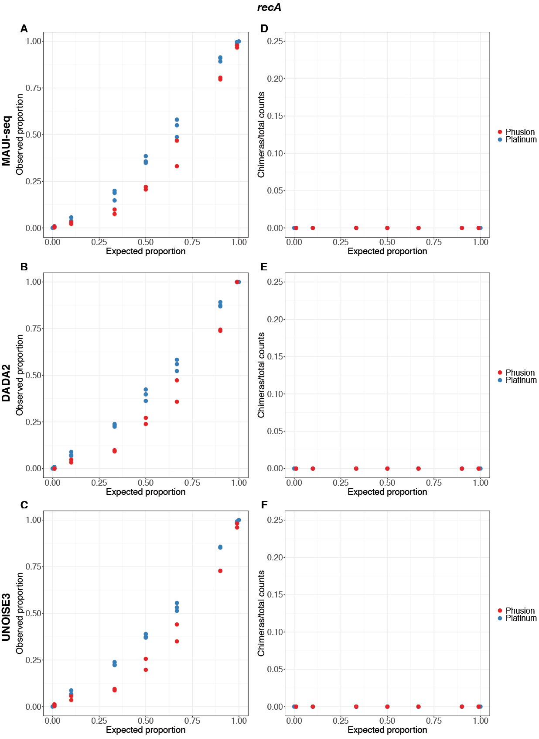
Supplementary Figure 2. Performance on DNA mixtures for recA. A and D: MAUI-seq. A: Observed proportion of SM170C recA reads versus the expected proportion. Pearson correlation for Phusion=0.948 and Platinum=0.984. D: Proportion of chimeras compared to total reads. B and E: DADA2. B: Observed proportion of SM170C recA reads versus the expected proportion. Pearson correlation for Phusion=0.952 and Platinum=0.991. E: Proportion of chimeras compared to total counts. C and F: UNOISE3. C: Observed proportion of SM170C recA reads versus the expected proportion. Pearson correlation for Phusion=0.947 and Platinum=0.989. F: Proportion of chimeras compared to total counts.
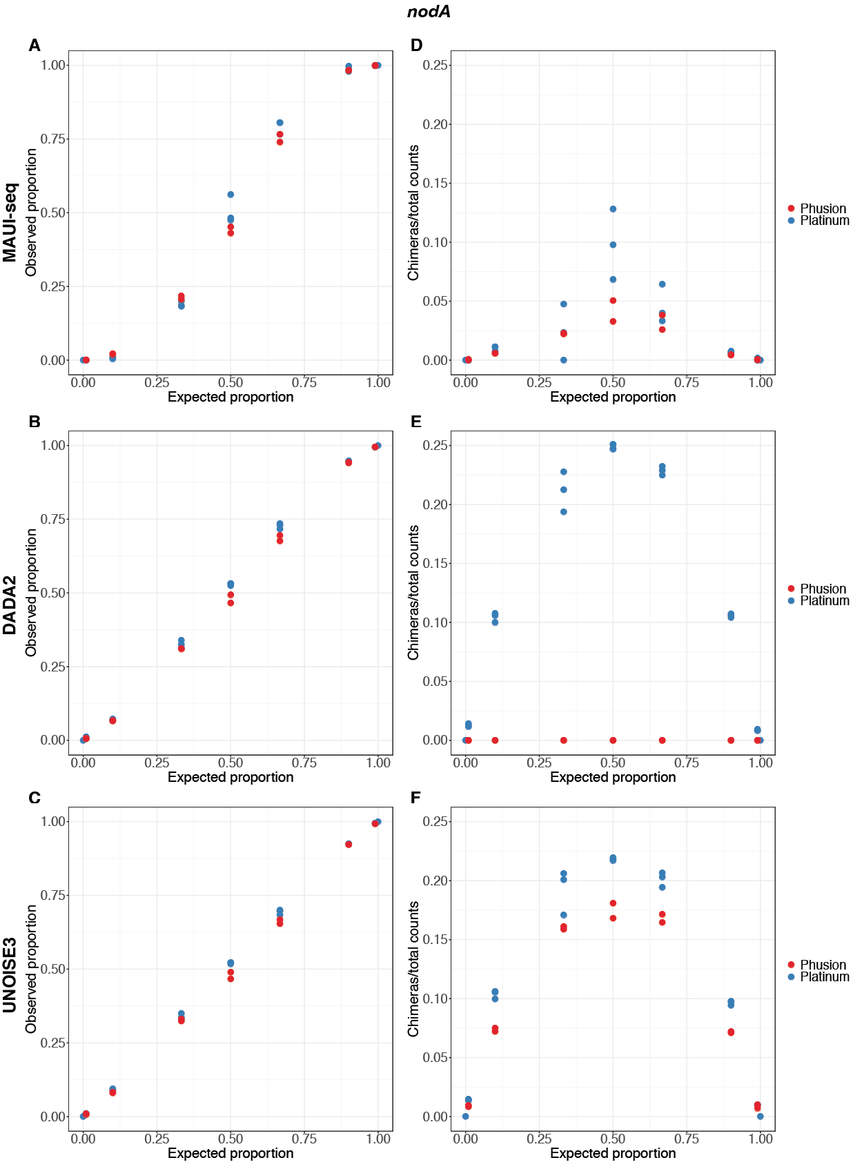
Supplementary Figure 3. Performance on DNA mixtures for nodA. A and D: MAUI-seq. A: Observed proportion of SM170C nodA reads versus the expected proportion. Pearson correlation for Phusion=0.989 and Platinum=0.985. D: Proportion of chimeras compared to total reads. B and E: DADA2. B: Observed proportion of SM170C nodA reads versus the expected proportion. Pearson correlation for Phusion=0.999 and Platinum=0.998. E: Proportion of chimeras compared to total counts. C and F: UNOISE3. C: Observed proportion of SM170C nodA reads versus the expected proportion. Pearson correlation for Phusion=0.999 and Platinum=0.999. F: Proportion of chimeras compared to total counts.
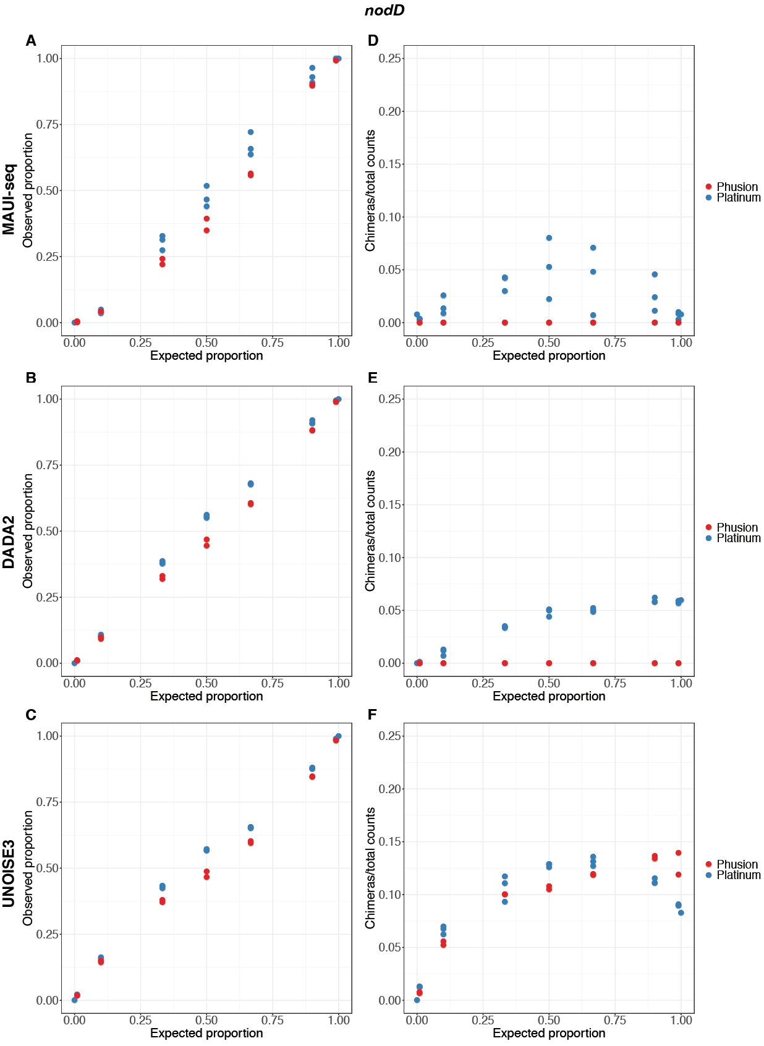
Supplementary Figure 4. Performance on DNA mixtures for nodD. A and D: MAUI-seq. A: Observed proportion of SM170C nodD reads versus the expected proportion. Pearson correlation for Phusion=0.990 and Platinum=0.998. D: Proportion of chimeras compared to total reads. B and E: DADA2. B: Observed proportion of SM170C nodD reads versus the expected proportion. Pearson correlation for Phusion=0.998 and Platinum=0.998. E: Proportion of chimeras compared to total counts. C and F: UNOISE3. C: Observed proportion of SM170C nodD reads versus the expected proportion. Pearson correlation for Phusion=0.995 and Platinum=0.995. F: Proportion of chimeras compared to total counts.
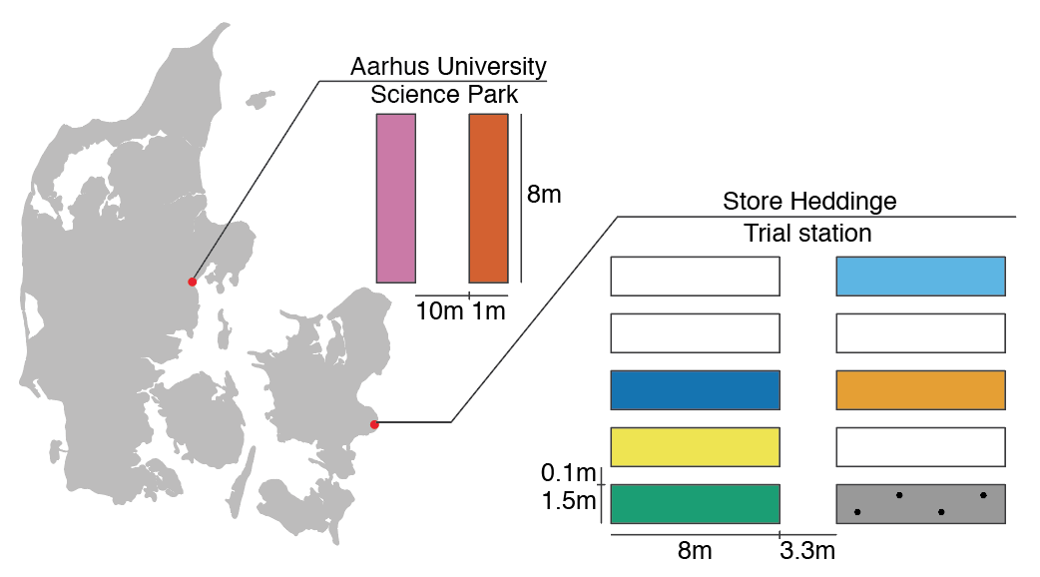
Supplementary Figure 5. Sampling sites for assessment of Rhizobium leguminosarum symbiovar trifolii diversity in root nodule samples. Sampling locations in the Aarhus University Science Park and a clover trial station in Store Heddinge. DNA was isolated from 100 nodules from four points (black dots) on each individual plot.

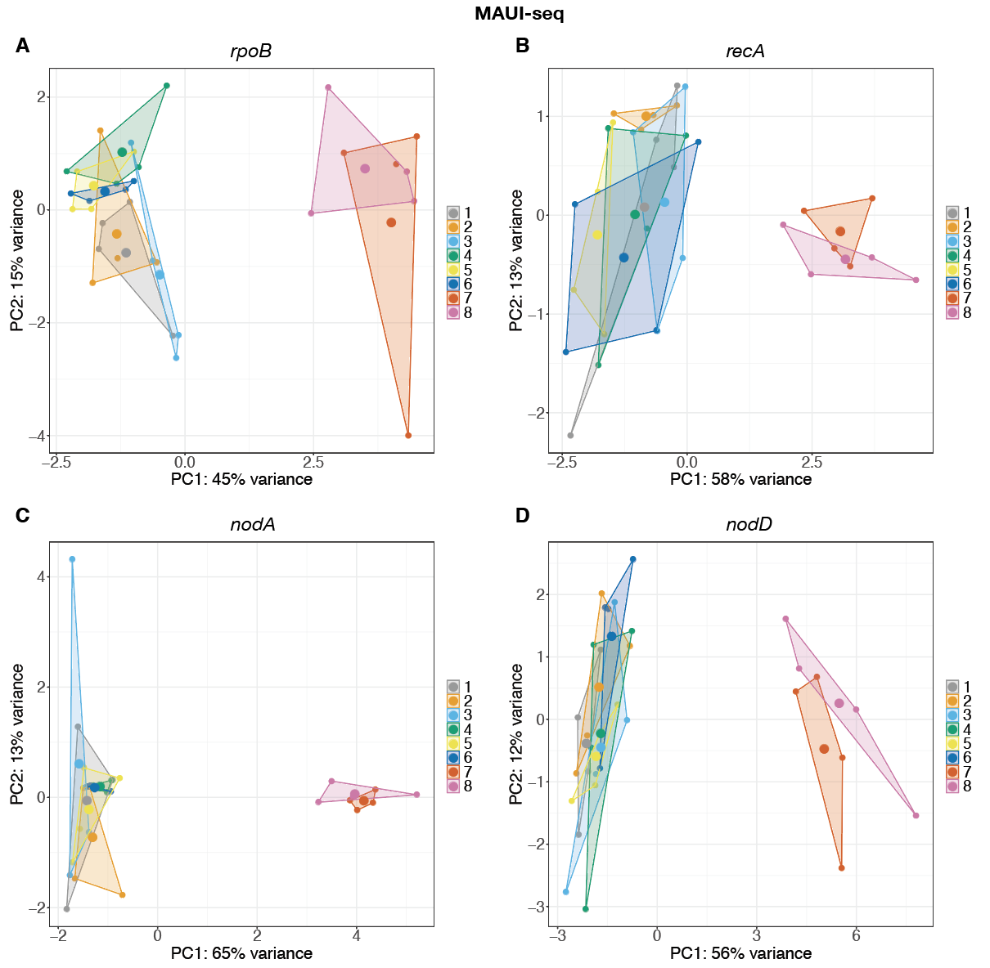
Supplementary Figure 6. Individual Principal Components Analysis of four Rhizobium leguminosarum symbiovar trifolii genes clustered by MAUI-seq. DNA was isolated from 100 nodules from four points on each individual plot. A: rpoB, B: recA, C: nodA and D: nodD.

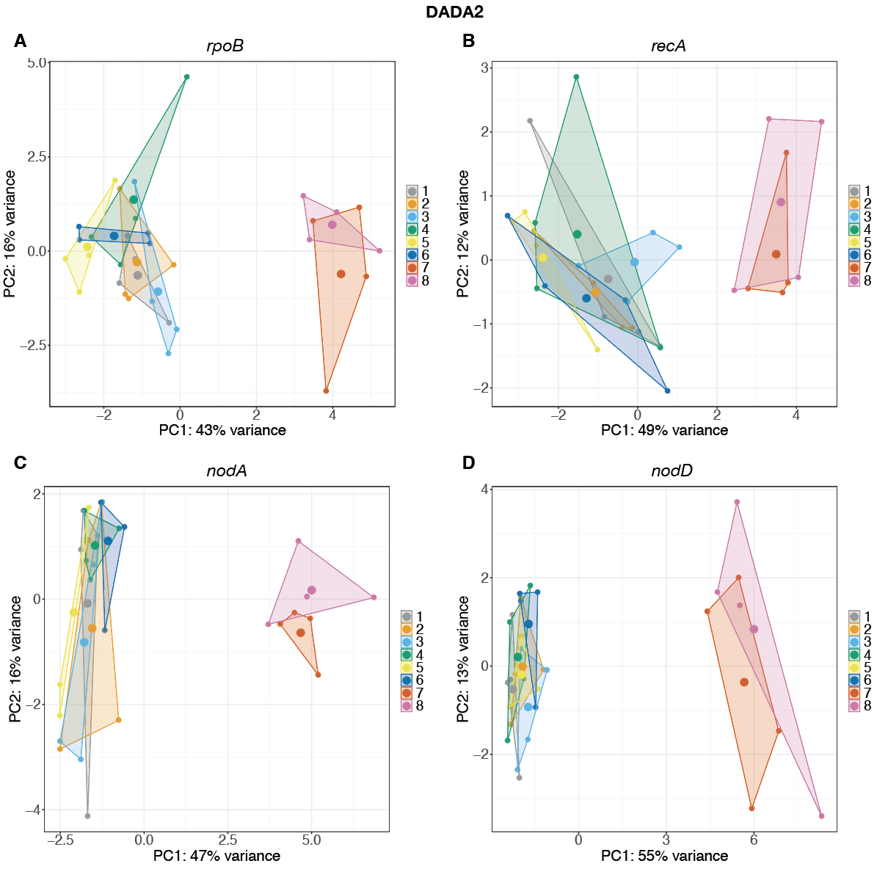
Supplementary Figure 7. Individual Principal Components Analysis of four Rhizobium leguminosarum symbiovar trifolii genes clustered by DADA2. DNA was isolated from 100 nodules from four points on each individual plot. A: rpoB, B: recA, C: nodA and D: nodD.

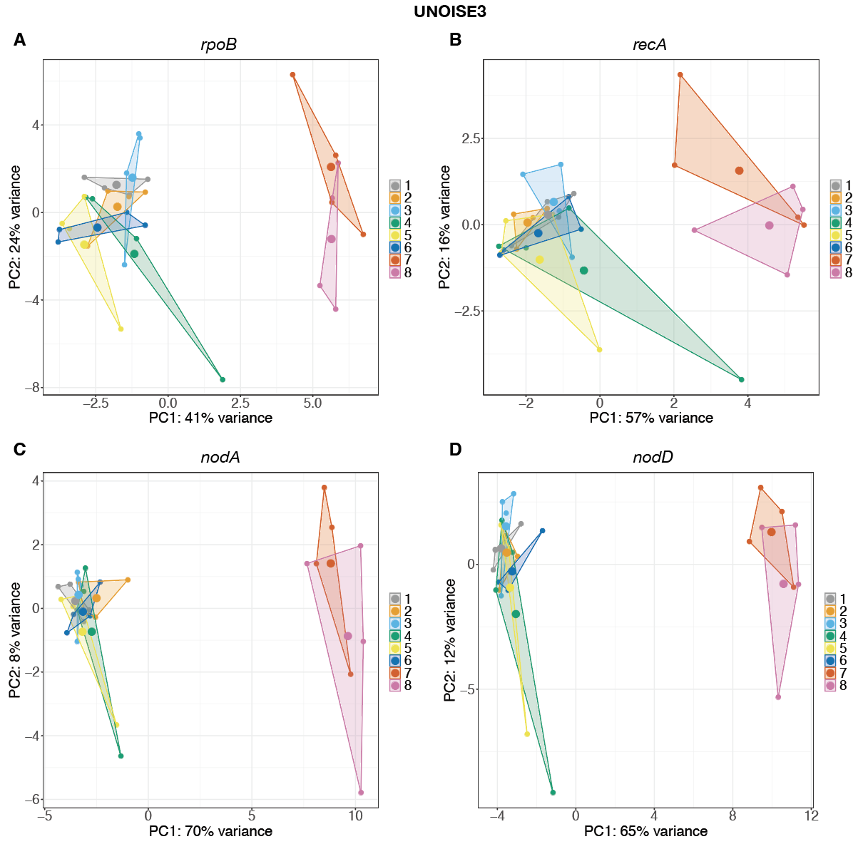
Supplementary Figure 8. Individual Principal Components Analysis of four Rhizobium leguminosarum symbiovar trifolii genes clustered by UNOISE3. DNA was isolated from 100 nodules from four points on each individual plot. A: rpoB, B: recA, C: nodA and D: nodD.

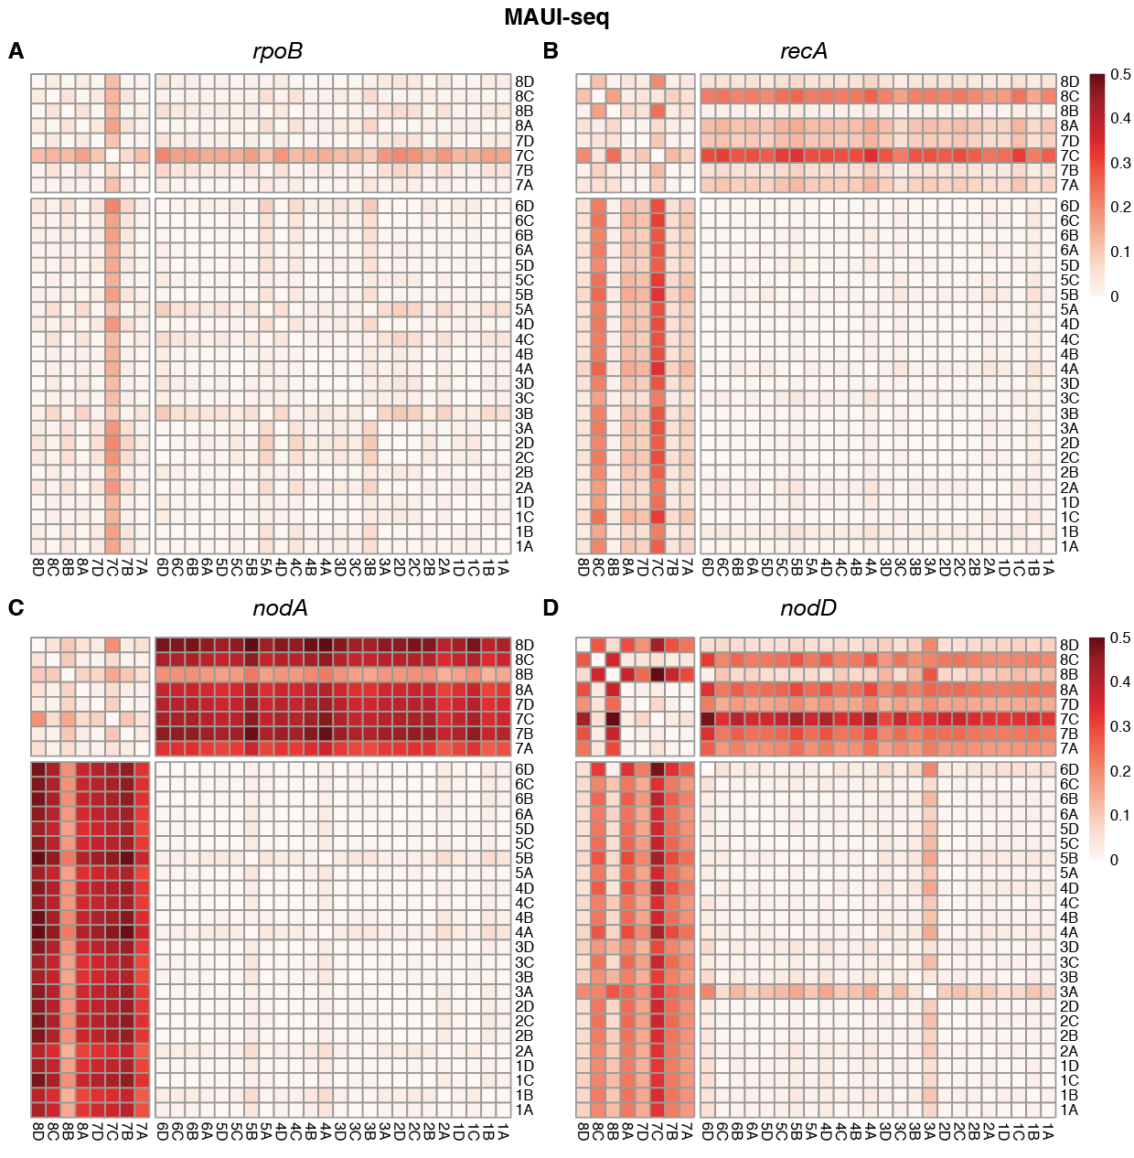
Supplementary Figure 9. F_{ST} calculated between samples for individual genes on reads clustered by MAUI-seq. A: rpoB, B: recA, C: nodA, and D: nodD.

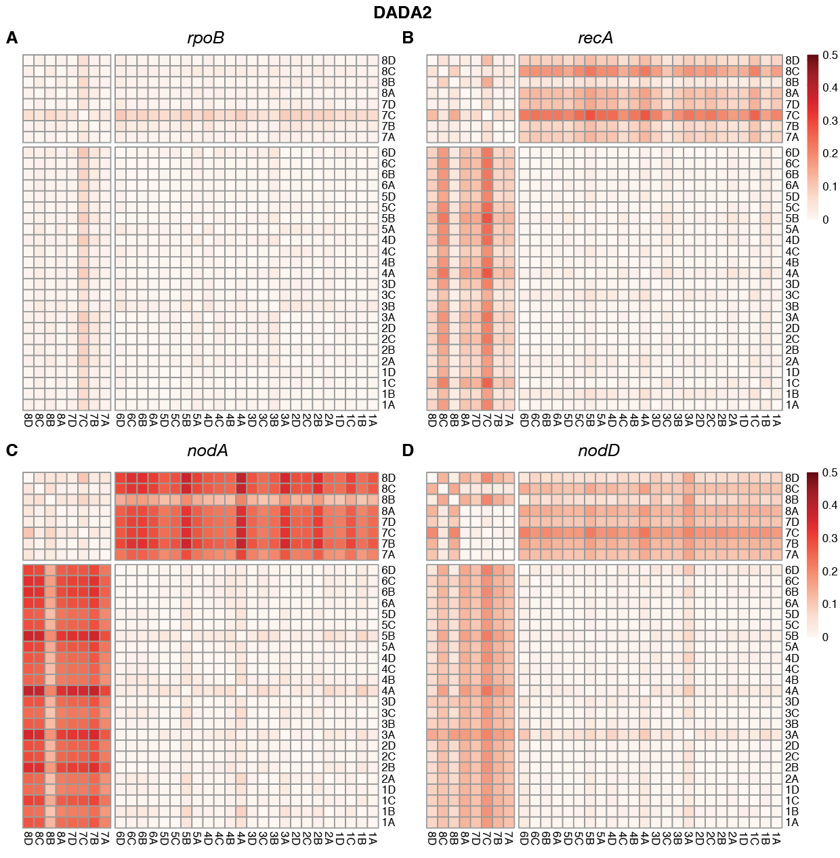
Supplementary Figure 10. F_{ST} calculated between samples for individual genes on reads clustered by DADA2. A: rpoB, B: recA, C: nodA, and D: nodD.

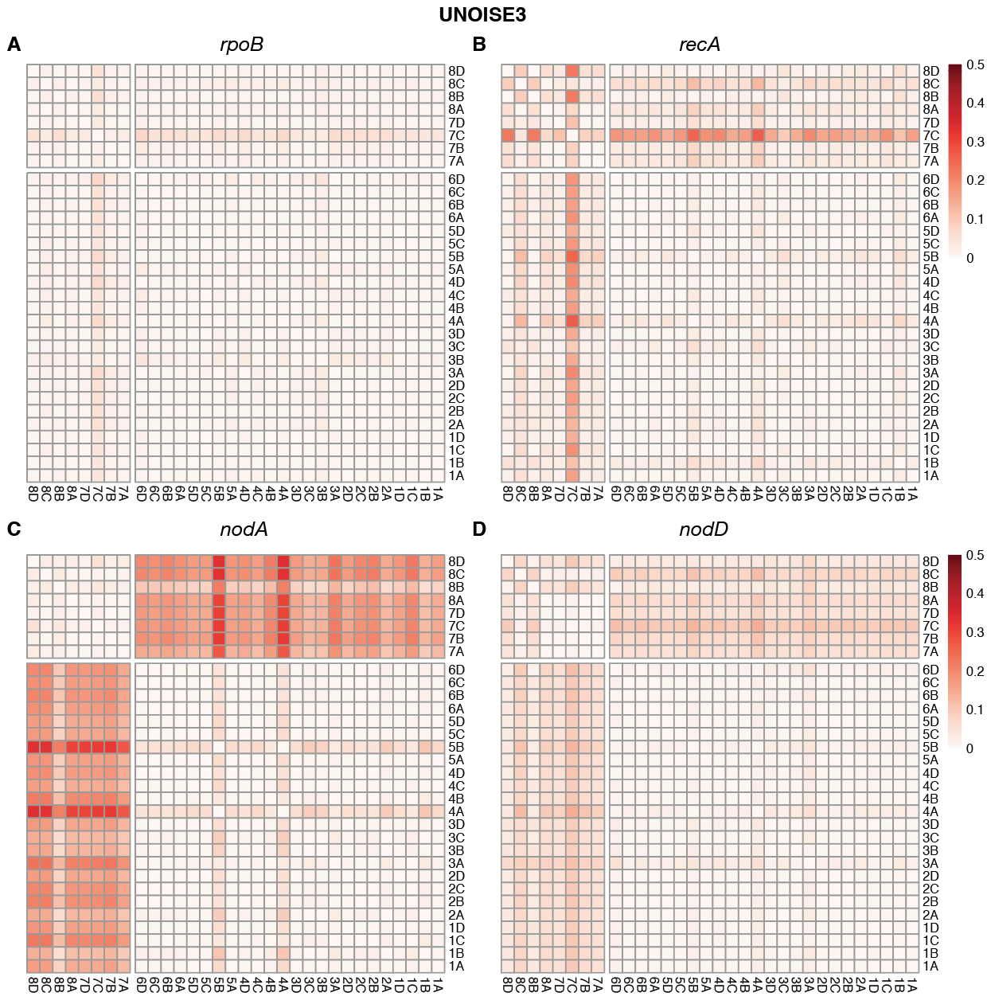
Supplementary Figure 11. F_{ST} calculated between samples for individual genes on reads clustered by UNOISE3. A: rpoB, B: recA, C: nodA, and D: nodD.

Supplementary Table 1. Synthetic community mixes sample design.
SampleID | Strain | Community percentage (%) | Strain | Community percentage (%) | Amplified  w. Platinum | Amplified  w. Phusion
A1 | SM3 | 100 | SM170C | 0 | 1 | 0
A2 | SM170C | 100 | SM3 | 0 | 1 | 0
B1 | SM3 | 50 | SM170C | 50 | 1 | 1
B2 | SM3 | 50 | SM170C | 50 | 1 | 1
B3 | SM3 | 50 | SM170C | 50 | 1 | 0
C1 | SM3 | 66.6 | SM170C | 33.3 | 1 | 1
C2 | SM3 | 66.6 | SM170C | 33.3 | 1 | 1
C3 | SM3 | 66.6 | SM170C | 33.3 | 1 | 0
D1 | SM3 | 90 | SM170C | 10 | 1 | 1
D2 | SM3 | 90 | SM170C | 10 | 1 | 1
D3 | SM3 | 90 | SM170C | 10 | 1 | 0
E1 | SM3 | 99 | SM170C | 1 | 1 | 1
E2 | SM3 | 99 | SM170C | 1 | 1 | 1
E3 | SM3 | 99 | SM170C | 1 | 1 | 0
F1 | SM170C | 66.6 | SM3 | 33.3 | 1 | 1
F2 | SM170C | 66.6 | SM3 | 33.3 | 1 | 1
F3 | SM170C | 66.6 | SM3 | 33.3 | 1 | 0
G1 | SM170C | 90 | SM3 | 10 | 1 | 1
G2 | SM170C | 90 | SM3 | 10 | 1 | 1
G3 | SM170C | 90 | SM3 | 10 | 1 | 0
H1 | SM170C | 99 | SM3 | 1 | 1 | 1
H2 | SM170C | 99 | SM3 | 1 | 1 | 1
H3 | SM170C | 99 | SM3 | 1 | 1 | 0

