Supplementary

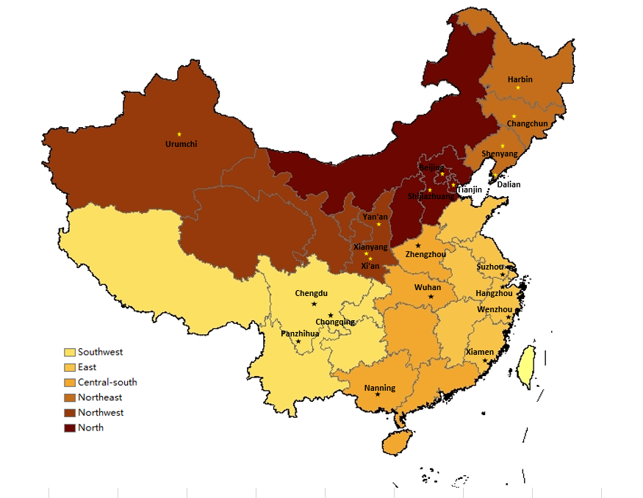

Figure 1 The distribution of six regions and selected cities among China (Online Supplemental Material)

Of 12,466 eligible pregnant women receiving antenatal visits from September 19, 2016 to November 20, 2016 were screened
Of 12,403 eligible pregnant women were consecutively enrolled
Excluded 63 pregnant women refusing enrollment
Of one pregnant woman with missing of hemoglobin, and three pregnant women with missing of serum ferritin
Finally, 12402 and 12400 eligible pregnant women were used to examine the outcomes of anemia and IDA in analysis, respectively
Figure 2 The flow chart of included population (Online Supplemental Material)

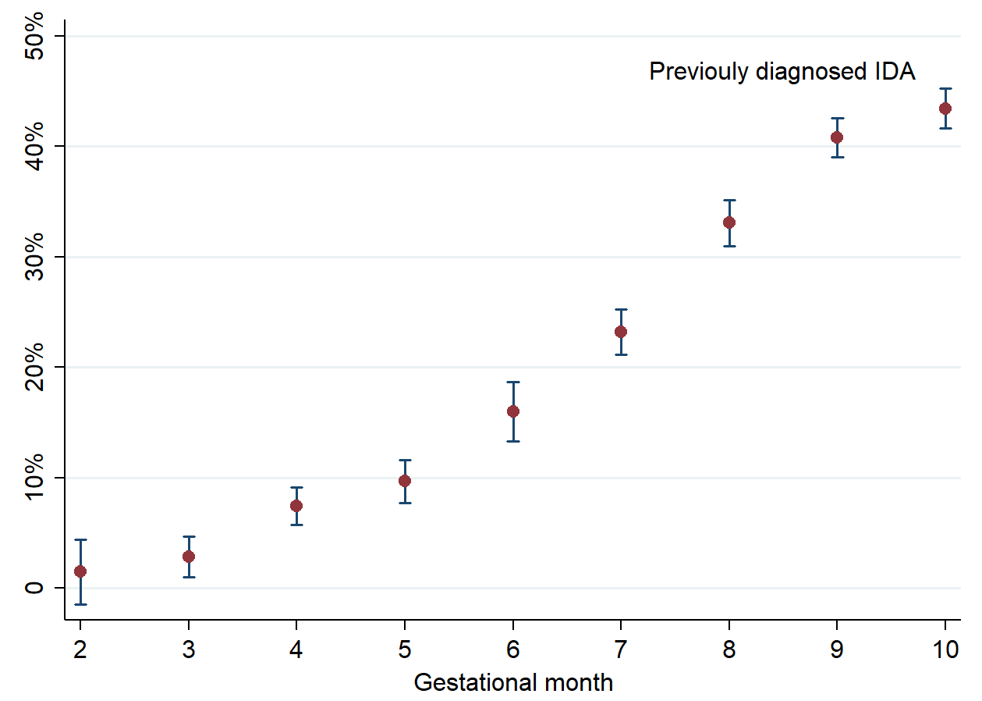

Figure 3 Median and 95% confidence intervals for prevalence of previously diagnosed IDA categorized by gestational month (Online Supplemental Material)

Table 1 List of 24 selected hospitals in our study and the number of included pregnant women (Online Supplemental Material)
Regions | Cities | Selected hospitals | Number of included individuals
Southwest | Chengdu | West China Second University Hospital, Sichuan University* | 861
 | Chengdu | Sichuan Provincial Hospital for Women and Children | 400
 | Panzhihua | Panzhihua Central Hospital | 404
 | Chongqing | Chongqing Health Center for Women and Children | 440
East | Hangzhou | Women’s Hospital School of Medicine, Zhejiang University* | 803
 | Xiamen | Xiamen Medical Center for Women and Children | 401
 | Wenzhou | Wenzhou People's Hospital | 401
 | Suzhou | Suzhou Second People's Hospital/ Suzhou Municipal Hospital | 403
Central South | Wuhan | Union Hospital, Tongji Medical College, Huazhong University of Science and Technology * | 813
 | Wuhan | Maternal and Child Health Hospital of Hubei Province | 414
 | Zhengzhou | The First Affiliated Hospital of Zhengzhou University | 409
 | Nanning | The First Affiliated Hospital of Guangxi Medical University | 825
Northeast | Shenyang | Shengjing Hospital of China Medical University* | 906
 | Dalian | Maternal and Child Health Hospital of Dalian | 430
 | Changchun | Changchun Obstetrics-Gynecology Hospital | 443
 | Harbin | The Fourth Affiliated Hospital of Harbin Medical University | 400
Northwest | Xi’an | Shanxi Provincial Hospital for Women and Children/ Northwest Women’s and Children’s Hospital * | 825
 | Xianyang | The Second Affiliated Hospital of Shanxi University of Traditional Chinese Medicine | 402
 | Yan'an | Yan'an University Affiliated Hospital | 424
 | Urumchi | Maternal and Child Health Hospital of Urumchi, Xinjiang | 400
North | Beijing | Beijing Obstetrics and Gynecology Hospital, Capital Medical University * | 810
 | Tianjin | Tianjin Central Hospital of Gynecology Obstetrics | 400
 | Shijiazhuang | The Fourth Hospital of Shijiazhuang/ Shijiazhuang Obstetrics and Gynecology Hospital | 405
 | Beijing | Beijing Friendship Hospital, Capital Medical University | 401
* coordinator of each region.

