Table 1. Participant and school information
 |  | n | %
Gender | Boy | 236 | 47.8
Gender | Girl | 258 | 52.2
Year group  (age in years) | Year 2 (6-7) | 165 | 33.3
Year group  (age in years) | Year 4 (8-9) | 185 | 37.4
Year group  (age in years) | Year 6 (10-11) | 145 | 29.3
Speak Welsh at home | Yes | 135 | 27.8
 | No | 350 | 72.2
School | 1 | 77 | 15.5
School | 2 | 68 | 13.7
School | 3 | 61 | 12.2
School | 4 | 72 | 14.5
School | 5 | 68 | 13.7
School | 6 | 20 | 4.0
School | 7 | 81 | 16.3
School | 8 | 51 | 10.2

Table 2. Questionnaire findings: children’s knowledge, perceptions and intention to use electronic and tobacco cigarettes (n=494)
 |  | %
Differentiating electronic and tobacco cigarettes on……. |  | Same | Different | Not Sure
Differentiating electronic and tobacco cigarettes on……. | Look | 3.7 | 93.3 | 3.1
Differentiating electronic and tobacco cigarettes on……. | Smell | 27.0 | 51.1 | 21.9
Differentiating electronic and tobacco cigarettes on……. | Taste | 11.6 | 46.1 | 42.3
Differentiating electronic and tobacco cigarettes on……. | Cost | 5.3 | 67.8 | 26.9
Differentiating electronic and tobacco cigarettes on……. | Inside | 6.0 | 82.5 | 11.5
Differentiating electronic and tobacco cigarettes on……. | Smoke | 32.2 | 48.0 | 19.8
Perceptions of electronic and tobacco cigarettes  Which do you…. |  | Electronic Cigarette | Tobacco Cigarette | Both the same | Don’t  Know
 | See more often | 14.5 | 73.7 | 8.0 | 3.9
 | Think more people use | 18.2 | 59.9 | 13.3 | 8.6
 | Think is safer to use | 61.8 | 15.7 | 6.5 | 15.9
 | Think it is easier to buy | 21.6 | 57.8 | 7.2 | 12.9
Intention to use: |  | Yes | No | Maybe/  don’t know |  | p value
Electronic cigarettes | Lives with user | 7.3 | 55.0 | 37.6 | 0.02
 | Does not live with user | 2.9 | 78.6 | 18.5
Tobacco cigarettes | Lives with smoker | 3.1 | 75.5 | 21.4 | <0.001
 | Does not live with smoker | 1.2 | 88.7 | 10.1
Acceptability of Adult Use: |  | Yes | No | Maybe/  don’t know | p value
Electronic cigarettes | Lives with user | 63.0 | 14.8 | 22.2 | 0.03
 | Does not live with user | 45.5 | 27.9 | 26.6
Tobacco cigarettes | Lives with smoker | 51.3 | 27.2 | 21.5 | 0.423
 | Does not live with smoker | 43.7 | 31.1 | 25.2
Acceptability of Child Use: |  | Yes | No | Maybe/  don’t know | p value
Electronic cigarettes | Lives with user | 1.8 | 84.4 | 13.8 | 0.005
 | Does not live with user | 1.0 | 94.2 | 4.8
Tobacco cigarettes | Lives with smoker | 0.6 | 97.5 | 1.9 | 0.502
 | Does not live with smoker | 0.0 | 98.5 | 1.5

Table 3. Draw and Write Responses for e-cigarette users
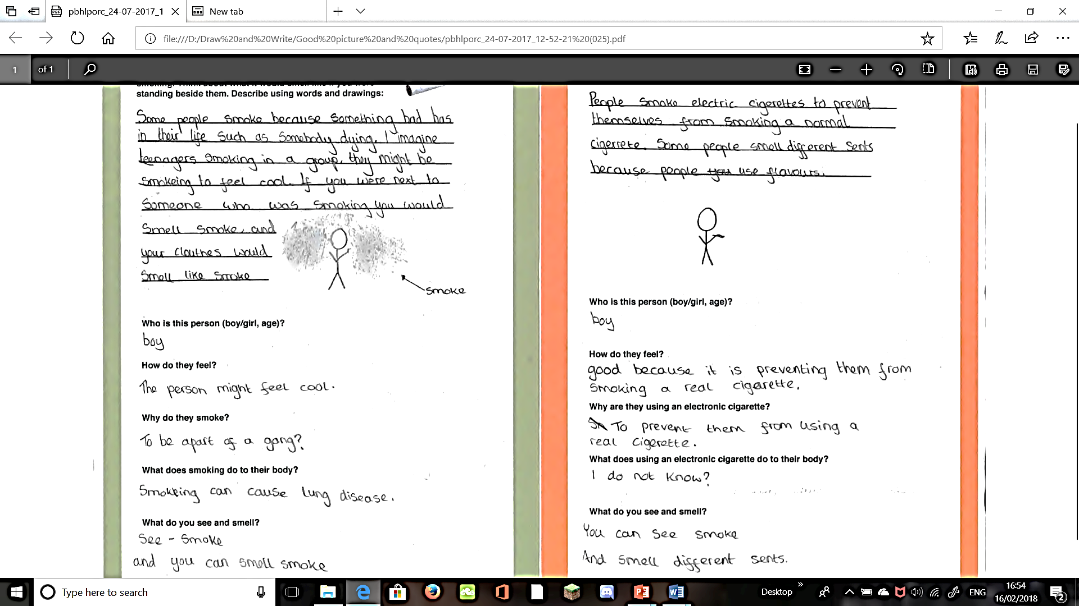  Female, Aged 11, School 5 | 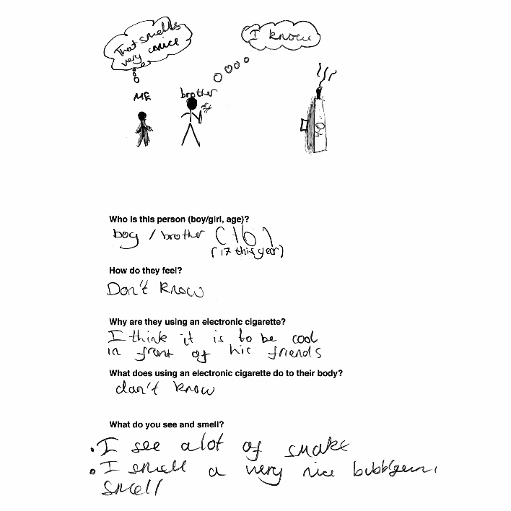  Male, Aged 11, School 4
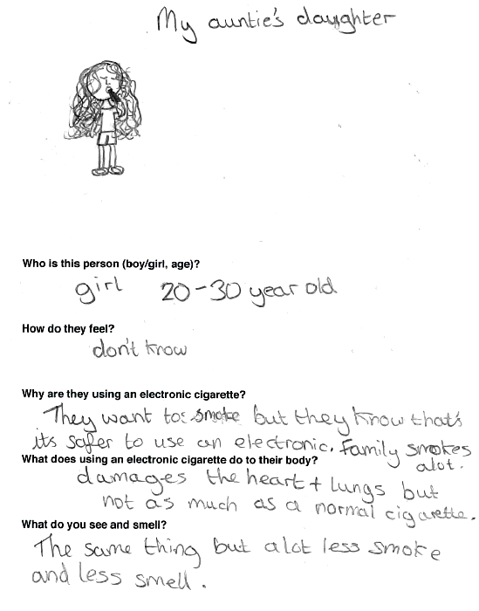  Female, Aged 11, School 2 | 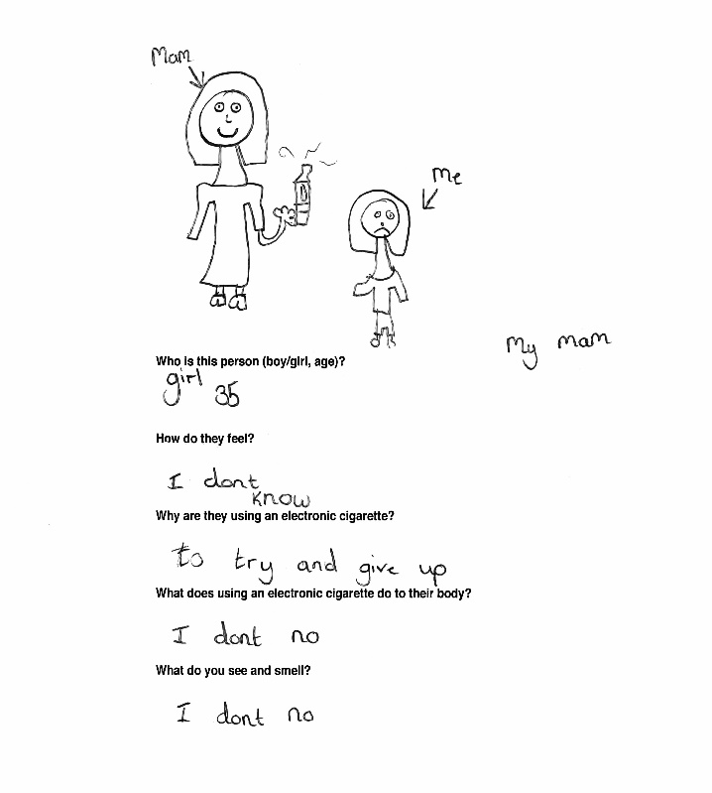  Female, Aged 9, School 4,

