Supplementary Figures
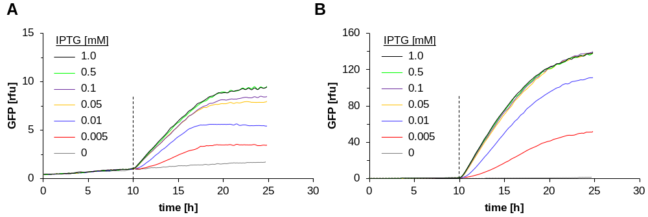
Figure S1 Determination of IPTG concentrations for full and partial induction. The dashed vertical lines indicate the time of induction. Induction was performed with 0 (gray, not induced), 0.005 (red), 0.01 (blue), 0.05 (orange), 0.1 (violet), 0.5 (green) or 1.0 (black) mM IPTG. (A) B<3lacO-T5>. (B) B3<T7>. The mean relative GFP fluorescence intensity (rfu) represents triplicate samples.

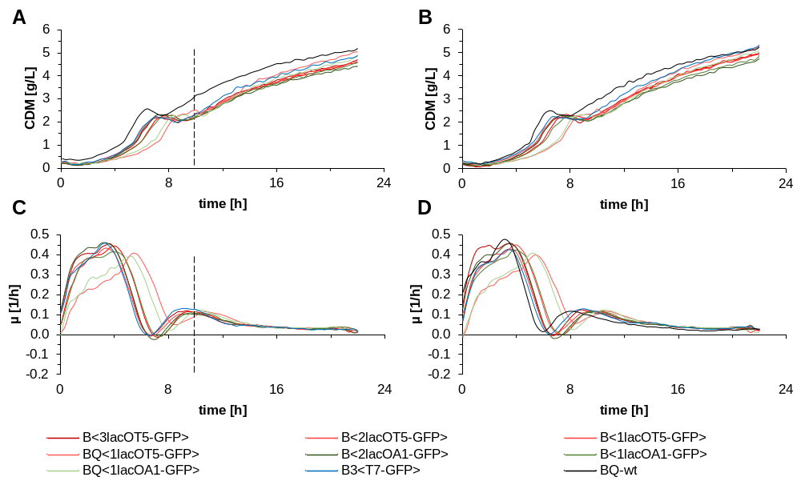
Figure S2 Growth characteristics of genome-integrated expression systems with different promoter/operator combinations. Cells were grown in enzymatic glucose release media in micro-titer fermentations over a period of 22 h. The dashed vertical lines indicate the time of induction with 0.5 mM IPTG. (A, B) Biomass trends (CDM) and (C, D) growth rates (µ) are shown for (A, C) induced and (B, D) non-induced cells. The mean values of triplicates are shown. The promoter/operators are defined in Figure 1.

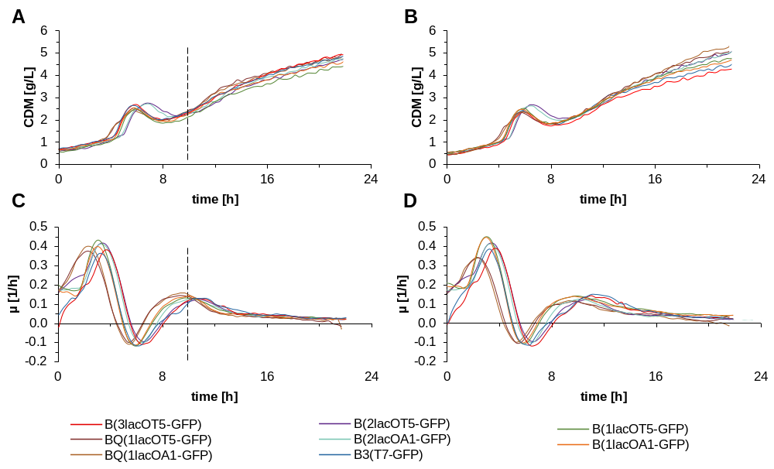
Figure S3 Growth characteristics of plasmid-based expression systems with different promoter/operator combinations. Cells were grown in enzymatic glucose release media in micro-titer fermentations over a period of 22 h. The dashed vertical lines indicate the time of induction with 0.5 mM IPTG. (A, B) Biomass trends (CDM) and (C, D) growth rates (µ) are shown for (A, C) induced and (B, D) non-induced cells. The mean values of triplicates are shown. The promoter/operators are defined in Figure 1.

Figure S4 Solubility analysis of GFPmut3.1. SDS-PAGE images show soluble (S) and insoluble (I) fractions of proteins produced under the indicated lacO-promoter combinations in genome-integrated (indicated with pointed brackets <>) and plasmid-based (indicated with round brackets ()) expression systems.

