Supplementary Figures
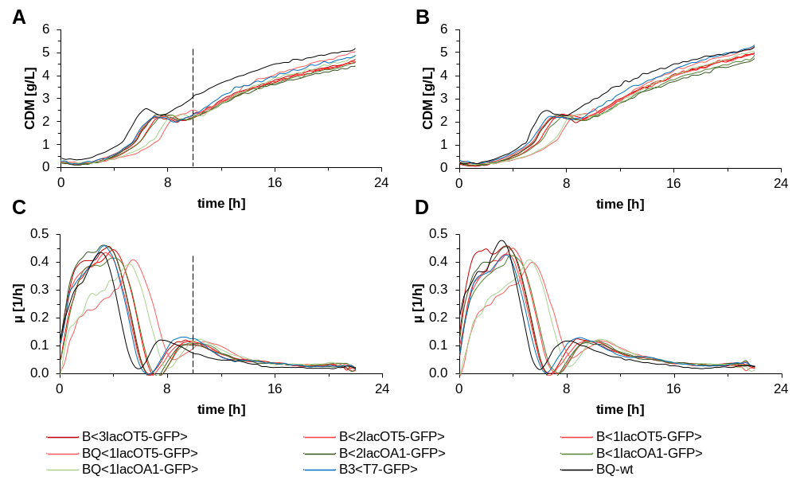
Figure S1 Growth characteristics of cells with different promoter/operator combinations. Cells were grown in enzymatic glucose release media in micro-titer fermentations over a period of 22 h. The dashed vertical lines indicate the time of induction with 0.5 mM IPTG. (A, B) Biomass trends (CDM) and (C, D) growth rates (µ) are shown for (A, C) induced and (B, D) non-induced cells. The mean values of triplicates are shown. The promoter/operators are defined in Figure 1.

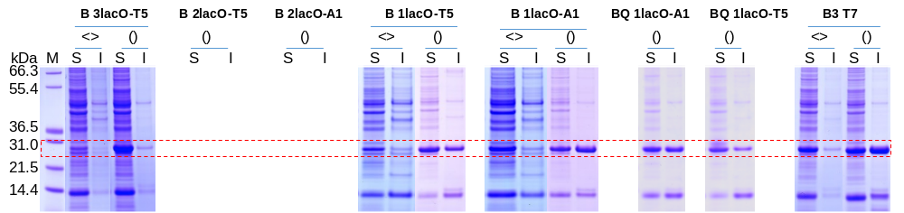
Figure S2 Solubility analysis of GFPmut3.1. SDS-PAGE images show soluble (S) and insoluble (I) fractions of proteins produced under the indicated lacO-promoter combinations in genome-integrated (indicated with pointed brackets <>) and plasmid-based (indicated with round brackets ()) expression systems. (M) Mark 12 molecular weight marker.

