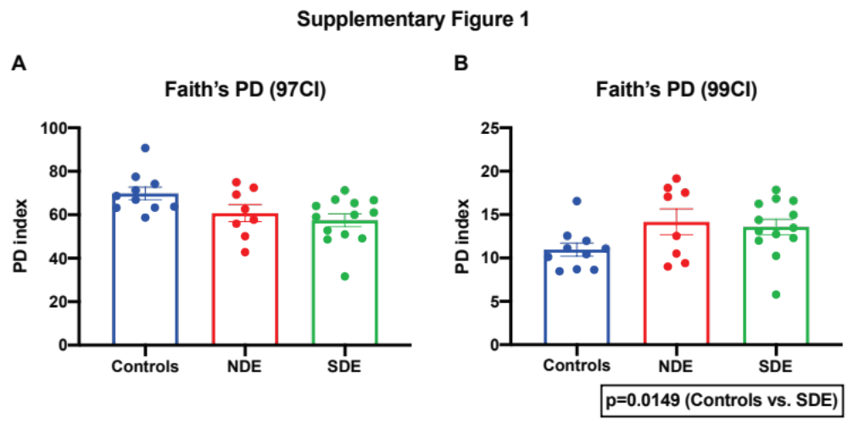
Supplementary Figure 1: Faith’s PD measurement between Controls, non-Sjögren’s-associated dry eye (NDE) and Sjögren’s-associated dry eye (SDE) when clustered against 97% CI and 99% CI SILVA database. (A) Dataset clustered against 97% CI-- Faith’s PD index is similar between the groups. (B) Dataset clustered against 99%CI—SDE samples show incremental, yet significant enhancement in phylogenetic index, compared to controls. The test of significance used was a pairwise Mann-Whitney U test.
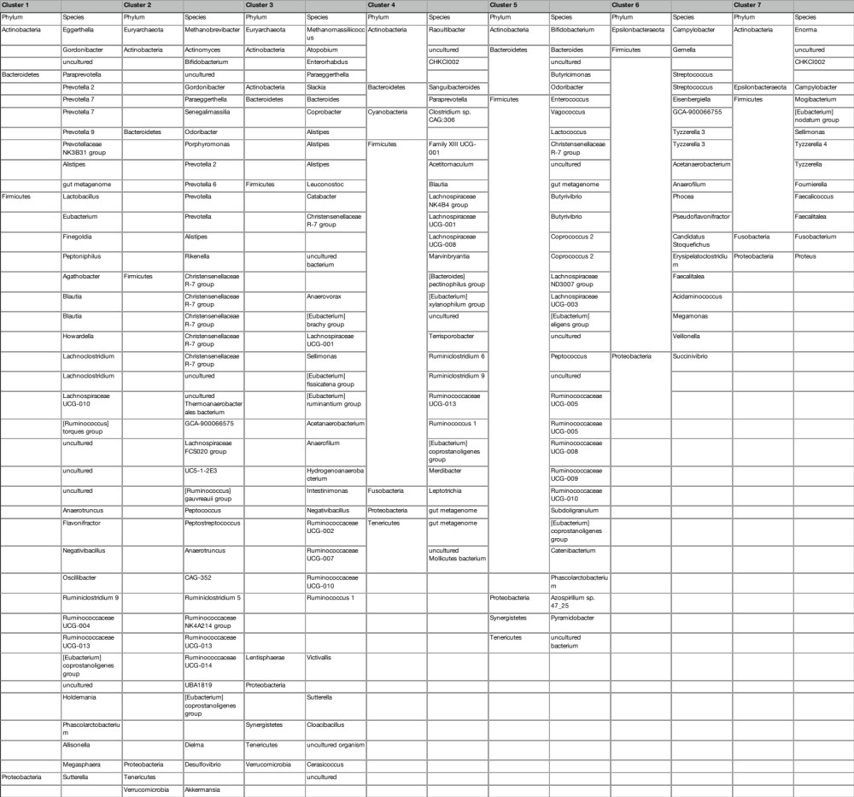
Supplementary Figure 2: Spreadsheet with the control group clusters with bacterial identities comprising each cluster marked in Figure 5.
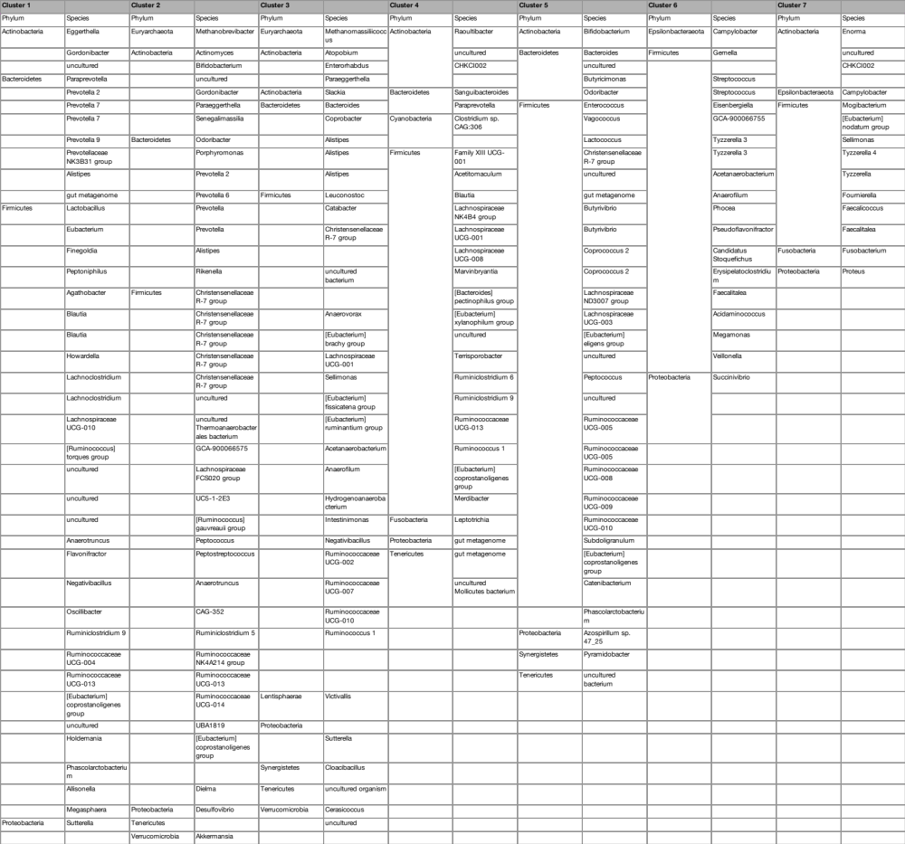
Supplementary Figure 3: Spreadsheet with the non-Sjögren’s-associated dry eye (NDE) group clusters with bacterial identities comprising each cluster marked in Figure 5. As evident from this list, there are changes in phyla representation in major clusters.
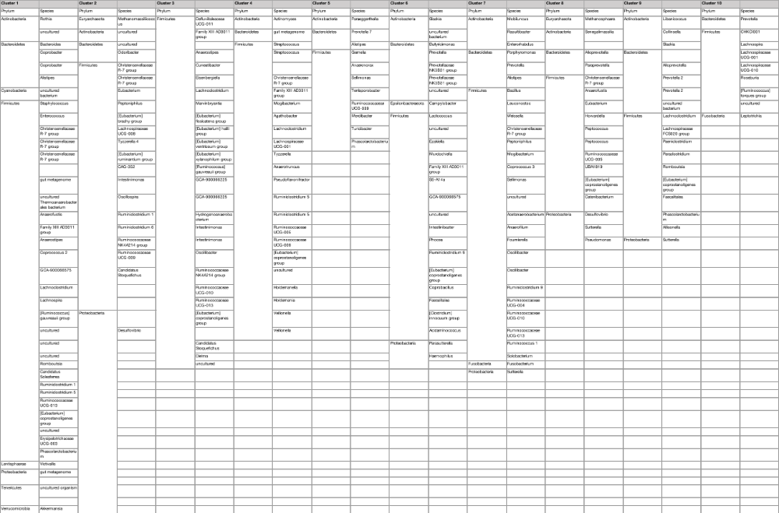
Supplementary Figure 4: Spreadsheet with the Sjögren’s-associated dry eye (SDE) group clusters with bacterial identities comprising each cluster marked in Figure 5. Within each phylum genera representation differed compared to controls (e.g. expanded representation of the genus Prevotella in non-Sjögren’s-associated dry eye (NDE) clusters and the phylum Actinobacteria having different genera in each of the three groups). As seen in Figure 5, SDE clusters have increased in number with major clusters composed of more diverse phyla with disparate genera representation.

