Fusion transcript detection using spatial transcriptomics
Supplementary materials

The Spatial Transcriptomics method
Messenger RNA (mRNA) and the poly(A) tails are captured with an poly-T20VN oligonucleotide in each of the 1,007 features (spots) of the spatial transcriptomics array and tagged with a unique molecular identifier (UMI), and a spatial barcode. From the captured mRNA, complementary DNA is generated by reverse transcription and sequenced using paired-end sequencing. The first read of the pairs encloses barcode and UMI, the second read contains the genetic information. Finally, the resulting read counts for every gene in every spot is overlaid with annotated brightfield image of H&E-stained tissue sections for further data analysis. The number of captured poly(A) tails mirrors the gene expression level on almost single-cell level. The fragment of the sequence before the cleavage site (101 or 121 base pairs, bp) is mapped to a reference genome. For any correctly transcribed gene, the amount of poly(A) tail reflects the expression level. [18,19]

The fusion transcripts in HeLa cancer cells
Table S1. The cis-SAGe LHX6-NDUFA8. Gene structure of parental genes LHX6 and NDUFA8.
 | LHX6 | NDUFA8
Strand | reverse | reverse
Gene | 5´ | 3´
Chr | 9 | 9
Start & stop position (GRCh38) | 122,185,652-122,229,626 | 122,132,466-122,159,819
Length [bp] | 43,975 | 27,354

Table S2. The cis-SAGe SLC2A11-MIF. Gene structure of parental genes SLC2A11 and MIF.
 | SLC2A11 | MIF
Strand | forward | forward
Gene | 5´ | 3´
Chr | 22 | 22
Start & stop position (GRCh38) | 23,856,703-23,886,309 | 23,894,004-23,895,227
Length [bp] | 29,607 | 1,224

Table S3. The cis-SAGe SLC45A3-ELK4. Gene structure of parental genes SLC45A3 and ELK4.
 | SLC45A3 | ELK4
Strand | reverse | reverse
Gene | 5´ | 3´
Chr | 1 | 1
Start & stop position (GRCh38) | 205,657,851-205,680,502 | 205,593,466-205,634,085
Length | 22,608 | 24,019

Table S4. The fusion transcript FOXRED2-TXN2. Gene structure of parental genes FOXRED2 and TXN2.
 | FOXRED2 | TXN2
Strand | reverse | reverse
Gene | 5´ | 3´
Chr | 22 | 22
Start & stop position (GRCh38) | 36,487,186-36,507,101 | 36,467,036-36,482,030
Length [bp] | 19,916 | 14,995

Table S5. The fusion transcript GFOD2-ENKD1. Gene structure of parental genes GFOD2 and ENKD1.
 | GFOD2 | ENKD1
Strand | revers | reverse
Gene | 5´ gene | 3´
Chr | 16 | 16
Start & stop position (GRCh38) | 67,674,531-67,719,421 | 67,662,945-67,667,265
Length [bp] | 44,891 | 4,321

Table S6. The fusion transcript TXNDC9-LYG1. Gene structure of parental genes LYG1 and TXNDC9.
 | TXNDC9 | LYG1
Strand | reverse | reverse
Gene | 5´ | 3´
Chr | 2 | 2
Start & stop position (GRCh38) | 99,318,982-99,340,702 | 99,284,238-99,304,742
Length [bp] | 21,721 | 20,505

Table S7. The fusion transcript MFSD7-ATP5I. Gene structure of parental genes MFSD7 and ATP5I.
 | MFSD7 | ATP5I
Strand | reverse | reverse
Gene | 5´ | 3´
Chr | 4 | 4
Start & stop position (GRCh38) | 674,690-689,468 | 672,436-674,338
Length [bp] | 14,779 | 1,903

Table S8. The fusion transcript UBE2Q2-FBXO22. Gene structure of parental genes UBE2Q2 and FBXO22.
 | UBE2Q2 | FBXO22
Strand | forward | forward
Gene | 5´ | 5´
Chr | 15 | 15
Start & stop position (GRCh38) | 75,843,285-75,901,078 | 75,903,859-75,942,510
Length [bp] | 57,794 | 38,652

Table S9. The fusion transcript DHRS13-FLOT2. Gene structure of parental genes DHRS13 and FLOT2.
 | DHRS13 | FLOT2
Strand | reverse | reverse
Gene | 5´ | 3´
Chr | 17 | 17
Start & stop position (GRCh38) | 28,897,781-28,903,071 | 28,879,335-28,897,697
Length [bp] | 5,291 | 18,363

Table S10. The fusion transcript VMP1-RPS6KB1. Gene structure of parental genes RPS6KB1 and VMP1.
 | VMP1 | RPS6KB1
Strand | forward | forward
Gene | 5´ | 3´
Chr | 17 | 17
Start & stop position (GRCh38) | 59,707,192-59,842,255 | 59,893,046-59,950,564
Length [bp] | 135,064 | 57,519

Table S11. The fusion transcript TINF2-NEDD8. Gene structure of parental genes TINF2 and NEDD8.
 | TINF2 | NEDD8
Strand | reverse | reverse
Gene | 5´ | 3´
Chr | 14 | 14
Start & stop position (GRCh38) | 24,234,403-24,243,027 | 24,216,851-24,232,454
Length [bp] | 8,625 | 15,604

Method verification in HeLa cancer cells

Table S12. Poly(A) tail occurrence in HeLa using paired-end sequenced mRNA produced by TAIL-seq [13]. This table contains the poly(A) tails found with an in-depth search shown in Table 1.
Cis-SAGe | Gene | Poly(A) tail read | Read name | Chr | Start GRCh38  [bp] | MAPQ  (aligner)
SLC45A3-ELK4 | SLC45A3 | none
SLC45A3-ELK4 | ELK4 | Yes | SRR1005384.2369110 | 1 | 205,607,958 | 50 (Tophat2 [15])
SLC45A3-ELK4 | ELK4 | yes | SRR1005384.7994172 | 1 | 205,608,026 | 255 (STAR [16])
SLC45A3-ELK4 | ELK4 | yes | SRR1005384.5120472 | 1 | 205,615,230 | 255 (STAR)
SLC45A3-ELK4 | ELK4 | yes | SRR1005384.709104 | 1 | 205,619,279 | 50 (Tophat2)
SLC45A3-ELK4 | ELK4 | yes | SRR1005384.7257115 | 1 | 205,619,300 | 50 (Tophat2)
GFOD2-ENKD1 | GFOD2 | none
 | ENKD1 | none
MFSD7-ATP5I | MFSD7 | none
 | ATP5I | none

Inversions identified in HeLa cells

Table S13. Inversions in Hela cancer cells identified using Breakdancer [34] against GRCh38.
Chr1 | Pos1  [Mega bp ] | Chr2 | Pos2  [Mega bp] | Inversion size | Score | Number of reads
1 | 80.3 | 1 | 80.3 | 703 | 90 | 2
1 | 207.1 | 1 | 207.1 | 251 | 87 | 2
1 | 230.5 | 1 | 230.5 | 1,614 | 99 | 2
2 | 87.2 | 2 | 111.7 | 24,491,189 | 85 | 2
2 | 87.5 | 2 | 111.5 | 23,961,213 | 94.5 | 4
2 | 87.6 | 2 | 111.3 | 23,690,047 | 85 | 2
2 | 110.0 | 2 | 110.4 | 393,771 | 99 | 2
2 | 179.3 | 2 | 195.7 | 16,391,275 | 92 | 2
3 | 43.8 | 3 | 43.8 | 711 | 99 | 4
3 | 44.7 | 3 | 44.7 | 1,258 | 83 | 2
4 | 87.9 | 4 | 87.9 | 11,153 | 96 | 2
5 | 0.2 | 5 | 1.6 | 1,386,092 | 99 | 2
5 | 11.6 | 5 | 11.6 | 764 | 87 | 2
5 | 20.7 | 5 | 34.1 | 13,377,479 | 90 | 2
5 | 20.9 | 5 | 34.3 | 13,398,338 | 88 | 6
5 | 28.9 | 5 | 28.9 | 1,664 | 99 | 8
5 | 148.2 | 5 | 148.2 | 668 | 99 | 10
6 | 89.2 | 6 | 89.2 | 586 | 99 | 5
6 | 130.5 | 6 | 130.5 | 3,537 | 99 | 3
7 | 67.2 | 7 | 72.6 | 5,469,533 | 98 | 2
7 | 143.6 | 7 | 143.8 | 233,734 | 90 | 2
7 | 150.2 | 7 | 153.8 | 3,656,988 | 98 | 2
8 | 7.4 | 8 | 7.9 | 532,698 | 94 | 2
10 | 4.9 | 10 | 5.0 | 81,426 | 85 | 2
11 | 2.9 | 11 | 102.0 | 99,130,281 | 86 | 2
11 | 28.9 | 11 | 61.3 | 32,333,538 | 85 | 2
11 | 37.8 | 11 | 81.2 | 43,355,730 | 99 | 3
11 | 80.9 | 11 | 85.8 | 4,823,529 | 99 | 4
12 | 71.1 | 12 | 71.1 | 397 | 99 | 2
12 | 71.3 | 12 | 71.3 | 526 | 99 | 2
14 | 85.2 | 14 | 85.2 | 2,080 | 82 | 2
15 | 30.4 | 15 | 32.2 | 1,787,699 | 85 | 2
15 | 30.8 | 15 | 31.7 | 903,270 | 92 | 2
17 | 15.5 | 17 | 18.8 | 3,294,643 | 99 | 2
18 | 13.0 | 18 | 13.0 | 1,919 | 88 | 2
21 | 26.6 | 21 | 26.6 | 1,002 | 94 | 4

cis-SAGe SLC45A3-ELK4 in the clinical tissue samples
The cis-SAGe SLC45A3-ELK4 was first identified by Rickman et al. [46]. He suspected it to be caused “through a mechanism other than chromosomal rearrangement”. Zhang et al. [32] proved that SLC45A3-ELK4 is a cis-splicing fusion transcript with a premature RNA transcribed across the gene boundarie. Exons belonging to the parental genes SLC45A3 and ELK4 are spliced together. Its level of expression correlates with disease progression. Rickman et al. [46] found the highest levels in prostate cancer metastases. The fusion transcript of SLC45A3-ELK4 is a mixture of two pre-mRNA sequences, its level of transcription is defined by the transcription factors of the 5´ gene SLC45A3 which is higher expressed in prostate tissues. However, only the ELK4 fragment is translated into a protein [7]. This fact becomes increasingly interesting if both genes should have been transcribed at different expression levels and one has an importing role in regulating cell proliferation as it is the case for ELK4. Moreover, ELK4 is Androgen Receptor (AR) regulated and makes it thus to a potential target for cancer treatment [46,47].

Table S14. The cis-SAGe SLC45A3-ELK4 in detail. Gene structures and motif sequences of the parental genes SLC45A3 and ELK4 (GRCh38)
 | SLC45A3 | ELK4
TSS | 205,680,459 (1.rf) | 205,631,962 (2.rf)
Promoter | 205,681,001-205,679,601 | 205,632,601-205,630,200
Cis-regulatory elements  - TATA box  - Kozak signal  - TF binding site I  - TF binding site II  - CTCF binding site I  - CTCF binding site II  - Enhancer I  - Enhancer II  - Enhancer III | none  205,658,602-205,659,402  205,657,402-205,658,202 | none
Exons  - Exon 1  - Exon 2  - Exon 3  - Exon 4  - Exon 5 | 205,680,459-205,680,394  205,664,886-205,664,485  205,663,618-205,662,833  205,662,126-205,661,861  205,659,671-205,657,851 | 205,631,962-205,631,632  205,623,891-205,623,676  205,620,838-205,619,966  205,619,073-205,618,957  205,616,644-205,607,943
Start codon in initial exon (AUG) | 205,664,648 (2.rf) | 205,623,882 (1.rf)
Stop codon in terminal exon (TAG,TAA,TGA) | 205,659,228 (3.rf) | 205,616,549 (2.rf)
Poly (A) signals  (AATAAA) | 205,658,856 (1.rf) | 205,607,965 (2.rf)  205,608.999 (1.rf)  205,613,620 (2.rf)
Cleavage site | 205,657,851 (3.rf) | 205,607,943 (3.rf)

SLC45A3-ELK4 confirmation in bulk sequenced RNA of the clinical samples

Table S15. Encompassing and spanning reads in the alignment using Tophat2. In total, the cis-SAGe could be confirmed in 8 of the 12 tissue samples. The samples 1.1, 2.3, 3.1, and 4.1, where the cis-SAGe could not be identified in bulk sequenced data, a very low coverage at the two fusion points was observed.
Sample | # reads at 1:205,659,488 | # reads at 1:205,661,860 | # reads at 1:205,623,890 | # encom- passing reads | # spanning reads | #v ariants detected with Fusioncatcher [28]
 | SLC45A3 | SLC45A3 | ELK4 | SLC45A3 -ELK4 | SLC45A3 -ELK4
1.1 | 88 | 149 | 4 | 0 | 0
1.2 | 1149 | 2353 | 27 | 2 | 12 | 2
1.3 | 155 | 244 | 14 | 2 | 4 | 2
2.1 | 125 | 173 | 7 | 1 | 2 | 2
2.3 | 70 | 93 | 2 | 0 | 0
2.4 | 832 | 1528 | 15 | 1 | 2 | 1
3.1 | 76 | 15 | 12 | 0 | 0
3.2 | 165 | 272 | 8 | 1 | 4 | 1
3.3 | 1538 | 2753 | 17 | 3 | 9 | 2
4.1 | 57 | 79 | 1 | 0 | 0
4.2 | 123 | 172 | 7 | 1 | 2 | 1
4.3 | 168 | 291 | 15 | 2 | 8 | 2

Table S16. Encompassing and spanning reads in the alignment using STAR. The cis-SAGe could be confirmed in 9 of the 12 tissue samples, one more sample as in the alignment using Tophat2 (Table S18). This additional sample 2.3 had one encompassing read.
Sample | # reads at 1:205,659,488 | # reads at 1:205,661,860 | # reads at 1:205,623,890 | # encom- passing reads | # spanning reads | # variants detected with Fusioncatcher
 | SLC45A3 | SLC45A3 | ELK4 | SLC45A3 -ELK4 | SLC45A3 -ELK4
1.1 | 184 | 329 | 5 | 0 | 0
1.2 | 875 | 1598 | 21 | 9 | 8 | 2
1.3 | 803 | 1227 | 18 | 5 | 4 | 2
2.1 | 334 | 508 | 10 | 4 | 4 | 2
2.3 | 110 | 177 | 2 | 1 | 0
2.4 | 612 | 1035 | 13 | 1 | 3 | 1
3.1 | 153 | 260 | 14 | 0 | 0
3.2 | 1063 | 1699 | 11 | 5 | 6 | 1
3.3 | 871 | 1474 | 17 | 8 | 7 | 2
4.1 | 85 | 155 | 3 | 0 | 0
4.2 | 341 | 577 | 8 | 2 | 2 | 1
4.3 | 1365 | 2110 | 19 | 10 | 7 | 2

SLC45A3-ELK4 variants
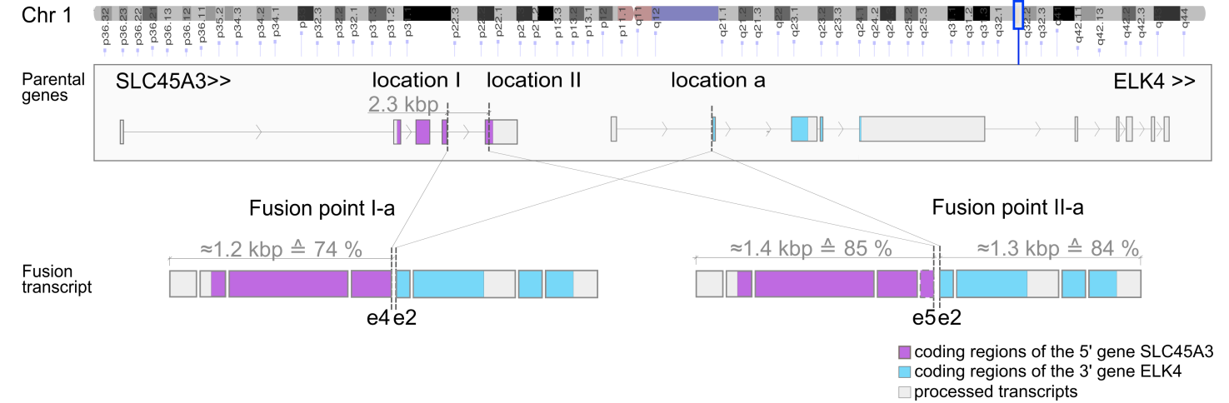
Figure S1. Cis-SAGe SLC45A3-ELK4 variants. Two fusion variants were detected in bulk sequenced RNA of the prostate tissue samples: two fusion points in SLC45A3 on Chr1:205661860 (exon 4) and Chr1:205659488 (exon 5) and one fusion point in ELK4 on chr1:205623890 (exon 2).

Table S17. Cis-SAGe SLC45A3-ELK4 variants in the 12 clinical tissue samples.
Fusion points | SLC45A3 | ELK4 | Distance  [bp]
- I-a e4e2  - II-a e5e2 | - I Chr1:205,661,860  (after exon 4)  - II Chr1:205,659,488  (within exon 5) | - a Chr1:205,623,890  (before exon 2) | 37,970  35,598

SLC45A3-ELK4 localisation in the remaining clinical tissue samples
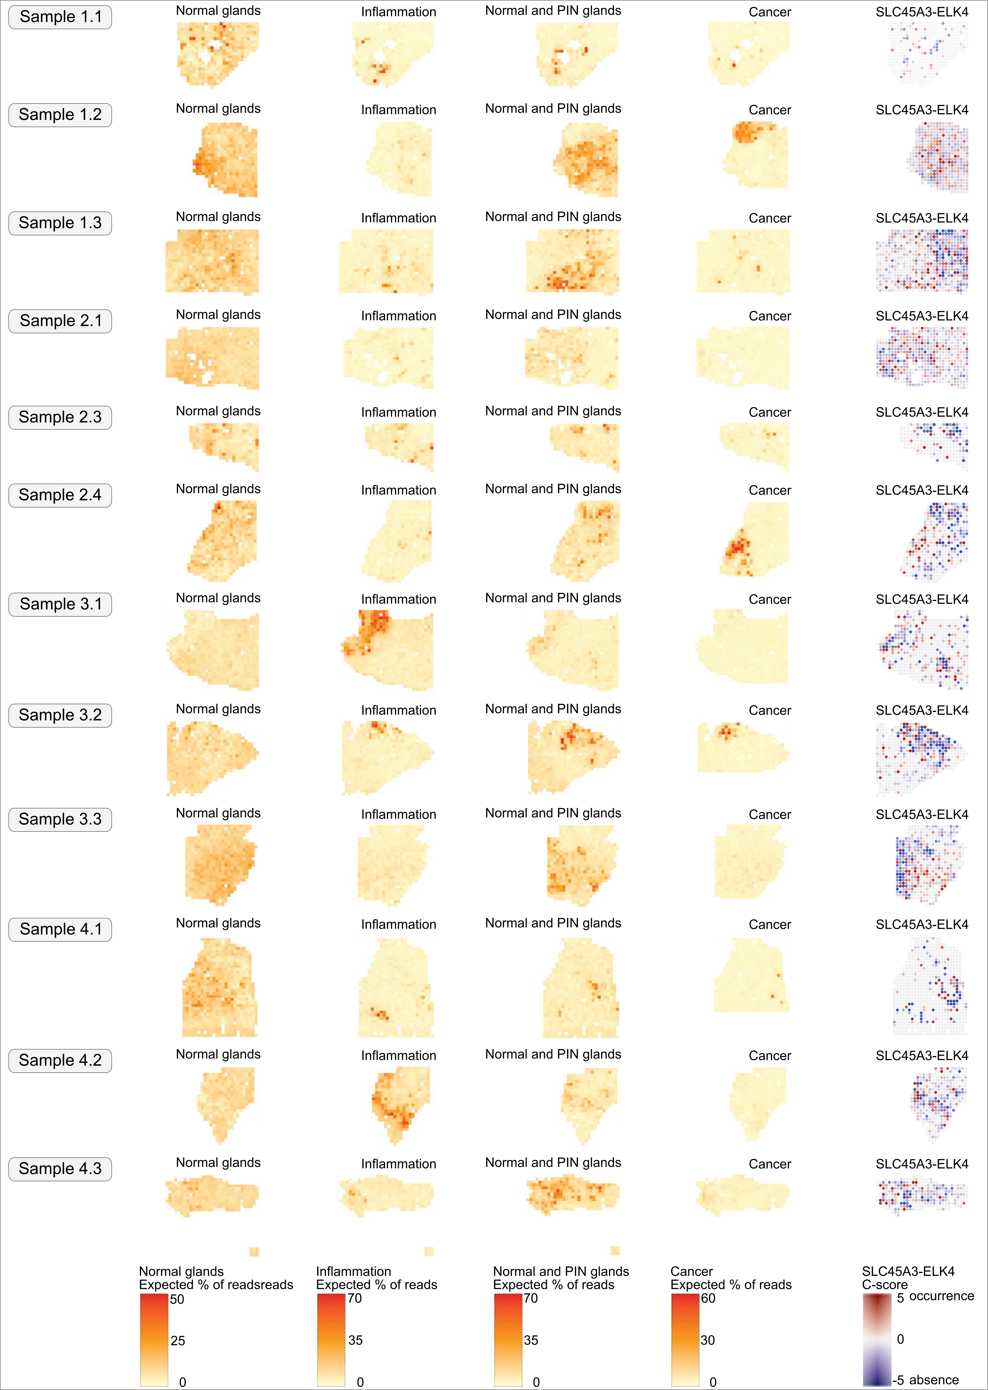
Figure S2. Factor activity maps compared to cis-SAGe occurrence for the twelve clinical tissue samples. Activity maps for transcriptomics factors “Normal glands”, “Inflammation”, “Normal and PIN glands” and “Cancer” were compared to cis-SAGe SLC45A3-ELK4 occurrence. The factor activity maps were based on a joined approach for 12 samples.

Differentially expressed genes and pathway annotation
For an in-depth comparison of different intensities of a fusion transcript SLC45A3-ELK4 occurrence or absence in sample 1.2, the sample with the highest data quality among the tissue samples, three comparisons were performed (Figure S3):
(i) Mild absence versus strong absence
(ii) Strong absence versus strong occurrence
(iii) Strong occurrence versus mild occurrence

To assign a spot to the groups “strong” or “mild”, these C-score thresholds were applied regardless of an annotation as stroma or epithelial:

(i) Strong absence $˗2.0<C˗score$

(ii) Mild absence $˗1.0<C˗score<˗MSD$

(iii) Mild occurrence $MSD<C−score<1.0$

(iv) Strong occurrence $2.0<C−score$

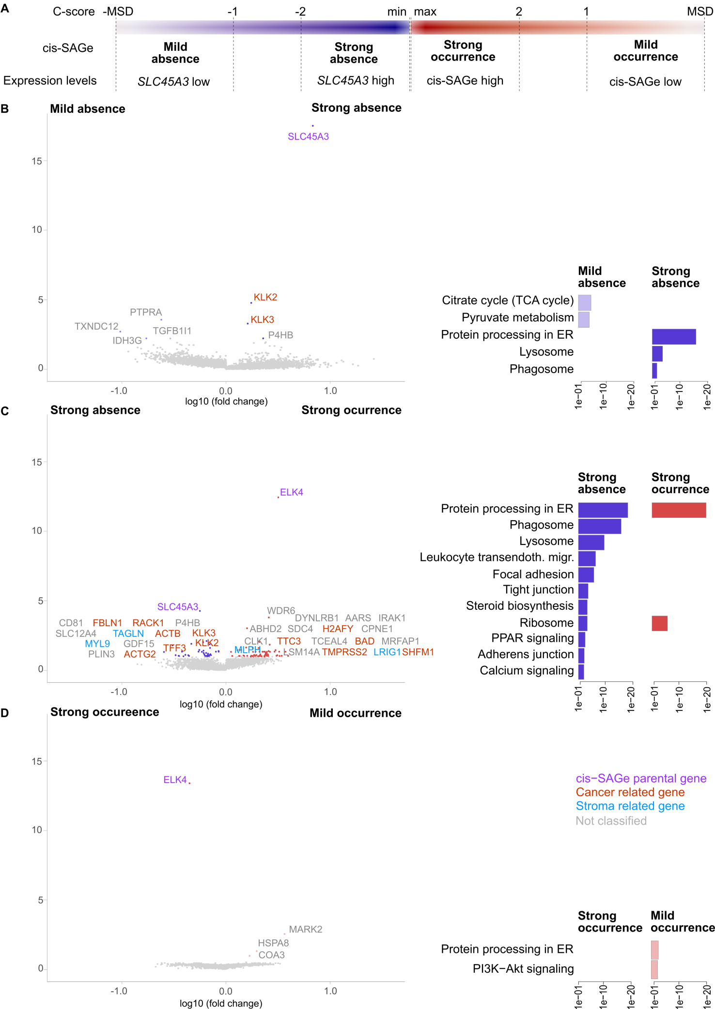
Figure S3. Differential expression and pathway annotation of cis-SAGe occurence for sample 1.2. Epithelial areas were dominant in this sample (Berglund et al., 2018). A Depending on the C-score, four groups of spots were defined. Each of the four groups represents two levels (mild, strong) of cis-SAGe occurrence or absence. B - D Significantly differentially expressed genes (FDR, q < 0.1) obtained from the comparisons of the four groups are presented. Significantly differentially expressed genes were submitted to PathwAX on the KEGG database. Enriched pathways are shown. B Differential expression analysis and pathway annotation for the comparison of mild absence and strong absence. C Differential expression analysis and pathway annotation for the comparison of strong absence and strong occurrence. D Differential expression analysis and pathway annotation for the comparison of strong occurrence and mild occurrence.

Comparison of mild absence and strong absence
In spots with low SLC45A3 expression (light blue), the genes PTPRA and TGFB1I1 are upregulated. PTPRA is a signalling molecule involved in cell growth, proliferation and oncogenic transformation [48]. TGFB1I1 is a coactivator of AR and thus, plays a role in prostate cancer progression [49]. Notably, in the group of strong absence (dark blue), KLK3 and KLK2 are co-expressed with SLC45A3. Both genes, KLK3 and KLK2, are AR-regulated and often upregulated in prostate cancer [50]. The activated pathway Citrate cycle (TCA cycle) is a typical phenomena of malignant transformation in prostate cancer mirroring a shift towards citrate oxidation to meet the higher energy demands of prostate cancer cells [51]. Areas of strong cis-SAGe absence (dark blue) show higher activation of the pathways protein processing in endoplasmic reticulum and lysosome. The pathway lysosome comprises digestive processes of macromolecules [52]. This indicates higher transcriptional stress, elevated levels of misfolded proteins and misfolded protein digestion.

Comparison of strong absence and strong occurrence
Significantly upregulated genes in areas with strong absence are RACK1, ACTG2, KLK3 and KLK2. These genes are also significantly upregulated in areas with absent SLC45A3-ELK4 in sample 3.3 (Figure 4). The pathway protein processing in endoplasmic reticulum is activated in both areas with strong absence and strong occurrence. As in Figure 4, the pathways Lysosome and Phagosome are activated in areas of strong absence. The pathway phagosome is linked to inflammation [53].

Comparison of strong occurrence and mild occurrence
In areas with mild cis-SAGe occurrence, only three significantly upregulated genes were observed, i.e. MARK2, HSPA8 and COA3. The pathways protein processing in endoplasmic reticulum and PI3K-Akt signalling are slightly activated. The latter is linked to disease progression, poor outcome and resistance to androgen deprivation therapy [41].

C-scores distributions for the 12 clinical tissue samples

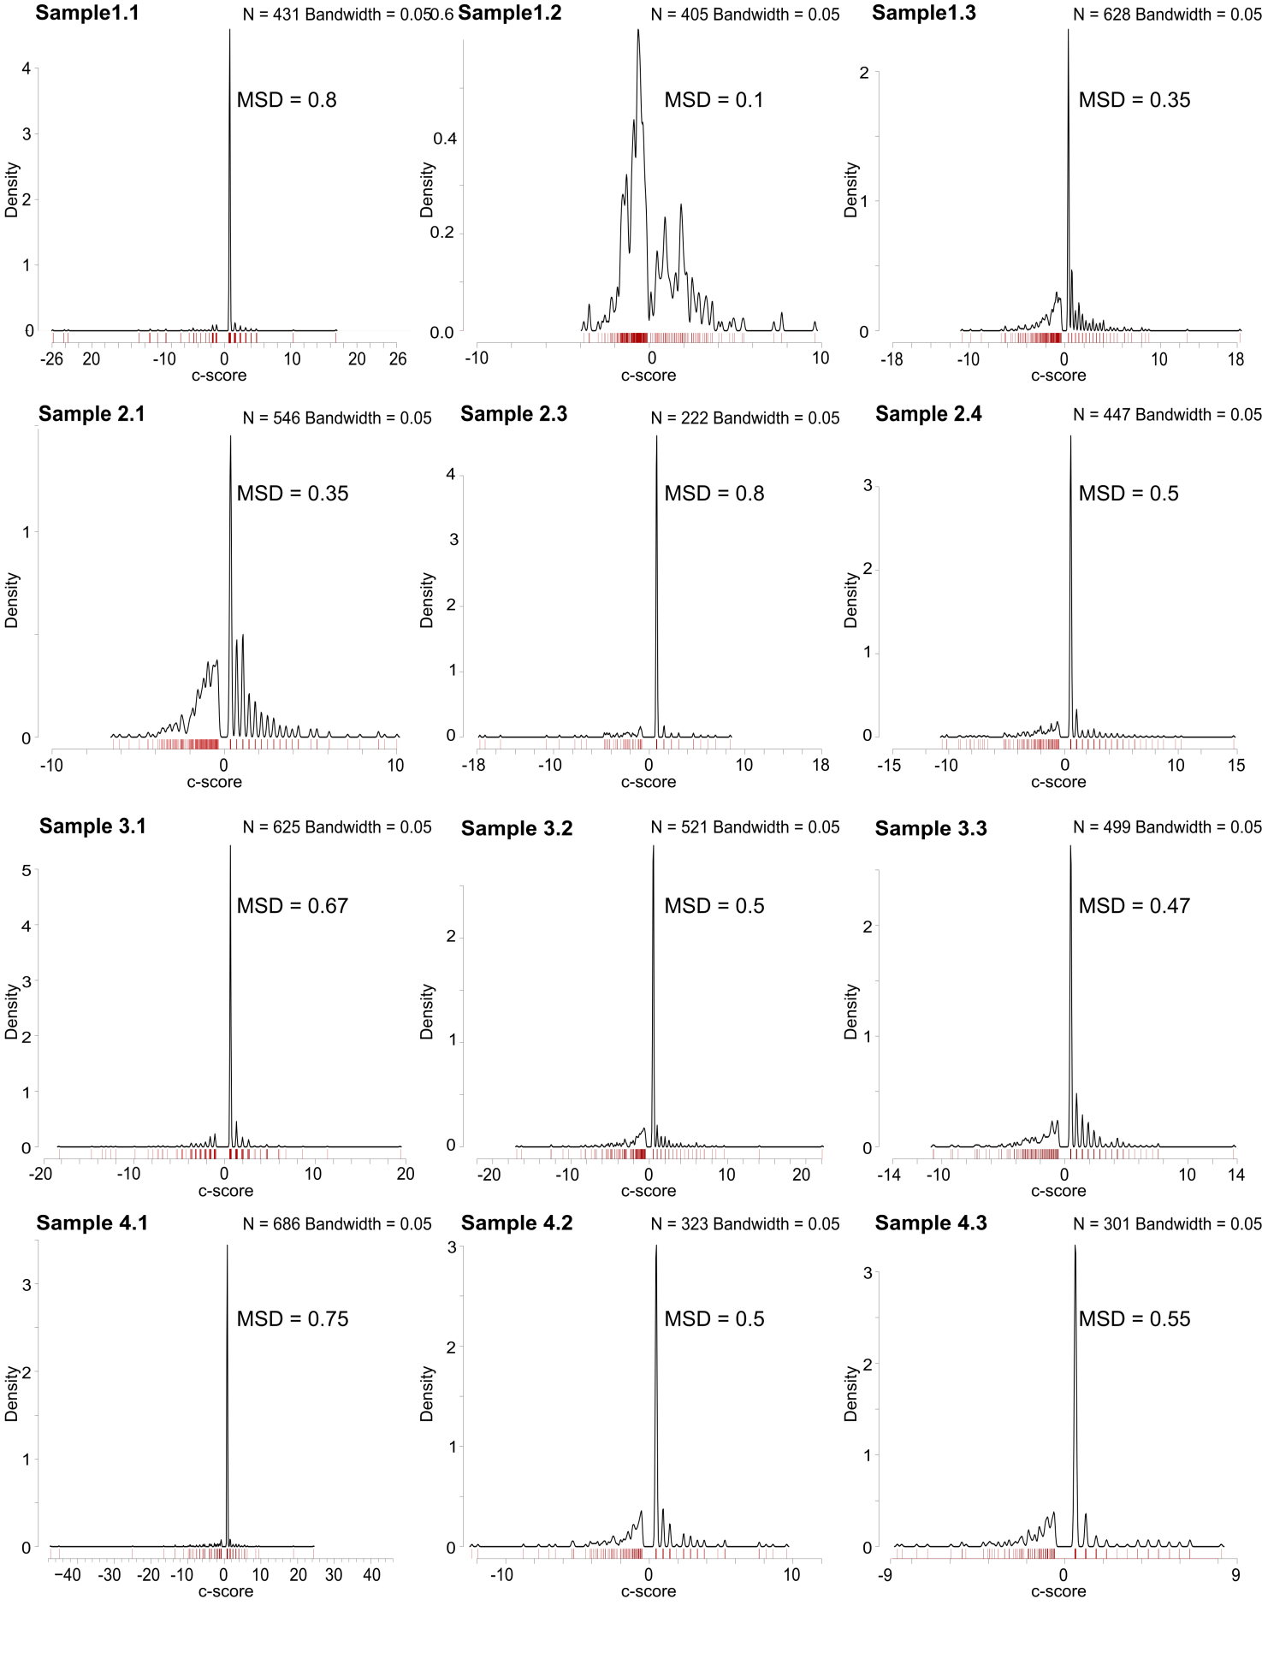
Figure S4. Distribution of C-scores. In each sample, except in sample 1.2 with very high ST data quality, a peak occured between 0.35 and 0.8. The peak arised if a C-score for a spot was calculated with a parental gene expression of 0 and a parental gene mean expression in a sample below 1. The minimal detectable signal (MSD) was set to the C-score frequency maximum. Red lines at the y-axis indicate the data points.

Non-canonical DNA-structures
A pre-mRNA, resulting from a failure in transcription initiation or termination, would contain all exons of both parental genes. However, in the studied samples, only fragments of the parental genes were observed, that is, not all exons of the parental genes were transcribed. This indicates that the transcription process neglects the corrupted sequence (Figure 1).

If the corrupted sequence starts or ends within an intron, the neighbouring exons are spliced and the fusion point is identified at the first or last base of these exons. However, if a fusion point was detected within an exon, the fusion point is in fact at this position. The fusion point of the 5´ gene of the cis-SAGe SLC45A3 happens within exon 5 (Chr1:205,659,488).

Table S18. An i-Motif was found 7 bp downstream of the fusion point of the intra-exonic fusion point of the cis-SAGe SLC45A3-ELK4 detected in the 12 clinical tissue samples. These non-canonical DNA structures are only a few nucleotides long (~10 nt) and regulate transcription by blocking [43].
Chimeric transcript | Parental gene | Fusion point according to FusionCatcher | Strand | Motif sequence on genome | Non-canonical DNA structure
SLC45A3- ELK4 | SLC45A3 | Chr1:205,659,488 | reverse | CACCCACCACCACAC | i-Motif  (CCA)₃

