


Rainfall
Relative humidity

Insignificant association
Associated with decrease in risk
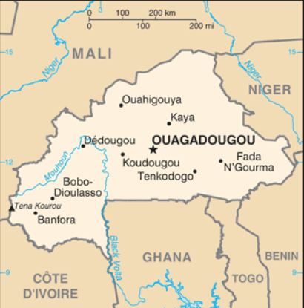
Insignificant association
Associated with increase in risk
Meningitis
Wind speed
Temperature

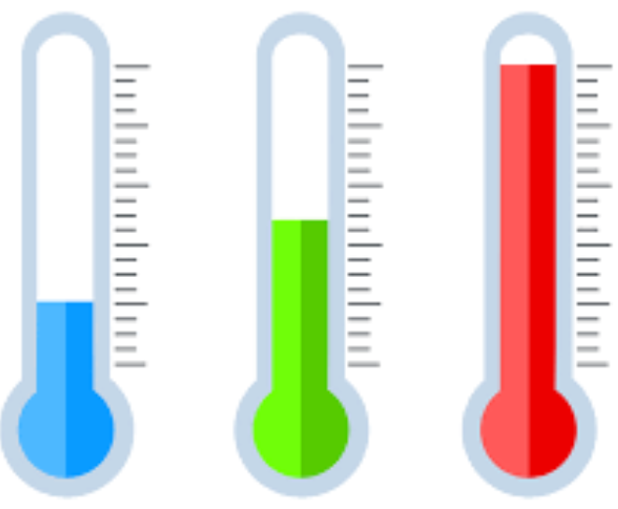


Results show that the decrease in relative humidity and the increase in temperatures are favorable conditions for the occurrence of meningitis epidemics in some cities(districts) in Burkina Faso but Rainfall and Wind speed are not significantly associated with the onset of meningitis
Strong correlations that are both negative (humidity) and positive (temperature) suggest that monitoring these parameters may contribute to the establishment of a warning system for meningitis epidemics at the local level.

