Appendix
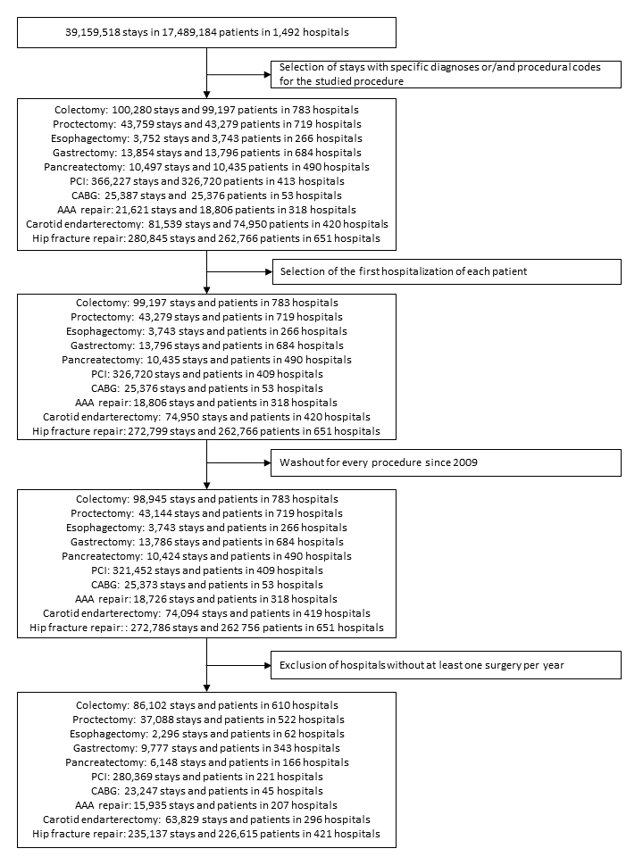
Figure E1 Study flowchart

Table E1 Volume change rate per year in hospitals experiencing volume increase or decrease according to procedures.

 | Increased  (%) | Decreased  (%)
Colectomy | 5.6 | -4..6
Proctectomy | 5.2 | -5.7
Esophagectomy | 23.1 | -2.9
Gastrectomy | 2.4 | -1.0
Pancreatectomy | 9.9 | -4.3
PCI | 30.2 | -14.0
CABG | 34.45 | -32.7
AAA repair | 16.6 | -9.9
Carotid endarterectomy | 9.4 | -14.5
Hip fracture repair | 37.4 | -10.9

Figure E2 Reoperation difference and learning effect between volume trend groups according to procedures. between 2010 and 2014. CABG coronary artery bypass grafting. AAA abdominal aortic aneurysm. PCI percutaneous coronary intervention. ª Hazard-ratios estimated from Fine and Gray’s competing risk model considering patient characteristics (age. gender. Elixhauser list of comorbidities. type and year of procedure. transfer. emergency admission. and median income) and hospital characteristics (hospital status. volume of procedures. specialization degree. and attraction rate). The clustering effect of patients within hospitals was taken into account with robust variance estimator. ^{b} Analyze to determine if patient reoperation in hospitals with procedure volume increase or decrease over time was altered from those in hospitals with unchanged volume. ^{c} Analyse to determine if mortality improve or diminish over time with an increasing or decreasing volume of procedures.
Figure E3 Unplanned hospital readmission difference and learning effect between volume trend groups according to procedures. between 2010 and 2014.
CABG coronary artery bypass grafting. AAA abdominal aortic aneurysm. PCI percutaneous coronary intervention. ª Hazard-ratios estimated from Fine and Gray’s competing risk model considering patient characteristics (age. gender. Elixhauser list of comorbidities. type and year of procedure. transfer. emergency admission. and median income) and hospital characteristics (hospital status. volume of procedures. specialization degree. and attraction rate). The clustering effect of patients within hospitals was taken into account with robust variance estimator. ^{b} Analyze to determine if patient unplanned hospital readmission in hospitals with procedure volume increase or decrease over time was altered from those in hospitals with unchanged volume. ^{c} Analyse to determine if mortality improve or diminish over time with an increasing or decreasing volume of procedures.

