Supplementary Table 1. Postpartum characteristics of study participants (n=3510)
Variables | Frequency of coffee consumption |  |  |  |  |  |  |  |  |  |  |  |  | p-value
Variables | Seldom coffee drinkers  (n=1077) |  | Light coffee drinkers  (<1 cup/day)  (n=595) |  | Moderate coffee drinkers  (1 cup/day)  (n=1202) |  |  |  |  | Heavy coffee drinkers  (≥2 cups/day)  (n=636) |  |  |  | p-value
Result of pregnancy
Miscarriage/abortion | 10 | (0.9) | 4 | (0.7) | 7 |  |  | (0.6) |  | 9 |  | (1.4) |  | 0.724
Stillbirth | 5 | (0.5) | 3 | (0.5) | 7 |  |  | (0.6) |  | 1 |  | (0.2) |  | 0.724
Birth | 1062 | (98.6) | 588 | (98.8) | 1188 |  |  | (98.8) |  | 626 |  | (98.4) |  | 0.724
Gestational age at birth, weeks (n=3464)
Pre-term (<37) | 59 | (5.5) | 29 | (4.9) | 65 |  |  | (5.4) |  | 38 |  | (6.0) |  | 0.892
Normal-term (37-41) | 1002 | (93.0) | 559 | (93.9) | 1122 |  |  | (93.3) |  | 588 |  | (92.5) |  | 0.892
Post-term (≥42) | 1 | (0.1) | 0 | (0.0) | 1 |  |  | (0.1) |  | 0 |  | (0.0) |  | 0.892
Type of birth
Vaginal | 648 | (60.2) | 350 | (58.8) | 713 |  |  | (59.3) |  | 344 |  | (54.1) |  | 0.091
Cesarean | 414 | (38.4) | 238 | (40.0) | 475 |  |  | (238.0) |  | 282 |  | (44.3) |  | 0.091
Postpartum depressive symptoms | 96 | (8.9) | 89 | (15.0) | 139 |  |  | (11.6) |  | 94 |  | (14.8) |  | <0.001
Complications at birth | 122 | (11.3) | 60 | (10.1) | 149 |  |  | (12.4) |  | 72 |  | (11.3) |  | 0.541
Injuries of parturient canal | 45 | (4.2) | 17 | (2.9) | 42 |  |  | (3.5) |  | 21 |  | (3.3) |  | 0.646
Placental rupture | 4 | (0.4) | 2 | (0.3) | 1 |  |  | (0.1) |  | 2 |  | (0.3) |  | 0.646
Premature rupture of membranes | 65 | (6.0) | 34 | (5.7) | 97 |  |  | (8.1) |  | 43 |  | (6.8) |  | 0.646
Rupture of uterus/Eclampsia/etc. | 8 | (0.7) | 7 | (1.2) | 9 |  |  | (0.7) |  | 6 |  | (0.9) |  | 0.646
Data expressed as mean ± standard deviation or number (percentage)

Supplementary Table 2. Association between the frequency of coffee consumption and risk of bleeding in early pregnancy in pregnant women aged <40 years (n=3314)
 | Total No. | No. (%) |  | Unadjusted OR  (95% CI) |  |  |  | Adjusted OR  (95% CI)ª
Aged <40 years | 3314 | 590 | (17.8)
Seldom coffee drinkers | 1032 | 163 | (15.8) | 1.000 |  |  |  | 1.000
Light coffee drinkers (<1 cup/day) | 568 | 96 | (16.9) | 1.084 | (0.823 | - | 1.429) | 1.090 | (0.823 | - | 1.443)
Moderate coffee drinkers (1 cup/day) | 1139 | 215 | (18.9) | 1.240 | (0.992 | - | 1.551) | 1.267 | (1.008 | - | 1.592)
Heavy coffee drinkers (≥2 cups/day) | 575 | 116 | (20.2) | 1.347 | (1.035 | - | 1.754) | 1.353 | (1.033 | - | 1.772)
ªadjusted for age, body mass index, systolic blood pressure, cigarette smoking and alcohol consumption behavior, previous and current physical activity levels, stress levels, history of depression, presence of antenatal depressive symptoms during the first trimester, type of emesis, parity, and the number of livebirths, stillbirths, miscarriages, and abortions

Supplementary Table 3. Association between the type of coffee consumption and risk of bleeding in early pregnancy (n=2394)
 | Total No. | No. (%) |  | Unadjusted OR  (95% CI) |  |  |  | Adjusted OR  (95% CI)ª
Black coffee | 1538 | 292 | (19.0) | 1.000 |  |  |  |  | 1.000
Black coffee with sugar | 169 | 43 | (25.4) | 1.457 | (1.007 | - | 2.079) |  | 1.446 | (0.992 | - | 2.107)
Black coffee with non-dairy creamer | 90 | 13 | (14.4) | 0.721 | (0.395 | - | 1.737) |  | 0.694 | (0.378 | - | 1.277)
Instant coffee | 597 | 108 | (18.1) | 0.942 | (0.738 | - | 2.533) |  | 0.893 | (0.694 | - | 1.151)
ªadjusted for age, body mass index, systolic blood pressure, cigarette smoking and alcohol consumption behavior, previous and current physical activity levels, stress levels, history of depression, presence of antenatal depressive symptoms during the first trimester, type of emesis, parity, and the number of livebirths, stillbirths, miscarriages, and abortions

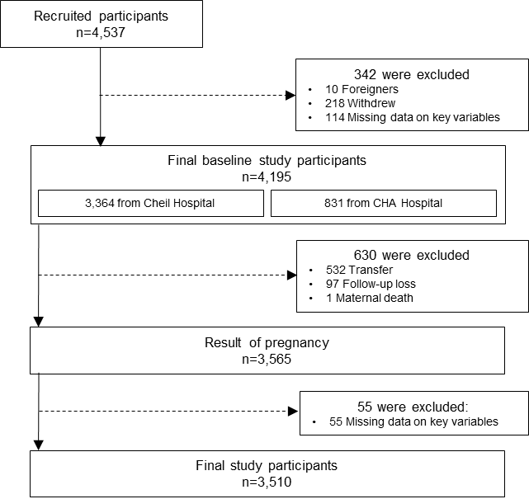
Supplementary Figure 1. Flowchart of participant selection

Supplementary Figure 2. Post-hoc analysis using the Bonferroni test
Variable: Age
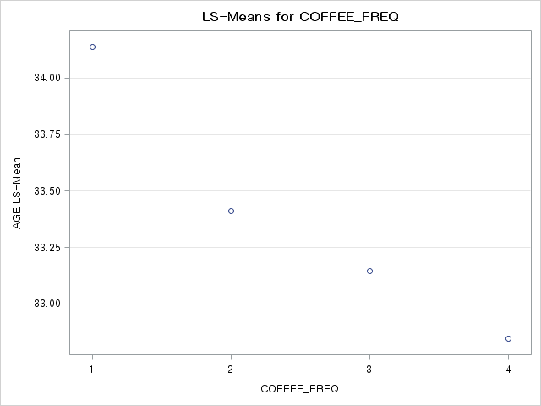
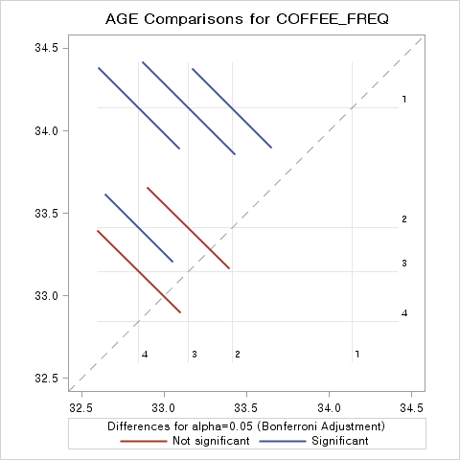
Variable: Systolic blood pressure
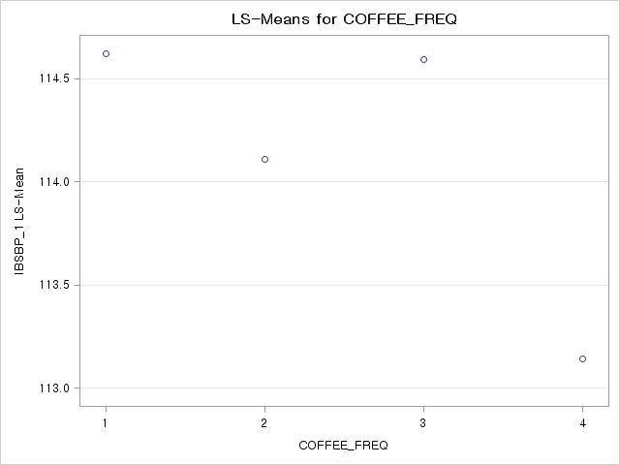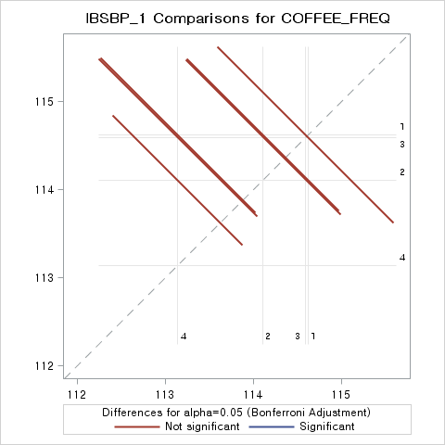
Variable: Diastolic blood pressure
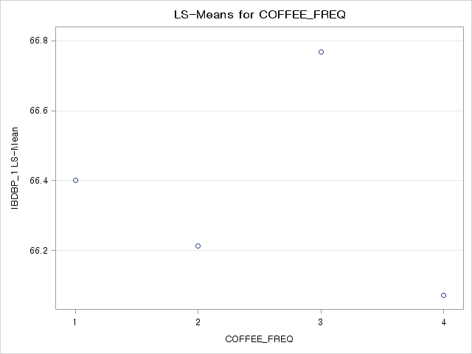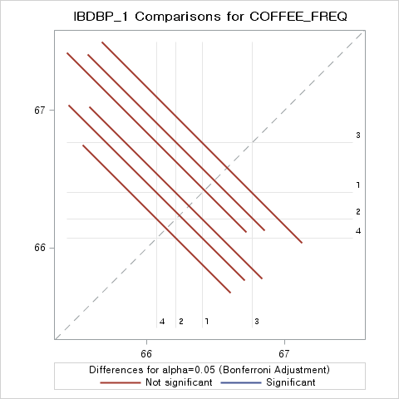
Variable: Body mass index
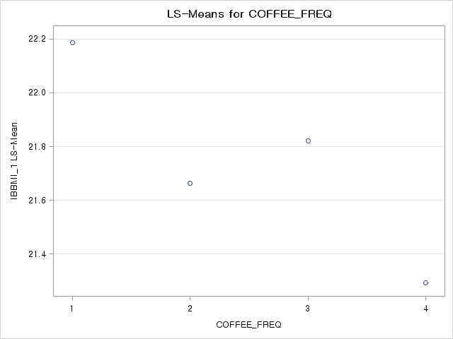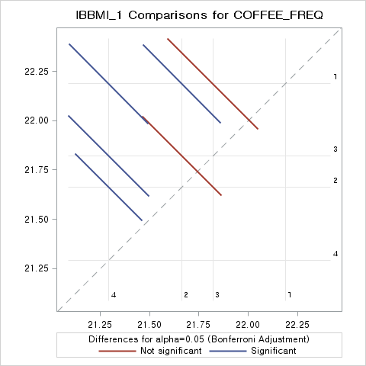
Variable: Parity
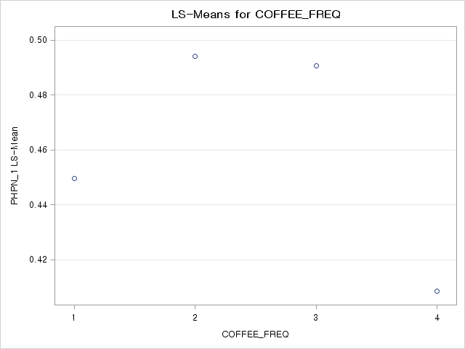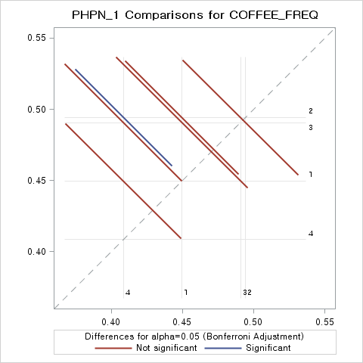
Questionnaires for the KPOS Study
The Korean Pregnancy Outcome study (KPOS)

Examination date: - - (YYYY-MM-DD)
ID: PIC- -
Date of birth: - - (YYYY-MM-DD)
Date of consent to participation: - - (YYYY-MM-DD)
Gestation weeks: - (WW-DD)

[Socio-demographics]
Socio-demographics | Unit
Height | cm
Current weight | __ _.__ kg
Pre-pregnancy weight | __ _.__ kg/m²
Current BMI | __ _.__ kg
Pre-pregnancy BMI | __ _.__ kg/m²
Systolic blood pressure | mmHg
Diastolic blood pressure | mmHg
Marital status | ①Never married ②Cohabited ③Married  ④Separated ⑤Divorced ⑥Widowed
Job status | ①Yes ②No
└ If you have a job, what type of employment do you have?
①Self-employed or Employer ②Wage worker
③Unpaid family worker
└ If you are a wage worker, what is your position
 | ①Full-time worker ②Part-time worker ③Daily worker
Educational status | ①Uneducated ②Elementary school ③Middle school  ④High school ⑤College or University ⑥Graduate school
Household income  (1,000 Korean won / month) | ①<1,000 ②1,000-2,000 ③2,000-3,000  ④3,000-4,000 ⑤4,000-5,000 ⑥≥5,000

[Health behavior]
Health behavior | Unit
Cigarette smoking | ①Never smoker ②Former smoker ③Current smoker
└ If you are a former smoker, when did you quit?
①Before pregnancy ②Before 6 weeks of gestation
③6 – 10 weeks of gestation worker ④after 10 weeks of gestation
└ If you are a former or current smoker, how much did you smoking?
 | piece(s) / day
└ If you are a former or current smoker, how long did you smoking?
 | year month
Passive smoking | ①Yes ②No
Alcohol drinking | ①Never drinker ②Former drinker ③Current drinker
└ If you are a former drinker, when did you quit drinking?
①Before pregnancy ②Before 6 weeks of gestation
③6 – 10 weeks of gestation worker ④after 10 weeks of gestation
└ If you are a former or current drinker, how much did you drinking?
 | glass(es) / once
└ If you are a former or current drinker, how long did you drinking?
 | ①≤1/month ②2-4/month ③2-3/week ④≥4/week ⑤Daily

[Physical activity]
Pre-pregnancy | Unit
Major physical activity | ①Static activity ②Light activity ③Moderate activity  ④Vigorous activity ⑤Strong activity
└ Did you have a vigorous activity before pregnancy?
①Yes ( day / week, hour(s) minute(s))
②No
└ Did you have a moderate activity before pregnancy?
①Yes ( day / week, hour(s) minute(s))
②No
└ Did you go out for walking before pregnancy?
①Yes ( day / week, hour(s) minute(s))
②No
└ Did you have a resistance exercise before pregnancy?
①Yes ( day / week, hour(s) minute(s))
②No
Current pregnancy | Unit
Major physical activity | ①Static activity ②Light activity ③Moderate activity  ④Vigorous activity ⑤Strong activity
└ Did you have a vigorous activity after pregnancy?
①Yes ( day / week, hour(s) minute(s))
②No
└ Did you have a moderate activity after pregnancy?
①Yes ( day / week, hour(s) minute(s))
②No
└ Did you go out for walking after pregnancy?
①Yes ( day / week, hour(s) minute(s))
②No
└ Did you have a resistance exercise after pregnancy?
①Yes ( day / week, hour(s) minute(s))
②No

[Dietary pattern]
Dietary pattern before pregnancy | Unit
Breakfast | ①Everyday ②5-6/week ③5-6/week ④5-6/week ⑤Seldom
Lunch | ①Everyday ②5-6/week ③5-6/week ④5-6/week ⑤ Seldom
Dinner | ①Everyday ②5-6/week ③5-6/week ④5-6/week ⑤ Seldom
Snack | ①Everyday ②5-6/week ③5-6/week ④5-6/week ⑤ Seldom
Eating out | ①Everyday ②5-6/week ③5-6/week ④5-6/week ⑤ Seldom
Late-night meal | ①Everyday ②5-6/week ③5-6/week ④5-6/week ⑤ Seldom
Preference for taste | ①Salty ②Sweet ③Sour ④Spicy ⑤Greasy
Coffee intake | ①≥2 cups/day ②1 cup/day ③4-5 cup/week ④2-3 cup/week ⑤Seldom
└ If you are a regular coffee drinker, check the preference type of coffee?
①Black coffee
②Black coffee with sugar
③Black coffee with non-dairy creamer
④Instant coffee with sugar and non-dairy creamer
Multigrain rice | ①3/day ②2/day ③1/day ④4-6/week ⑤2-3/week ⑥1/week ⑦Seldom
High-fat meat | ①3/day ②2/day ③1/day ④4-6/week ⑤2-3/week ⑥1/week ⑦Seldom
Fish | ①3/day ②2/day ③1/day ④4-6/week ⑤2-3/week ⑥1/week ⑦Seldom
Bean or Tofu | ①3/day ②2/day ③1/day ④4-6/week ⑤2-3/week ⑥1/week ⑦Seldom
Pickled vegetables or Salted seafood | ①3/day ②2/day ③1/day ④4-6/week ⑤2-3/week ⑥1/week ⑦Seldom
Instant food | ①3/day ②2/day ③1/day ④4-6/week ⑤2-3/week ⑥1/week ⑦Seldom
Soda | ①3/day ②2/day ③1/day ④4-6/week ⑤2-3/week ⑥1/week ⑦Seldom
Snack | ①3/day ②2/day ③1/day ④4-6/week ⑤2-3/week ⑥1/week ⑦Seldom
Ramen | ①3/day ②2/day ③1/day ④4-6/week ⑤2-3/week ⑥1/week ⑦Seldom
Marine algae | ①3/day ②2/day ③1/day ④4-6/week ⑤2-3/week ⑥1/week ⑦Seldom
Fried foods | ①3/day ②2/day ③1/day ④4-6/week ⑤2-3/week ⑥1/week ⑦Seldom
Fruits | ①3/day ②2/day ③1/day ④4-6/week ⑤2-3/week ⑥1/week ⑦Seldom
Vegetables | ①3/day ②2/day ③1/day ④4-6/week ⑤2-3/week ⑥1/week ⑦Seldom
Dairy foods | ①3/day ②2/day ③1/day ④4-6/week ⑤2-3/week ⑥1/week ⑦Seldom

[History of diseases]
Name of diseases | Existence of diseases | Date of diagnosis  (YYYY) | Usage of medication | Name of medication
Hypertension | ①Yes ②No ③Not sure | ________ | ①Yes ②No | ________
Diabetes mellitus | ①Yes ②No ③Not sure | ________ | ①Yes ②No | ________
Thyroid insufficiency | ①Yes ②No ③Not sure | ________ | ①Yes ②No | ________
Congenital heart disease | ①Yes ②No ③Not sure | ________ | ①Yes ②No | ________
Asthma | ①Yes ②No ③Not sure | ________ | ①Yes ②No | ________
Chronic kidney disease | ①Yes ②No ③Not sure | ________ | ①Yes ②No | ________
Auto-immune disease | ①Yes ②No ③Not sure | ________ | ①Yes ②No | ________
Atopic dermatitis | ①Yes ②No ③Not sure | ________ | ①Yes ②No | ________
Depression | ①Yes ②No ③Not sure | ________ | ①Yes ②No | ________
Epilepsy | ①Yes ②No ③Not sure | ________ | ①Yes ②No | ________
Polycystic ovarian syndrome | ①Yes ②No ③Not sure | ________ | ①Yes ②No | ________
Hepatitis type A | ①Yes ②No ③Not sure | ________ | ①Yes ②No | ________
Hepatitis type B | ①Yes ②No ③Not sure | ________ | ①Yes ②No | ________
Tuberculosis | ①Yes ②No ③Not sure | ________ | ①Yes ②No | ________
Mental disorders  (except depression) | ①Yes ②No ③Not sure | ________ | ①Yes ②No | ________
Etc (______ __) | ①Yes ②No ③Not sure | ________ | ①Yes ②No | ________
[Family history of diseases]
Name of diseases | Existence of diseases | Related family
Hypertension | ①Yes ②No ③Not sure | ①Grandfather ②Grandmother  ③Father ④Mother ⑤Sibling
Diabetes mellitus | ①Yes ②No ③Not sure | ①Grandfather ②Grandmother  ③Father ④Mother ⑤Sibling
Gestational diabetes mellitus | ①Yes ②No ③Not sure | ①Grandfather ②Grandmother  ③Father ④Mother ⑤Sibling
Eclampsia | ①Yes ②No ③Not sure | ①Grandfather ②Grandmother  ③Father ④Mother ⑤Sibling
Depression | ①Yes ②No ③Not sure | ①Grandfather ②Grandmother  ③Father ④Mother ⑤Sibling
Mental disorders  (except depression) | ①Yes ②No ③Not sure | ①Grandfather ②Grandmother  ③Father ④Mother ⑤Sibling

[Reproductive and Birth history]
Reproductive history | Unit
Gravidity (No) | ________ time(s)
Pregnancy (No) | ________ time(s)
Living child (No) | ________ person(s)
Death child (No) | ________ person(s)
Artificial abortion (No) | ________ time(s)
Spontaneous abortion (No) | ________ time(s)

Birth history | Unit
Number of birth | ________ time(s)
Number of fetus | ①Singleton ②Twin or more
Date of birth | ________ year
Gestation weeks | ________ weeks
Birth weight | _ _.____ kg
Delivery mode | ①Vaginal ②Cesarean
History of gestational diabetes mellitus | ①Yes ②No
History of hypertensive disorders of pregnancy | ①Yes ②No
History of antenatal depression | ①Yes ②No
History of postpartum depression | ①Yes ②No
History of mental disorders during pregnancy | ①Yes ②No

[Current pregnancy information]
Current pregnancy information | Unit
Last normal menstrual period | - - (YYYY-MM-DD)
Expected of delivery date | - - (YYYY-MM-DD)
Method of conception | ①Normal ②Ovulation induction  ③Artificial insemination ④In vitro fertilization
Number of fetus | ①Singleton ②Twin
Emesis | ①Yes ②No
└ If you have an emesis during pregnancy, check the severity of your status.
 | ①Mild ②Severe ③Inpatient treatment
Bleeding in early pregnancy | ①Yes ②No
└ If you have a bleeding in early pregnancy, check the severity of your status.
 | ①Stabilization ②Drug treatment ③Inpatient treatment
Supplement intake
└ Multivitamin | ①Yes ②No ①Pre-pregnancy ②After pregnancy ___weeks
└ Folic acid | ①Yes ②No ①Pre-pregnancy ②After pregnancy ___weeks
└ Iron | ①Yes ②No ①Pre-pregnancy ②After pregnancy ___weeks
└ Calcium | ①Yes ②No ①Pre-pregnancy ②After pregnancy ___weeks
└ Multivitamin | ①Yes ②No ①Pre-pregnancy ②After pregnancy ___weeks
└ Oriental medicine | ①Yes ②No ①Pre-pregnancy ②After pregnancy ___weeks
└ etc | ①Yes ②No ①Pre-pregnancy ②After pregnancy ___weeks

[Laboratory values]
Laboratory values | Result | Unit
Hb |  | g/dL
Hct |  | %
PLT |  | x10³/uL
WBC |  | x10³/uL
Glucose |  | mg/dL
AST |  | IU/L
ALT |  | IU/L
BUN |  | mg/dL
Creatinine |  | mg/dL
Total protein |  | g/dL
Albumin |  | g/dL
Cholesterol |  | mg/dL

[Results of pregnancy]
Examination date: - - (YYYY-MM-DD)

Results of mother | Unit
Gestation weeks of delivery | - (WW-DD)
Pregnancy result | ①Miscarriage or Abortion ②Stillbirth  ③Pre-term delivery ④Full-term delivery
Height | Cm
Current weight | __ _.__ kg
Current BMI | __ _.__ kg
Systolic blood pressure | mmHg
Diastolic blood pressure | mmHg
Delivery mode | ①Vaginal ②Cesarean
Complications at delivery | ①Yes ②No
└ If you have complications at delivery, what type of complications did you have?
①Injuries of parturient canal ②Abruption placenta
③Premature rupture of membranes ④Other
Results of fetus | Unit
Number of live births | ①Singleton ②Twin
 | 1st baby | 2nd baby
Sex | ①Boy ②Girl | ①Boy ②Girl
Height | . Cm | . Cm
Weight | g | g
Head Circumference | . cm | . cm
APGAR score | 1 minute:  5 minutes: | 1 minute:  5 minutes:
Neonatal intensive care unit | ①Yes ②No | ①Yes ②No
Endotracheal intubation | ①Yes ②No | ①Yes ②No
Convulsions of newborn | ①Yes ②No | ①Yes ②No
Bilirubin value | . mg/dL | . mg/dL
Congenital malformation | ①Yes ②No | ①Yes ②No
 | □Head and Neck  □Eye  □ENT  □Lungs  □Heart  □Abdomen  □Kidney  □Genitalia  □Thorax  □Skeletal (trunk, spine)  □Neuto  □Others ( ) | □Head and Neck  □Eye  □ENT  □Lungs  □Heart  □Abdomen  □Kidney  □Genitalia  □Thorax  □Skeletal (trunk, spine)  □Neuto  □Others ( )

