Supplementary Table 1. Postpartum characteristics of study participants (n=3510)
Variables | Frequency of coffee consumption |  |  |  |  |  |  |  |  |  |  |  |  | p-value
Variables | Seldom coffee drinkers  (n=1077) |  | Light coffee drinkers  (<1 cup/day)  (n=595) |  | Moderate coffee drinkers  (1 cup/day)  (n=1202) |  |  |  |  | Heavy coffee drinkers  (≥2 cups/day)  (n=636) |  |  |  | p-value
Result of pregnancy
Miscarriage/abortion | 10 | (0.9) | 4 | (0.7) | 7 |  |  | (0.6) |  | 9 |  | (1.4) |  | 0.724
Stillbirth | 5 | (0.5) | 3 | (0.5) | 7 |  |  | (0.6) |  | 1 |  | (0.2) |  | 0.724
Birth | 1062 | (98.6) | 588 | (98.8) | 1188 |  |  | (98.8) |  | 626 |  | (98.4) |  | 0.724
Gestational age at birth, weeks (n=3464)
Pre-term (<37) | 59 | (5.5) | 29 | (4.9) | 65 |  |  | (5.4) |  | 38 |  | (6.0) |  | 0.892
Normal-term (37-41) | 1002 | (93.0) | 559 | (93.9) | 1122 |  |  | (93.3) |  | 588 |  | (92.5) |  | 0.892
Post-term (≥42) | 1 | (0.1) | 0 | (0.0) | 1 |  |  | (0.1) |  | 0 |  | (0.0) |  | 0.892
Type of birth
Vaginal | 648 | (60.2) | 350 | (58.8) | 713 |  |  | (59.3) |  | 344 |  | (54.1) |  | 0.091
Cesarean | 414 | (38.4) | 238 | (40.0) | 475 |  |  | (238.0) |  | 282 |  | (44.3) |  | 0.091
Postpartum depressive symptoms | 96 | (8.9) | 89 | (15.0) | 139 |  |  | (11.6) |  | 94 |  | (14.8) |  | <0.001
Complications at birth | 122 | (11.3) | 60 | (10.1) | 149 |  |  | (12.4) |  | 72 |  | (11.3) |  | 0.541
Injuries of parturient canal | 45 | (4.2) | 17 | (2.9) | 42 |  |  | (3.5) |  | 21 |  | (3.3) |  | 0.646
Placental rupture | 4 | (0.4) | 2 | (0.3) | 1 |  |  | (0.1) |  | 2 |  | (0.3) |  | 0.646
Premature rupture of membranes | 65 | (6.0) | 34 | (5.7) | 97 |  |  | (8.1) |  | 43 |  | (6.8) |  | 0.646
Rupture of uterus/Eclampsia/etc. | 8 | (0.7) | 7 | (1.2) | 9 |  |  | (0.7) |  | 6 |  | (0.9) |  | 0.646
Data expressed as mean ± standard deviation or number (percentage)

Supplementary Table 2. Association between the frequency of coffee consumption and risk of bleeding in early pregnancy in pregnant women aged <40 years (n=3314)
 | Total No. | No. (%) |  | Unadjusted OR  (95% CI) |  |  |  | Adjusted OR  (95% CI)ª
Aged <40 years | 3314 | 590 | (17.8)
Seldom coffee drinkers | 1032 | 163 | (15.8) | 1.000 |  |  |  | 1.000
Light coffee drinkers (<1 cup/day) | 568 | 96 | (16.9) | 1.084 | (0.823 | - | 1.429) | 1.090 | (0.823 | - | 1.443)
Moderate coffee drinkers (1 cup/day) | 1139 | 215 | (18.9) | 1.240 | (0.992 | - | 1.551) | 1.267 | (1.008 | - | 1.592)
Heavy coffee drinkers (≥2 cups/day) | 575 | 116 | (20.2) | 1.347 | (1.035 | - | 1.754) | 1.353 | (1.033 | - | 1.772)
ªadjusted for age, body mass index, systolic blood pressure, cigarette smoking and alcohol consumption behavior, previous and current physical activity levels, stress levels, history of depression, presence of antenatal depressive symptoms during the first trimester, type of emesis, parity, and the number of livebirths, stillbirths, miscarriages, and abortions

Supplementary Table 3. Association between the type of coffee consumption and risk of bleeding in early pregnancy (n=2394)
 | Total No. | No. (%) |  | Unadjusted OR  (95% CI) |  |  |  | Adjusted OR  (95% CI)ª
Black coffee | 1538 | 292 | (19.0) | 1.000 |  |  |  |  | 1.000
Black coffee with sugar | 169 | 43 | (25.4) | 1.457 | (1.007 | - | 2.079) |  | 1.446 | (0.992 | - | 2.107)
Black coffee with non-dairy creamer | 90 | 13 | (14.4) | 0.721 | (0.395 | - | 1.737) |  | 0.694 | (0.378 | - | 1.277)
Instant coffee | 597 | 108 | (18.1) | 0.942 | (0.738 | - | 2.533) |  | 0.893 | (0.694 | - | 1.151)
ªadjusted for age, body mass index, systolic blood pressure, cigarette smoking and alcohol consumption behavior, previous and current physical activity levels, stress levels, history of depression, presence of antenatal depressive symptoms during the first trimester, type of emesis, parity, and the number of livebirths, stillbirths, miscarriages, and abortions

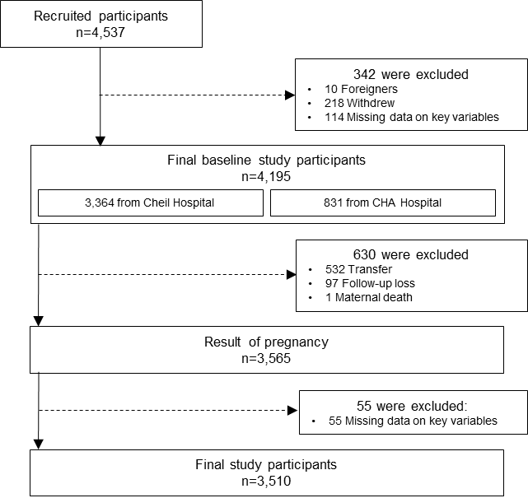
Supplementary Figure 1. Flowchart of participant selection

Supplementary Figure 2. Post-hoc analysis using the Bonferroni test
Variable: Age
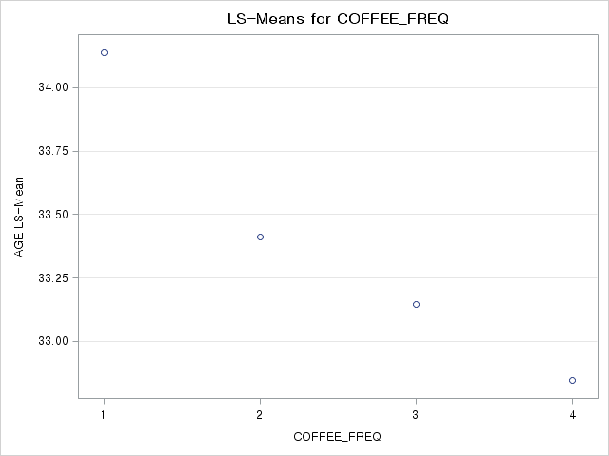
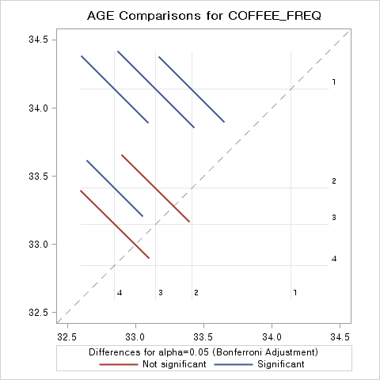
Variable: Systolic blood pressure
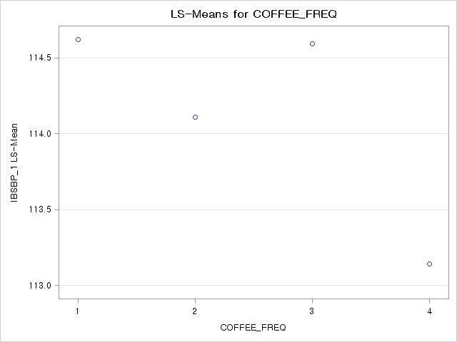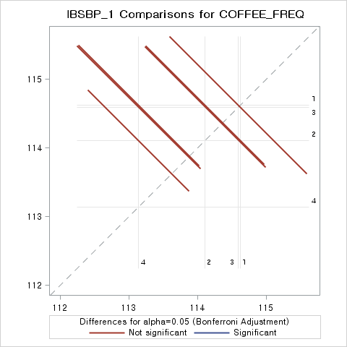
Variable: Diastolic blood pressure
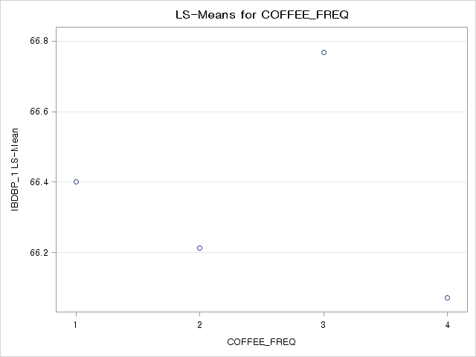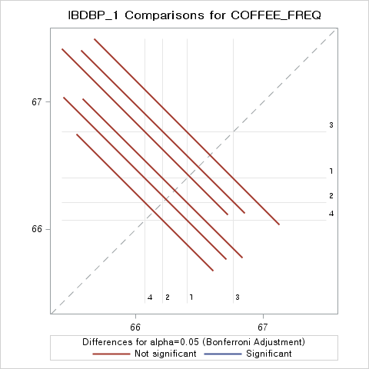
Variable: Body mass index
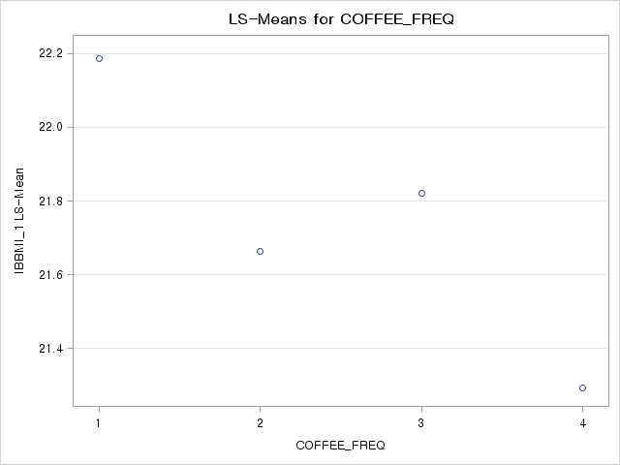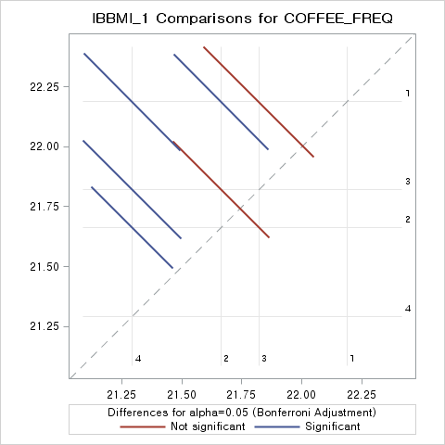
Variable: Parity
