Additional file.2
Detail analysis of semi-data from Questionnaire
To obtain information about the migration season of bats and its impact on Ebola virus transmission, we conducted face-to-face interviews using a simple questionnaire. The interviewees described the exact migration season of bats in each participated country and its related impact in this study. All interviewees were relaxed and comfortable answering our questions. Interviews were conducted in April 2019 in good season for all people in the city even though its climate change every time is different, and these enable us to meet with a high number of participant. The questionnaire inquired about demographic information of interviewees, interacted with bats and its impact to the last Ebola outbreak in their nationalities, and then the best migration season of bats. We also asked related questions including the influence of climate conditions to transmit Ebola. The output of direct interviews is summarized in the main document (table 1 and 2). The questionnaire distributed to 212 participants but some did not answer due to different reasons. Some were the first time they understood fruit bats but already know Ebola diseases. Well filled questionnaire were 134 participants from 11 Nationalities, 4 did not know fruit bats, and their information was not considered during the data analysis. The detailed analysis of the findings was done on bats migration season, Activities interacting with bats influence the spreading EVD, New EVD transmission in migration season and recent EVD transmission in migration season and outbreaks. The predicated of susceptible and infected individuals involving in the bushmeat commodity chain has been followed the figure 1 in this file.
Bats migration season
In the affected countries of Ebola and their surroundings, fruit bats migration season confirmed as measure contributor to the EVD spreading. The interviews from eight countries have been established their proper season, some are similar other differ, however, that is because some countries are neighbors and their climate change, and geographical representation are almost the same. DRC is among the biggest country in Africa with different climate change because there is more time zone passed through it. Maybe it was the reason among 41 interviewees from DRC, 22 (53.6%) confirmed the yearly bat's migration season is on July to September, while 19 (46.4%) confirmed in October to December. In Gabon and Ghana, this migration season starts from October to December, as it confirmed by 22(100%) i.e all participant from Gabon. In Guinea, the migration season starts from April to June as all participant confirmed, 20(100%). In Liberia, it starts on July to September as confirmed by 20(100%), in Ivory Coast it is on April to June as confirmed by 8(100%), and in Zambia, it starts on January to March as confirmed by 9 (100%). Although these different migration seasons confirmed as three months, the participant declared that some it extended to four months.
Activities interacting with bats influence the spreading EVD
Hunting, trading and consuming bats are main activities transmit EVD from bats to people in affected countries. Excluding Ghana, where all people eat bats meat with no worry of being affected by Ebola diseases as all participant confirmed that bats are not even suspected to transmit EVD (22 (100%)), while in DRC, 34(82.9%) confirmed the transmission, 8(17.1%) disagree, in Gabon confirmed 22 (100%), Zambia 9 (100%), Ivory Coast 8 (100%), Guinea 10 (100%), and Liberia 16 (80%) confirmed while 4 (20%) disagree .
Recent EVD transmission in migration season and outbreaks
The influence of bats migration season has been suggested a long time ago and it still is contributing to new EVD transmission as has been confirmed in this study by a high number of participant. In DRC, 41 (100%), Gabon, 22 (100%), Guinea, 10 (100%), confirmed this influence of migration season. In Liberia, 12(60%) confirmed while 8(40%) less agree, Zambia, 6 (66.6%) confirmed, 3 (33.4%) not confirm, Ivory Cost 6 (75%) confirmed while 2(25%) not confirm, and on another side, Ghana does not know this influence of migration season as described by 22 (100%). In this study, in DRC and Gabon, 13 families had faced EVD from bats, 7 survival and 6 deaths. In Liberia and Guinea, 9 families infected due to infected bats, 4 survival and 5 deaths.
Bushmeat commodity chain
The susceptible and infected individuals are estimated in the following figure. Primary and secondary vendors and chop bars are combined and estimated the same numbers.
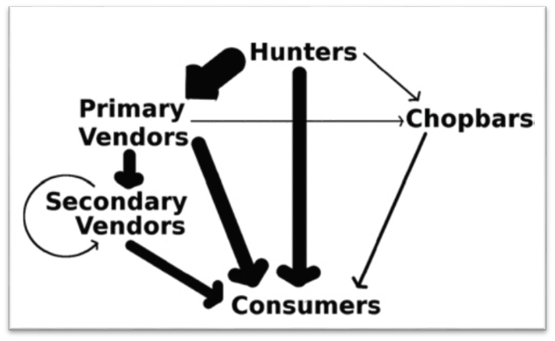
Fig. 1. The basic structure of bushmeat commodity chain in southern Ghana almost the same in every affected country of Ebola. The width of arrows is proportional to the relative proportions of reported connections between each pair of actors along the chain.

