Supplementary Figures
Figure S1. Distribution of CNV length
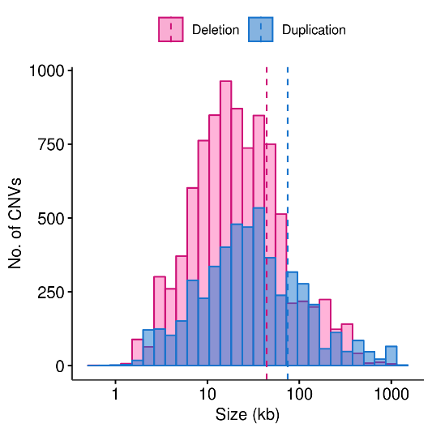

Histogram of the length of 14,272 CNVs detected in ARS-UCD1.2. Deletion and duplication calls were shown in pink and blue colour, respectively.
Figure S2. Circular map of autosomal copy number variant regions based on results in UMD3.1 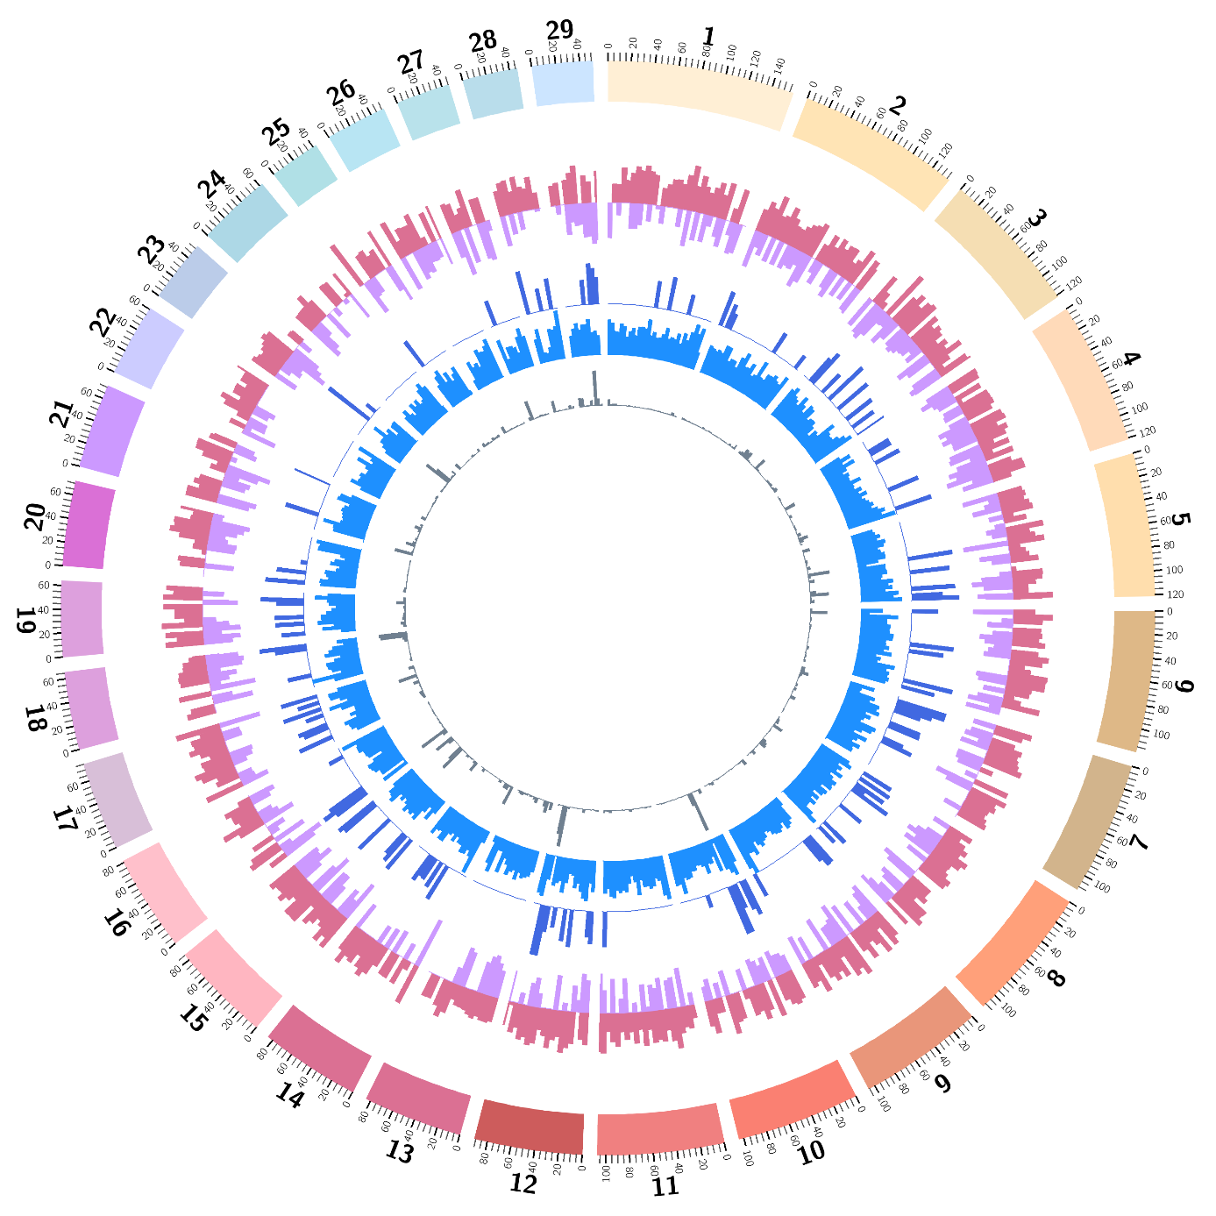
From the outside to the inside of the external circle: chromosome name; genomic location (in Mb); histogram representing density of deletion CNVRs in 5 Mb bin (pink); histogram representing density of duplication CNVRs in 5 Mb bin (purple); histogram representing density of complex CNVRs in 5 Mb bin (dark blue); number of BovineHD BeadChip array SNPs in 5 Mb bin (blue); histogram representing segmental duplication in 5 Mb bin (grey)
Figure S3. Linkage disequilibrium of CNVRs in different allele frequencies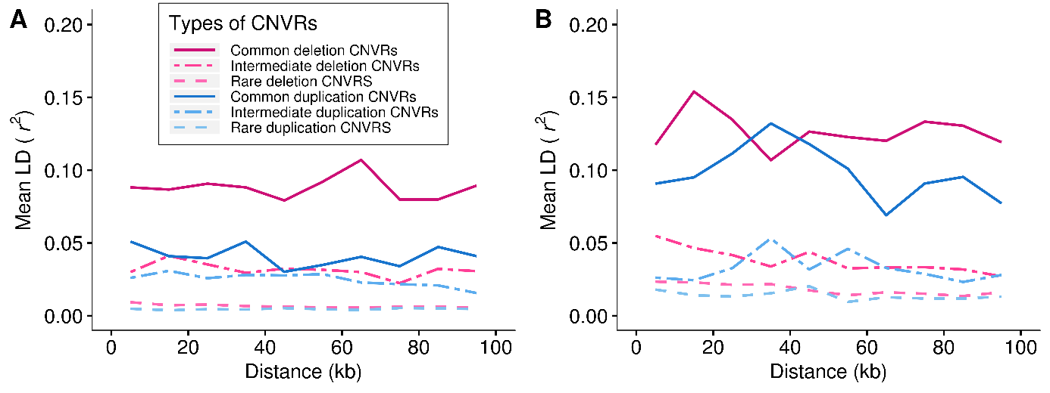
Average strength of linkage disequilibrium (mean r²) as a function of distance from a SNP for CNVRs in different allele frequency groups (common: 0.05 ≤ MAF, intermediate: 0.01 ≤ MAF < 0.05, rare: MAF < 0.01) is shown for HOL (A) and JER (B). For each frequency group following legend was used: common deletion CNVRs- solid magenta; intermediate deletion CNVRs - two dashed magenta; rare deletion CNVRs – dashed pink; common duplication CNVRs- solid blue; intermediate duplication CNVRs - two dashed blue; rare duplication CNVRs – dashed sky blue.
Figure S4. QQ plots used for performing quality control in CNV discovery
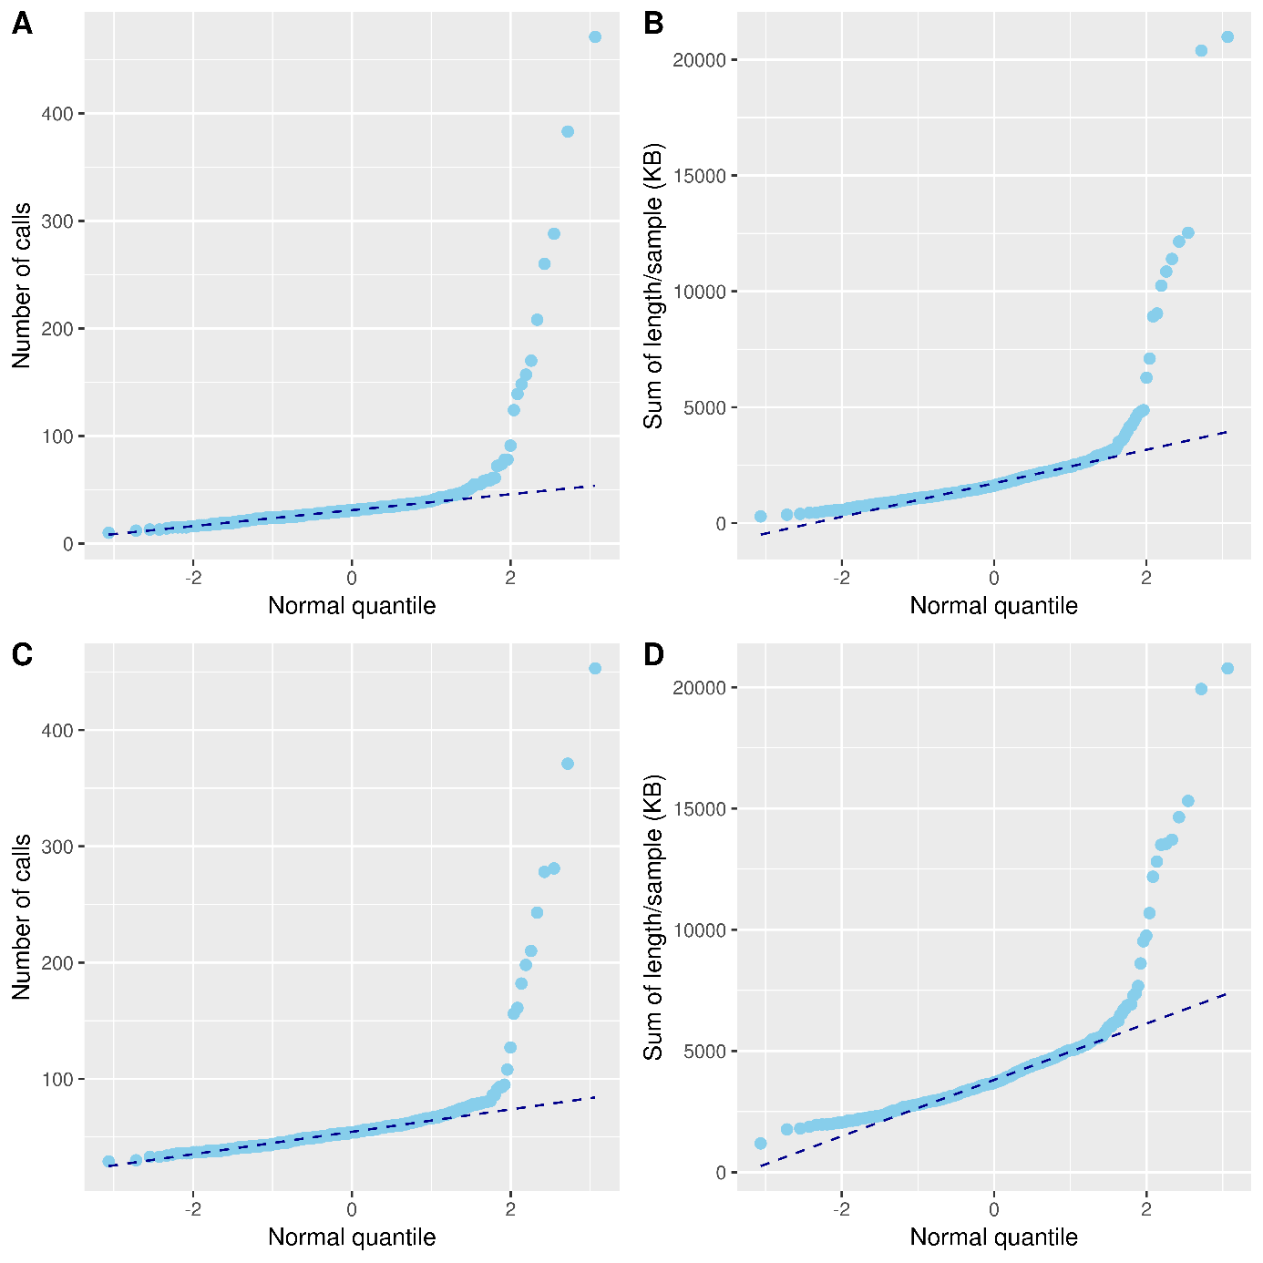QQ plots used for quality control of CNVs are shown. (A, B) QQ plots based on the number of CNVs per sample (A) and sum of the length of total CNVs per sample (B) based on genome assembly ARS-UCD1.2. (C, D) QQ plot based on the number of CNVs per sample (C) and sum of the length of total CNVs per sample (D) based on genome assembly UMD3.1. Excessive amount of CNVs called in samples indicate suboptimal sample quality. Thus, samples deviated from the normal distribution were excluded both based on the number of CNVs called and the length of total CNVs per sample.

