Subjective cognitive decline and subsequent dementia: a nationwide cohort study of 579,710 people (66-year-olds) in South Korea

Yeong Chan Lee,* Jae Myeong Kang,* Hyewon Lee,* Kiwon Kim, Soyeon Kim, Tae Yang Yu, Eun-Mi Lee, Clara Tammy Kim, Doh Kwan Kim, Matthew Lewis, Hong-Hee Won†, Frank Jessen, Woojae Myung†

Supplementary Material

Index of supplementary material
1. Supplementary methods……………………………………………………………………………………….3

2. Supplementary tables
Table S1: Cox regression analysis for risk of subsequent dementia according to the five items of the Prescreening Korean Dementia Screening Questionnaire (KDSQ-P)…….…………………………………5
Table S2: Definition of psychiatric disorders, neurological diseases, medical conditions, and dementia other than Alzheimer’s disease …………………………………………………………………………………….…...6
Table S3: Sensitivity analysis: Cox regression analysis for the association between subjective cognitive decline and subsequent dementia…………………………………………………………………………………….7

3. Supplementary figures
Figure S1: A flow diagram of the study population …….……………………………………………...…………8

4. References………………………………………………………………………………………………...…….9

1. Supplementary methods
Data sources and study cohort
Data were obtained from the South Korean National Health Insurance Service (NHIS) database.[1, 2] The NHIS provides mandatory healthcare for most South Koreans (97%) under a single-payer model. The NHIS collects data on all of the healthcare usage of approximately 50 million citizens, including diagnostic codes, medication prescriptions, admission or outpatient visit records, and national health examination data. Since 2007, the NHIS has also provided an age-specific national health examination program, the National Screening Program for Transitional Ages (NSPTA), for all Korean citizens who are 40 or 66 years of age.[3] The program focuses on these age groups to detect diseases in important lifecycle transition periods. For the 66-year-old group, the NSPTA records contain information on physical examinations, laboratory tests of urine and blood, questionnaires for cognitive function, depressive symptoms, and functional activities. Our study population consisted of a subset of individuals from the NHIS database who participated in the NSPTA at age 66 between 2009 and 2011. The study population covered 51.8% of the total South Korean population (66-years-old) during the enrolment period.

Inclusion and exclusion criteria
We included all subjects who had information available on a questionnaire on cognitive function. Exclusion criteria were as follows: 1) Individuals who reported impaired function in activities of daily living (ADLs) because of possible pre-existing dementia (ADLs were assessed by a questionnaire consisting of six questions derived from a modified Korean activities of daily living scale and Korean instrumental activities of daily living scale[4]); 2) individuals with dementia (ICD-10 [international classification of disease, 10th revision] code: F00-F03, G30, or G31), mild cognitive impairment (ICD-10 code: F06·7), or documented history of dementia medication (donepezil, rivastigmine, galantamine, or memantine) before the index date; and 3) individuals with a psychotic disorder (ICD-10 code: F20-F29; these criteria were applied to approximately meet the research criteria for pre-mild cognitive impairment subjective cognitive decline (SCD) as suggested in a previous study[5]); 4) individuals with missing or duplicate data on the primary variable of interest or covariates; 5) individuals with outlier values in continuous variables (mean ± 4 standard deviations); and 6) individuals who died or dropped out between the time they participated in the NSPTA and the index date.

Primary outcomes
The primary outcome was the incidence of dementia following SCD. Based on previous studies, we defined dementia based on ICD-10 codes and prescription history of cognitive enhancing medications.[6] This definition is relevant to our study considering that the Korean government covers medical expenditure for dementia based on ICD-10 codes. Additionally, clinicians are required to document ICD-10 codes for dementia as well as the results of neuropsychological tests to prescribe cognitive enhancing medications. The first date on which patients were not only diagnosed with dementia (ICD-10 codes), but also prescribed with dementia medication, was considered the onset date of dementia.

Covariates
We assessed demographic variables such as sex and income, which we defined from lowest to highest as Medicaid aid, first income group (1st to 6th ventiles), second income group (7th to 14th ventiles), and third income group (15th to 20th ventiles). Lifestyle variables such as smoking status, alcohol consumption habits, and exercise frequency were included as covariates. We adjusted for healthcare visit frequency in the survival analyses. Information on medical history, including psychiatric disorders, neurological diseases, and medical diseases, was defined based on ICD-10 codes before the index date (Table S2). The use of medications was assessed before the index date. We defined a positive prescription history when individuals had received medications for at least 180 days. Information from laboratory tests and physical examinations included low-density lipoprotein cholesterol (mg/dL), high-density lipoprotein cholesterol (mg/dL), triglycerides (mg/dL), fasting glucose (mg/dL), hemoglobin (g/dL), systolic blood pressure (mmHg), diastolic blood pressure (mmHg), and body mass index (weight in kg divided by height in m²), all entered as covariates.
We used a depression screening questionnaire (DSQ) to assess depressive symptoms. This questionnaire includes three questions derived from a modified geriatric depression scale[7] (e.g., “Have you lost much of your activity or motivation these days?”, “Do you feel that you are worthless now?”, and “Do you feel that you have no hope now?”). Each question can be self-answered with two possible choices, “yes” or “no”, scored as 1 or 0, respectively. Total DSQ scores range from 0 to 3, with higher scores indicating more depressive symptoms.

Statistical analysis
For all participants, continuous variables and categorical variables were compared between groups using t-tests and Chi-squared tests, respectively. A Cox proportional hazard regression analysis was conducted to determine adjusted hazard ratios (aHRs) by SCD after controlling for covariates. The effect of SCD on subsequent dementia was first analyzed in a sex-adjusted model, then in three additional models adjusted for various covariates (Models 1 to 3, see details in Appendix P 4): Adjusted for income, lifestyle, and healthcare visit frequency; Model 2: Adjusted for medical history and medication history; Model 3: adjusted for depressive screening score, laboratory findings, and physical examination findings). In the secondary analysis, we used the remaining four items and total KDSQ-P score as independent variables to evaluate the association between the severity of subjective memory impairment and subsequent dementia. We also used an interaction term of SCD and depressive symptoms (coded as dichotomous variables: 0 indicating the absence of any depressive symptoms, and 1 indicating the presence of any depressive symptoms among the three DSQ items) to test the potential interaction effect on subsequent dementia.
The index date of follow-up was defined as January 1 of the year after each participant participated in the NSPTA. To investigate the association between SCD and incidence of dementia, study participants were followed from the index date until the date of onset of dementia, death, censored due to disqualification of NHIS, or the end of follow-up (December 31, 2017), whichever occurred first. The proportional hazards assumption was graphically tested and verified using the Schoenfeld residual method. No variables violated the proportional hazards assumption. Multicollinearity between all covariates was tested using a variance inflation factor (VIF), and no significant collinearity was found (VIF<4 for all variables).
After conducting a survival analysis of all participants, we performed an additional analysis by sampling the control group using the propensity score matching method based on logistic regression.[8] This statistical step was used to correct for potential systematic differences between the SCD and non-SCD groups. The nearest neighbor matching method and a 1:1 matching algorithm without replacement were used to identify matches for each individual. Propensity score matching was performed using the ‘Matchit’ packages in R (http://cran.r-project.org).
We also performed survival analyses for sensitivity analysis after excluding the following subgroups: Patients who developed dementia within one year of the index date, dementia other than Alzheimer’s disease, dementia due to Alzheimer’s disease, history of psychiatric disorders, history of neurological diseases, presence of depressive symptoms according to the DSQ, and KDSQ-P score ≥4 (the cut-off points for further dementia screening tests).[9]
Statistical analyses were conducted using two-tailed tests, a significance level of 0.05, and 95% confidence intervals (CIs). SAS Enterprise Guide version 7.2 (SAS Institute, Inc.) and R Studio version 1.0.136 (R Studio, Inc., with packages “Survival” version 2.43-3 and “Survminer” version 0.4.3) were used.
Supplementary Table S1. Cox regression analysis for the risk of subsequent dementia according to the five items of the Prescreening Korean Dementia Screening Questionnaire (KDSQ-P)
 | Comparisons | Adjusted HR  (95% CI) ª
Item 1: “Do you think your memory is not as good as your friends’ or colleagues’?” | “0: no” (reference) | 1 [Reference]
 | “1: sometimes yes” or “2: frequently yes” | 1·49 (1·45–1·53)
 | “0: no” (reference) | 1 [Reference]
 | “1: sometimes yes” | 1·41 (1·38–1·45)
 | “2: frequently yes” | 2·24 (2·13–2·37)
Item 2: “Do you think your memory has declined compared to a year ago?” | “0: no” (reference) | 1 [Reference]
 | “1: sometimes yes” or “2: frequently yes” | 1·38 (1·34–1·41)
 | “0: no” (reference) | 1 [Reference]
 | “1: sometimes yes” | 1·31 (1·28–1·35)
 | “2: frequently yes” | 2·17 (2·06–2·29)
Item 3: “Are there any cases in which your memory is a problem in doing important things?” | “0: no” (reference) | 1 [Reference]
 | “1: sometimes yes” or “2: frequently yes” | 1·41 (1·37–1·45)
 | “0: no” (reference) | 1 [Reference]
 | “1: sometimes yes” | 1·34 (1·30–1·38)
 | “2: frequently yes” | 2·26 (2·13–2·41)
Item 4: “Does anyone know that your memory has declined?” | “0: no” (reference) | 1 [Reference]
Item 4: “Does anyone know that your memory has declined?” | “1: sometimes yes” or “2: frequently yes” | 1·56 (1·51–1·60)
Item 4: “Does anyone know that your memory has declined?” | “0: no” (reference) | 1 [Reference]
Item 4: “Does anyone know that your memory has declined?” | “1: sometimes yes” | 1·50 (1·46–1·55)
Item 4: “Does anyone know that your memory has declined?” | “2: frequently yes” | 2·31 (2·13–2·50)
Item 5: “Do you think that you have been clumsier than before when doing daily work you used to do well?” | “0: no” (reference) | 1 [Reference]
 | “1: sometimes yes” or “2: frequently yes” | 1·32 (1·29–1·36)
 | “0: no” (reference) | 1 [Reference]
 | “1: sometimes yes” | 1·27 (1·23–1·31)
 | “2: frequently yes” | 2·16 (2·02–2·32)
Abbreviations: CI, confidence interval; HR, hazard ratio.
ª Adjusted for sex, income, lifestyle factors, healthcare visit frequency, psychiatric disorders, neurological diseases, medical diseases, medication history, depression screening questionnaire scores, laboratory findings, and physical examination findings.

Supplementary Table S2. Definition of psychiatric disorders, neurological diseases, medical conditions, and dementia other than Alzheimer’s disease
Conditions | ICD-10 code
Definition of psychiatric disorders, neurological diseases, and medical conditions
Psychiatric disorders
Depression | F32, F33, F34·1
Bipolar affective disorder | F30, F31, F34·0
Substance use disorder | F10–F19
Panic disorder | F41·0
Obsessive-compulsive disorder | F42
Personality disorder | F60, F61
Other psychiatric disorder | F04–09, F34·8, F34·9, F38–F40, F41·1–9, F43–F45, F48, F50, F52-F59, F62–F69, F70–F99
Neurological diseases
Cerebrovascular disease | G45, G46, I60–I69, H340
Epilepsy | G40, G41
Migraines | G43
Headaches | G44
Sleep disorder | G47, F51
Head injury | S00–S09
Medical diseases
Diabetes mellitus | E10–E14
Myocardial infarction | I21, I22, I252
Congestive heart failure | I099, I110, I130, I132, I255, I420, I425–I429, I43, I50, P290
Liver disease | B18, K70, K71, K721, K729, K73, K74, K76, I85, I864, I982, Z944
Renal disease | N032–N037, N052–N057, N18, N19, N250, I120, I131, Z490–Z492, Z940, Z992
Peptic ulcer disease | K25–K28
Thyroid gland disorder | E03, E05, E06
Asthma | J45
Cancer | C00–C97
Definition and incidence of dementia other than Alzheimer’s disease during the follow-up period
Vascular dementia (n=3,073)
Vascular dementia | F01 (n=10)
Vascular dementia of acute onset | F01·0 (n=52)
Multi-infarct dementia | F01·1 (n=107)
Subcortical vascular dementia | F01·2 (n=148)
Mixed cortical and subcortical vascular dementia | F01·3 (n=144)
Other vascular dementia | F01·8 (n=696)
Vascular dementia, unspecified | F01·9 (n=1,916)
Dementia in other diseases classified elsewhere (n=166)
Dementia in Pick’s disease | F02·0 (n=7)
Dementia in Creutzfeldt–Jakob disease | F02·1 (n=1)
Dementia in Parkinson’s disease | F02·3 (n=107)
Dementia in other specified disease classified elsewhere | F02·8 (n=51)
Unspecified dementia (n=1,867)
Unspecified dementia | F03 (n=1,867)
Other degenerative disease of the nervous system, not classified elsewhere (n=247)
Behavioral variant of frontotemporal dementia | G31·00 (n=39)
Nonfluent primary progressive aphasia | G31·02 (n=3)
Other circumscribed brain atrophy | G31·08 (n=39)
Senile degeneration of brain, not classified elsewhere | G31·1 (n=38)
Degeneration of nervous system due to alcohol | G31·2 (n=1)
Lewy body dementia | G31·82 (n=48)
Corticobasal syndrome | G31·83 (n=2)
Other specified degenerative diseases of the nervous system | G31·88 (n=10)
Degenerative disease of the nervous system, unspecified | G31·9 (n=67)

Supplementary Table S3. Sensitivity analysis: Cox regression analysis for the association between subjective cognitive decline and subsequent dementia
 | Exclusion conditions
 | Developed dementia within one year of index date | Dementia other than Alzheimer’s disease | Alzheimer’s disease | History of psychiatric disorders | History of neurological diseases | Presence of depressive symptoms (DSQ score>0) | Total KDSQ-P score≥4
Non-SCD group, n  (n excluded) | 356,811  (843 excluded) | 354,846  (2,808 excluded) | 346,961  (10,693 excluded) | 263,241  (94,413 excluded) | 218,944  (138,710 excluded) | 310,447  (47,207 excluded) | 355,761  (1,893 excluded)
SCD group, n  (n excluded) | 221,183  (873 excluded) | 219,511  (2,545 excluded) | 211,835  (10,221 excluded) | 153,789  (68,267 excluded) | 126,788  (95,268 excluded) | 151,959  (70,097 excluded) | 136,526  (85,530 excluded)
Sex adjusted HR (95% CI) | 1·47 (1·43–1·51) | 1·49 (1·45–1·53) | 1·46 (1·38–1·54) | 1·46 (1·41–1·50) | 1·50 (1·45–1·55) | 1·35 (1·31–1·38) | 1·20 (1·17–1·24)
aHR in Model 1 (95% CI) ª | 1·45 (1·42–1·49) | 1·47 (1·43–1·51) | 1·45 (1·37–1·53) | 1·45 (1·41–1·50) | 1·50 (1·44–1·55) | 1·35 (1·31–1·39) | 1·21 (1·17–1·24)
aHR in Model 2 (95% CI) ^{b} | 1·41 (1·38–1·45) | 1·43 (1·39–1·47) | 1·40 (1·33–1·48) | 1·43 (1·38–1·47) | 1·48 (1·42–1·53) | 1·33 (1·29–1·37) | 1·19 (1·16–1·23)
aHR in Model 3 (95% CI) ^{c} | 1·37 (1·34–1·41) | 1·38 (1·35–1·42) | 1·37 (1·30–1·45) | 1·38 (1·34–1·43) | 1·43 (1·38–1·49) | 1·33 (1·29–1·37) | 1·18 (1·14–1·21)
Abbreviations: aHR, adjusted hazard ratio; CI, confidence interval; DSQ, depression screening questionnaire; KDSQ-P, Prescreening Korean Dementia Screening Questionnaire; SCD, subjective cognitive decline.
ª Adjusted for sex, income, lifestyle factors, and healthcare visit frequency.
^{b} Adjusted for sex, income, lifestyle factors, healthcare visit frequency, medical history, and medication history.
^{c} Adjusted for sex, income, lifestyle factors, healthcare visit frequency, medical history, medication history, depression screening questionnaire scores, laboratory findings, and physical examination findings.

Figure S1. A flow diagram of the study population
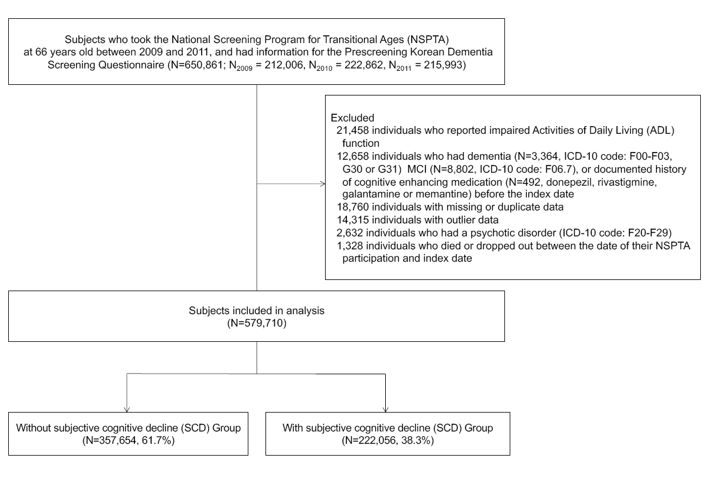

4. References

1. Lee J, Lee JS, Park SH, Shin SA, Kim K. Cohort Profile: The National Health Insurance Service-National Sample Cohort (NHIS-NSC), South Korea. Int J Epidemiol. 2017;46:e15.
2. Bahk J, Kim Y-Y, Kang H-Y, Lee J, Kim I, Lee J, et al. Using the National Health Information Database of the National Health Insurance Service in Korea for monitoring mortality and life expectancy at national and local levels. J Korean Med Sci. 2017;32:1764-70.
3. Kim HS, Shin DW, Lee WC, Kim YT, Cho B. National screening program for transitional ages in Korea: a new screening for strengthening primary prevention and follow-up care. J Korean Med Sci. 2012;27:S70-S5.
4. Won J, Yang K, Noh Y. The development of Korean activities of daily living (K-ADL) and Korean instrumental activities of daily living (K-IADL) scale. J Korean Geriatr Soc. 2002;6:107-20.
5. Jessen F, Amariglio RE, Van Boxtel M, Breteler M, Ceccaldi M, Chételat G, et al. A conceptual framework for research on subjective cognitive decline in preclinical Alzheimer's disease. Alzheimers Dement. 2014;10:844-52.
6. Katon W, Pedersen HS, Ribe AR, Fenger-Grøn M, Davydow D, Waldorff FB, et al. Effect of depression and diabetes mellitus on the risk for dementia: a national population-based cohort study. JAMA Psychiatry. 2015;72:612-9.
7. Bae JN, Cho MJ. Development of the Korean version of the Geriatric Depression Scale and its short form among elderly psychiatric patients. J Psychosom Res. 2004;57:297-305.
8. Rosenbaum PR, Rubin DB. Constructing a control group using multivariate matched sampling methods that incorporate the propensity score. Am Stat. 1985;39:33-8.
9. Jeon Y, Yun K, Kim Y. Validation of KDSQ-P as selecting elderly for KDSQ-C. Korean J Health Promot. 2010;10:45-52.

