Supplement file,
Active constituents of Zanthoxylum nitidum from Yunnan Province against leukemia
Ying Deng^{a, b, c}, Tongtong Ding^{b}, Lulu Deng^{b, c}, Xiaojiang Hao^{b, c}, Shuzhen Mu^{b, c*}
ª College of Pharmacy, Guizhou University, Guiyang 550025, China.
^{b} State Key Laboratory of Functions and Applications of Medicinal Plants, Guizhou Medcial University, Guiyang 550014, China.
^{c} Key Laboratory of Chemistry for Natural Products of Guizhou Province and Chinese Academy of Sciences, Guiyang 550002, China.
* Correspondence: e-mail: muzi0558@126.com; Tel.: 13765801160

Figure S1. ¹H-NMR spectrum of compound 4 in CDCl₃.
Figure S2. ¹³C-NMR spectrum and DEPT of compound 4 in CDCl₃.
Figure S3. HSQC spectrum of compound 4 in CDCl₃.
Figure S4. HMBC spectrum of compound 4 in CDCl₃.
Figure S5. ¹H- ¹H COSY spectrum of compound 4 in in CDCl₃.
Figure S6. IR spectrum of compound 4.
Figure S7. HR-ESI-MS spectrum of compound 4.
Figure S8. UV-Vis spectrum of compound 4 in CH₃OH.
Figure S9. ¹H-NMR spectrum of compound 5 in CDCl₃.
Figure S10. ¹³C-NMR spectrum and DEPT of compound 5 in CDCl₃.
Figure S11. HSQC spectrum of compound 5 in CDCl₃.
Figure S12. HMBC spectrum of compound 5 in CDCl₃.
Figure S13. ¹H- ¹H COSY spectrum of compound 5 in CDCl₃.
Figure S14. IR spectrum of compound 5.
Figure S15. HR-ESI-MS spectrum of compound 5.
Figure S16. UV-Vis spectrum of compound 5 in CH₃OH.
Figure S17. ¹H-NMR spectrum of compound 6 in CDCl₃.
Figure S18. ¹³C-NMR spectrum and DEPT of compound 6 in CDCl₃.
Figure S19. HSQC spectrum of compound 6 in CDCl₃.
Figure S20. HMBC spectrum of compound 6 in CDCl₃.
Figure S21. ¹H- ¹H COSY spectrum of compound 6 in CDCl₃.
Figure S22. IR spectrum of compound 6.
Figure S23. HR-ESI-MS spectrum of compound 6.
Figure S24. UV-Vis spectrum of compound 6 in CH₃OH.
Figure S25. ¹H-NMR spectrum of compound 16 in Pyridine-d₅.
Figure S26. ¹³C-NMR spectrum and DEPT of compound 16 in Pyridine-d₅.
Figure S27. HSQC spectrum of compound 16 in Pyridine-d₅.
Figure S28. HMBC spectrum of compound 16 in Pyridine-d₅.
Figure S29. ¹H- ¹H COSY spectrum of compound 16 in Pyridine-d₅.
Figure S30. IR spectrum of compound 16.
Figure S31. HR-ESI-MS spectrum of compound 16.
Figure S32. UV-Vis spectrum of compound 16 in CH₃OH.

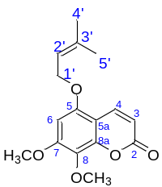
Figure S1. ¹H-NMR spectrum of compound 4 in CDCl₃ (600 MHz).
Figure S2. ¹³C-NMR spectrum and DEPT of compound 4 in CDCl₃ (151 MHz).
Figure S3. HSQC spectrum of compound 4 in CDCl₃.
Figure S4. HMBC spectrum of compound 4 in CDCl₃.
Figure S5. ¹H- ¹H COSY spectrum of compound 4 in in CDCl₃.
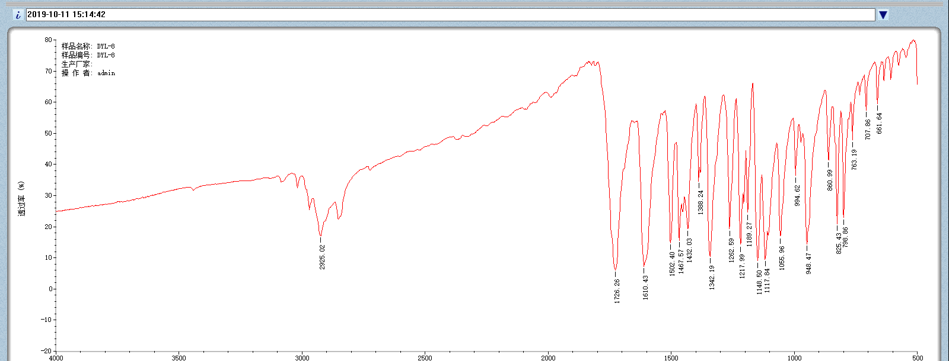
Figure S6. IR spectrum of compound 4.
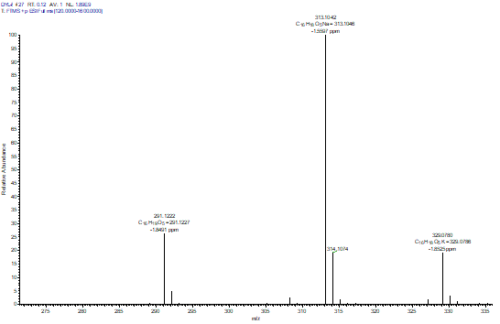
Figure S7. HR-ESI-MS spectrum of compound 4.
Figure S8. UV-Vis spectrum of compound 4 in CH₃OH. 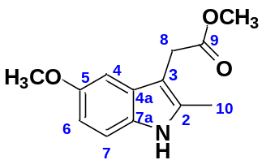
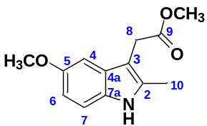
Figure S9. ¹H-NMR spectrum of compound 5 in CDCl₃ (600 MHz).
Figure S10. ¹³C-NMR spectrum and DEPT of compound 5 in CDCl₃ (151 MHz).
Figure S11. HSQC spectrum of compound 5 in CDCl₃.
Figure S12. HMBC spectrum of compound 5 in CDCl₃.
Figure S13. ¹H- ¹H COSY spectrum of compound 5 in CDCl₃.

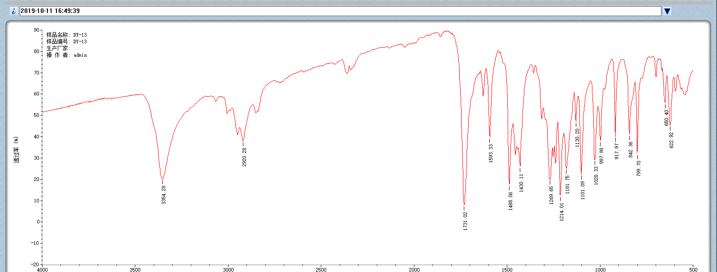
Figure S14. IR spectrum of compound 5.
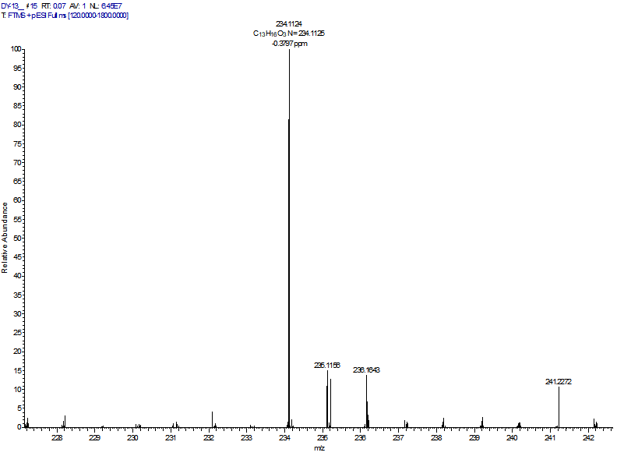
Figure S15. HR-ESI-MS spectrum of compound 5.
Figure S16. UV-Vis spectrum of compound 5 in CH₃OH.

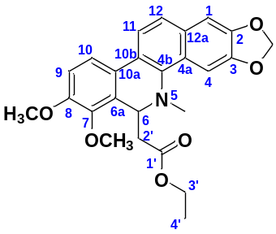
Figure S17. ¹H-NMR spectrum of compound 6 in CDCl₃ (600 MHz).
Figure S18. ¹³C-NMR spectrum and DEPT of compound 6 in CDCl₃ (151 MHz).
Figure S19. HSQC spectrum of compound 6 in CDCl₃.
Figure S20. HMBC spectrum of compound 6 in CDCl₃.
Figure S21. ¹H- ¹H COSY spectrum of compound 6 in CDCl₃.
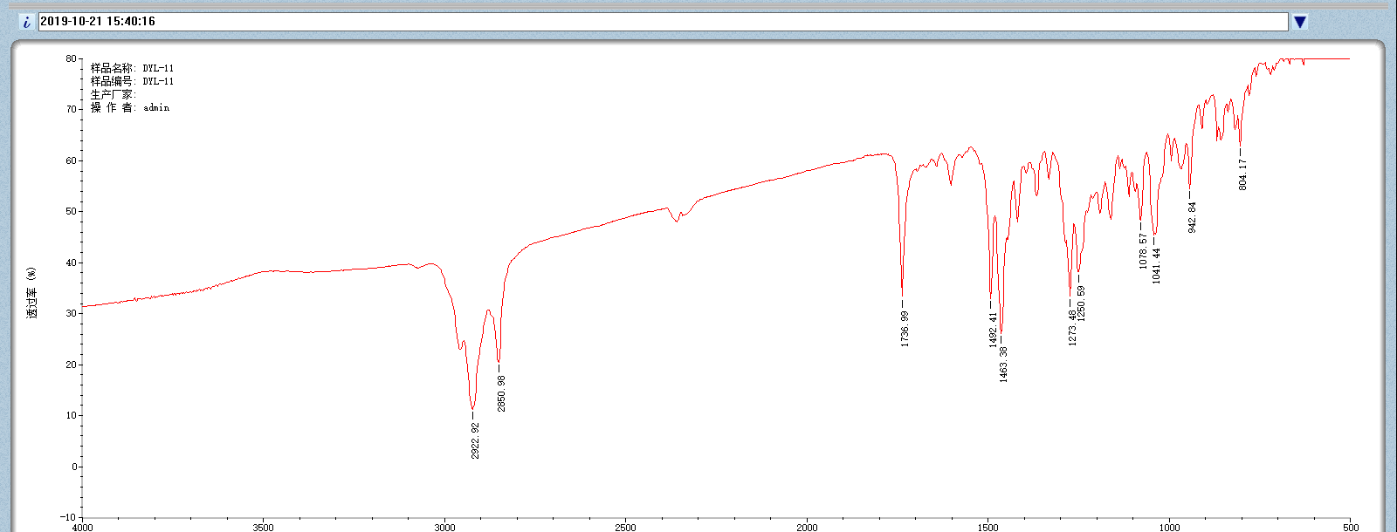
Figure S22. IR spectrum of compound 6.
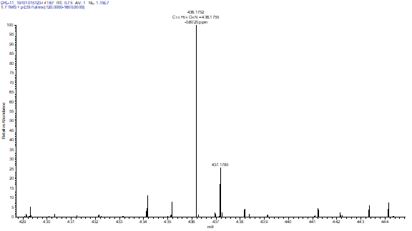
Figure S23. HR-ESI-MS spectrum of compound 6.
Figure S24. UV-Vis spectrum of compound 6 in CH₃OH.
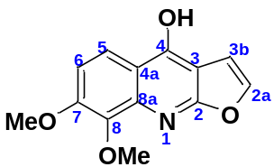
Figure S25. ¹H-NMR spectrum of compound 16 in Pyridine-d₅ (600 MHz).
Figure S26. ¹³C-NMR spectrum and DEPT of compound 16 in Pyridine-d₅ (151 MHz).

Figure S27. HSQC spectrum of compound 16 in Pyridine-d₅
Figure S28. HMBC spectrum of compound 16 in Pyridine-d₅.
Figure S29. ¹H- ¹H COSY spectrum of compound 16 in Pyridine-d₅.
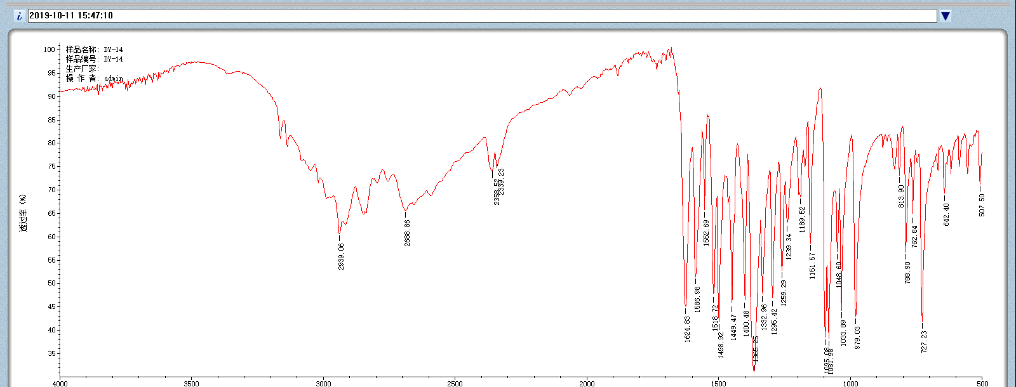
Figure S30. IR spectrum of compound 16.
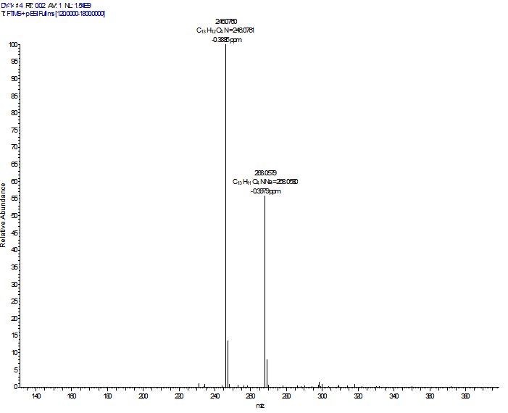
Figure S31. HR-ESI-MS spectrum of compound 16.
Figure S32. UV-Vis spectrum of compound 16 in CH₃OH.

