Appendices
Appendix 1. Search strategy used in PubMed/MEDLINE
 | Search terms
No. 4 | No 1 and No 2 and No 3
No. 3 | (((hand*) OR hand) OR manual*)
No. 2 | (((((((((((((sonic*) OR ultrasonic*) OR oscillat*) OR reciprocat*) OR rotat*) OR diamond*) OR air*AND abras*) OR power-driven*) OR machine-driven*)) OR (("Ultrasonic Therapy"[Mesh]) OR (((Ultrasonic Therapy) OR Therapies, Ultrasonic) OR Ultrasonic Therapies))) OR (("Lithotripsy"[Mesh]) OR (((((((((((((((((((((((((((((((Lithotripsies) OR Litholapaxy) OR Litholapaxies) OR Percutaneous Ultrasonic Lithotripsy) OR Lithotripsies, Percutaneous Ultrasonic) OR Lithotripsy, Percutaneous Ultrasonic) OR Percutaneous Ultrasonic Lithotripsies) OR Ultrasonic Lithotripsies, Percutaneous) OR Ultrasonic Lithotripsy, Percutaneous) OR Ultrasonic Lithotripsy) OR Lithotripsies, Ultrasonic) OR Lithotripsy, Ultrasonic) OR Ultrasonic Lithotripsies) OR Extracorporeal Shockwave Lithotripsy) OR Extracorporeal Shockwave Lithotripsies) OR Lithotripsies, Extracorporeal Shockwave) OR Lithotripsy, Extracorporeal Shockwave) OR Shockwave Lithotripsies, Extracorporeal) OR Shockwave Lithotripsy, Extracorporeal) OR Electrohydraulic Shockwave Lithotripsy) OR Electrohydraulic Shockwave Lithotripsies) OR Lithotripsies, Electrohydraulic Shockwave) OR Lithotripsy, Electrohydraulic Shockwave) OR Shockwave Lithotripsies, Electrohydraulic) OR Shockwave Lithotripsy, Electrohydraulic) OR ESWL (Extracorporeal Shockwave Lithotripsy)) OR ESWLs (Extracorporeal Shockwave Lithotripsy)) OR Noninvasive Litholapaxy) OR Litholapaxies, Noninvasive) OR Litholapaxy, Noninvasive) OR Noninvasive Litholapaxies))) OR (("Ultrasonic Surgical Procedures"[Mesh]) OR (((((((((Procedure, Ultrasonic Surgical) OR Procedures, Ultrasonic Surgical) OR Surgical Procedure, Ultrasonic) OR Surgical Procedures, Ultrasonic) OR Ultrasonic Surgical Procedure) OR Ultrasonic Surgery) OR Surgeries, Ultrasonic) OR Surgery, Ultrasonic) OR Ultrasonic Surgeries))))
No. 1 | (((((((((((((("Chronic Periodontitis"[Mesh]) OR ((((((((((Chronic Periodontitides) OR Periodontitides, Chronic) OR Periodontitis, Chronic) OR Adult Periodontitis) OR Adult Periodontitides) OR Periodontitides, Adult) OR Periodontitis, Adult) OR Periodontitides) OR Pericementitis) OR Pericementitides))) OR (("Periodontal Pocket"[Mesh]) OR (((Pocket, Periodontal) OR Periodontal Pockets) OR Pockets, Periodontal))) OR (("Dental Plaque"[Mesh]) OR Plaque, Dental)) OR (("Periodontal Debridement"[Mesh]) OR (((((((((((((Debridement, Periodontal) OR Debridements, Periodontal) OR Periodontal Debridements) OR Nonsurgical Periodontal Debridement) OR Debridement, Nonsurgical Periodontal) OR Debridements, Nonsurgical Periodontal) OR Nonsurgical Periodontal Debridements) OR Periodontal Debridement, Nonsurgical) OR Periodontal Debridements, Nonsurgical) OR Periodontal Pocket Debridement) OR Debridement, Periodontal Pocket) OR Debridements, Periodontal Pocket) OR Periodontal Pocket Debridements))) OR (("Dental Calculus"[Mesh]) OR ((Tartar) OR Calculus, Dental))) OR (("Dental Scaling"[Mesh]) OR (((((((((Subgingival Scaling) OR Scaling, Subgingival) OR Scalings, Root) OR Root Scalings) OR Root Scaling) OR Scaling, Root) OR Supragingival Scaling) OR Scaling, Supragingival) OR Scaling, Dental))) OR (("Root Planing"[Mesh]) OR ((Planing, Root) OR Planings, Root))) OR (("Subgingival Curettage"[Mesh]) OR (((((((((((((Curettage, Subgingival) OR Curettages, Subgingival) OR Subgingival Curettages) OR Gingival Curettage) OR Curettage, Gingival) OR Curettages, Gingival) OR Gingival Curettages) OR Periodontal Epithelial Debridement) OR Debridement, Periodontal Epithelial) OR Debridements, Periodontal Epithelial) OR Epithelial Debridement, Periodontal) OR Epithelial Debridements, Periodontal) OR Periodontal Epithelial Debridements))) OR (("Dental Prophylaxis"[Mesh]) OR Prophylaxis, Dental)) OR (("Dental Deposits"[Mesh]) AND ((((Materia Alba) OR Deposits, Dental) OR Dental Deposit) OR Deposit, Dental))))

Appendix 2. Data merger formulas
 | Group 1 | Group 2 | Combined groups
Sample size
Mean |  |  | 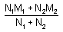
SD |  |  | 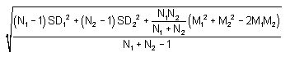

Appendix 3. Reasons for excluding studies
Study | Reasons
[24-34] | No UD-to-SRP comparisons.
[35-56] | Different PPD categories present in the same study or experimental group.
[57] | UD-SRP comparisons present and different PPD categories in the same study or experimental group.
[58, 59] | An in vitro study.
[10, 60] | Uncertain sample size.
[61, 62] | Study results were diagrams with unclear data.
[5] | There were treatments after the initial treatments during a follow-up period.
[63] | Follow-up was 24 months which is a long enough period for tissue changes affected factors other than the interventions. The injured tissue may have completely recovered spontaneously.
[64] | At each reassessment, study data was measured using different categories of PPD making it impossible to determine PPD change.

Appendix 4. Characteristics of studies awaiting classification
title | first author | year
Debris forced through apical foramina by ultrasonic and hand instrumentation | Wright, G. L. | 1993
A clinical and SEM evaluation of the efficiency of sofscale gel and hand scaling and hand scaling alone | Thomas, K. | 2002
Effects of curet and ultrasonics on root surfaces | Cross-Poline, G. N. | 1995
A clinical evaluation of hand and ultrasonic instruments on subgingival debridement. 1. With unmodified and modified ultrasonic inserts | Dragoo, M. R. | 1992
Periodontal healing after treatment with either the Titan-S sonic scaler or hand instruments | Laurell, L. | 1988
Calculus removal and loss of tooth substance in response to different periodontal instruments. A scanning electron microscope study | Lie, T. | 1977
A comparative study between different techniques in non-surgical periodontal treatment | Forabosco, A. | 2006
A quadrant-design trial of four therapeutic modalities in chronic moderate periodontitis | Nonhoff, J. | 2006
Study of the influence of different instruments for removing dental deposits on tooth surface | Kuchumova, E. D. | 2006
Scanning eletronmicroscopical studies of the root surface following the use of various hand and ultrasonic instruments | Diedrich, P. | 1975
Effect of manual and ultrasonic instrumentation on the radicular surface | Caffesse, R. G. | 1973

Appendix 5. Risk of bias graph
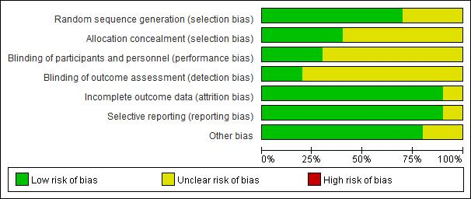

Appendix 6. Risk of bias summary
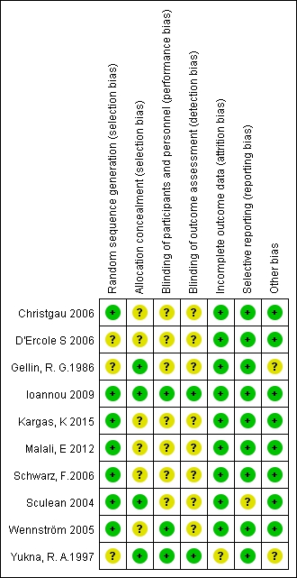

Appendix 7. GRADE quality of evidence
Primary outcome: PPD
Quality assessment |  |  |  |  |  |  | No of patients |  | Effect |  | Quality | Importance
No of studies | Design | Risk of bias | Inconsistency | Indirectness | Imprecision | Other considerations | Ultrasonic subgingival scaling | Control | Relative  (95% CI) | Absolute | Quality | Importance
3month - PPD≥6mm (follow-up 3 months; Better indicated by lower values)
4 | randomised trials | no serious risk of bias | no serious inconsistency | no serious indirectness | serious¹ | none | 274 | 262 | - | MD 0.13 higher (0.02 lower to 0.28 higher) | ⊕⊕⊕Ο  MODERATE | CRITICAL
6month - PPD4-6mm (follow-up 6 months; Better indicated by lower values)
3 | randomised trials | no serious risk of bias | no serious inconsistency | no serious indirectness | no serious imprecision | none | 790 | 1022 | - | MD 0.19 higher (0.11 to 0.27 higher) | ⊕⊕⊕⊕  HIGH | CRITICAL
6month - PPD≥6mm (follow-up 6 months; Better indicated by lower values)
3 | randomised trials | no serious risk of bias | no serious inconsistency | no serious indirectness | serious² | none | 353 | 403 | - | MD 0.61 higher (0.33 to 0.89 higher) | ⊕⊕⊕Ο  MODERATE | CRITICAL
¹ the CI cross the clinical decision threshold between recommending and not recommending treatment
² large span of CI

Primary outcome: CAL
Quality assessment |  |  |  |  |  |  | No of patients |  | Effect |  | Quality | Importance
No of studies | Design | Risk of bias | Inconsistency | Indirectness | Imprecision | Other considerations | Ultrasonic subgingival scaling | Control | Relative  (95% CI) | Absolute | Quality | Importance
3month - PPD≥6mm (follow-up 3 months; Better indicated by lower values)
3 | randomised trials | no serious risk of bias | no serious inconsistency | no serious indirectness | serious^{1,2} | none | 263 | 246 | - | MD 0.19 higher (0.36 lower to 0.73 higher) | ⊕⊕⊕Ο  MODERATE | CRITICAL
6month - PPD4-6mm (follow-up 6 months; Better indicated by lower values)
3 | randomised trials | no serious risk of bias | no serious inconsistency | no serious indirectness | serious¹ | none | 798 | 1031 | - | MD 0 higher (0.06 lower to 0.05 higher) | ⊕⊕⊕Ο  MODERATE | CRITICAL
6month - PPD≥6mm (follow-up 6 months; Better indicated by lower values)
3 | randomised trials | no serious risk of bias | no serious inconsistency | no serious indirectness | serious² | none | 354 | 405 | - | MD 0.58 higher (0.27 to 0.89 higher) | ⊕⊕⊕Ο  MODERATE | CRITICAL
¹ the CI cross the clinical decision threshold between recommending and not recommending treatment
² large span of CI

