Result
After screening 38,605 MIMIC-III adult admissions, we identified sepsis in 17,420 admissions according to the Angus criteria. After including only patient age between 18 and 90 years and MICU or SICU admissions and excluding patients without data of CVP and AKI, we included 3672 patients in our study cohort (Fig. 1). AKI was diagnosed in 3207 patients (87.3%) upon ICU admission.

Sepsis patients from MMIC-III based on Angus criteria
N=17420
Fig.1 Flowchart of included in the study. CVP, central venous pressure; AKI, acute kidney injury.

Non-AKI group n=465
AKI group n=3207
Only include age between 18y and 90y
(1,362 excluded)
Only include patients in MICU OR SICU, excluded CCU and CSRU(4,886 excluded)
with the data of CVP measured in 24h
(7,499 excluded)
with the data of AKI recorded within 7d
(1 excluded)
Final cohort
N=3672

Fig.2 Flowchart of included in the study（after PSM）

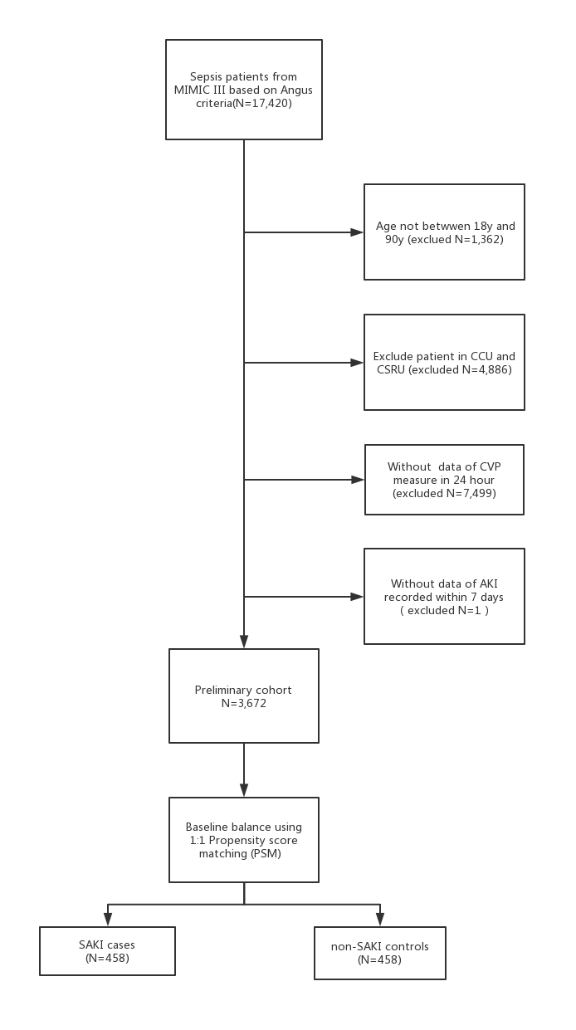

Table 1 Baseline characteristics between AKI patients and non-AKI patients
Clinical variables | AKI(95%CI) | No AKI(95%CI) | p value
Gender | 53.35% | 46.26% | 0.01
Admission age | 62.90(61.91-63.89) | 64.08(62.59-65.57) | 0.19
SAPSII | 41.87(40.92-42.84) | 42.39(40.78-43.99) | 0.57
LODS | 5.40(5.21-5.60) | 5.14(4.823-5.45) | 0.14
DPP | 43.30(41.81-44.79) | 43.047(40.69-45.41) | 0.85
MPP | 60.12(58.56-61.68) | 59.5704(57.12-62.02) | 0.7
MBP_mean | 75.90(75.21-76.60) | 74.751(73.71-75.79) | 0.06
MBP_min | 55.06(54.17-55.95) | 51.91(50.46-53.37) | 0.0002
SBP_mean | 113.20(112.20-114.20) | 111.30(109.80-112.90) | 0.04
SBP_min | 85.49(84.43-86.54) | 81.62(79.72-83.51) | 0.0002
variability of CVP in the first 24 hours* | 26.13(21.89-30.38) | 17.97(13.12-22.81) | 0.02
Change of accum within the first 48 hours | 1393.80(1213.10-1574.40) | 949.3(721.60-1177.10) | 0.005
Average change of the accum in the first 72h | 858.90(760.30-957.60) | 692.20(568.20-816.20) | 0.05
Albumin_min | 2.72(2.69-2.75) | 2.56(2.51-2.60) | 0.0001
Aniongap_max | 16.93(16.60-17.25) | 14.71(14.28-15.13) | 0.0001
Bicarbonate_min | 20.58(20.25-20.91) | 21.97(21.42-22.51) | 0.0001
Bun_max | 33.04(31.59-34.50) | 22.84(21.12-24.54) | 0.0001
Creatinine_max | 1.61(1.53-1.68) | 0.92(0.86-0.99) | 0.0001
Congestive_heart_failure | 33.68% | 28.97% | 0.08
Weight_loss | 8.37% | 12.85% | 0.09
Hypertension | 39.33% | 32.71% | 0.02
Liver_disease | 22.18% | 14.49% | 0.001
Epinephrine_usage | 0.94% | 2.1% | 0.07
Noradren_usage | 48.85% | 41.36% | 0.01

Table 2 Multiple Logistic Regression for AKI using training sample

Selected | OR(95%CI)
Change of accumulation within the first 48 hours | 1.016(1.002-1.02)
albumin_min | 2.035(1.441-2.874)
creatinine_max | 4.217(2.969-5.99)
change of CVP in the first 24 hours* | 1.005(1.002-1.009)
dpp | 1.015(1.006-1.025)
sysbp_min | 1.021(1.01-1.031)
noradren_usage （yes vs.no) | 1.504(1.077-2.1)
weight_loss (yes vs.no) | 0.586(0.355-0.968)
liver_disease (yes vs.no) | 1.475(0.944-2.307)

Figure 3 AUC of the model using training sample
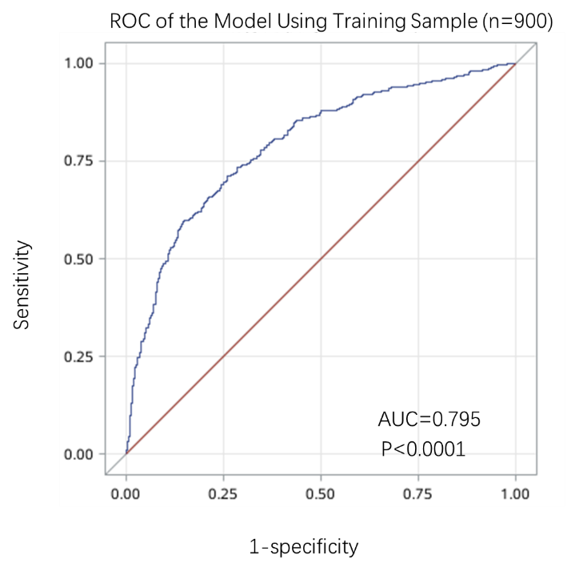

Figure 4 AUC of the model using testing sample

