Supplemental Material
Particulate matter and emergency visits for asthma: comparison of their associations in the presence and absence of wildfire smoke in Reno, Nevada, 2013-2018

Daniel Kiser, William J. Metcalf, Gai Elhanan, Brendan Schnieder, Karen Schlauch, Andrew Joros, Craig Petersen, Joseph Grzymski

Table of Contents
Table S1 – Rate ratios for the change in asthma visits due to a 5 µg/m³ increase in PM on non-wildfire and wildfire days in the single-fraction models (primary analysis).
Table S2 – Rate ratios for the change in asthma visits due to a 5 µg/m³ increase in PM on non-wildfire and wildfire days in the single-fraction models (sensitivity analysis with a rolling seven-day average of daily minimum temperature substituted for a rolling seven-day average of daily mean temperature in the base model).
Table S3 – Rate ratios for the change in asthma visits due to a 5 µg/m³ increase in PM on non-wildfire and wildfire days in the single-fraction models (sensitivity analysis with a rolling seven-day average of daily maximum temperature substituted for a rolling seven-day average of daily mean temperature in the base model).
Table S4 – Rate ratios for the change in asthma visits due to a 5 µg/m³ increase in PM on non-wildfire and wildfire days in the single-fraction models (sensitivity analysis with a rolling seven-day average of daily mean relative humidity included in the base model in addition to a rolling seven-day average of daily mean temperature).
Table S5 – Estimated coefficients from the two-fraction model: comparison between the primary and sensitivity analyses.
Figure S1 – Rate ratios for asthma visits to the ED and UC centers in the presence or absence of wildfire smoke (sensitivity analysis with a rolling seven-day average of daily minimum temperature substituted for a rolling seven-day average of daily mean temperature in the base model). PM was scaled to 5 µg/m³ for all fractions and lags. Numeric labels between points are estimates of the change in the rate ratio when wildfire smoke is present compared to when it is not present, presented as a factor. This change can also be presented as a percent (i.e., the factor 1.028 is equivalent to an increase of 2.8%), which is how the changes are presented in the body of the paper. Rate ratios and the differences between them are presented in tabular form in Table S2.
Figure S2 – Rate ratios for asthma visits to the ED and UC centers in the presence or absence of wildfire smoke (sensitivity analysis with a rolling seven-day average of daily maximum temperature substituted for a rolling seven-day average of daily mean temperature in the base model). PM was scaled to 5 µg/m³ for all fractions and lags. Numeric labels between points are estimates of the change in the rate ratio when wildfire smoke is present compared to when it is not present, presented as a factor. This change can also be presented as a percent (i.e., the factor 1.028 is equivalent to an increase of 2.8%), which is how the changes are presented in the body of the paper. Rate ratios and the differences between them are presented in tabular form in Table S3.
Figure S3 – Rate ratios for asthma visits to the ED and UC centers in the presence or absence of wildfire smoke (sensitivity analysis with a rolling seven-day average of daily mean relative humidity included in the base model in addition to a rolling seven-day average of daily mean temperature). PM was scaled to 5 µg/m³ for all fractions and lags. Numeric labels between points are estimates of the change in the rate ratio when wildfire smoke is present compared to when it is not present, presented as a factor. This change can also be presented as a percent (i.e., the factor 1.028 is equivalent to an increase of 2.8%), which is how the changes are presented in the body of the paper. Rate ratios and the differences between them are presented in tabular form in Table S4.
Figure S4 – Percent increase in asthma visits due to wildfire smoke, at given levels of PM_{2.5} and PM_{10-2.5} (sensitivity analysis with a rolling seven-day average of daily minimum temperature substituted for a rolling seven-day average of daily mean temperature in the base model). Estimates were constrained to the regions within 5 µg/m³ of a wildfire data point to limit extrapolation. Shaded regions indicate estimates that were significant at the 0.05 level.
Figure S5 – Percent increase in asthma visits due to wildfire smoke, at given levels of PM_{2.5} and PM_{10-2.5} (sensitivity analysis with a rolling seven-day average of daily maximum temperature substituted for a rolling seven-day average of daily mean temperature in the base model). Estimates were constrained to the regions within 5 µg/m³ of a wildfire data point to limit extrapolation. Shaded regions indicate estimates that were significant at the 0.05 level.
Figure S6 – Percent increase in asthma visits due to wildfire smoke, at given levels of PM_{2.5} and PM_{10-2.5} (sensitivity analysis with a rolling seven-day average of daily mean relative humidity included in the base model in addition to a rolling seven-day average of daily mean temperature). Estimates were constrained to the regions within 5 µg/m³ of a wildfire data point to limit extrapolation. Shaded regions indicate estimates that were significant at the 0.05 level.

Table S1 – Rate ratios for the change in asthma visits due to a 5 µg/m³ increase in PM on non-wildfire and wildfire days (primary analysis).
 |  | Rate Ratios
PM | Non-wildfire days |  | Wildfire days |  | $$Δ$$
PM_{2.5}
Lag 0 | 1.007 (0.988, 1.026) |  | 1.068 (1.033, 1.105)* |  | 1.061 (1.021, 1.103)*
Lags 0-2 | 1.014 (0.992, 1.037) |  | 1.083 (1.031, 1.138)* |  | 1.068 (1.012, 1.127)*
Lags 0-6 | 1.019 (0.992, 1.046) |  | 1.088 (1.015, 1.167)* |  | 1.068 (0.992, 1.150)
PM_{10-2.5}
Lag 0 | 1.010 (0.998, 1.023) |  | 1.057 (0.998, 1.119) |  | 1.046 (0.987, 1.109)
Lags 0-2 | 1.016 (1.001, 1.031)* |  | 1.100 (0.994, 1.218) |  | 1.083 (0.978, 1.200)
Lags 0-6 | 1.026 (1.007, 1.045)* |  | 0.902 (0.691, 1.176) |  | 0.879 (0.674, 1.146)
PM₁₀
Lag 0 | 1.006 (0.998, 1.015) |  | 1.062 (1.032, 1.092)* |  | 1.055 (1.025, 1.086)*
Lags 0-2 | 1.009 (0.999, 1.019) |  | 1.082 (1.036, 1.130)* |  | 1.072 (1.026, 1.120)*
Lags 0-6 | 1.013 (1.001, 1.025)* |  | 1.082 (1.009, 1.160)* |  | 1.068 (0.995, 1.146)
Note: $Δ$: multiplicative change in the rate ratio when wildfire smoke is present versus when wildfire smoke is not present, given by $\exp\left(β_{2}\right)$ (see equation 1). 95% confidence intervals for each estimate are included in parentheses.
* Confidence intervals that do not span 1.0.

Table S2 – Rate ratios for the change in asthma visits due to a 5 µg/m³ increase in PM on non-wildfire and wildfire days (sensitivity analysis with a rolling seven-day average of daily minimum temperature substituted for a rolling seven-day average of daily mean temperature in the base model).
 |  | Rate Ratios
PM | Non-wildfire days |  | Wildfire days |  | $$Δ$$
PM_{2.5}
Lag 0 | 1.003 (0.984, 1.022) |  | 1.069 (1.033, 1.106)* |  | 1.066 (1.025, 1.108)*
Lags 0-2 | 1.009 (0.986, 1.032) |  | 1.082 (1.030, 1.137)* |  | 1.073 (1.016, 1.133)*
Lags 0-6 | 1.011 (0.984, 1.039) |  | 1.085 (1.012, 1.163)* |  | 1.073 (0.997, 1.156)
PM_{10-2.5}
Lag 0 | 1.006 (0.993, 1.019) |  | 1.049 (0.990, 1.111) |  | 1.043 (0.984, 1.105)
Lags 0-2 | 1.009 (0.993, 1.025) |  | 1.087 (0.982, 1.203) |  | 1.077 (0.973, 1.193)
Lags 0-6 | 1.017 (0.998, 1.037) |  | 0.895 (0.686, 1.167) |  | 0.879 (0.674, 1.147)
PM₁₀
Lag 0 | 1.004 (0.995, 1.012) |  | 1.060 (1.030, 1.090)* |  | 1.056 (1.026, 1.087)*
Lags 0-2 | 1.006 (0.995, 1.016) |  | 1.078 (1.033, 1.126)* |  | 1.072 (1.026, 1.121)*
Lags 0-6 | 1.008 (0.996, 1.021) |  | 1.078 (1.005, 1.156)* |  | 1.069 (0.996, 1.147)
Note: $Δ$: multiplicative change in the rate ratio when wildfire smoke is present versus when wildfire smoke is not present, given by $\exp\left(β_{2}\right)$ (see equation 1). 95% confidence intervals for each estimate are included in parentheses.
* Confidence intervals that do not span 1.0.

Table S3 – Rate ratios for the change in asthma visits due to a 5 µg/m³ increase in PM on non-wildfire and wildfire days (sensitivity analysis with a rolling seven-day average of daily maximum temperature substituted for a rolling seven-day average of daily mean temperature in the base model).
 |  | Rate Ratios
PM | Non-wildfire days |  | Wildfire days |  | $$Δ$$
PM_{2.5}
Lag 0 | 1.013 (0.995, 1.032) |  | 1.065 (1.030, 1.102)* |  | 1.051 (1.012, 1.092)*
Lags 0-2 | 1.023 (1.001, 1.045)* |  | 1.080 (1.028, 1.135)* |  | 1.056 (1.001, 1.114)*
Lags 0-6 | 1.028 (0.999, 1.059) |  | 1.099 (1.026, 1.178)* |  | 1.069 (0.992, 1.152)
PM_{10-2.5}
Lag 0 | 1.015 (1.003, 1.028)* |  | 1.062 (1.003, 1.125)* |  | 1.046 (0.987, 1.109)
Lags 0-2 | 1.023 (1.008, 1.039)* |  | 1.110 (1.002, 1.229)* |  | 1.084 (0.979, 1.202)
Lags 0-6 | 1.036 (1.018, 1.055)* |  | 0.907 (0.695, 1.184) |  | 0.875 (0.671, 1.142)
PM₁₀
Lag 0 | 1.009 (1.001, 1.018)* |  | 1.062 (1.032, 1.093)* |  | 1.052 (1.022, 1.083)*
Lags 0-2 | 1.014 (1.004, 1.024)* |  | 1.082 (1.036, 1.130)* |  | 1.067 (1.021, 1.115)*
Lags 0-6 | 1.019 (1.008, 1.031)* |  | 1.080 (1.007, 1.158)* |  | 1.059 (0.987, 1.137)
Note: $Δ$: multiplicative change in the rate ratio when wildfire smoke is present versus when wildfire smoke is not present, given by $\exp\left(β_{2}\right)$ (see equation 1). 95% confidence intervals for each estimate are included in parentheses.
* Confidence intervals that do not span 1.0.

Table S4 – Rate ratios for the change in asthma visits due to a 5 µg/m³ increase in PM on non-wildfire and wildfire days (sensitivity analysis with a rolling seven-day average of daily mean relative humidity included in the base model in addition to a rolling seven-day average of daily mean temperature).
 |  | Rate Ratios
PM | Non-wildfire days |  | Wildfire days |  | $$Δ$$
PM_{2.5}
Lag 0 | 1.008 (0.989, 1.027) |  | 1.068 (1.032, 1.105)* |  | 1.059 (1.019, 1.101)*
Lags 0-2 | 1.015 (0.993, 1.038) |  | 1.082 (1.030, 1.137)* |  | 1.066 (1.010, 1.126)*
Lags 0-6 | 1.020 (0.993, 1.047) |  | 1.087 (1.014, 1.166)* |  | 1.066 (0.990, 1.149)
PM_{10-2.5}
Lag 0 | 1.010 (0.997, 1.023) |  | 1.053 (0.994, 1.116) |  | 1.043 (0.984, 1.106)
Lags 0-2 | 1.015 (1.000, 1.031)* |  | 1.098 (0.991, 1.216) |  | 1.081 (0.976, 1.198)
Lags 0-6 | 1.026 (1.007, 1.045)* |  | 0.901 (0.691, 1.176) |  | 0.879 (0.674, 1.146)
PM₁₀
Lag 0 | 1.006 (0.998, 1.015) |  | 1.061 (1.031-1.091)* |  | 1.054 (1.024, 1.085)*
Lags 0-2 | 1.009 (0.999, 1.019) |  | 1.081 (1.035, 1.129)* |  | 1.071 (1.025, 1.119)*
Lags 0-6 | 1.013 (1.001, 1.025)* |  | 1.081 (1.007, 1.159)* |  | 1.066 (0.994, 1.145)
Note: $Δ$: multiplicative change in the rate ratio when wildfire smoke is present versus when wildfire smoke is not present, given by $\exp\left(β_{2}\right)$ (see equation 1). 95% confidence intervals for each estimate are included in parentheses.
* Confidence intervals that do not span 1.0.
Table S5 – Estimated coefficients from the two-fraction model: comparison between the primary and sensitivity analyses.
 | Coefficients |  |  |  | Estimate 1 |  |  |  | Estimate 2
Analyses | $$\hat{β_{2}}$$ | $$\hat{β_{4}}$$ | $$\hat{β_{5}}$$ | % |  | p-value |  | % |  | p-value
Primary | 0.0747 | 0.0341 | - 0.2259 | 19.1 |  | 0.00092 |  | 32.8 |  | 0.00022
Sensitivity
Min Temp | 0.0718 | 0.0326 | - 0.2163 | 18.4 |  | 0.00126 |  | 31.4 |  | 0.00034
Max Temp | 0.0720 | 0.0350 | - 0.2308 | 17.6 |  | 0.00213 |  | 30.9 |  | 0.00047
Humidity | 0.0722 | 0.0334 | - 0.2192 | 18.5 |  | 0.00148 |  | 31.7 |  | 0.00041
Note: Min Temp: rolling average of daily mean temperature replaced by rolling average of daily minimum temperature; Max Temp: rolling average of daily mean temperature replaced by rolling average of daily maximum temperature; Humidity: rolling average of daily mean relative humidity included in addition to rolling average of daily mean temperature; $\left(exp\left(\hat{β_{2}}PM_{2.5}+ \hat{β_{4}}PM_{10-2.5}+ \hat{β_{5}}\right)-1\right)×100$: equation used to estimate percent increase in asthma visits due to the presence of wildfire smoke (equation 3, $PM_{2.5}$ and $PM_{10-2.5}$ scaled to 5 µg/m³); Estimate 1: PM_{2.5} at 20 µg/m³ and PM_{10-2.5} at 15 µg/m³; Estimate 2: PM_{2.5} at 25 µg/m³ and PM_{10-2.5} at 20 µg/m³.
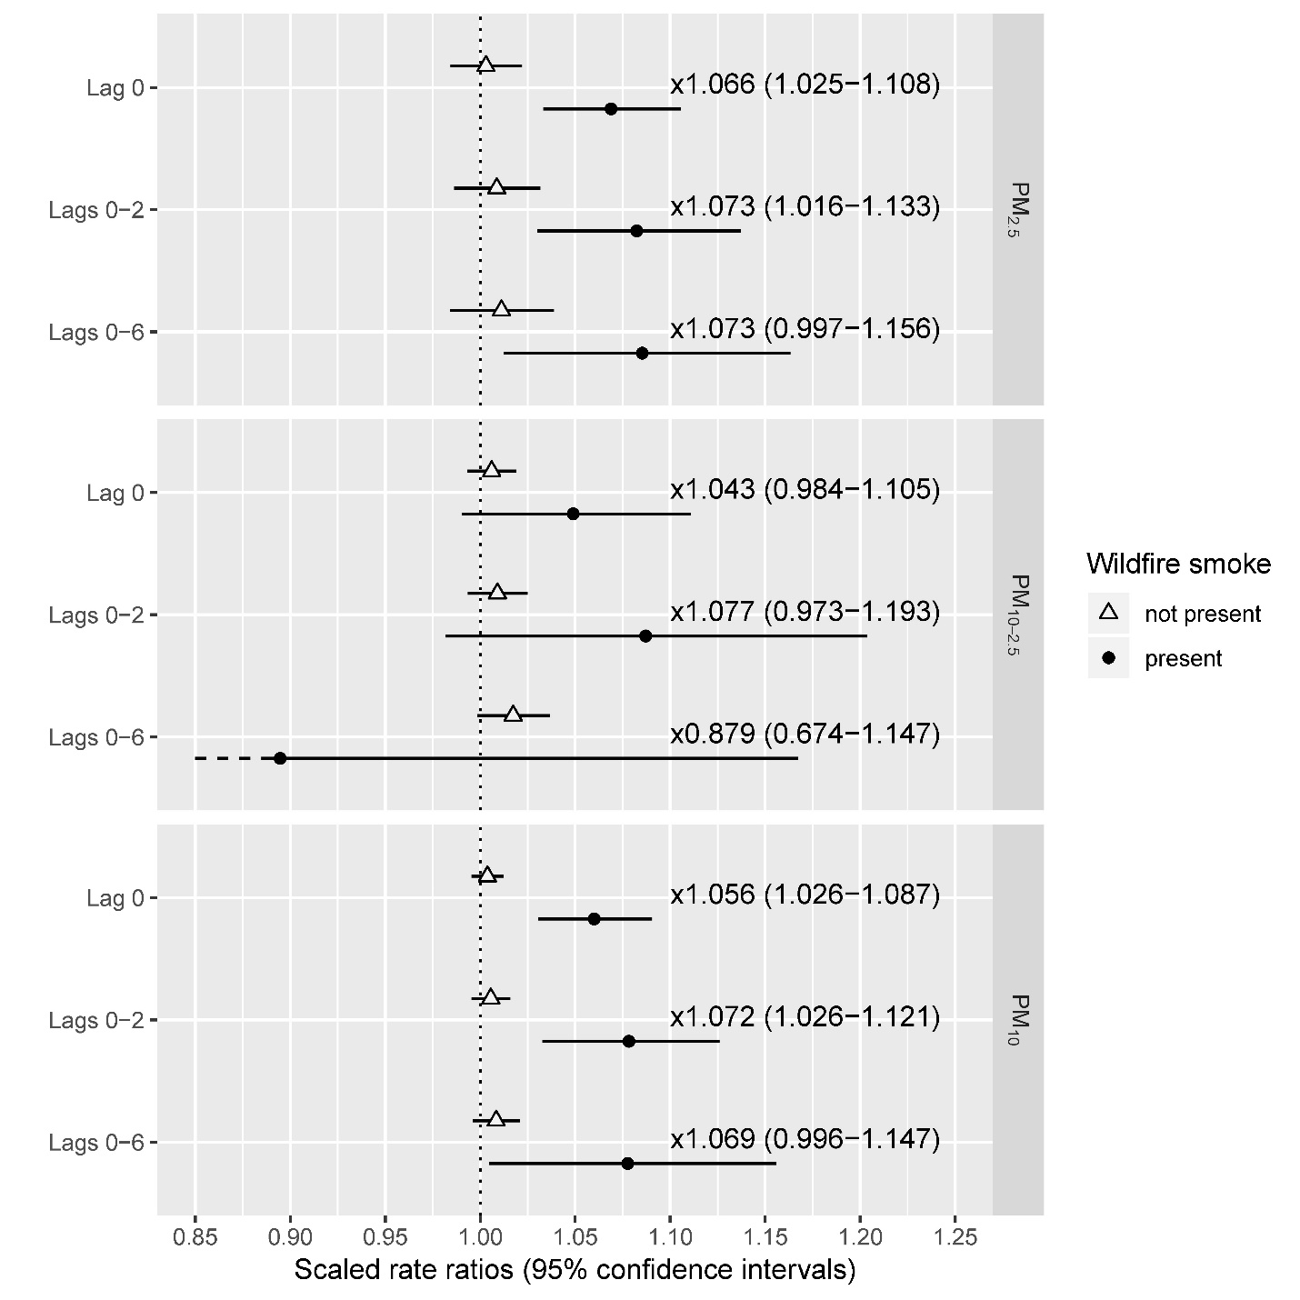
Figure S1 – Rate ratios for asthma visits to the ED and UC centers in the presence or absence of wildfire smoke (sensitivity analysis with a rolling seven-day average of daily minimum temperature substituted for a rolling seven-day average of daily mean temperature in the base model). PM was scaled to 5 µg/m³ for all fractions and lags. Numeric labels between points are estimates of the change in the rate ratio when wildfire smoke is present compared to when it is not present, presented as a factor. This change can also be presented as a percent (i.e., the factor 1.028 is equivalent to an increase of 2.8%), which is how the changes are presented in the body of the paper. Rate ratios and the differences between them are presented in tabular form in Table S2.

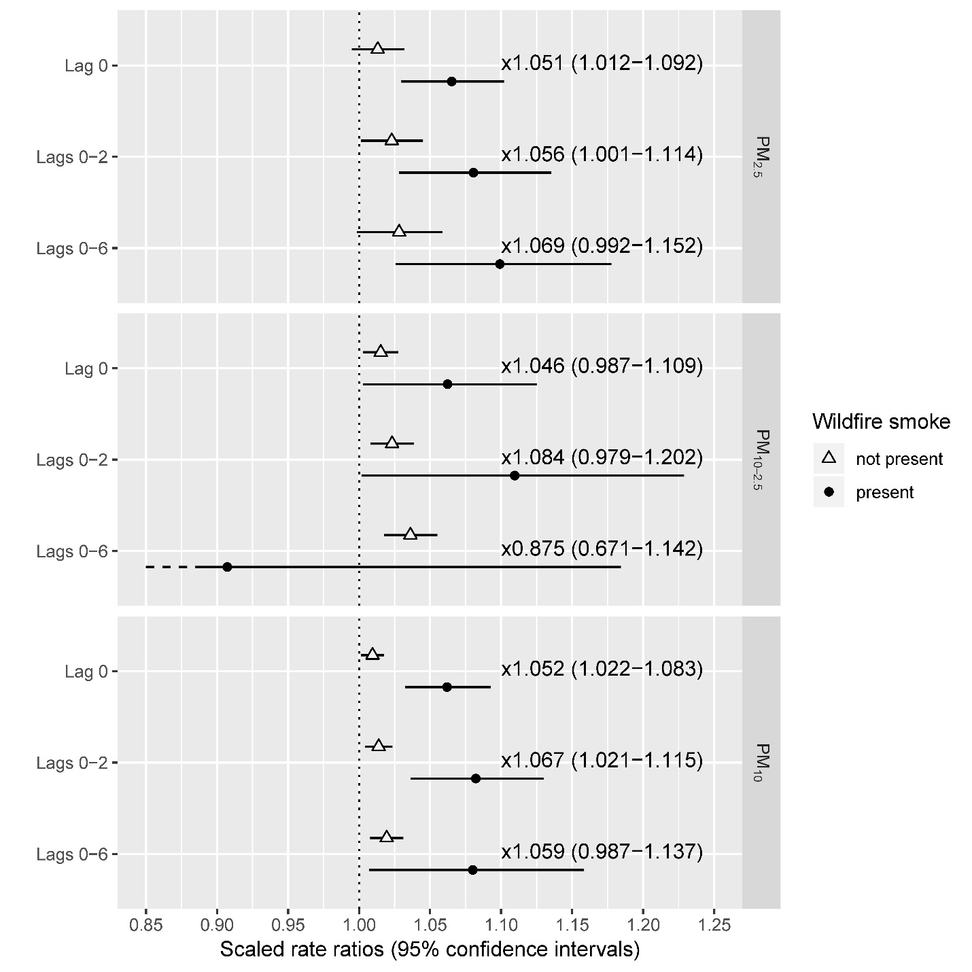
Figure S2 – Rate ratios for asthma visits to the ED and UC centers in the presence or absence of wildfire smoke (sensitivity analysis with a rolling seven-day average of daily maximum temperature substituted for a rolling seven-day average of daily mean temperature in the base model). PM was scaled to 5 µg/m³ for all fractions and lags. Numeric labels between points are estimates of the change in the rate ratio when wildfire smoke is present compared to when it is not present, presented as a factor. This change can also be presented as a percent (i.e., the factor 1.028 is equivalent to an increase of 2.8%), which is how the changes are presented in the body of the paper. Rate ratios and the differences between them are presented in tabular form in Table S3.
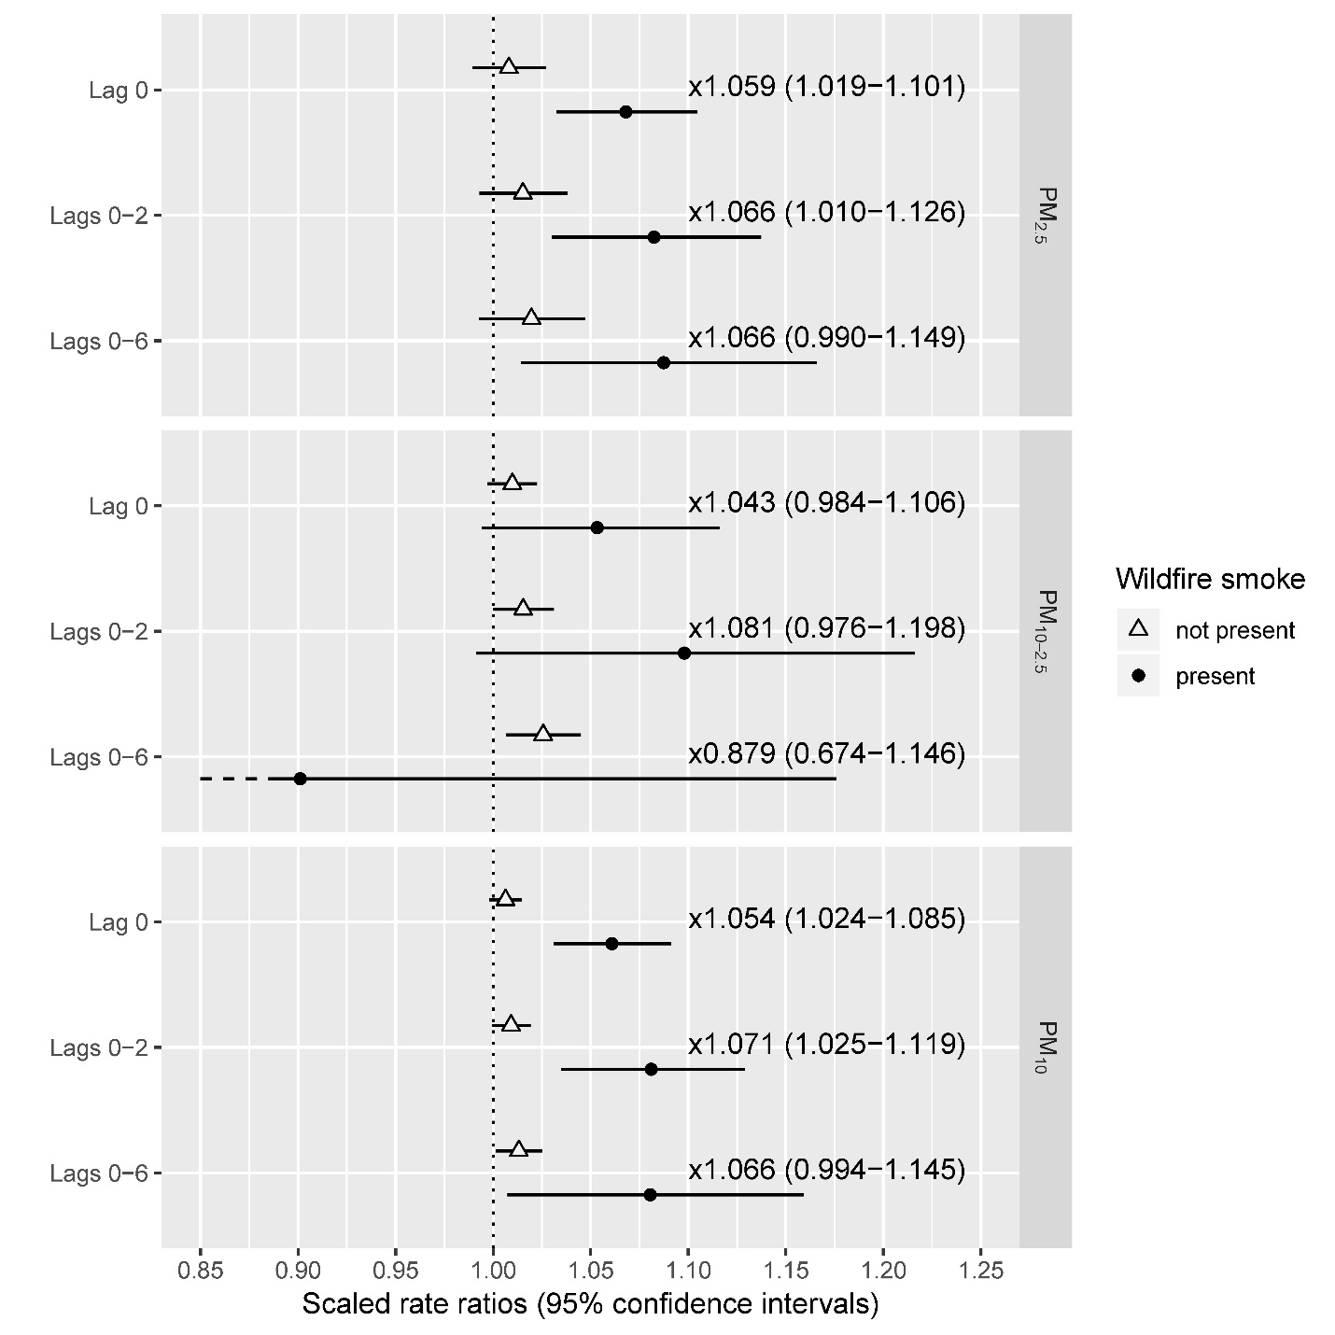
Figure S3 – Rate ratios for asthma visits to the ED and UC centers in the presence or absence of wildfire smoke (sensitivity analysis with a rolling seven-day average of daily mean relative humidity included in the base model in addition to a rolling seven-day average of daily mean temperature). PM was scaled to 5 µg/m³ for all fractions and lags. Numeric labels between points are estimates of the change in the rate ratio when wildfire smoke is present compared to when it is not present, presented as a factor. This change can also be presented as a percent (i.e., the factor 1.028 is equivalent to an increase of 2.8%), which is how the changes are presented in the body of the paper. Rate ratios and the differences between them are presented in tabular form in Table S4.
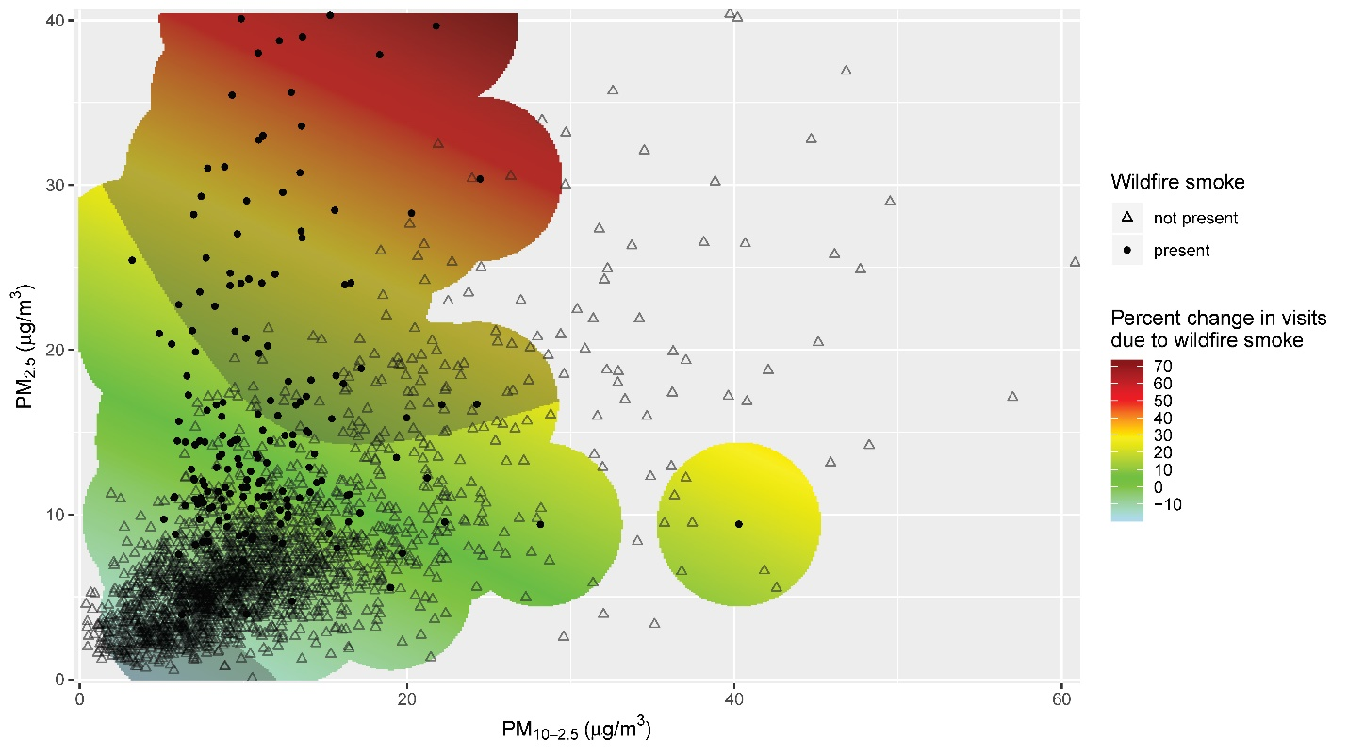
Figure S4 – Percent increase in asthma visits due to wildfire smoke, at given levels of PM_{2.5} and PM_{10-2.5} (sensitivity analysis with a rolling seven-day average of daily minimum temperature substituted for a rolling seven-day average of daily mean temperature in the base model). Estimates were constrained to the regions within 5 µg/m³ of a wildfire data point to limit extrapolation. Shaded regions indicate estimates that were significant at the 0.05 level.

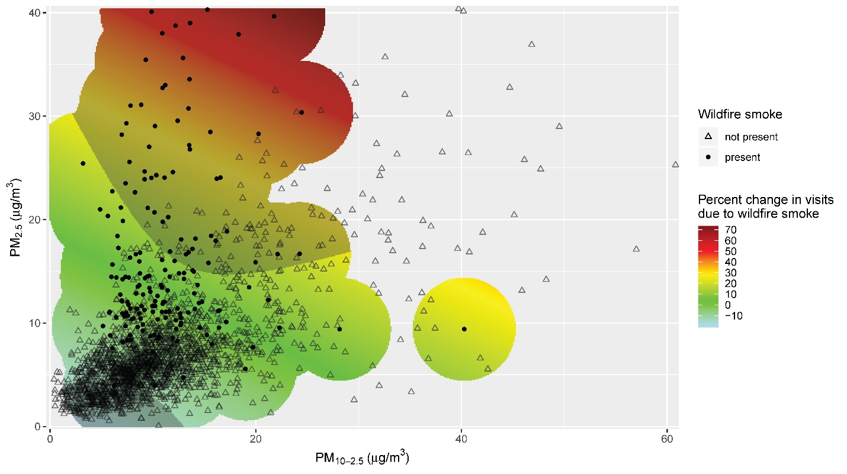
Figure S5 – Percent increase in asthma visits due to wildfire smoke, at given levels of PM_{2.5} and PM_{10-2.5} (sensitivity analysis with a rolling seven-day average of daily maximum temperature substituted for a rolling seven-day average of daily mean temperature in the base model). Estimates were constrained to the regions within 5 µg/m³ of a wildfire data point to limit extrapolation. Shaded regions indicate estimates that were significant at the 0.05 level.

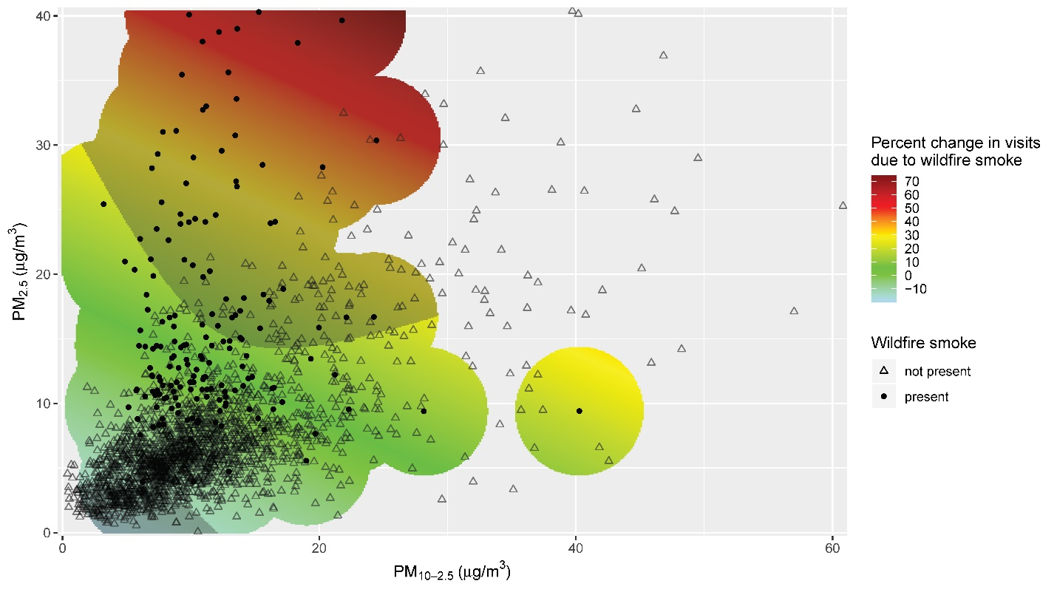
Figure S6 – Percent increase in asthma visits due to wildfire smoke, at given levels of PM_{2.5} and PM_{10-2.5} (sensitivity analysis with a rolling seven-day average of daily mean relative humidity included in the base model in addition to a rolling seven-day average of daily mean temperature). Estimates were constrained to the regions within 5 µg/m³ of a wildfire data point to limit extrapolation. Shaded regions indicate estimates that were significant at the 0.05 level.

