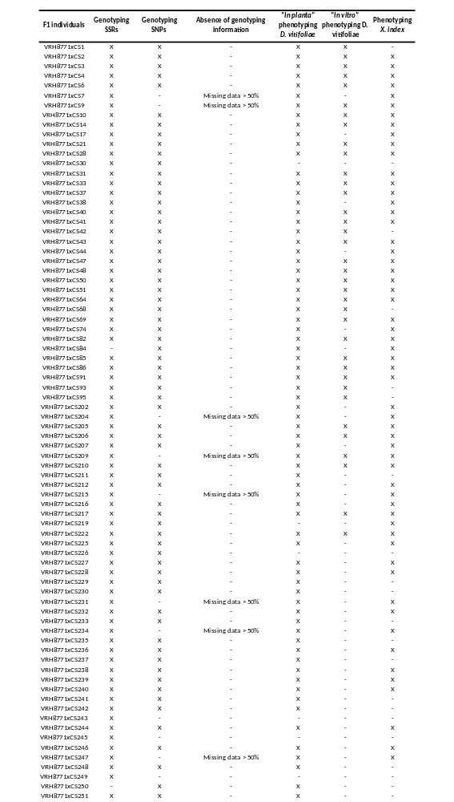
Table S1 Characteristics of the 135 BC1 individuals

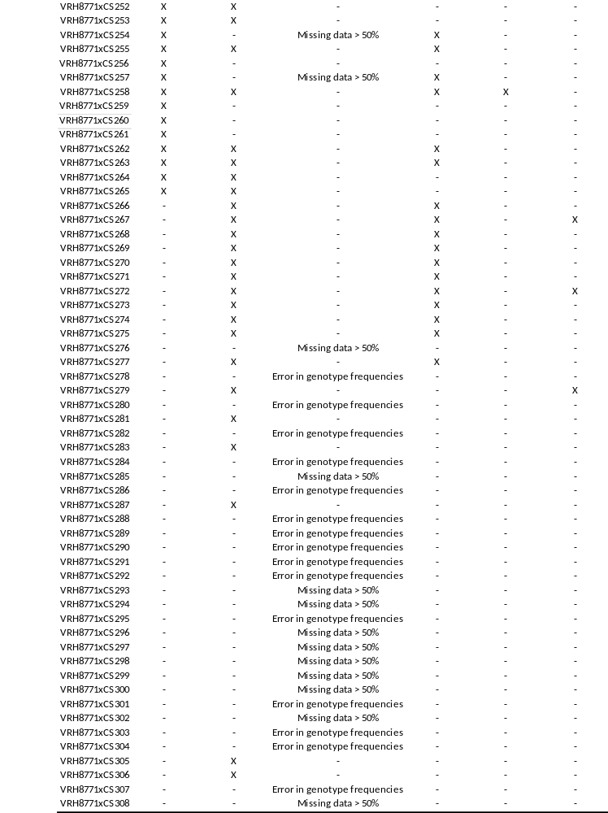

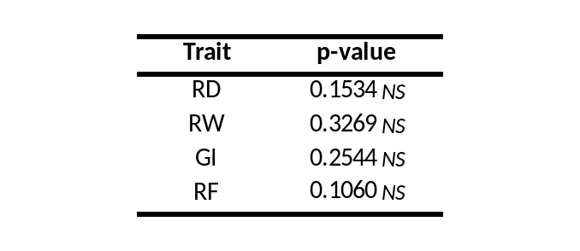
Table S2 Statistical analyzes comparing data between 2010-2011 and 2011-2012 experiments
The non-parametric Wilcoxon signed-rank test was performed on four traits: root system development (RD), weight of the roots (RW), nematode reproduction factor (RF) and gall index (GI)
Signif.codes: 0 ‘***’ 0.001 ‘**’ 0.01 ‘*’ 0.05 ‘.’ 0.1 - NS, not significant

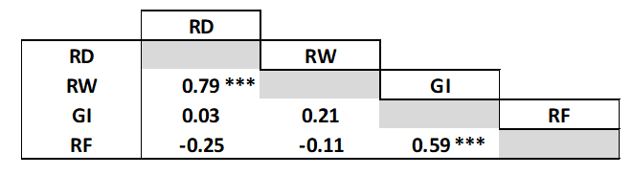
Table S3 Spearman correlations of the four criteria (RD – RW – RF – GI) in response to X. index
Signif.codes: 0 ‘***’ 0.001 ‘**’ 0.01 ‘*’ 0.05 ‘.’ 0.1

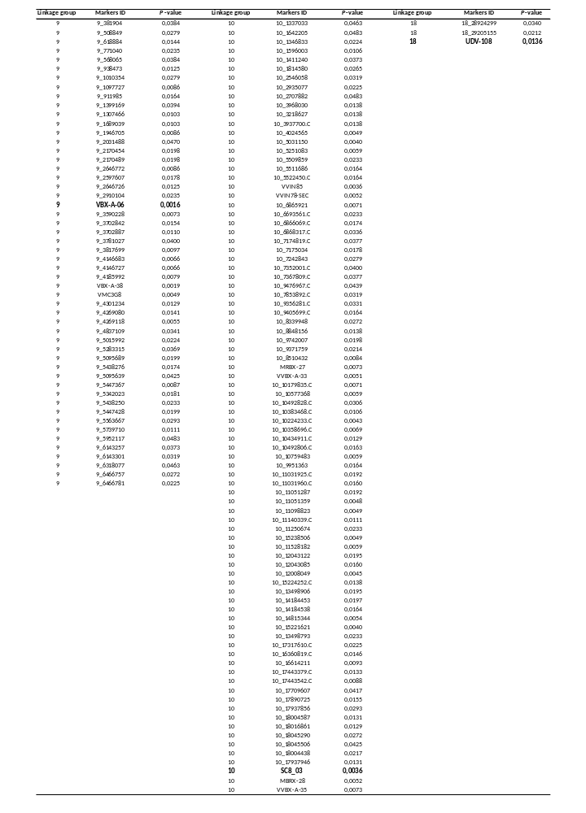
Table S4 Results of the proportion test performed on 60 BC1 individuals in response to X. index
The results presented are related to the markers for which the p-values are statistically significant at α = 5%

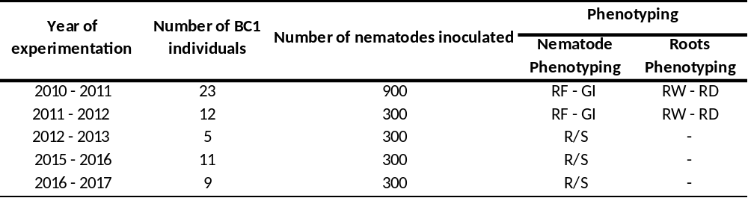
Table S5 Characteristics of the experiments in response to X. index carried out over five independent years
RF: reproduction factor, GI: gall index, RW: root weight, RD: root development, R/S: resistance vs. susceptible qualitative phenotyping

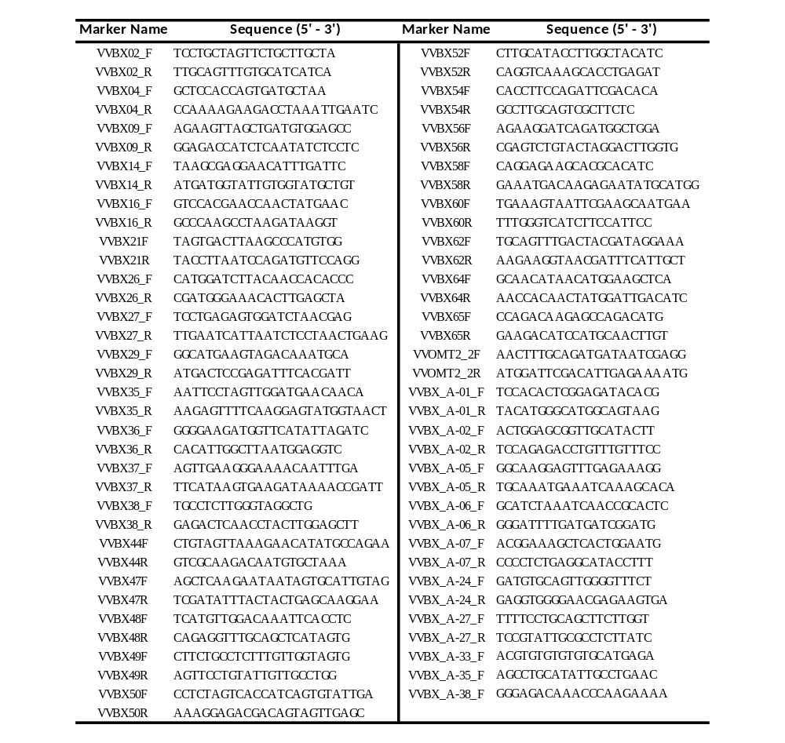
Table S6 Primers characteristics

