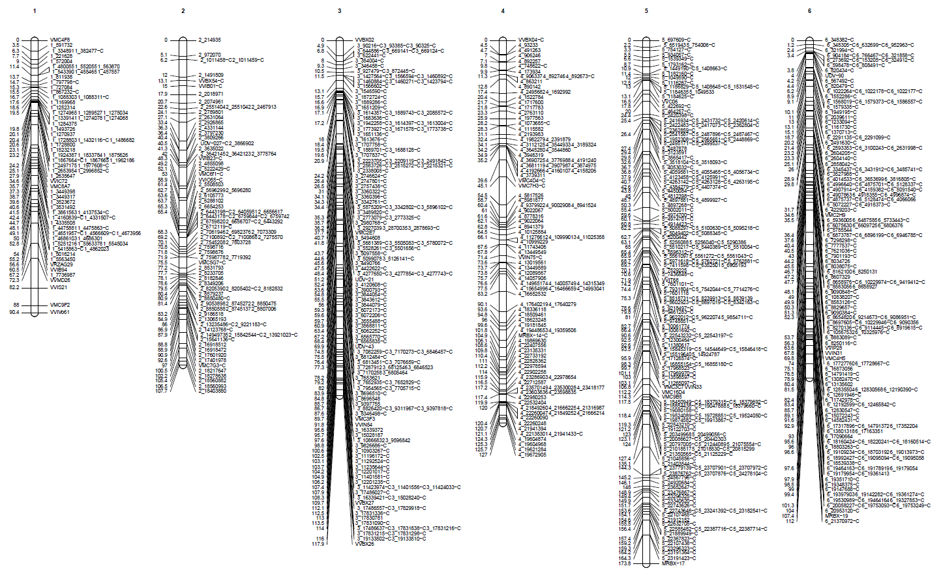
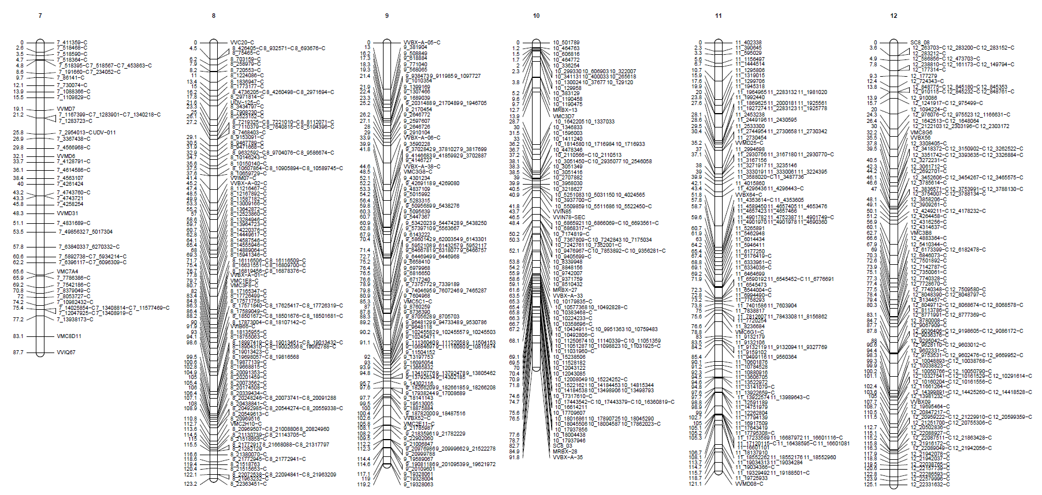
1
2
3
4
5
6
7
8
9
10
11
12
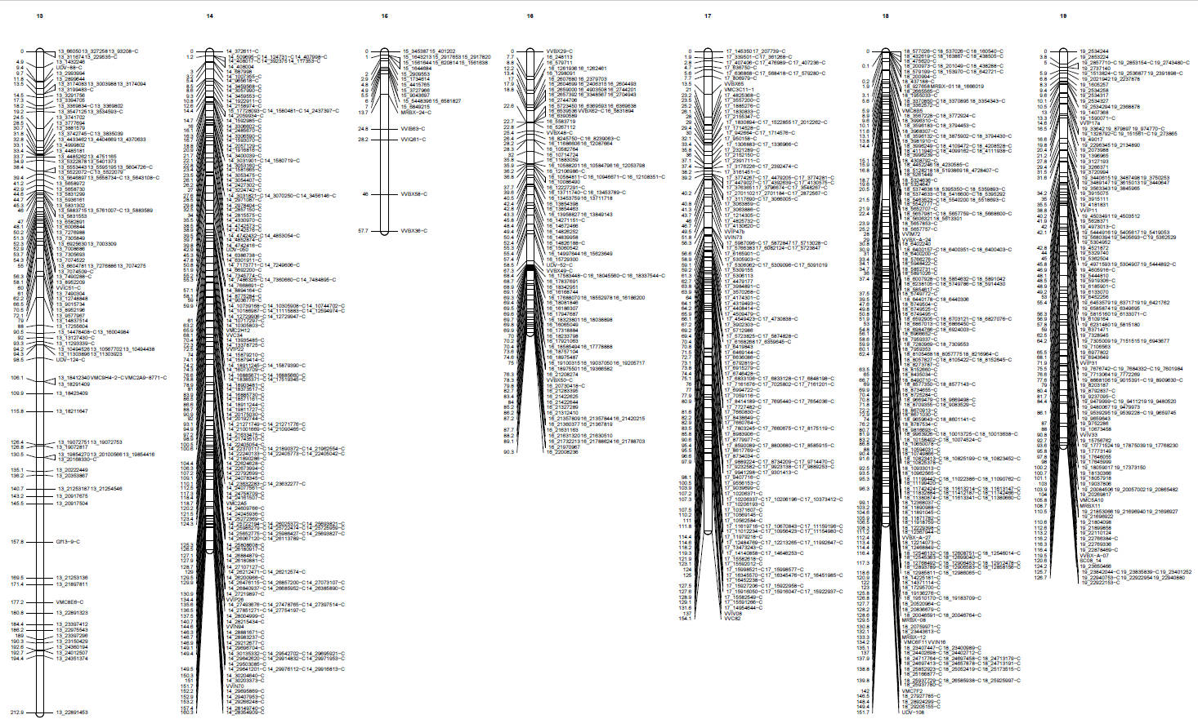
13
14
15
16
17
18
19
Fig. S1 Maternal genetic map related to VRH8771
Each linkage group is represented by a bar with the genetic positions on the left side and marker names on the right side

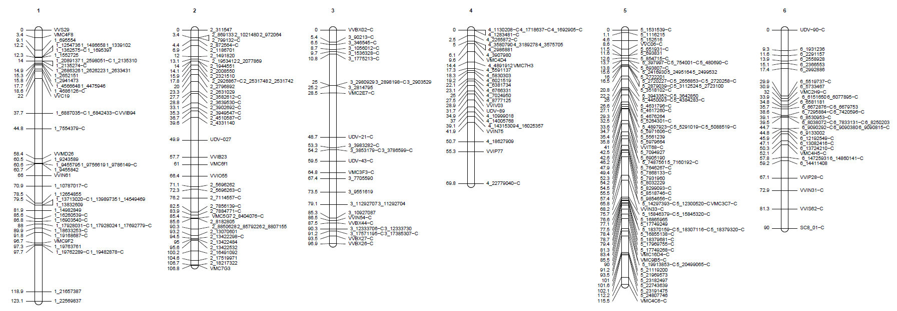
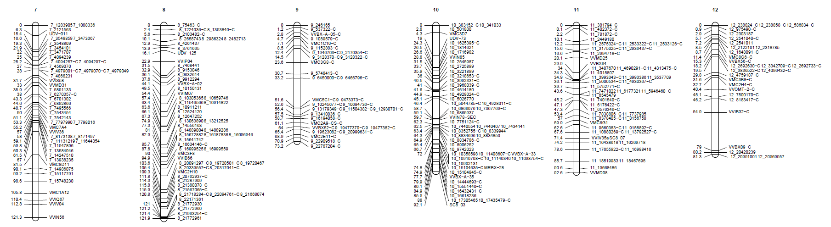
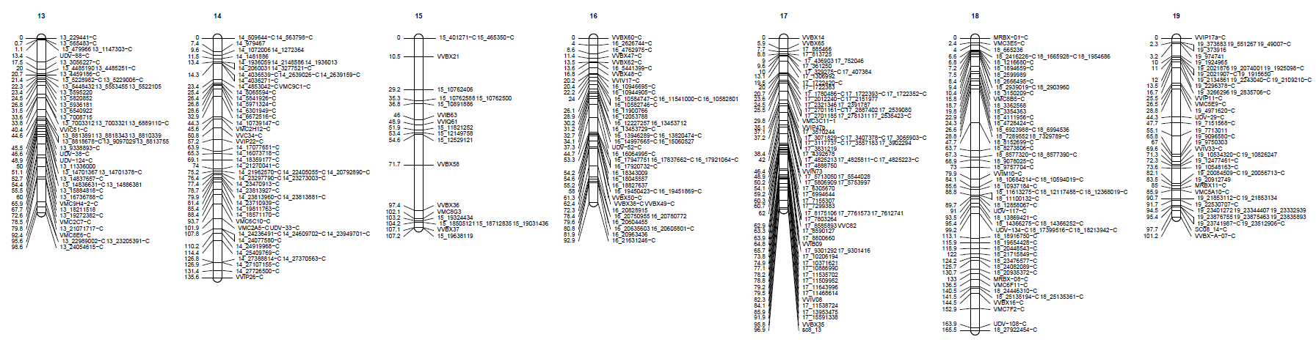
1
2
3
4
5
6
7
8
9
10
11
12
13
14
15
16
17
18
19
Fig. S2 Paternal genetic map related to CS
Each linkage group is represented by a bar with the genetic positions on the left side and marker names on the right side.

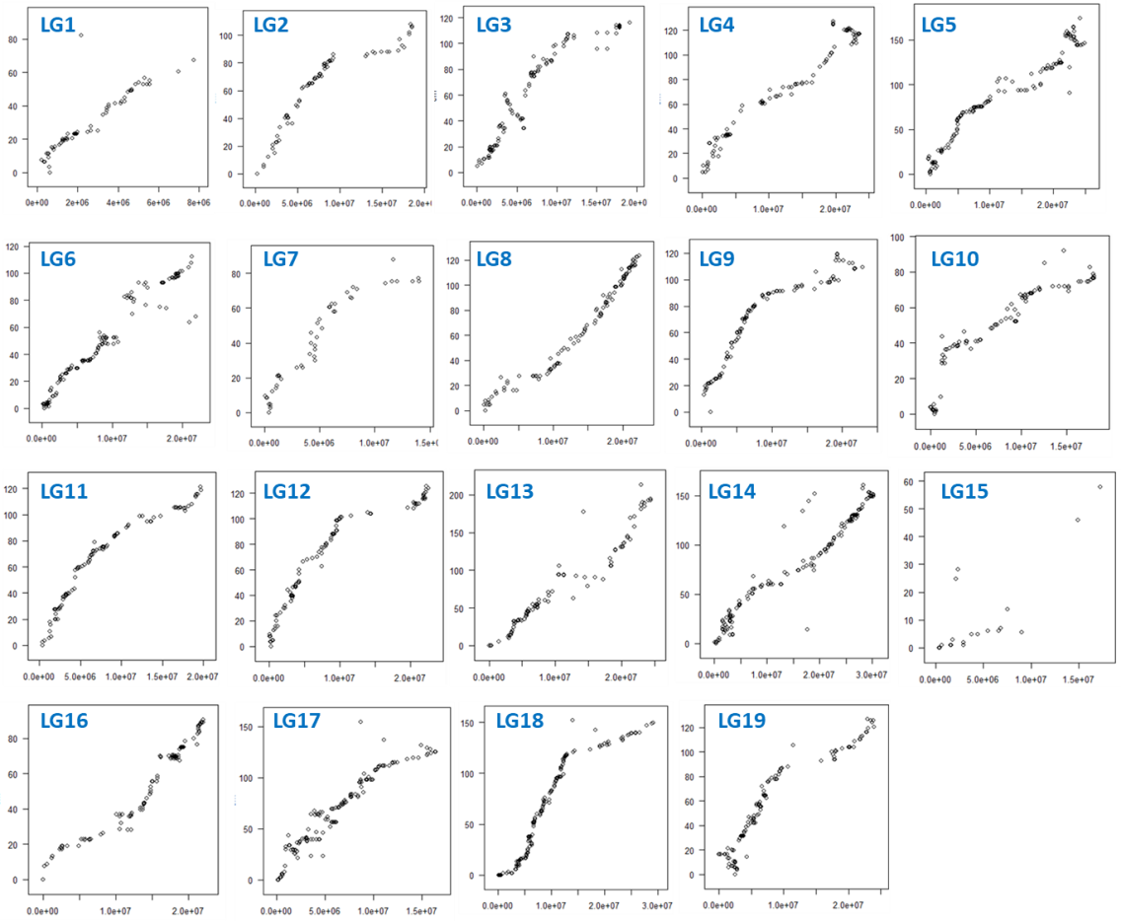
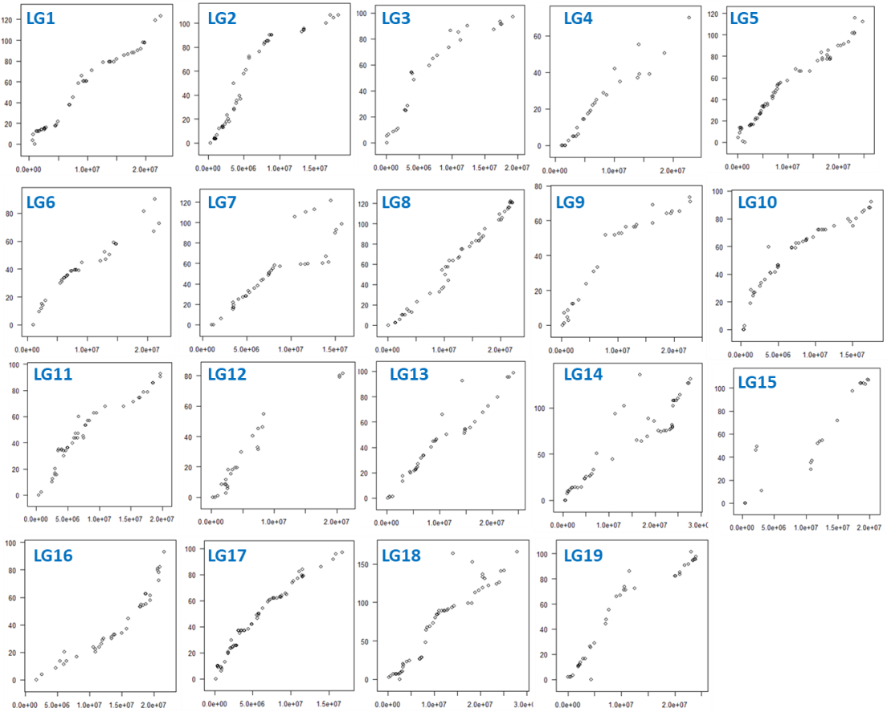
A
Fig. S3 Variation of genetic distance depending on physical distance on the VRH8771 (A) and CS (B) genetic maps
The y axis represents the genetic distances (in cM) and the x axis represents the physical distances (in bp) related to the V. vinifera cv ‘Pinot Noir’ (PN40024). Each plot represents an individual linkage group

B

Fig. S4 Principal component analysis (PCA) of the 35 F1 individuals tested in 2010-2011 and 2011-2012 experiments with root system development (RD), root weight (RW), nematode reproduction factor (RF) and gall index (GI).
The two major principal components that accounted for 94.25 % of the variance have been plotted. The individual factor map is represented: the BC1 individuals were assigned to two groups according to the year of experiment: 2010-2011 in blue and 2011-2012 in gray.

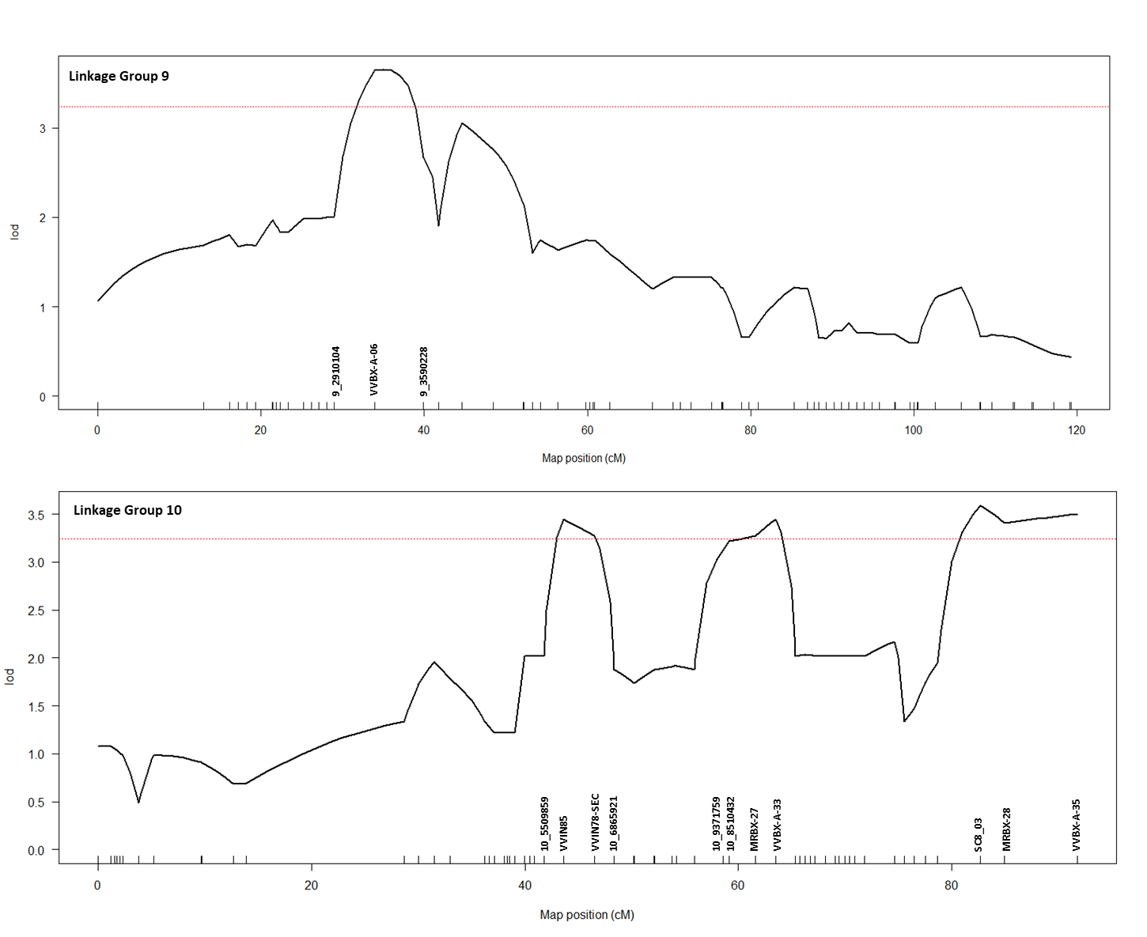
Fig. S5 QTL analysis of the resistance to X. index performed on 60 BC1 individuals. The results of the analysis performed on LG 9 and LG 10 are presented. The y-axis represents the LOD score obtained by the binary mapping and the x-axis represents the 19 linkage groups related to the maternal genetic map (VRH8771). Curves in plot indicate the genetic coordinate (x-axis) and LOD score (y-axis). The red dotted line represents the LOD significant threshold estimated with 1000 permutations for a level α of 0.05

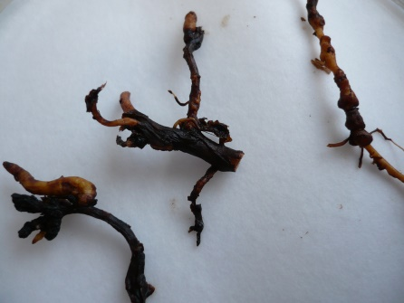
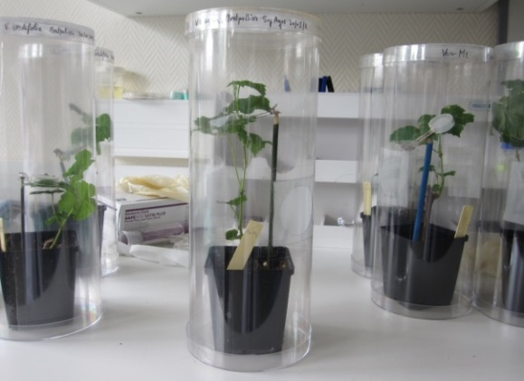
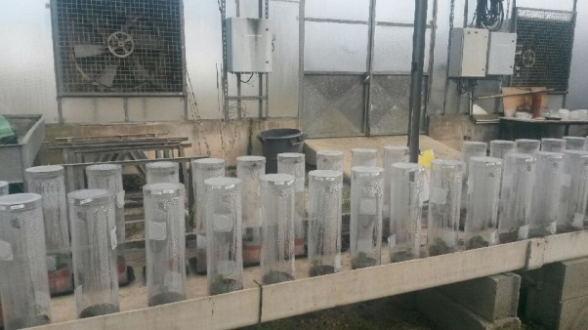
Fig. S6 In planta experiment (A) illustration of the experimental device with each plant grown in an individual pot covered by a transparent plastic bell and (B) example of nodosities developed on roots (red arrows)
A
B

