Supplemental Information

The genetic basis of diurnal preference in Drosophila melanogaster

Mirko Pegoraro, Laura M.M. Flavell, Pamela Menegazzi , Perrine Colmbi, Pauline Dao and Eran Tauber

Corresponding author: Eran Tauber
Email: eran.tauber@gmail.con

This PDF file includes:

Figs. S1 to S7
Tables S1 to S5
Supplemental Methods
Supplemental References

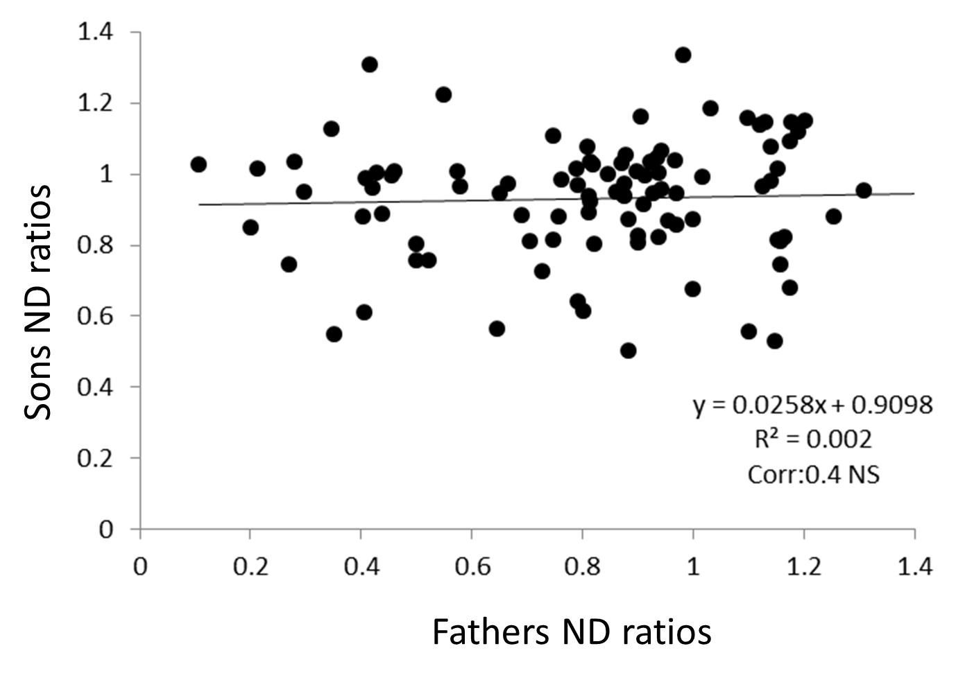
Fig. S1. Correlation between ND ratios of fathers and sons (n = 26 pairs).

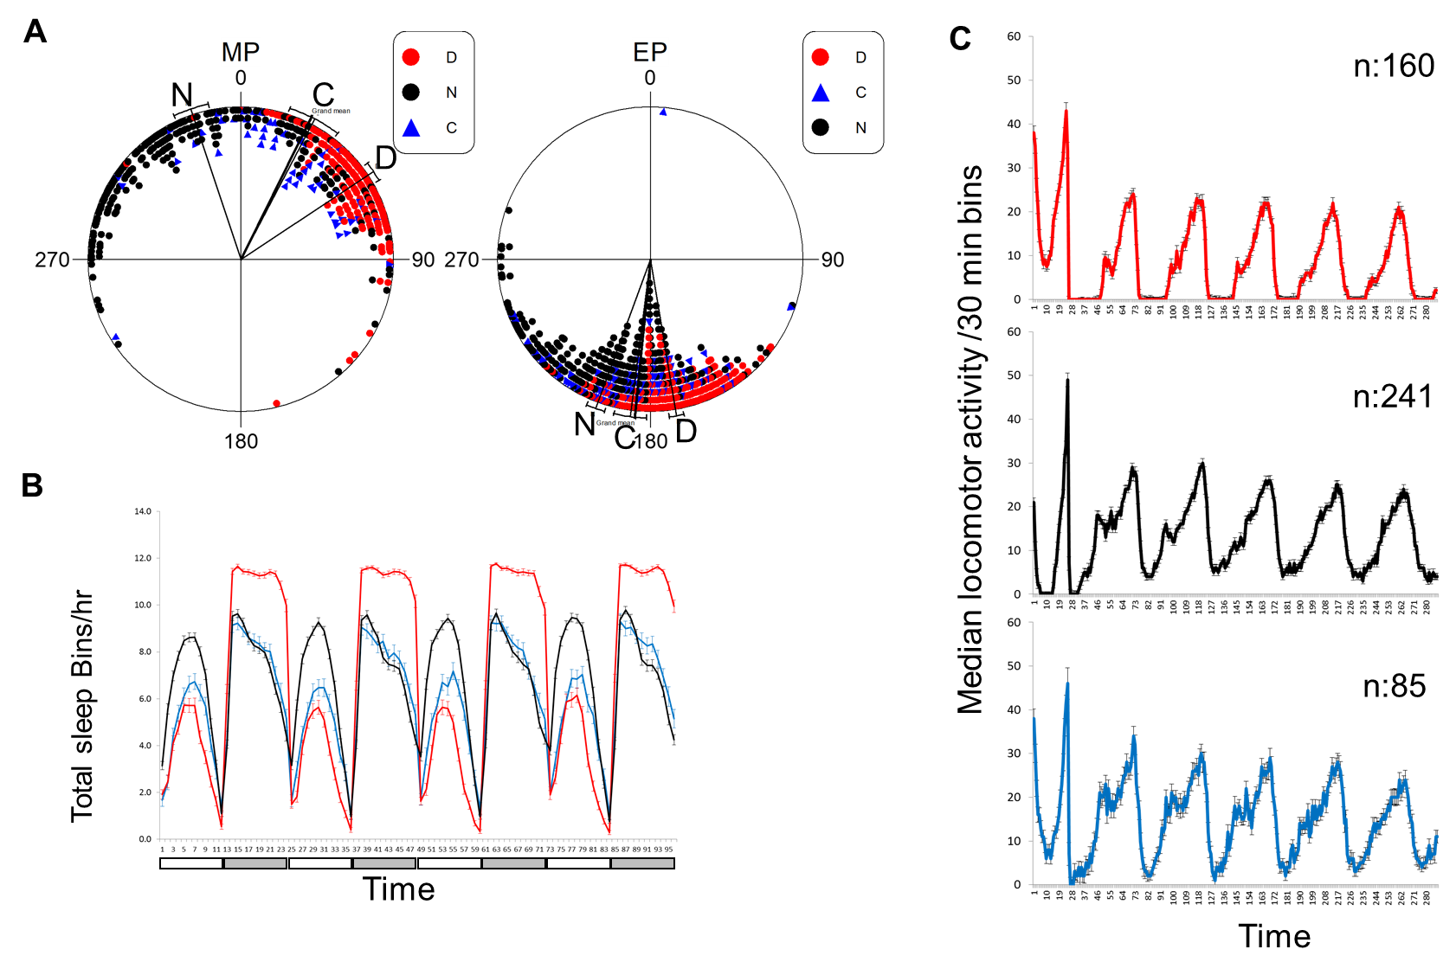
Fig. S2. Locomotor behaviour and sleep of the selection lines in LD. A. LD acrophase angles of Morning (MP) and Evening (EP) peak of activity for N (black circles, n=230), D (red circles, n=160) and C (blue triangles, n=57) populations. Lines represent mean vectors±95%CI. One hour corresponds to a 15° angle. ZT0 and ZT12 are represented by 0° and 180° angle respectively. The MP of N (n=230) was significantly advanced compared to both C (n=57) and D (n=160) as tested by ANOVA (F_{2,444}:163.87, p<0.0001). The EP of N (n=264) was significantly delayed compared to C (n=82) and D (n=170); (F_{2,513}:73.77, p<0.0001). B. Total sleep, bins per hour shown for N (black, n=304), D (red, n=171) and C (blue, n =100). Data points are average ± SEM. The white/grey boxes represent days/nights. N flies sleep more during the day (n=297) than D (n=166) and C (n=96) (F_{11,2224} = 71.02, p<0.0001). D flies sleep more that C and N flies during the night (F_{11,2232}:93.45, p<0.0001). There is no significant difference between N and C (TuskeyHSD, p=0.08, NS) for their night sleep. C. The median locomotor activity per 30 min bin (±SEM) its shows for D (red), N (black) and C (blue) flies during the last day in LD 12:12 and the first 5 days in constant conditions (DD, 25°C). For each profile, the number of flies is depicted.

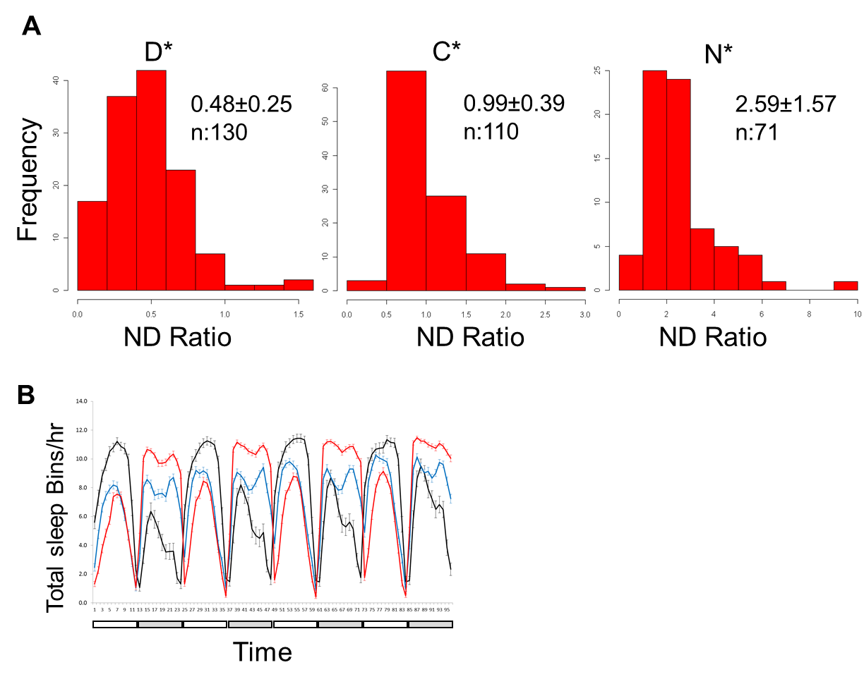
Fig. S3. ND ratios and sleep of isogenic strains. A. Distribution of ND ratios for males of the Diurnal (D*), Nocturnal (N*) and Control (C*) isogenic lines. Average ND ± SD is reported for each line (note different X-axis scale). B. Total sleep bins per hour over time for N* (black, n=70), D* (red, n=170) and the C* (blue, n=130) isogenic lines. Data points are average ± SEM. The white/grey boxes represent days/nights.

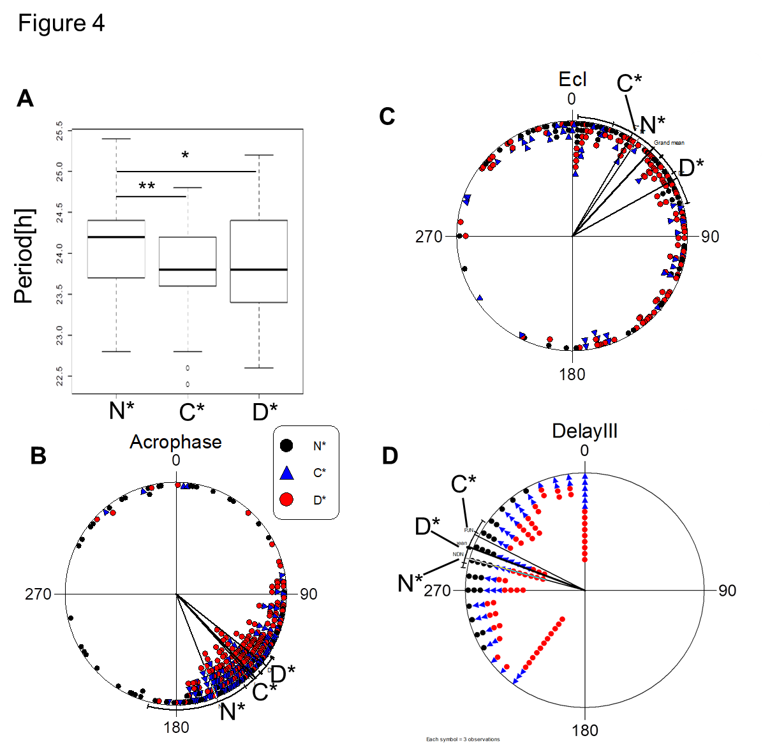
Fig. S4. Circadian behaviour of isogenic strains (N*, D* and C*). A. Boxplots of free-running periods of the N* (n=64), C* (n=124) and D* (n=157) isogenic lines. Solid lines represent median periods, the bottom and upper ends of the box correspond to the upper and lower quartiles, respectively and the whiskers denote maximum and minimum values, excluding outliers. TukeyHSD test, *p<0.05, **p<0.001 B. Acrophase angles of the free-running activity shown for the N* (black circles, n=64), D* (red circles, n=157) and C* (blue triangles, n=124) isogenic lines. The phase in the N* line was delayed by 2.02 h, as compared to what was measured in the D* line, and by 1.38 h, as compared to what was measured in the C* line (F_{2,342}:6.01, p<0.01). Lines represent mean vectors ± 95% CI. One hour corresponds to a 15° angle. C. Phase of eclosion in the N* (black circle, n=75), D* (red circle, n=111) and C* (blue triangle, n=50) lines. The eclosion phase of D* flies was delayed by ~2 h, as compared to what was measured with both the N* and C* lines (F_{2,233}:4.95, p<0.01). There was no difference between N* and C* flies (F_{1,123}:0.08, p =0.78, NS). Lines represent mean vectors ± 95% CI. One hour corresponds to an angle of 15°. Light-on (ZT0) and light-off (ZT12) translated to 0° and 180° angles, respectively. D. Phase delays of N* (black circles, n = 66), D* (red circles, n=170) and C* (blue triangles, n=126) flies. There was no difference between the strains (F_{2,359}:1.93, p = 0.15, NS). Lines represent mean vectors ± 95% CI.

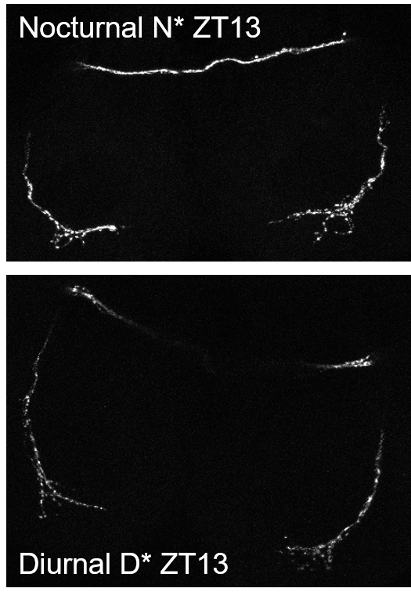
Fig. S5. Representative PDF staining in LNv projections. Representative PDF staining for the LNv projections in N* (top) and D*(bottom) lines at ZT 13 of flies maintained in LD12:12 at 25°C.

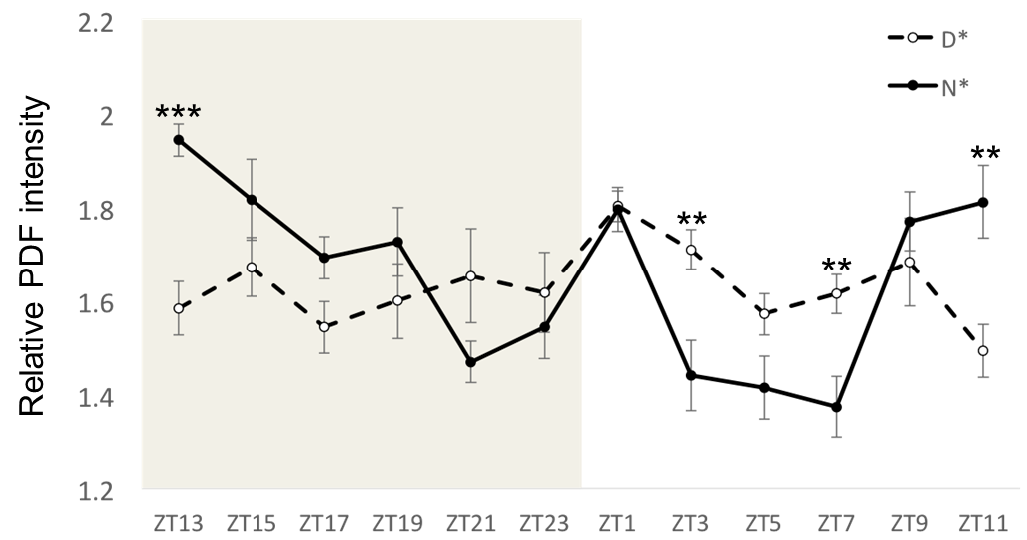
Fig. S6. Expression of PDF in LNv projections. PDF staining in the N* (full lines) and D* (dashed lines) lines maintained in a 12:12 LD cycle. Shading represents light-off. Representative staining is shown in Supplementary Fig. S4. Points represent averages ± standard error. The N* signal was lower than the D* signal at ZT3 (F_{1,18}=11.99, p<0.01) and ZT7 (F_{1,19}=10.13, p<0.01), and higher at ZT11 (F_{1,15}=10.53, p<0.01) and ZT13 (F_{1,17}=23.39, p<0.001).

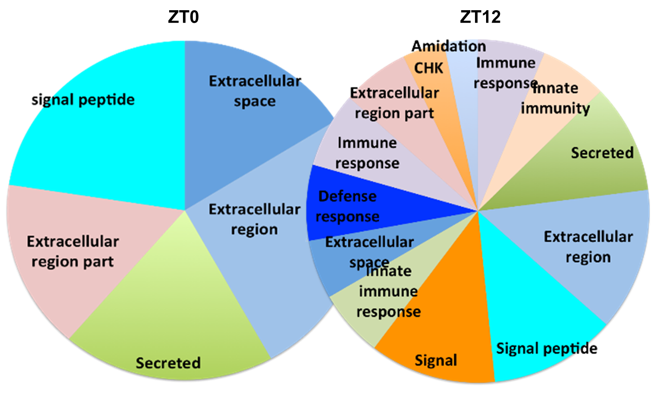

Fig. S7. Functional annotation of DEGs associated with diurnal preference. Pie charts representing significant terms of DEGs in 3 pairwise contrasts (D* vs N*, D* vs C*, N* vs C*) at ZT0 and ZT12. Sections represent the percent of enrichment for each term. p<0.05 after Benjamini correction with the exception of the “signal peptide” term at ZT0, where p = 0.054.

Table S1. Artificial selection ND ratios and heritability. ND ratios per cycle of selection (Cyc). Stdev indicates standard deviation and N is the number of rhythmic males. R is the response to selection and S is the selection differential per cycle of selection. Vp is variance of the ND ratio per cycle of selection and Var(h²) is the variance in h² due to genetic drift. Cum R and Cum S correspond to the cumulative response to selection and the cumulative selection differential. KS D and pval are the results of the Kolmogorov-Smirnov test comparing ND ratios of two consecutive generation (n = 25 in all cases).
Selection | Cyc | average | stdev | N | R | S | h2 | Vp | Var(h2) | Cum R | Cum S | KS D | KS pval
Nocturnal | C0 | 0.88 | 0.21 | 176 |  |  |  |  |  | 0 | 0
 | C1 | 1.04 | 0.29 | 183 | 0.15 | 0.52 | 0.29 | 0.09 | 0.007 | 0.15 | 0.52 | 0.35 | <0.0001
 | C2 | 1.01 | 0.38 | 249 | -0.03 | 0.78 | 0.00 | 0.14 | 0.002 | 0.12 | 1.30 | 0.18 | <0.01
 | C3 | 1.01 | 0.36 | 216 | 0.00 | 0.68 | 0.00 | 0.13 | 0.003 | 0.12 | 1.99 | 0.05 | 0.918
 | C4 | 1.13 | 0.34 | 223 | 0.12 | 0.67 | 0.19 | 0.12 | 0.004 | 0.25 | 2.66 | 0.20 | <0.0001
 | C5 | 1.10 | 0.24 | 160 | -0.03 | 0.36 | 0.00 | 0.06 | 0.005 | 0.22 | 3.02 | 0.10 | 0.294
 | C6 | 1.23 | 0.40 | 208 | 0.12 | 0.76 | 0.16 | 0.16 | 0.004 | 0.34 | 3.79 | 0.20 | <0.01
 | C7 | 1.24 | 0.37 | 238 | 0.02 | 0.76 | 0.02 | 0.14 | 0.002 | 0.36 | 4.55 | 0.06 | 0.773
 | C8 | 1.17 | 0.39 | 147 | -0.07 | 0.47 | 0.00 | 0.15 | 0.009 | 0.29 | 5.03 | 0.15 | <0.05
 | C9 | 1.09 | 0.46 | 220 | -0.09 | 0.46 | 0.00 | 0.21 | 0.009 | 0.20 | 5.48 | 0.16 | <0.05
 | C10 | 1.20 | 0.41 | 215 | 0.11 | 0.84 | 0.13 | 0.17 | 0.003 | 0.31 | 6.32 | 0.19 | <0.01
Selection | Cyc | average | stdev | N | R | S | h2 | Vp | Var(h2) | Cum R | Cum S | KS D | KS pval
Diurnal | C0 | 0.88 | 0.21 | 176 |  |  |  |  |  | 0.00 | 0.00
 | C1 | 0.81 | 0.21 | 104 | -0.07 | -0.30 | 0.25 | 0.04 | 0.015 | -0.07 | -0.30 | 0.22 | <0.01
 | C2 | 0.84 | 0.23 | 226 | 0.03 | -0.36 | 0.00 | 0.05 | 0.004 | -0.04 | -0.65 | 0.06 | 0.911
 | C3 | 0.76 | 0.21 | 164 | -0.08 | -0.35 | 0.21 | 0.04 | 0.008 | -0.12 | -1.01 | 0.12 | 0.098
 | C4 | 0.75 | 0.22 | 284 | -0.02 | -0.44 | 0.04 | 0.05 | 0.002 | -0.14 | -1.44 | 0.06 | 0.858
 | C5 | 0.68 | 0.24 | 233 | -0.07 | -0.42 | 0.16 | 0.06 | 0.005 | -0.20 | -1.86 | 0.14 | <0.01
 | C6 | 0.41 | 0.18 | 263 | -0.27 | -0.26 | 1.03 | 0.03 | 0.024 | -0.47 | -2.12 | 0.49 | <0.0001
 | C7 | 0.53 | 0.24 | 223 | 0.12 | -0.33 | 0.00 | 0.06 | 0.005 | -0.35 | -2.45 | 0.28 | <0.0001
 | C8 | 0.44 | 0.22 | 274 | -0.10 | -0.20 | 0.48 | 0.03 | 0.019 | -0.45 | -2.66 | 0.23 | <0.0001
 | C9 | 0.33 | 0.20 | 316 | -0.10 | -0.24 | 0.44 | 0.04 | 0.017 | -0.55 | -2.89 | 0.25 | <0.0001
 | C10 | 0.32 | 0.20 | 221 | -0.01 | -0.21 | 0.05 | 0.04 | 0.010 | -0.56 | -3.11 | 0.07 | 0.568

Table S2. List of Isofemale strains that were used for the synthetic population.

Name | n isofemale lines | Collection region | Collection year
MAR | 57 | Market Harborough (UK) | 2008
HOJ | 20 | Hojbjeng (Denmark) | 2009
DJ | 1 | Dijon (France) | 2000
KOR | 13 | Korpilahti (Finland) | 2008
BIT | 7 | Bitetto (Italy) | 2004
M-REN | 18 | Rende (Italy) | 2006
COR | 4 | Corces (Italy) | 2004
RUT | 8 | Rutigliano (Italy) | 2004
CORSTA | 2 | Corces st. Agidius (Italy) | 2004
NAT | 3 | Naturno (Italy) | 2004
FUL | 2 | Fulda (Germany)
POS | 3 | Postal (Italy) | 2004
KIL | 77 | Kilworth (Italy) | 2008
STO | 8 | Stockolm (Sweden) | 2008
KNO | 6 | Knoses (Creete) | 2002
BUR | 9 | Burgundy (France) | 2000
HU | 4 | Huten (Holland) | 2000
GOT | 7 | Goteborg (Sweden) | 2008
SAL | 1 | Salice (Italy) | 2004
NOV | 1 | Noventa (Italy) | 2004
VIL | 3 | Villorba | 2004
LEO | 1 | St. Leonhard (Italy) | 2004
NN | 2
ZS | 1 | Sengwa (Zimbabwe) | from David Dolezel (originally from Shu Fang)
ZH | 1 | Harare (Zimbabwe) | from David Dolezel (originally from Shu Fang)
CAV | 4 | Cavarzere (Italy) | 2004
AFRW | 1 | Africa
B16 | 1
NAT | 1 | Naturno (Italy) | 2004
LOR | 1 | St. Lorenz (Italy)
BAD | 1 | Bad Salzschlirf (Germany) | 2004
LE | 3 | Leiden (Nederland) | 2000
CORF | 1 | Corbires-Fribourg (Switzerland) | 2004

Table S3 List of differentially expressed genes (p<0.05) in all pairwise contrasts. A group of 34 genes were differentially expressed both at ZT0 and ZT12 (ZT0 ZT12). 19 genes were uniquely identified at ZT0 (ZT0) and 87 were differentially expressed only at ZT12 (ZT12). Unknown transcripts are indicated by suffix TCONS.

ZT0 ZT12 | ZT0 | ZT12
Lsp1beta | CG10680 | nAcRbeta-21C | CG3590 | CecA1
Tps1 | CG9928 | Cyp28d1 | Pdf | CecA2
nimB2 | CG15293 | Cpr | CG9691 | CG18673
IM4 | CG6543 | CG9505 | regucalcin | Ugt35b
Irc | Amy-p | CG8665 | CG31743 | CG18765
CG14273 | CG15068 | CG9498 | Cpr47Ee | CG10513
CG6012 | Mst98Cb | CG16978 | Ipk1 | CG1681
Cyp6w1 | CG9759 | Amy-d | CG16898 | CG15347
CG34227 | CG10553 | IM2 | CG6188 | TCONS_00015278
CG11395 | msta | IM14 | CG11317 | TCONS_00020522
CG16836 | CG9377 | Cyp9c1 | Cpr11B | TCONS_00029494
Cyp9b2 | Dro | CG8216 | Sr-CI
CG13335 | Nplp2 | Ance-4 | CG34172
CG30083 | CG7402 | CG15117 | CG15414
CG17574 | CG7678 | GV1 | CG12512
CG8329 | Obp99b | CG42324 | CG7532
CG7470 | CG2233 | CG32368 | CG30002
dAtg1 | TCONS_00013524 | LanB2 | CG30203
Cpr72Ec | TCONS_00013630 | CG9701 | Uhg5
Ccp84Ag |  | Lcp65Ag2 | Uhg1
CG31157 |  | pst | GstE2
TotC |  | Ilp3 | GstE8
CG31326 |  | Pdh | sano
CG6687 |  | CG4306 | NtR
Rh3 |  | CG12947 | CG4269
CG10550 |  | CG4757 | CG4250
CG11909 |  | TotA | CG7722
toy |  | CG5791 | Cyp12d1-p
CG4064 |  | Lsd-1 | CG16926
CG9360 |  | Ela | CG12362
Act79B |  | to | Pdp1
TCONS_00015283 |  | CG5527 | CG14105
TCONS_00027521 |  | CG11841 | Adgf-A
TCONS_00035728 |  | CG11842 | GNBP2
 |  | CG5195 | CG4525
 |  | CG7202 | Rh2
 |  | CG8319 | CG5849
 |  | CG14257 | CG7054

Table S4 Differentially expressed genes (p<0.05). The biological processes as reported in flybase (http://flybase.org/).

Direction of expression | Symbol | Annotation symbol | Time Points | Biological process
D*>C*>N* | Tps1 | CG4104 | ZT0, ZT12 | Photoreceptor cell maintenance; trehalose biosynthetic process.
 | nimB2 | CG31839 | ZT0 | Mesoderm development; defense response to bacterium.
 | Cyp9b2 | CG4486 | ZT0, ZT12 | Oxidation-reduction process.
 | Cyp9c1 | CG3616 | ZT12 | Oxidation-reduction process.
 | Amy-p | CG18730 | ZT0 | Sleep; carbohydrate metabolic process.
 | Irc | CG8913 | ZT0, ZT12 | Response to oxidative stress
 | TotA | CG31509 | ZT12 | Cellular response to UV; cellular response to oxidative stress.
 | TotC | CG31508 | ZT0, ZT12 | Cellular response to heat; cellular response to UV;
 | Rh3 | CG10888 | ZT0, ZT12 | Phototransduction, UV; visual perception.
 | nAcRbeta-21C | CG11822 | ZT12 | Synaptic transmission, cholinergic; sleep.
 | Cpr | CG11567 | ZT12 | Oxidation-reduction process.
 | Ance-4 | CG8196 | ZT12 | Proteolysis.
 | pst | CG8588 | ZT12 | Protein secretion; learning or memory.
 | Ilp3 | CG14167 | ZT12 | Female mating behavior; sleep; insulin receptor signaling pathway; locomotor rhythm.
 | Ela |  | ZT12 | Unknown
 | Uhg1 | CR32886 | ZT12 | Unknown
 | Pdp1 | CG17888 | ZT12 | Mitotic nuclear division; positive regulation of transcription; circadian rhythm; regulation of lipid metabolic process; DNA endoreduplication; growth; response to nutrient.
 | Adgf-A | CG5992 | ZT12 | Cell proliferation; adenosine catabolic process; cellular response to sucrose starvation; larval lymph gland hemopoiesis; hemocyte differentiation; regulation of carbohydrate metabolic process.
 | Gbp2 | CG11395 | ZT0, ZT12 | Signal transduction
 | Vha100-4 | CG7678 | ZT0 | ATP hydrolysis coupled proton transport.
 | AdSL | CG3590 | ZT12 | Purine ribonucleotide biosynthetic process; purine nucleotide metabolic process.
 | atk | CG5195 | ZT12 | Locomotion; cilium morphogenesis; sensory organ development.
 | CG9505 | CG9505 | ZT12 | Proteolysis.
 | CG9498 | CG9498 | ZT12 | Unknown
 | CG16978 | CG16978 | ZT12 | Unknown
 | CG14273 | CG14273 | ZT0, ZT12 | Unknown
 | CG34227 | CG34227 | ZT0, ZT12 | Unknown
 | CG13335 | CG13335 | ZT0 | Unknown
 | CG17574 | CG17574 | ZT0, ZT12 | Unknown
 | CG7470 | CG7470 | ZT0, ZT12 | Epithelium development; germarium-derived egg chamber formation; proline biosynthetic process; oxidation-reduction process.
 | CG9759 | CG9759 | ZT0 | Unknown
 | CG31326 | CG31326 | ZT0, ZT12 | Unknown
 | CG15117 | CG15117 | ZT12 | Multicellular organism reproduction; carbohydrate metabolic process.
 | CG9701 | CG9701 | ZT12 | Carbohydrate metabolic process.
 | CG5527 | CG5527 | ZT12 | Proteolysis.
 | CG11317 | CG11317 | ZT12 | Neurogenesis.
 | CG7202 | CG7202 | ZT12 | Unknown
 | CG5849 | CG5849 | ZT12 | Proteolysis.
Direction of expression | Symbol | Annotation symbol | Time Points | Biological process
N*>C*>D* | Dro | CG10816 | ZT0 | Defense response to bacterium; defense response to Gram-positive bacterium.
 | dATG1 | CG10967 | ZT0, ZT12 | Response to oxidative stress; negative regulation of signaling; instar larval or pupal morphogenesis; organic substance catabolic process;; negative regulation of intracellular signal transduction; regulation of polysaccharide metabolic process.
 | Ccp84Ag | CG2342 | ZT0, ZT12 | Chitin-based cuticle development.
 | Cpr47Ee | CG13222 | ZT12 | Chitin-based cuticle development.
 | GV1 | CG12023 | ZT12 | Unknown
 | Lcp65Ag2 | CG10534 | ZT12 | Chitin-based cuticle development.
 | Pdh | CG4899 | ZT12 | Retinal metabolic process; phagocytosis; oxidation-reduction process.
 | to | CG11853 | ZT12 | Circadian rhythm; adult feeding behavior; mating behavior; male courtship behavior.
 | Pdf | CG6496 | ZT12 | Response to abiotic stimulus; single-organism behavior; positive regulation of circadian rhythm; reproduction; taxis; sensory perception; regulation of metabolic process; system process; positive regulation of circadian sleep/wake cycle, wakefulness.
 | GstE2 | CG17523 | ZT12 | Glutathione metabolic process.
 | GstE8 | CG17533 | ZT12 | Glutathione metabolic process.
 | Act79B | CG7478 | ZT12 | Cytoskeleton organization.
 | Ugt35b | CG6649 | ZT12 | UDP-glucose metabolic process.
 | Rh2 | CG16740 | ZT12 | Phototransduction; G-protein coupled receptor signaling pathway; visual perception.
 | GNBP2 | CG4144 | ZT12 | Regulation of innate immune response; carbohydrate metabolic process.
 | l(2)34Fc | CG7532 | ZT12 | Unknown
 | GstT4 | CG1681 | ZT12 | Unknown
 | CG8329 | CG8329 | ZT0, ZT12 | Sleep; proteolysis.
 | CG31157 | CG31157 | ZT0, ZT12 | Unknown
 | CG9360 | CG9360 | ZT0, ZT12 | Unknown
 | CG8665 | CG8665 | ZT12 | 10-formyltetrahydrofolate catabolic process; one-carbon metabolic process; oxidation-reduction process; biosynthetic process.
 | CG42324 | CG42324 | ZT12 | Unknown
 | CG12947 | CG12947 | ZT12 | Unknown
 | CG9691 | CG9691 | ZT12 | Unknown
 | CG34172 | CG34172 | ZT12 | Unknown
 | CG12512 | CG12512 | ZT12 | Metabolic process.
 | CG12362 | CG12362 | ZT12 | Protein ubiquitination involved in ubiquitin-dependent protein catabolic process.
 | CG4525 | CG4525 | ZT12 | Cilium assembly.
 | CG7054 | CG7054 | ZT12 | Unknown
 | CG14257 | CG14257 | ZT12 | Unknown
 | CG18765 | CG18765 | ZT12 | Unknown

Table S5 Complementation tests. Average ND ratios and standard deviation for each complementation test cross are shown. “n” indicate number of tested flies. The Kolmogorov-Smirnov tests (KS-test) are reported as matrixes with p values on the top half and D values on bottom half [1,2]. Kruskal-Wallis rank sum test (KW-test) results with 2 degree of freedom are also shown for each complementation test [1,2]. Compl indicate the result of the complementation test. Positive complementation was confirmed only when the ND D*cross<C*cross<N*cross, the KS-test was significant for the N*cross vs D*cross contrast and the KW-test was also significant.
 |  |  |  | Ks-test |  |  | Kruskal-Wallis |  | Compl
gen | average | stdev | n | D* | C* | N* | Chi-sq | p-value | Compl
Ilp6⁴¹/D* | 0.475 | 0.279 | 30 | ||||||| | <0.05 | <0.0001 | 21.375 | <0.0001 | Positive
Ilp6⁴¹/C* | 0.566 | 0.220 | 32 | 0.3958 | ||||||| | 0.073 |  |  | Positive
Ilp6⁴¹/N* | 0.685 | 0.178 | 31 | 0.6409 | 0.3125 | ||||||| |  |  | Positive
para^{MB08120}/D* | 0.596 | 0.197 | 32 | ||||||| | 0.069 | <0.0001 | 49.028 | <0.0001 | Positive
para^{MB08120}/C* | 0.701 | 0.160 | 32 | 0.3125 | ||||||| | <0.0001 |  |  | Positive
para^{MB08120}/N* | 1.164 | 0.294 | 31 | 0.8075 | 0.745 | ||||||| |  |  | Positive
para^{KG01807}/D* | 0.432 | 0.161 | 63 | ||||||| | <0.05 | <0.0001 | 68.396 | <0.0001 | Positive
para^{KG01807}/C* | 0.518 | 0.182 | 64 | 0.2631 | ||||||| | <0.0001 |  |  | Positive
para^{KG01807}/N* | 0.745 | 0.225 | 80 | 0.6187 | 0.4594 | ||||||| |  |  | Positive
Pdfr⁵³⁰⁴/D* | 0.510 | 0.199 | 31 | ||||||| | 0.612 | <0.0001 | 26.339 | <0.0001 | Positive
Pdfr⁵³⁰⁴/C* | 0.564 | 0.143 | 31 | 0.1845 | ||||||| | <0.0001 |  |  | Positive
Pdfr⁵³⁰⁴/N* | 0.804 | 0.217 | 32 | 0.5938 | 0.5313 | ||||||| |  |  | Positive
Pdfr³³⁶⁹/D* | 0.459 | 0.190 | 28 | ||||||| | 0.72 | <0.01 | 12.890 | <0.01 | Positive
Pdfr³³⁶⁹/C* | 0.448 | 0.129 | 28 | 0.1786 | ||||||| | <0.01 |  |  | Positive
Pdfr³³⁶⁹/N* | 0.591 | 0.163 | 30 | 0.4357 | 0.5143 | ||||||| |  |  | Positive
cry⁰²/D* | 0.315 | 0.153 | 42 | ||||||| | <0.0001 | <0.0001 | 86.693 | <0.0001 | Positive
cry⁰²/C* | 0.893 | 0.235 | 57 | 0.8534 | ||||||| | <0.05 |  |  | Positive
cry⁰²/N* | 0.990 | 0.261 | 59 | 0.8644 | 0.2774 | ||||||| |  |  | Positive
per⁰¹/D* | 0.574 | 0.158 | 31 | ||||||| | <0.05 | <0.0001 | 32.218 | <0.0001 | Positive
per⁰¹/C* | 0.704 | 0.201 | 50 | 0.3342 | ||||||| | <0.0001 |  |  | Positive
per⁰¹/N* | 0.933 | 0.419 | 58 | 0.6207 | 0.4234 | ||||||| |  |  | Positive
na ¹/D* | 0.356 | 0.356 | 23 | ||||||| | <0.0001 | <0.0001 | 36.379 | <0.0001 | Positive
na¹/C* | 0.626 | 0.269 | 61 | 0.5046 | ||||||| | <0.0001 |  |  | Positive
na¹/N* | 0.969 | 0.969 | 14 | 0.8696 | 0.5995 | ||||||| |  |  | Positive
msn¹⁰²/D* | 0.382 | 0.173 | 32 | ||||||| | <0.01 | <0.0001 | 47.297 | <0.0001 | Positive
msn¹⁰²/C* | 0.641 | 0.207 | 31 | 0.6313 | ||||||| | <0.0001 |  |  | Positive
msn¹⁰²/N* | 1.083 | 0.817 | 32 | 0.8125 | 0.4304 | ||||||| |  |  | Positive
cora⁵/D* | 0.356 | 0.225 | 30 | ||||||| | 0.136 | <0.01 | 15.032 | <0.001 | Positive
cora⁵/C* | 0.479 | 0.308 | 29 | 0.2908 | ||||||| | <0.05 |  |  | Positive
cora⁵/N* | 0.631 | 0.287 | 30 | 0.5 | 0.3506 | ||||||| |  |  | Positive
Pdf⁰¹/D* | 0.671 | 0.193 | 26 | ||||||| | <0.0001 | <0.0001 | 58.667 | <0.0001 | Positive
Pdf⁰¹/C* | 0.464 | 0.227 | 48 | 0.4856 | ||||||| | <0.0001 |  |  | Positive
Pdf⁰¹/N* | 0.892 | 0.247 | 59 | 0.4654 | 0.6522 | ||||||| |  |  | Positive
Arr2³/D* | 0.563 | 0.198 | 30 | ||||||| | <0.05 | 0.317 | 8.410 | <0.05 | Negative
Arr2³/C* | 0.870 | 0.366 | 10 | 0.5333 | ||||||| | <0.05 |  |  | Negative
Arr2³/N* | 0.647 | 0.196 | 31 | 0.2366 | 0.4742 | ||||||| |  |  | Negative
chico^{KG00032}/D* | 0.355 | 0.107 | 29 | ||||||| | <0.01 | <0.01 | 20.333 | <0.0001 | Negative
chico^{KG00032}/C* | 0.589 | 0.220 | 25 | 0.5131 | ||||||| | 0.095 |  |  | Negative
chico^{KG00032}/N* | 0.485 | 0.156 | 31 | 0.4549 | 0.3187 | ||||||| |  |  | Negative
Clk^{ar}/D* | 0.883 | 0.173 | 31 | ||||||| | <0.01 | <0.05 | 9.606 | <0.01 | Negative
ClK^{ar}/C* | 0.754 | 0.247 | 31 | 0.4839 | ||||||| | 0.216 |  |  | Negative
Clk^{ar}/N* | 0.830 | 0.120 | 31 | 0.3548 | 0.2581 | ||||||| |  |  | Negative
Clk^{out}/D* | 0.587 | 0.196 | 30 | ||||||| | <0.0001 | <0.05 | 18.600 | <0.0001 | Negative
Clk^{out}/C* | 0.943 | 0.346 | 21 | 0.6476 | ||||||| | <0.05 |  |  | Negative
Clk^{out} /N* | 0.743 | 0.219 | 32 | 0.3625 | 0.3988 | ||||||| |  |  | Negative
Clk^{jrk}/D* | 1.117 | 0.241 | 30 | ||||||| | <0.01 | 0.356 | 5.869 | 0.053 | Negative
Clk^{jrk}/C* | 0.996 | 0.488 | 31 | 0.4484 | ||||||| | <0.0001 |  |  | Negative
Clk^{jrk}/N* | 1.094 | 0.206 | 32 | 0.2271 | 0.5504 | ||||||| |  |  | Negative
fok^{EY11126}/D* | 0.422 | 0.273 | 20 | ||||||| | 0.546 | 0.288 | 1.333 | 0.514 | Negative
fok^{EY11126}/C* | 0.434 | 0.185 | 13 | 0.2692 | ||||||| | 0.461 |  |  | Negative
fok^{EY11126}/N* | 0.478 | 0.237 | 32 | 0.2688 | 0.2668 | ||||||| |  |  | Negative
fok^{KG05913}/D* | 0.388 | 0.135 | 31 | ||||||| | 0.559 | <0.05 | 2.503 | 0.286 | Negative
fok^{KG05913}/C* | 0.453 | 0.231 | 31 | 0.1935 | ||||||| | 0.559 |  |  | Negative
fok^{KG05913}/N* | 0.535 | 0.296 | 31 | 0.3548 | 0.1935 | ||||||| |  |  | Negative
fok^{M110499}/D* | 0.459 | 0.162 | 31 | ||||||| | 0.207 | 0.164 | 2.639 | 0.267 | Negative
fok^{M110499}/C* | 0.424 | 0.245 | 19 | 0.2971 | ||||||| | 0.099 |  |  | Negative
fok^{M110499}/N* | 0.482 | 0.161 | 27 | 0.2832 | 0.3509 | ||||||| |  |  | Negative

Supplemental Methods

Artificial Selection
The locomotor activity of 300 males was recorded over 5 days in a 12:12 LD cycle at 25°C. Using the R library GeneCycle and a custom-made script, we identified rhythmic flies and calculated their ND ratio. In each cycle of selection, we selected 25 males with the most extreme nocturnal or diurnal ND ratios, and crossed them with their (unselected) virgin sisters. The 10 following generations underwent the same selection procedure. In addition, three control groups (CA, CB, CC) were generated from the original population (C₀) by collecting 25 fertilized females in 3 new bottles. At each selection cycle, the controls underwent the same bottleneck as did the nocturnal (N) and diurnal (D) populations but without any selective pressure. During and following selection, the flies were maintained at 25°C in a 12:12 LD cycle.

Realize heritability was calculated for both the N and D populations from the regression of the cumulative response to selection (as a difference from the original population C₀) and the cumulative selection differential base on the data from the 10 cycles of selection (Fig. 1B) [3]. Statistical differences between cycles of selection or between lines have been calculated using the Kolmogorov-Smirnov test (KS-test) and the Kruskal-Wallis rank sum test [1,2].
To calculate the correlation between the ND ratios of parents and offspring we phenotyped 130 virgin males and 130 virgin females from the original copulation (C₀) as describe above and randomly cross them. We calculated ND ratios of the progeny of each cross (a male and a virgin female) and correlate it with parents ND ratios. The correlation between average parents ND ratios and average offspring ND ratios was tested as well as all other possible correlations (Mothers’ vs Daughters’; Fathers’ vs Sons’; Mothers’ vs Sons’; Fathers’ vs Daughters’). For each correlation we calculated the correlation coefficient and the relative p values.

Analysis of Fitness correlated traits
The selected populations have been keep at 12:12LD 25°C for 5 months (~15 overlapping generation) before testing for differences in viability, fitness and egg to adult developmental time. From the selected population N and D as well as the 3 control populations we collected 40 virgin males and 40 virgin females. We prepared for each populations (N, D and pool C) 10 crosses with 4 males and 4 females. The crosses were maintained in standard sugar food that was changed every 3 days. Dead flies were recorded for each vials as well as the number of adults (progeny) produced and the developmental time (egg to adults).
To analyse the viability of the different populations, we used survival curves. We used the Survival R library to fit Kaplan-Meier curves, which were compared by log-rank tests using χ2 statistics with two degrees of freedom [4]. The progeny produced per vial was recorded, and difference between numbers of progeny per females between N, C, and D was analysed using ANOVA on log transformed data. The developmental time (egg to adults) was calculated per vial, per surviving parental females, and ANOVA was used to test for differences between N, C, D populations males and females separately.

Locomotor activity
Locomotor activity was recorded as previously described [5] at 25°C. We used the TriKinetics system to record the locomotor activity of 3-4 days old males maintained initially at LD12:12 for 5 days follow by 7 days in constant conditions (DD) at 25°C. The flies were then entrained again in LD12:12 for 4 days and a 20 min light pulse (saturating white light > 500 lux) was given at ZT15 (3h after light off) during the last night before releasing the flies in DD for further 5 days.
The first 5 days in LD were used to calculate ND ratios, the amount of sleep define as 5 min of inactivity or longer [6,7] and the entrained morning and evening phases of activity. The phase of morning and evening activity was calculated using cosinor-Rhythmometry [8,9]. The sleep amount during 4 days of LD was analysed separately for the 12 hours of light (min/12hr) and 12 hours of dark (min/12hr) using nested ANOVA. The first 7 days in DD were used to calculate the free-run period (FRP) and acrophase (φ) using cosinor-Rhythmometry [8,9]. Changes in free running period were analysed using ANOVA.
The difference between the phase after light pulse (φlp) and the reference phase (φref: phase before light pulse) was calculated with custom-made Excel macro. Circular statistic software (Oriana, Kovach Computing Services, UK) and Watson-Williams F-test were used to analyse the phase data.
In another set of experiments, we recorded the locomotor activity of the isogenic lines during 5 days in LD12:12 at 25°C follow by 8 hours phase delay (realized by night extension of 8 hours) and an additional 8 days in LD 12:12 at 25°C (Fig. 5B). To measure the light dependent masking effect, we calculated the ratio (M) between the activity during 3 hours after the light on and 3 hours before the light on (normalized over 24-hour activity) on the delay day. The M ratios were arcsin-transformed for ANOVA analysis. The phase of morning onset (Mon) of activity was recorded for 3 days before the delay and for 4 days after the delay beginning from the second day. The average Mon of activity before the delay was compared to each day after the delay using circular statistic (Oriana, Kovach Computing Services, UK) and Watson-Williams F-test.

Eclosion measurements
Eclosion of adults was recorded automatically as previously described [10] at 25°C LD12:12. TriKinetics DAM2 monitors were placed horizontally on a Drosophila eclosion logger adaptor (DELA) [10]. A single fly pupa was place in modified (shorter) activity tubes just below the infrared sensor of the DAM2 monitor. Because of the strong negative geotaxis of flies the time the fly need to cross the infrared sensor after eclosion is minimized. To control for larvae density, groups of 20 males and 20 females were left to lay eggs for 6 hours and the vials were maintained in LD 12:12 at 25°C. Pupae were collected 2 days pre-eclosion and loaded in the eclosion monitors. The gender of flies was scored after eclosion. A Perl script was used to extract the eclosion time from the TriKinetics data file (see Suppl. material: eclosion script). Circular statistic software (Oriana, Kovach Computing Services, UK) and Watson-Williams F-test were used to analyse the eclosion time.

Isogenic lines
We generated isogenic lines from the selected populations by crossing three flies from the 8th selection cycle with balancer strains. The nocturnal males had ND ratios of 2.28, 2.22 and 2.10, while the diurnal males had ND ratios of 0.05, 0.05 and 0.07. The females used in this crossing scheme were the unselected sisters of the selected males.

Immunocytochemistry
ICC was used to analyse the expression of PER and PDF in the fly brain. For quantification of PDF levels, we used mouse monoclonal anti-PDF and polyclonal rabbit anti-PER antibodies [11,12]. The protocol used for whole-brain staining was previously described [13,14].

We used 3 days old males and collected and stain the brains after 3 days of entrainment in LD 12:12 (100Lux LED) at 25°C. Samples were collected every 2 hours beginning at ZT1. After staining the confocal images were obtained using a Leica TCS SPE confocal microscope. The images were visualized and quantified using ImageJ distribution Fiji. Brightness and contrast were adjusted, but no other manipulations were performed on the images. Samples used for quantification were processed in the same way during the staining protocol and were scanned with exactly the same settings. Nuclear PER signal was quantified drawing a square-shaped area of 9 pixels (3X3 pixels) in the nucleus of the cells of interest and average pixel intensity was measured at the brightest focal plane. Intensity values from cells of different hemispheres (n:5-10) were background corrected and averaged for each neuronal group. The quantification of PDF in the neuron terminals was done accordingly to Hermann-Luibl et al 2014 [12]. We included in our quantification the full projections from the LNv (Fig 7) and we removed all additional PDF staining outside this area. The resulting images were the same size and included only the PDF projections from the LNv. The background of the image was set to zero and the total intensity of the image was recorded. We quantified between 5 and 12 brains for each time point and genotypes. A generalized linear model was fit to the data that were then analyzed using ANOVA testing for time and genotype main effect as well as the time X genotype interaction.

RNAseq
RNAseq library preparation and sequencing was carried by Glasgow Polyomics using an IlluminaNextseq500 platform. Two independent libraries (single-end) were generated per time point per line. The data were then processed using Trimmomatic (version 0.32) [15] to remove adapters. The libraries were quality checked using fastQC (version 0.11.2) [16]. The total sequence obtained for each library ranged from 9.7 Mbp to 21 Mbp, with a “per base quality score” > 30 phred and a “mean per sequence quality score” > 33 phred. The RNA-seq was aligned to the Drosophila melanogaster transcriptome (NCBI_build5.41) downloaded from the Illumina iGenome website.
We use TopHat (version 2.1.0) [17] for libraries alignment with these options: -i 50 -I 5000 --transcriptome-index NCBI_genes --coverage-search -p 8 Bowtie2Index/genome -G genes.gtf (from NCBI_build5.41) as genome annotation reference. Between 72.8% and 77.7% of sequence was aligned (concordant pair alignment rate) with 1.1-2.5% with multiple alignments and 0.4-1% discordant alignments. Cufflinks and cuffmerge (version 2.2.1) [18,19] were used to quantify the expression of the transcripts isoforms of the TopHat aligned RNA with the following options: –u multi-reads correction, -g genes.gtf (from NCBI_build5.41) as gene annotation reference –b genome.fa (from NCBI_build5.41/Bowtie2Index) as reference genome –M Mask_sequences.fa (including mitochondrial and ribosomal RNA as well polyA, polyC sequences). The expression data were returned in Fragments Per Kilobase of transcript per Million fragments mapped (FPKM). To calculate difference of expressions between samples we used cuffdiff. As for cuffmerge we used –b genome.fa –M Mask_sequences.fa. In addition we used -u multi-read correction, merged.gtf (the transcript annotation file produced by cuffmerge) and a geometric method for library normalization as described in Anders and Huber [20]. Samples were compared separately for the 2 time points (2 replicates for each line) or merging the time points (4 replicated for each line). This generated a list of differentially expressed genes (p<0.05) per time point and across time points (Table S2). We used the online tool DAVID (https://david.ncifcrf.gov/) to identify enriched biological functions in our list of significant differentially expressed genes [21,22].

Complementation test
We used a modified version of the quantitative complementation test (QCT) to explore the contribution of several genes to the ND behaviour of the isogenic lines [23,24]. The isogenic lines (N*, D* and C*) were crossed with null mutants, hypomorphic alleles and or transposable element insertion lines disrupting the normal expression of target genes. The ND ratio of 3-4 days old F1 males was calculated as describe above. For each complementation cross we used the Kolmogorov-Smirnov tests (KS-test) and Kruskal-Wallis rank sum test (KW-test) with 2 degree of freedom to test for differences between N*cross, D*cross and C*cross (see Table 4) [1,2]. Positive complementation indicating that genetic variation in the target gene is contributing to the ND behaviour, was confirmed only when the ND D*cross<C*cross<N*cross, the KS-test was significant for the N*cross vs D*cross contrast and the KW-test was also significant.

References

1. Gaddis, G.M., and Gaddis, M.L. (1990). Introduction to biostatistics: Part 5, Statistical inference techniques for hypothesis testing with nonparametric data. Ann. Emerg. Med. 9, 1054-1059.
2. Nahm, F.S. (2016). Nonparametric statistical tests for the continuous data: the basic concept and the practical use. Korean J. Anesthesiol. 1, 8-14.
3. Falconer, D.S., and Mackay, T.F.C. (1996). Introduction to Quantitative Genetics Longman).
4. Harrington, D.P., and Fleming, T.R. (1982). A class of rank test procedures for censored survival data. Biometrika 3, 553-566.
5. Rosato, E., and Kyriacou, C.P. (2006). Analysis of locomotor activity rhythms in Drosophila. Nat. Protoc. 2, 559-568.
6. Shaw, P.J., Cirelli, C., Greenspan, R.J., and Tononi, G. (2000). Correlates of sleep and waking in Drosophila melanogaster. Science 5459, 1834-1837.
7. Hendricks, J.C., Finn, S.M., Panckeri, K.A., Chavkin, J., Williams, J.A., Sehgal, A., and Pack, A.I. (2000). Rest in Drosophila is a sleep-like state. Neuron 1, 129-138.
8. Onyeocha, F.A., and Fuzeau-Braesch, S. (1991). Circadian rhythm changes in toxicity of the insecticide dieldrin on larvae of the migratory locust Locusta migratoria migratorioides. Chronobiol. Int. 2, 103-109.
9. Nelson, W., Tong, Y.L., Lee, J.K., and Halberg, F. (1979). Methods for cosinor-rhythmometry. Chronobiologia 4, 305-323.
10. Pegoraro, M., Picot, E., Hansen, C.N., Kyriacou, C.P., Rosato, E., and Tauber, E. (2015). Gene expression associated with early and late chronotypes in Drosophila melanogaster. Frontiers in Neurology 100.
11. Stanewsky, R., Frisch, B., Brandes, C., Hamblen-Coyle, M.J., Rosbash, M., and Hall, J.C. (1997). Temporal and spatial expression patterns of transgenes containing increasing amounts of the Drosophila clock gene period and a lacZ reporter: mapping elements of the PER protein involved in circadian cycling. J. Neurosci. 2, 676-696.
12. Hermann-Luibl, C., Yoshii, T., Senthilan, P.R., Dircksen, H., and Helfrich-Forster, C. (2014). The ion transport peptide is a new functional clock neuropeptide in the fruit fly Drosophila melanogaster. J. Neurosci. 29, 9522-9536.
13. Hermann, C., Yoshii, T., Dusik, V., and Helfrich-Forster, C. (2012). Neuropeptide F immunoreactive clock neurons modify evening locomotor activity and free-running period in Drosophila melanogaster. J. Comp. Neurol. 5, 970-987.
14. Hermann, C., Saccon, R., Senthilan, P.R., Domnik, L., Dircksen, H., Yoshii, T., and Helfrich-Forster, C. (2013). The circadian clock network in the brain of different Drosophila species. J. Comp. Neurol. 2, 367-388.
15. Bolger, A.M., Lohse, M., and Usadel, B. (2014). Trimmomatic: a flexible trimmer for Illumina sequence data. Bioinformatics 15, 2114-2120.
16. Andrews S. (2010). FastQC: a quality control tool for high throughput sequence data.
Available online at: http://www.bioinformatics.babraham.ac.uk/projects/fastqc.
17. Trapnell, C., Pachter, L., and Salzberg, S.L. (2009). TopHat: discovering splice junctions with RNA-Seq. Bioinformatics 9, 1105-1111.
18. Trapnell, C., Williams, B.A., Pertea, G., Mortazavi, A., Kwan, G., van Baren, M.J., Salzberg, S.L., Wold, B.J., and Pachter, L. (2010). Transcript assembly and quantification by RNA-Seq reveals unannotated transcripts and isoform switching during cell differentiation. Nat. Biotechnol. 5, 511-515.
19. Trapnell, C., Roberts, A., Goff, L., Pertea, G., Kim, D., Kelley, D.R., Pimentel, H., Salzberg, S.L., Rinn, J.L., and Pachter, L. (2012). Differential gene and transcript expression analysis of RNA-seq experiments with TopHat and Cufflinks. Nat. Protoc. 3, 562-578.
20. Anders, S., and Huber, W. (2010). Differential expression analysis for sequence count data. Genome Biol. 10, R106-2010-11-10-r106. Epub 2010 Oct 27.
21. Huang da, W., Sherman, B.T., and Lempicki, R.A. (2009). Bioinformatics enrichment tools: paths toward the comprehensive functional analysis of large gene lists. Nucleic Acids Res. 1, 1-13.
22. Huang da, W., Sherman, B.T., and Lempicki, R.A. (2009). Systematic and integrative analysis of large gene lists using DAVID bioinformatics resources. Nat. Protoc. 1, 44-57.
23. Long, A.D., Mullaney, S.L., Mackay, T.F., and Langley, C.H. (1996). Genetic interactions between naturally occurring alleles at quantitative trait loci and mutant alleles at candidate loci affecting bristle number in Drosophila melanogaster. Genetics 4, 1497-1510.
24. Mackay, T.F., and Fry, J.D. (1996). Polygenic mutation in Drosophila melanogaster: genetic interactions between selection lines and candidate quantitative trait loci. Genetics 2, 671-688.

