Fig .S1. Primers for screening candidate SNPs.

Fig .S2. The genomic sequence-specific primers of T-DNA insertion lines.
Fig .S3. Percentage of aborted seeds of self-cross progenies of ap1g2-3^{-/-}.
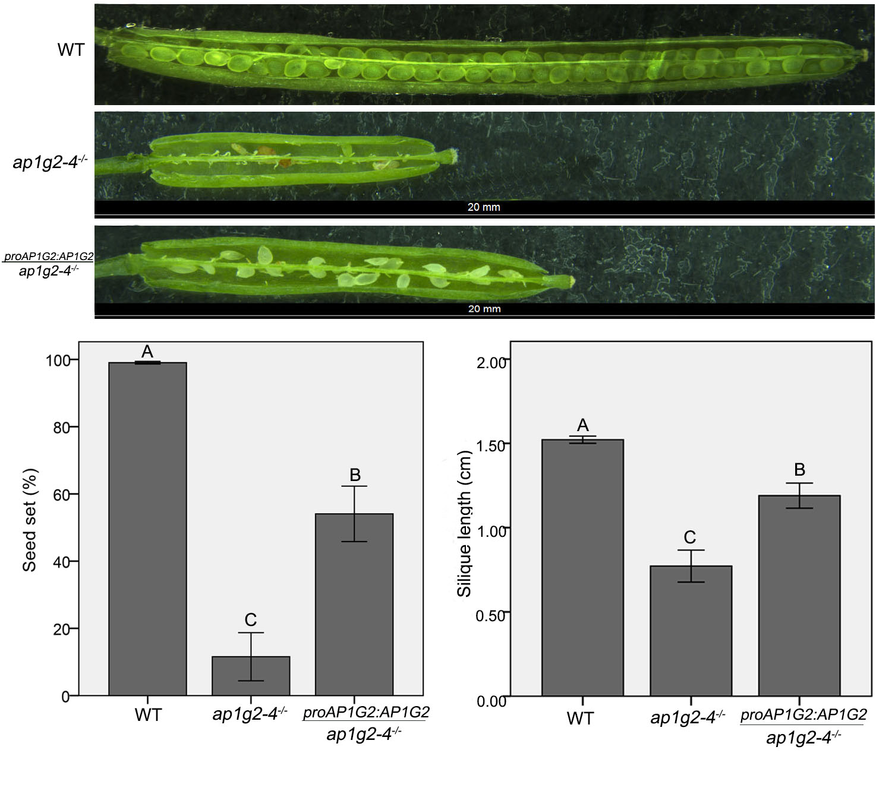
Fig .S5. Siliques from WT, ap1g2-4^{-/-} and complemented ap1g2-4^{-/-} plants. Error bars indicate standard error. The capital letters above the bars mean very significant difference with the wild type (P<0.01).
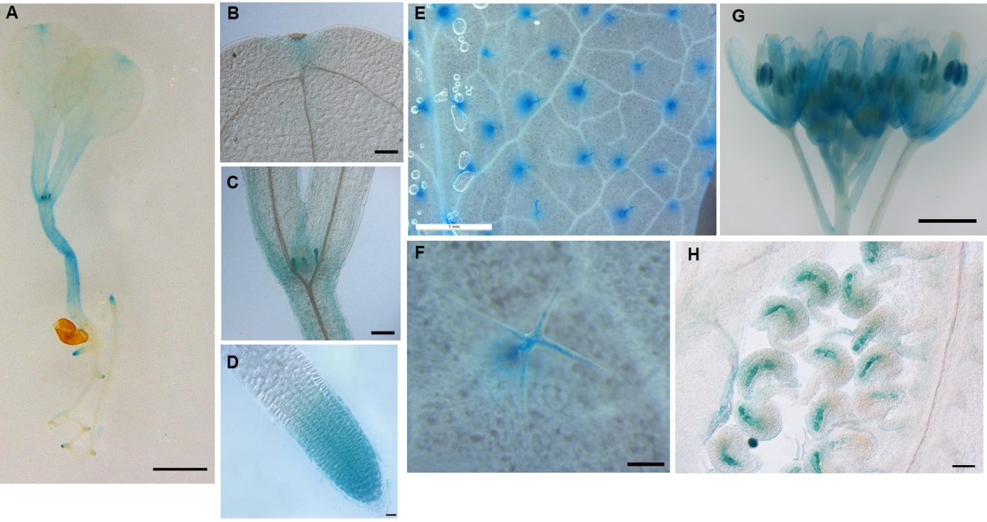
Fig .S5. ProAP1G2:GUS localization patterns.(A-D) 8-day-old seeding: leaf primordial (B) apical meristem (C), root tip (D). (E-F) strong GUS staining in trichomes (G) inflorescence, (H) ovules. Bar=1 cm in A, E, G; 50μm in B,C; 2

