SUPPLEMENTARY MATERIAL

Table S1. Table of archaeological Mus/Apodemus specimens studied, with associated period and context information.
Specimen | Location | Period | Context information
OG01 | Potterne, Wiltshire | Late Bronze Age/Iron Age | N35 134 122 Cutting 12
OG02 | Potterne, Wiltshire | Late Bronze Age/Iron Age | W35 221 5 159 Cutting 12
OG03 | Potterne, Wiltshire | Late Bronze Age/Iron Age | W35 202 565 Cutting 12
OG04 | Potterne, Wiltshire | Late Bronze Age/Iron Age | W35 202 564 Cutting 12
OG05 | Potterne, Wiltshire | Late Bronze Age/Iron Age | W35 221 5160 Cutting 12
OG06 | Potterne, Wiltshire | Late Bronze Age/Iron Age | W35 3716 5.676R Cutting 12
OG07 | Potterne, Wiltshire | Late Bronze Age/Iron Age | W35 221 5160 Cutting 12
OG08 | Battlesbury Bowl, Wiltshire | Iron Age | W4896 4817 <2143>
OG09 | Battlesbury Bowl, Wiltshire | Iron Age | W4896 4817 <2143>
OG10 | Battlesbury Bowl, Wiltshire | Iron Age | W4896 4174 <2010>
OG11 | Battlesbury Bowl, Wiltshire | Iron Age | W4896 5137
OG12 | Battlesbury Bowl, Wiltshire | Iron Age | W4896 5056
OG13 | North West Farm, Dorset | Bronze Age | NWF17 340 "2" bag 79
OG14 | North West Farm, Dorset | Bronze Age | NWF17 340 "1" bag 78
OG15 | Druce Farm, Dorset | Roman Period | DF13 (2) (197) HXAM
OG16 | Druce Farm, Dorset | Roman Period | DF13 (2) (197) HXAM

Table S2. Details of published modern European house mouse sequences used for drawing reduced median-joining networks for haplogroups D and E (Figure 1).
Region | Country | # in D network | # in E network | Reference(s)
British Isles | Britain | 8 | 29 | Prager et al. (1993); Nachman et al. (1994); Bonhomme et al. (2011)
 | England | 0 | 10 | Jones et al. (2011); Jones et al. (2012)
 | Wales | 0 | 1 | Jones et al. (2011); Jones et al. (2012)
Ireland | Ireland | 3 | 25 | Jones et al. (2011); Jones et al. (2012)
France | France | 2 | 25 | Ihle et al. (2006); Bonhomme et al. (2011); Jones et al. (2011)
Germany | Germany | 69 | 21 | Prager et al. (1993); Ihle et al. (2006); Bonhomme et al. (2011)
Scandinavia | Denmark | 54 | 0 | Prager et al. (1993)
 | Norway | 0 | 1 | Prager et al. (1996); Searle et al. (2009)
 | Sweden | 30 | 0 | Prager et al. (1993)
Iberia | Portugal | 9 | 1 | Prager et al. (1993); Gündüz et al. (2001)
 | Spain | 6 | 0 | Prager et al. (1993); Nachman et al. (1994); Bonhomme et al. (2011)
SE Europe | Bulgaria | 3 | 0 | Rajabi-Mahamet al. (2008)
 | Greece | 0 | 3 | Prager et al. (1993); Nachman et al. (1994)
 | Italy | 27 | 0 | Prager et al. (1993); Nachman et al. (1994); Rajabi-Mahamet al. (2008)

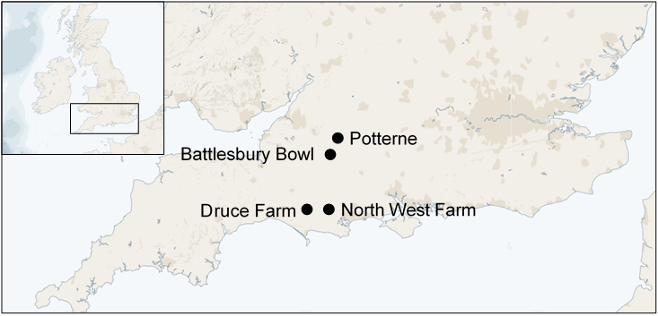
Figure S1. Map of the archaeological sites sampled in this study.
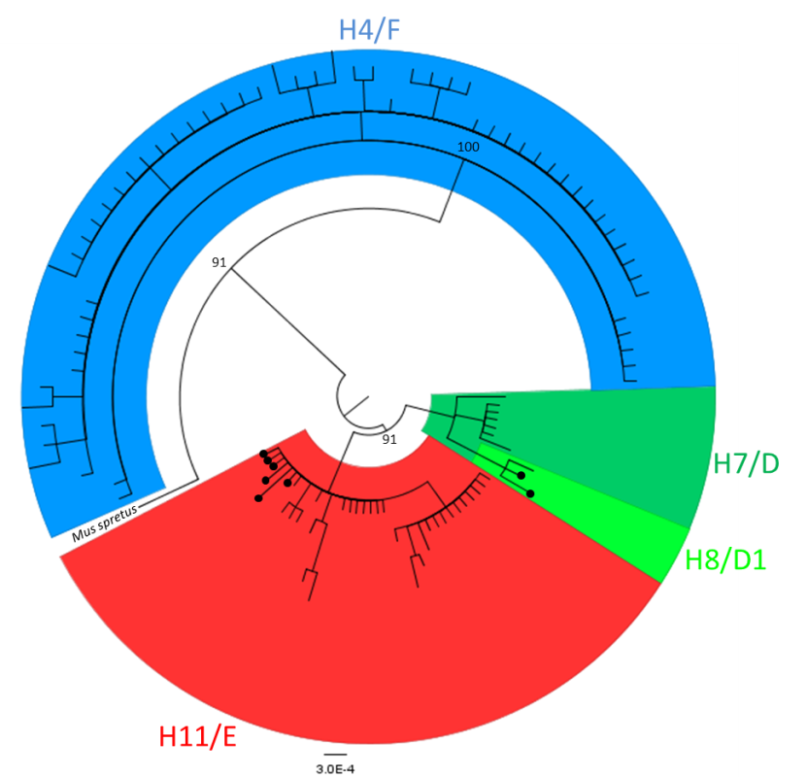
Figure S2. Bayesian phylogenetic tree for 111 modern and eight ancient British mtDNA control-region sequences. Ancient samples are indicated with a black dot.

