Table 1 The number of ST genes and genomes size of the four brown algae [23, 25, 26]
Species | Number of ST genes | Size of genome (Mbp)
S. japonica | 73 | 545
E. siliculosus | 23 | 214
N. decipiens | 10 | 154
C. okamuranus | 9 | 140

Table 2 Features of the S. japonica ST genes and their corresponding proteins
Gene | ID | Scaffolds | Genomic Location | ORF | Exon | AA | MW (kDa) | pIs
ST1 | GENE_011842 | 4 | 10762476-10778806 | 1272 | 13 | 423 | 48.36 | 5.99
ST2 | GENE_021484 | 27 | 754976-771068 | 1416 | 8 | 471 | 51.37 | 6.17
ST3 | GENE_009777 | 15 | 5230475-5248182 | 1266 | 10 | 421 | 46.49 | 8.35
ST4 | XLOC_011209 | 4 | 10825718-10851003 | 1266 | 12 | 421 | 48.31 | 5.13
ST5 | GENE_026617 | Contig2134 | 6272-25732 | 1236 | 9 | 411 | 46.61 | 9.4
ST6 | GENE_013439 | 4 | 12759861-12768682 | 1134 | 5 | 377 | 40.53 | 5.14
ST7 | GENE_011825 | 4 | 10671246-10701618 | 1281 | 13 | 426 | 48.49 | 5.99
ST8 | GENE_026961 | 10 | 4062078-4075767 | 972 | 7 | 323 | 36.23 | 5.88
ST9 | XLOC_019981 | 14 | 13173204-13147606 | 774 | 6 | 257 | 28.67 | 8.82
ST10 | GENE_019245 | Contig569 | 94071-106934 | 783 | 8 | 260 | 28.80 | 9.26
ST11 | GENE_027335 | 6 | 11353032-11356416 | 441 | 4 | 146 | 16.15 | 8.38
ST12 | GENE_019205 | 13 | 7045322-7080034 | 990 | 8 | 329 | 37.22 | 5.67
ST13 | XLOC_015241 | 3 | 8411455-8434996 | 1050 | 10 | 349 | 38.47 | 5.72
ST14 | GENE_005471 | 19 | 3980992-4011984 | 1296 | 11 | 431 | 48.54 | 5.89
ST15 | XLOC_024652 | 6 | 11475841-11490125 | 942 | 7 | 313 | 35.33 | 6.5
ST16 | GENE_024538 | Contig148 | 34484-58037 | 1158 | 11 | 385 | 44.10 | 6.57
ST17 | XLOC_026654 | 14 | 13042373-13061909 | 354 | 3 | 117 | 13.48 | 4.77
ST18 | GENE_016486 | 29 | 6287160-6299378 | 822 | 9 | 273 | 30.81 | 5.96
ST19 | GENE_018833 | 23 | 7201518-7212302 | 948 | 6 | 315 | 34.92 | 7.22
ST20 | GENE_006499 | 6 | 1127751-1135830 | 600 | 6 | 199 | 22.72 | 4.87
ST21 | GENE_017164 | Contig3228 | 10008-34404 | 1320 | 8 | 439 | 49.59 | 8.72
ST22 | GENE_016121 | 25 | 1006090-1010442 | 1371 | 8 | 456 | 51.17 | 9.32
ST23 | GENE_027595 | 3 | 8856825-8882319 | 1146 | 9 | 381 | 43.22 | 6.03
ST24 | GENE_014314 | Contig3637 | 6130-10174 | 1032 | 5 | 343 | 37.22 | 8.76
ST25 | GENE_018873 | 23 | 7165015-7173771 | 1233 | 8 | 410 | 45.28 | 6.29
ST26 | XLOC_010290 | Contig1790 | 17173-23856 | 489 | 5 | 163 | 18.81 | 5.42
ST27 | GENE_007786 | Contig317 | 372098-396742 | 1422 | 6 | 473 | 51.37 | 6.15

Table 3 Transcript profiles of the S. japonica ST genes during different development stages
Trend | Name | ID | Trend | Name | ID
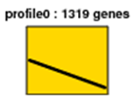 | ST8  ST20  ST21  ST24 | GENE_026961  GENE_006499  GENE_017164  GENE_014314 | 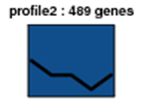 | ST6  ST26 | GENE_013439  XLOC_010290
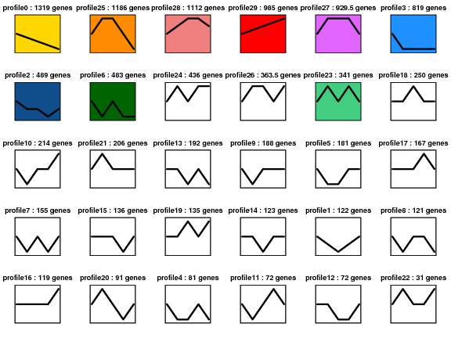 | ST1  ST10  ST27 | GENE_011842  GENE_019245  GENE_007786 |  | ST15  ST23 | XLOC_024652  GENE_027595
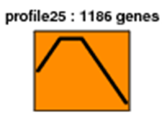 | ST14 | GENE_005471 |  | ST25 | GENE_018873
 | ST5  ST12  ST18 | GENE_026617  GENE_019205  GENE_016486 | 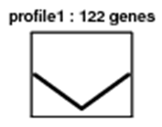 | ST16 | GENE_024538
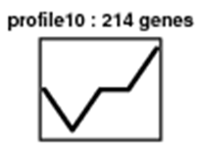 | ST9 | XLOC_019981

Table 4 Transcript profiles of the ST genes in different S. japonica tissues
Trend | Name | ID | Trend | Name | ID
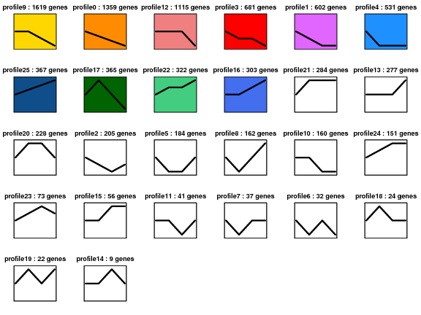 | ST17  ST18  ST25 | XLOC_026654  GENE_016486  GENE_018873 |  | ST8 | GENE_026961
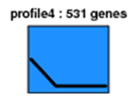 | ST12  ST19 | GENE_019205  GENE_018833 |  | ST2  ST11  ST14  ST22  ST24 | GENE_021484  GENE_027335  GENE_005471  GENE_016121  GENE_014314
 | ST23 | GENE_027595 | 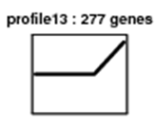 | ST27 | GENE_007786
 | ST6  ST10 | GENE_013439  GENE_019245
Table 5 S. japonica sample collection
Name | Collection time | Tissue site
A1 | 22nd January | Basal
B1 | 4th March | Basal
C1 | 10th April | Basal
C2 | 10th April | 1/3
C3 | 10th April | 2/3
C4 | 10th April | Distal
D1 | 10th May | Basal
D4 | 10th May | Distal
E1 | 16th June | Basal
E4 | 16th June | Distal

Table 6 Primers used for gene cloning and qRT-PCR
Reaction | Gene ID | Forward primer (5’-3’) | Reverse primer (5’-3’)
Genes cloning | GENE_011842 | ATGGCACGACTCTCTCTCAG | TCAGAACTGGTTCATCGGCGGT
Genes cloning | GENE_026617 | ATGGCGGCGATAGTATCAAG | TCAAGCCACGGCTGCAGCTGGA
Genes cloning | GENE_013439 | ATGTACTGTGTGTATGGCCT | CTACGGTTCATAACCTAGAGCATCC
Genes cloning | GENE_014314 | ATGGTGCATGGCTTGGAGTG | CTATAGCTCATAACCTAGAG
qRT-PCR | GENE_011842 | GAAACAAAACGGGGTGGACG | GGTCCGTGGTTGCTACTGAA
qRT-PCR | GENE_021484 | GCTGATAGTGGTGGACTCGG | CATGTCGTTGTGGTCGGAGA
qRT-PCR | GENE_009777 | GCAATCTTGCTTCTGCGACC | CAATCTCAACACCAACGCCC
qRT-PCR | XLOC_011209 | TACCTGGCGAAACCACGAAA | TTCATCAAACCGCTCCGTCA

