Supplementary Table 1. Population size and age structure by urbanity: data from the 2015 Population Census of Korea
 | Dong | Eup | Myeon
Total population | 41,677,695 | 4,616,802 | 4,774,878
Age group
Under 15 (%) | 14.0 | 15.3 | 9.0
15–64 (%) | 74.8 | 70.4 | 64.3
65+ (%) | 11.2 | 14.4 | 26.7
Mean (yr) | 39.4 | 40.4 | 48.4
Median (yr) | 40.1 | 41.1 | 51.2

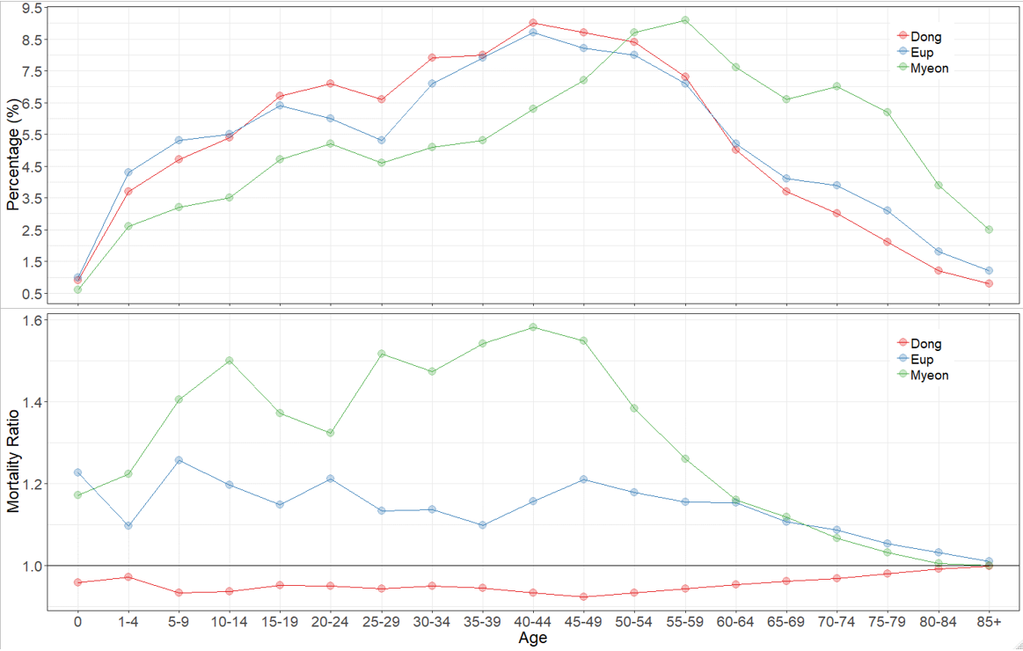
Supplementary Figure 1. Age distribution and age-specific mortality ratios by urbanity with the standard population.

Supplementary Table 2. Distribution of SMRs according to urbanity when the age-specific mortality rate was hypothesized to be the same in all neighborhoods: findings from the National Health Information Database of Korea, 2013–2017.
 | Median | IQR | Min | Max
Dong | 98.5 | 0.6 | 97.5 | 104.6
Eup | 98.5 | 0.3 | 97.6 | 102.0
Myeon | 98.3 | 0.3 | 97.7 | 101.2
Notes. IQR = Interquartile range; Max = Maximum; Min = Minimum.

Supplementary Table 3. Comparison of the top 30 neighborhoods with high mortality as measured by CMF with their results for SMR and LE: findings from the National Health Information Database of Korea, 2013–2017
ID | Type | CMF  (95% CI) | SMR  (95% CI) | LE  (95% CI) | CMF rank  (highest to lowest)  (1) | SMR rank  (highest to lowest)  (2) | LE rank  (lowest to highest)  (3) | (1) - (2) | (1) - (3)
862 | Myeon | 189.0  (172.6,207.0) | 181.8  (166.1,198.9) | 74.8  (73.6,76.1) | 1 | 1 | 3 | 0 | -2
112 | Myeon | 164.3  (151.1,178.8) | 153.8  (141.7,166.9) | 76.1  (74.1,78.1) | 2 | 4 | 13 | -2 | -11
778 | Dong | 164.3  (144.6,186.7) | 157.6  (139.4,178.2) | 77.2  (76.1,78.3) | 3 | 2 | 7 | 1 | -4
1573 | Myeon | 159.5  (133.9,189.9) | 121.8  (108.1,137.2) | 76.5  (75.3,77.6) | 4 | 227 | 26 | -223 | -22
2685 | Myeon | 158.3  (126.2,198.7) | 127.9  (106.5,153.5) | 78.4  (77.3,79.3) | 5 | 102 | 4 | -97 | 1
2952 | Dong | 156.5  (145.8,168.0) | 153.9  (143.7,164.8) | 79.0  (77.6,80.4) | 6 | 3 | 32 | 3 | -26
2326 | Myeon | 156.5  (128.2,191.0) | 122.8  (106.4,141.7) | 78.4  (77.4,79.3) | 7 | 194 | 28 | -187 | -21
1757 | Myeon | 156.2  (137.5,177.4) | 133.6  (119.3,149.6) | 76.4  (71.9,80.0) | 8 | 36 | 19 | -28 | -11
260 | Myeon | 155.1  (128.5,187.2) | 133.1  (114.6,154.6) | 79.1  (78.1,80.2) | 9 | 40 | 25 | -31 | -16
1593 | Myeon | 154.5  (128.0,186.5) | 134.3  (116.8,154.5) | 79.4  (78.3,80.5) | 10 | 30 | 5 | -20 | 5
562 | Dong | 154.1  (133.0,178.6) | 131.6  (115.0,150.6) | 79.2  (78.3,80.1) | 11 | 54 | 27 | -43 | -16
2221 | Myeon | 153.5  (125.9,187.3) | 121.2  (104.9,140.1) | 78.1  (76.7,79.5) | 12 | 249 | 8 | -237 | 4
3266 | Myeon | 153.1  (124.0,189.0) | 143.8  (117.7,175.6) | 79.0  (77.6,80.3) | 13 | 8 | 10 | 5 | 3
1739 | Dong | 152.1  (130.3,177.6) | 132.8  (117.5,150.1) | 78.7  (77.7,79.7) | 14 | 43 | 14 | -29 | 0
1033 | Myeon | 149.5  (124.4,179.7) | 118.5  (103.8,135.3) | 79.0  (78.1,80.0) | 15 | 353 | 12 | -338 | 3
3143 | Myeon | 149.3  (119.7,186.4) | 117.4  (99.7,138.2) | 77.7  (74.0,81.1) | 16 | 401 | 23 | -385 | -7
2302 | Dong | 148.4  (134.9,163.3) | 151.0  (137.7,165.6) | 79.0  (78.3,79.8) | 17 | 5 | 78 | 12 | -61
1813 | Myeon | 147.1  (120.5,179.4) | 137.8  (115.3,164.7) | 78.1  (76.6,79.5) | 18 | 16 | 41 | 2 | -23
2812 | Myeon | 146.2  (122.5,174.4) | 124.8  (108.6,143.4) | 78.6  (75.6,80.9) | 19 | 149 | 31 | -130 | -12
1670 | Myeon | 146.1  (126.6,168.7) | 130.4  (115.9,146.7) | 79.2  (78.1,80.3) | 20 | 67 | 36 | -47 | -16
680 | Myeon | 146.0  (128.4,166.1) | 133.6  (119.7,149.1) | 79.6  (78.6,80.6) | 21 | 37 | 52 | -16 | -31
1398 | Myeon | 145.9  (119.0,178.8) | 127.8  (110.3,148.0) | 78.4  (76.8,79.8) | 22 | 105 | 2 | -83 | 20
2820 | Myeon | 145.6  (127.4,166.4) | 128.5  (114.2,144.6) | 79.0  (77.8,80.2) | 23 | 94 | 48 | -71 | -25
2934 | Dong | 145.5  (134.7,157.2) | 144.7  (134.2,156.0) | 79.3  (78.4,80.1) | 24 | 7 | 76 | 17 | -52
2433 | Myeon | 145.5  (120.7,175.3) | 119.1  (103.8,136.7) | 79.7  (78.1,81.3) | 25 | 330 | 15 | -305 | 10
2747 | Myeon | 144.8  (127.5,164.5) | 127.2  (113.8,142.2) | 79.1  (78.2,80.0) | 26 | 114 | 22 | -88 | 4
966 | Myeon | 144.7  (127.9,163.6) | 130.5  (116.8,145.8) | 78.3  (77.0,79.6) | 27 | 65 | 65 | -38 | -38
2638 | Myeon | 144.5  (123.0,169.8) | 119.4  (105.6,135.1) | 78.8  (77.7,80.0) | 28 | 315 | 9 | -287 | 19
197 | Dong | 144.3  (128.8,161.7) | 135.9  (122.0,151.4) | 79.1  (77.5,80.6) | 29 | 18 | 56 | 11 | -27
2651 | Myeon | 144.3  (120.4,172.9) | 110.5  (97.3,125.5) | 79.1  (77.9,80.1) | 30 | 905 | 37 | -875 | -7
Notes. CI = Confidence interval; CMF = Comparative mortality figure; LE = Life expectancy; SMR = Standardized mortality ratio.

Supplementary Table 4. Comparison of the top 30 neighborhoods with low mortality as measured by CMF with their results for SMR and LE: findings from the National Health Information Database of Korea, 2013–2017
ID | Type | CMF  (95% CI) | SMR  (95% CI) | LE  (95% CI) | SMR rank  (lowest to highest) (1) | CMF rank  (lowest to highest)  (2) | LE rank  (highest to lowest)  (3) | (1) - (2) | (1) - (3)
1016 | Dong | 49.4  (42.4,57.7) | 51.4  (44.1,59.9) | 89.8  (88.9,90.8) | 1 | 1 | 2 | 0 | -1
1864 | Dong | 55.3  (50.3,60.8) | 57.7  (52.5,63.4) | 88.6  (88.0,89.3) | 2 | 4 | 4 | -2 | -2
1290 | Dong | 58.2  (49.1,69.0) | 57.8  (48.9,68.3) | 89.2  (87.9,90.5) | 3 | 5 | 3 | -2 | 0
1270 | Dong | 59.1  (51.9,67.4) | 57.0  (50.2,64.7) | 87.7  (86.8,88.6) | 4 | 3 | 12 | 1 | -8
2776 | Dong | 59.5  (54.9,64.5) | 60.3  (55.6,65.4) | 87.9  (87.4,88.5) | 5 | 10 | 6 | -5 | -1
231 | Dong | 60.2  (52.1,69.4) | 55.3  (48.2,63.5) | 87.6  (86.5,88.7) | 6 | 2 | 14 | 4 | -8
502 | Dong | 60.3  (53.6,67.8) | 61.2  (54.5,68.7) | 88.0  (87.0,89.0) | 7 | 11 | 5 | -4 | 2
3360 | Dong | 60.5  (54.4,67.4) | 58.5  (52.6,65.0) | 87.5  (86.8,88.2) | 8 | 7 | 17 | 1 | -9
3115 | Dong | 60.7  (53.5,68.8) | 59.8  (52.8,67.7) | 87.6  (86.8,88.5) | 9 | 8 | 13 | 1 | -4
318 | Dong | 60.7  (55.0,66.9) | 57.8  (52.5,63.6) | 87.7  (87.0,88.4) | 10 | 6 | 11 | 4 | -1
1298 | Dong | 61.0  (54.3,68.6) | 60.0  (53.4,67.4) | 87.8  (87.0,88.7) | 11 | 9 | 8 | 2 | 3
311 | Dong | 62.2  (56.9,68.0) | 62.7  (57.4,68.5) | 87.6  (86.9,88.2) | 12 | 17 | 15 | -5 | -3
1111 | Dong | 62.8  (56.1,70.2) | 63.3  (56.6,70.8) | 86.9  (86.2,87.7) | 13 | 21 | 32 | -8 | -19
2665 | Dong | 63.0  (55.4,71.6) | 62.8  (55.3,71.4) | 87.7  (86.7,88.6) | 14 | 18 | 10 | -4 | 4
1303 | Dong | 63.1  (57.7,69.1) | 64.2  (58.7,70.2) | 87.4  (86.7,88.1) | 15 | 26 | 19 | -11 | -4
1480 | Dong | 63.7  (58.3,69.5) | 63.3  (58.2,68.9) | 87.2  (86.6,87.9) | 16 | 22 | 25 | -6 | -9
1756 | Dong | 63.8  (59.1,68.9) | 62.5  (57.9,67.5) | 87.0  (86.5,87.5) | 17 | 15 | 31 | 2 | -14
1371 | Dong | 64.1  (58.8,69.9) | 62.8  (57.7,68.4) | 86.9  (86.3,87.4) | 18 | 19 | 35 | -1 | -17
2828 | Dong | 64.3  (57.4,71.9) | 64.4  (57.6,72.0) | 87.2  (86.3,88.0) | 19 | 27 | 26 | -8 | -7
3214 | Dong | 64.4  (57.5,72.3) | 63.8  (57.0,71.4) | 87.9  (87.0,88.7) | 20 | 24 | 7 | -4 | 13
1269 | Dong | 64.7  (57.5,72.8) | 63.4  (56.7,70.9) | 87.8  (86.8,88.7) | 21 | 23 | 9 | -2 | 12
2728 | Dong | 64.8  (56.8,74.0) | 64.8  (56.9,73.8) | 87.6  (86.5,88.6) | 22 | 28 | 16 | -6 | 6
3067 | Dong | 65.3  (58.1,73.4) | 62.5  (55.7,70.1) | 87.4  (86.5,88.2) | 23 | 16 | 21 | 7 | 2
2232 | Dong | 65.3  (59.0,72.4) | 63.2  (57.2,69.9) | 86.8  (86.1,87.5) | 24 | 20 | 37 | 4 | -13
2568 | Dong | 65.8  (58.6,73.8) | 65.9  (58.8,73.8) | 86.7  (85.8,87.6) | 25 | 34 | 39 | -9 | -14
879 | Dong | 66.2  (59.1,74.1) | 64.1  (57.5,71.5) | 86.7  (85.8,87.5) | 26 | 25 | 43 | 1 | -17
965 | Dong | 66.2  (60.8,72.1) | 65.2  (59.9,70.9) | 87.1  (86.5,87.7) | 27 | 30 | 27 | -3 | 0
1427 | Dong | 66.6  (61.6,72.0) | 65.2  (60.3,70.5) | 86.5  (86.0,87.1) | 28 | 31 | 50 | -3 | -22
2103 | Dong | 66.8  (58.3,76.4) | 65.2  (57.1,74.4) | 86.7  (85.7,87.6) | 29 | 32 | 44 | -3 | -15
1871 | Dong | 66.8  (60.8,73.3) | 61.6  (56.3,67.5) | 86.6  (86.0,87.3) | 30 | 13 | 45 | 17 | -15
Notes. CI = Confidence interval; CMF = Comparative mortality figure; LE = Life expectancy; SMR = Standardized mortality ratio.

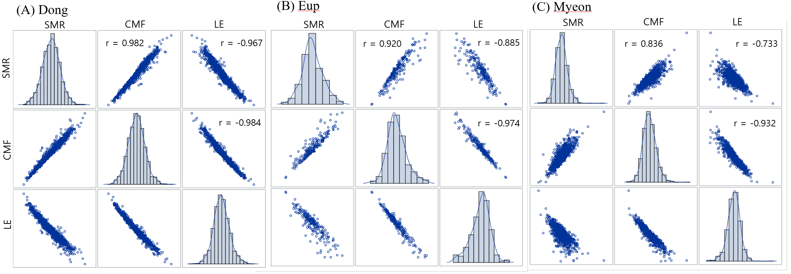
Supplementary Figure 2. Scatter plots and correlation coefficients [r] for SMR, CMF, and LE of neighborhoods stratified by urbanity: findings from the National Health Information Database of Korea, 2013–2017.
Notes. CMF = Comparative mortality figure; LE = Life expectancy; SMR = Standardized mortality ratio.

