Supplementary information
Article title: Taxonomic composition and diversity of gut microbiota in relation to long-term dietary intake in healthy Korean adults
Authors and Affiliations: Hwayoung Noh¹, Hwan-Hee Jang², Gichang Kim², Semi Zouiouich¹, Su-Yeon Cho², Hyeon-Jeong Kim², Jeong-Seon Kim³, Jeong-Sook Choe², Marc J. Gunter¹, Pietro Ferrari¹, Augustin Scalbert¹, Heinz Freisling¹
1. Section of Nutrition and Metabolism, International Agency for Research on Cancer (IARC-WHO), Lyon, France
2. National Institute of Agricultural Science, Rural Development Administration, Jeonju, Republic of Korea
3. Cancer Epidemiology Branch, National Cancer Center, Goyang, Republic of Korea

This document contains the following items:
Table S1: Difference of relative abundance (% OUT) of four major phyla and Firmicutes-to-Bacteroidetes (F/B) ratio by basic characteristic and lifestyle factors of the healthy Korean adults
Table S2: Associations of within-subject (α-) and between-subject (β-) diversity of the gut microbiota with basic characteristic and lifestyle factors of the healthy Korean adults
Table S3. Spearman correlations between the within-subject (α-) diversity of the gut microbiota and dietary intake at food and nutrient levels in the NAS-IARC cross-sectional study
Table S4. General characteristic and lifestyle factors among enterotypes in the healthy Korean adults
Figure S1. Heatmaps of Spearman correlations between of intakes of macronutrients and relative abundance of gut microbiota at phylum and genus levels in the NAS-IARC cross-sectional study
Figure S2. Plots to select optimal numbers of clusters with (a) Elbow, (b) Silhouette, and (c) Gap statistic methods on K-means clustering

Table S1. Differenceª of relative abundance (% OUT) of four major phyla and Firmicutes-to-Bacteroidetes (F/B) ratio by basic characteristic and lifestyle factors of the healthy Korean adults (n=222 participants)
 | Actinobacteria |  |  | Bacteroidetes |  |  |  |  | Firmicutes |  |  |  | Proteobacteria |  | F/B ratio
 | Median(%) | Range(%)^{b} | Median(%) |  |  | Range(%)^{b} | Median(%) |  |  | Range(%)^{b} | Median(%) |  |  | Range(%)^{b} | Median | Range^{b}
Total subjects (n=222) | 0.41 | 0.11-1.24 | 54.3 |  | 40.7-64.9 |  |  | 37.7 |  | 26.4-50.0 |  | 3.8 |  | 1.9-7.2 | 0.69 | 0.41-1.22
Sex
Men (n=108) | 0.44 | 0.11-1.25 | 54.4 |  | 43.9-67.0 |  |  | 33.0 |  | 23.6-46.9 |  | 4.9 |  | 2.7-10.7 | 0.60 | 0.36-1.06
Women (n=114) | 0.37 | 0.11-1.24 | 53.8 |  | 39.4-62.6 |  |  | 39.6 |  | 29.9-51.4 |  | 3.0 |  | 1.5-5.6 | 0.73 | 0.48-1.32
P-valueª | 0.946 |  | 0.133 |  |  |  |  | 0.008 |  |  |  | <.001 |  |  | 0.023
Age group
<40 years (n=175) | 0.44 | 0.11-1.18 | 53.8 |  | 41.1-65.6 |  |  | 35.6 |  | 25.4-48.7 |  | 4.2 |  | 2.3-8.1 | 0.63 | 0.39-1.21
≥ 40 years (n=47) | 0.37 | 0.09-1.47 | 54.8 |  | 39.4-64.2 |  |  | 39.9 |  | 28.8-51.4 |  | 3.0 |  | 1.4-5.4 | 0.74 | 0.47-1.32
P-valueª | 0.920 |  | 0.447 |  |  |  |  | 0.128 |  |  |  | 0.024 |  |  | 0.203
BMI group
<23 kg/m² (n=128) | 0.41 | 0.02-5.18 | 52.8 |  | 25.5-78.2 |  |  | 37.7 |  | 14.5-67.3 |  | 4.1 |  | 0.6-18.7 | 0.69 | 0.19-2.62
≥23 kg/m² (n=94) | 0.42 | 0.02-3.60 | 56.5 |  | 24.0-79.2 |  |  | 37.0 |  | 13.4-72.2 |  | 3.7 |  | 0.5-19.4 | 0.64 | 0.20-2.84
P-valueª | 0.937 |  | 0.179 |  |  |  |  | 0.508 |  |  |  | 0.371 |  |  | 0.344
Dietary supplement intake
Yes (n=76) | 0.30 | 0.09-1.12 | 54.8 |  | 41.8-63.4 |  |  | 37.6 |  | 27.1-50.7 |  | 2.7 |  | 1.4-5.9 | 0.67 | 0.42-1.23
No (n=143) | 0.48 | 0.13-1.26 | 53.3 |  | 40.6-65.6 |  |  | 37.7 |  | 26.3-50.0 |  | 4.3 |  | 2.4-7.7 | 0.68 | 0.39-1.24
P-valueª | 0.146 |  | 0.926 |  |  |  |  | 0.914 |  |  |  | 0.015 |  |  | 0.972
Regular physical activity
Yes (n=92) | 0.36 | 0.09-1.16 | 52.2 |  | 39.4-63.9 |  |  | 38.4 |  | 28.1-50.7 |  | 3.8 |  | 1.8-6.6 | 0.70 | 0.45-1.32
No (n=130) | 0.44 | 0.13-1.26 | 55.5 |  | 41.1-65.6 |  |  | 35.6 |  | 25.2-48.7 |  | 3.8 |  | 2.0-7.5 | 0.64 | 0.38-1.15
P-valueª | 0.411 |  | 0.369 |  |  |  |  | 0.416 |  |  |  | 0.845 |  |  | 0.319
Smoking status
Ever (n=54) | 0.35 | 0.09-1.14 | 57.4 |  | 48.5-70.0 |  |  | 33.5 |  | 23.9-45.9 |  | 3.6 |  | 2.5-7.1 | 0.61 | 0.36-0.97
Never (n=168) | 0.44 | 0.12-1.24 | 53.1 |  | 39.2-63.1 |  |  | 38.4 |  | 27.8-50.9 |  | 3.9 |  | 1.8-7.2 | 0.70 | 0.43-1.33
P-valueª | 0.392 |  | 0.017 |  |  |  |  | 0.075 |  |  |  | 0.874 |  |  | 0.040
Education
<University (n=110) | 0.52 | 0.13-1.10 | 55.7 |  | 40.3-65.3 |  |  | 33.7 |  | 25.4-48.2 |  | 4.5 |  | 2.4-8.9 | 0.61 | 0.39-1.22
≥University (n=113) | 0.34 | 0.09-1.30 | 52.8 |  | 41.5-64.3 |  |  | 39.8 |  | 26.9-50.6 |  | 3.4 |  | 1.6-5.9 | 0.74 | 0.42-1.23
P-valueª | 0.300 |  | 0.893 |  |  |  |  | 0.235 |  |  |  | 0.067 |  |  | 0.402
Household Income
<4,000 USD/month (n=79) | 0.42 | 0.13-0.97 | 52.9 |  | 43.2-65.6 |  |  | 36.4 |  | 23.6-50.6 |  | 3.8 |  | 1.5-5.9 | 0.63 | 0.39-1.21
≥4,000 USD/month (n=93) | 0.37 | 0.09-1.10 | 55.4 |  | 40.6-65.6 |  |  | 38.4 |  | 26.5-48.2 |  | 3.4 |  | 1.8-6.1 | 0.68 | 0.39-1.15
P-valueª | 0.690 |  |  | 0.905 |  |  |  |  | 0.650 |  |  |  | 0.762 |  | 0.661
^{a.} The differences of % OTU of major four phyla by basic characteristic and lifestyle factors were examined by Wilcoxon-Mann-Whitney test
^{b.}as interquartile range
Table S2. Associations of within-subject (α-) and between-subject (β-) diversity of the gut microbiota with basic characteristic and lifestyle factors of the healthy Korean adults (n=222 participants)
 | α-diversity ^{a, b}  Shannon index |  | β-diversity ^{c}  Weighted UniFrac
 | F statistic | P-value |  | F statistic | P-value
Sex | 6.41 | 0.012 |  | 2.03 | 0.111
Age group | 11.58 | 0.001 |  | 1.11 | 0.295
BMI group | 1.47 | 0.227 |  | 3.14 | 0.040
Dietary supplement intake | 0.47 | 0.495 |  | 0.40 | 0.810
Smoking status | 3.59 | 0.059 |  | 2.84 | 0.034
Age group (≥ 40 vs. <40 years); BMI group (<23 kg/m² vs. ≥23 kg/m²); Dietary supplement intake within 3 month (yes vs. no); Smoking status (ever vs. never)
^{a.} The α-diversity index – Shannon index was log-transformed
^{b.} The statistical significance of associations of the α-diversity with basic characteristic and lifestyle factors were tested by general linear models (GLM)
^{c.} The statistical significance of associations of the β-diversity with basic characteristic and lifestyle factors were tested by permutational multivariate analysis of variance (PERMANOVA)

Table S3. Spearman correlations ª between the within-subject (α-) diversity of the gut microbiota and dietary intake at food and nutrient levels in the NAS-IARC cross-sectional study (n=222 participants)
 | α-diversity index – Shannon ^{b}
 | Coefficients | P-value
Food groups ^{c}
Potatoes | 0.197 | 0.004
Vegetables | 0.205 | 0.003
Fermented vegetables | 0.079 | 0.246
Legumes | 0.092 | 0.179
Fermented legumes | 0.201 | 0.003
Fruit/Fruit Juice | 0.134 | 0.049
Nuts/Seeds | 0.139 | 0.041
Dairy | 0.087 | 0.203
Refined grains | -0.060 | 0.383
Multi/whole grains | -0.008 | 0.911
Other cereal products | -0.080 | 0.240
Meats | 0.043 | 0.530
Fish/Seashells | 0.108 | 0.113
Eggs | 0.034 | 0.616
Vegetable oils | 0.079 | 0.250
Other fats | 0.040 | 0.563
Suger/Confectionary | 0.076 | 0.266
Cakes/Sweets | 0.069 | 0.311
Coffee | 0.068 | 0.317
Tea | 0.102 | 0.134
Non-alcoholic Beverages | -0.102 | 0.134
Salty snacks | 0.042 | 0.541
Macronutrients ^{c}
Plant Protein | 0.123 | 0.070
Animal Protein | 0.108 | 0.113
Carbohydrate | -0.025 | 0.717
Dietary fiber | 0.199 | 0.003
Plant Fat | 0.067 | 0.328
Animal Fat | 0.064 | 0.346
SFA | 0.043 | 0.527
MUFA | 0.047 | 0.493
PUFA | 0.102 | 0.135
Alcohol | 0.029 | 0.669
ª Partial Spearman correlation analysis with adjustment for sex, age, BMI, dietary supplement intake, smoking status, and batch effect
^{b} The α-diversity index – Shannon index was log-transformed
^{c} The intakes of food groups were log-transformed and adjusted for total energy intake using the residual method

Table S4. General characteristic and lifestyle factors among three enterotypes in the healthy Korean adults (n=222 participants)
 | Enterotype 1 |  |  | Enterotype 2 |  |  | Enterotype 3
 | (n=82, 36.9%) |  |  | (n=64, 28.8%) |  |  | (n=76, 34.2%)
Sex – men (n, %) | 43 | 52.4% | 32 |  | 50.0% | 33 |  | 43.4%
Age (yr)ª | 29.4 | 21-48 | 29.3 |  | 20-50 | 30.1 |  | 20-54
BMI (kg/m²) ª | 23.1 | 19.1-29.0 | 23.3 |  | 19.6-28.0 | 22.4 |  | 18.9-27.0
Dietary supplement – yes (n, %) | 30 | 36.6% | 21 |  | 32.8% | 25 |  | 32.9%
Smoking status – never (n, %) | 61 | 74.4% | 44 |  | 68.8% | 63 |  | 82.8%
ª Mean and range (5-95 percentile)
^{b} No significant difference in each variable by three enterotypes examined by general linear models (GLMs) for continuous variables (age and BMI) and by chi-square tests for categorical variables (sex, dietary supplement, and smoking status)
Figure S1. Heatmaps of partial Spearman correlations between intakes of macronutrients and relative abundance of gut microbiota at phylum (a) and genus (b) levels in the NAS-IARC cross-sectional study (n=222 participants). Partial Spearman correlation analysis adjusted for sex, age, BMI, dietary supplement intake, smoking status, and batch effect; The intakes of macronutrients were log-transformed and adjusted for total energy intake using the residual method; Firmicutes-to-Bacteriodetes ratio was labeled as F_B_Ratio in the heatmap (a); The names of genera were labeled as phylum initial(B, P, A or F)_genus in the heatmap (b)
A. Phylum level
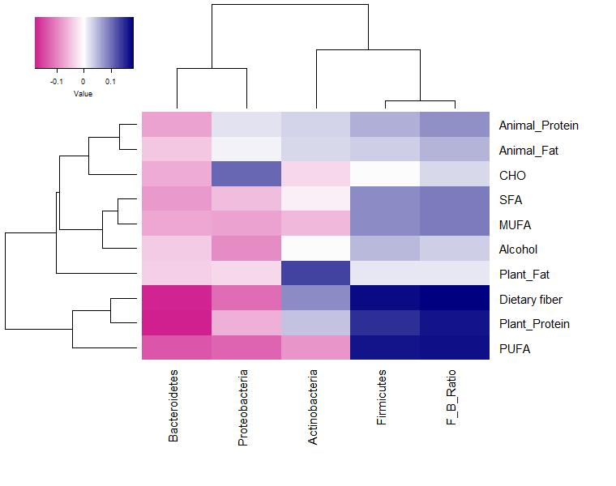
B. Genus level
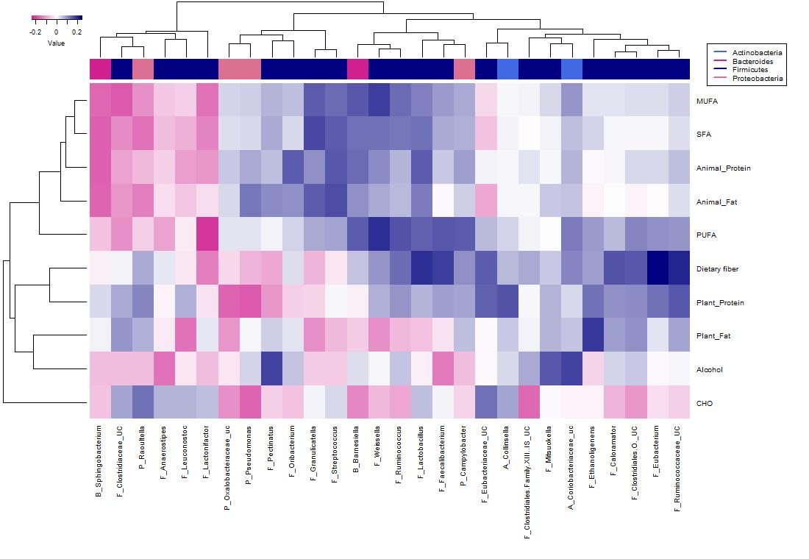
Figure S2. Plots for selecting optimal numbers of clusters with (a) Elbow, (b) Silhouette, and (c) Gap statistic methods on K-means clustering
(a) Elbow method (b) Silhouette method (c) Gap statistic method
