SUPPLEMENTARY DATA

NTP42, a novel antagonist of the thromboxane receptor, attenuates experimentally induced pulmonary arterial hypertension

Eamon P. Mulvaney¹, Helen M. Reid^{1, 2}, Lucia Bialesova¹, Annie Bouchard³, Dany Salvail³ and B. Therese Kinsella^{1, 2}

¹ ATXA Therapeutics Limited, UCD Conway Institute of Biomolecular and Biomedical Research, University College Dublin, Belfield, Dublin 4, Ireland
² UCD School of Biomolecular and Biomedical Sciences, UCD Conway Institute of Biomolecular and Biomedical Research, University College Dublin, Belfield, Dublin 4, Ireland
³ IPS Therapeutique Inc., 3035 Boulevard Industriel, Sherbrooke, QC J1L 2T9, Canada

Corresponding Author: Prof. B. Therese Kinsella, PhD, MRIA
ATXA Therapeutics Limited
UCD Conway Institute of Biomolecular and Biomedical Research
University College Dublin
Belfield, Dublin 4
IRELAND
Email: therese.kinsella@ucd.ie; Telephone: +353 1 716 6727
Supplementary Methods

Human lung tissue
Human lung tissue samples, obtained from the Royal Papworth Hospital NHS Foundation Trust Tissue Bank (Cambridge, UK), were sectioned at 4 μm thickness and baked onto slides at 50–56 °C for 60 min. Sections were dewaxed in two changes of xylene (2 × 10 min incubations) and rehydrated through a series of decreasing alcohol solutions (100%, 3 min × 2; 95%, 1 min; 80%, 1 min) before being washed in double-distilled water (ddH₂O). Sections were stained with haematoxylin and eosin (H&E) or were subject to immunohistochemical (IHC) staining for the I Prostanoid (IP) and both TPα and TPβ isoforms of the T Prostanoid receptor (TP). For IHC staining, antigen retrieval was first performed by boiling the slides in sodium citrate buffer, pH 6 in a pressure cooker for 5 min. Endogenous peroxidase activity was blocked by incubating the slides in hydrogen peroxide (3% v/v prepared in absolute methanol) for 10 min at room temperature (RT), followed by washing in 1× phosphate-buffered saline (PBS). To block non-specific binding and endogenous biotin, the tissue sections were incubated for 30 min at RT with 5% goat serum in PBS (Blocking Buffer) containing Avidin D (4 drops/ml; Avidin/Biotin Blocking Kit). Sections were then incubated with the desired primary (1°) antibody (~500 μl/slide) for the required incubation period (30 min or overnight) in a humidified chamber, where affinity-purified rabbit anti-IP (2.0 μg/ml), anti-TPα (9 μg/ml) or anti-TPβ (1.8 μg/ml) antibodies were used to detect IP, TPα or TPβ, respectively.^{1, 2} All primary antibodies were diluted in Blocking Buffer, containing Biotin (4 drops/ml; Avidin/Biotin Blocking Kit). As a negative control, sections were also incubated with Blocking Buffer in the absence of primary antibody. Following incubation with primary antibody, sections were washed in PBS (3 × 5 min washes; 500 μl/slide) and incubated for 30 min with a biotinylated anti-rabbit immunoglobulin (Ig) G secondary antibody prepared in 5% goat serum (1:500). Sections were then washed in PBS (3 × 5 min washes), followed by incubation with streptavidin-conjugated horseradish peroxidase (diluted 1:1500 in Blocking Buffer) for 30 min at room temperature. Thereafter, the slides were incubated with the chromogen 3,3’diaminobenzidine substrate for 5 min. Finally, tissue sections were counterstained for 1 min with haematoxylin (Harris modified), followed by washing in ddH₂O. Sections were then dehydrated through increasing alcohol series (80%, 1 min; 95%, 1 min; 100%, 3 min × 2) and xylene (2 × 10 min), prior to mounting in DPX. Slides were scanned at 40X magnification using the Aperio Slide Scanner ScanScope XT and viewed using QuPath quantitative pathology and bioimage analysis software³.

Pulmonary histology and vascular morphometry
Formalin-fixed paraffin-embedded (FFPE) tissue blocks from the middle regions of the left lungs from animals within Cohorts #1 & #2 on the monocrotaline (MCT)-induced PAH syudy (see Supplemental Table 1) were subject to sectioning to yield 4 μm thick sections and stained with H&E to facilitate detailed morphometric analysis to evaluate pulmonary vascular remodelling. H&E-stained tissue sections were scanned at 40X magnification using the Aperio Slide Scanner ScanScope XT and viewed using QuPath quantitative pathology and bioimage analysis software³. The digital image of the tissue section was overlaid with a 1 mm² grid. The squares in the gridded image were numbered where only squares with ≥ 50 % lung tissue present were considered for analysis. Using random number generation in Microsoft Excel, 10 squares were selected and annotated within the image in QuPath, using the grid as a guide to obtain 1 mm² regions for analysis. Note that if any of the squares possessed large or primary blood vessels or significant bronchial tissue, then an adjacent grid square was selected as an alternate. Within each of the squares selected per lung tissue, all blood vessels were measured for luminal and total vessel diameter using the QuPath measurement & annotation tool. Vessels smaller than 15 µm were not included in the analysis. Note that the lumen area was defined as the area within the lamina elastica interna, the layer just below the endothelial cells. Hence, lumen diameter was measured from inner edge of the lamina elastic interna on one side to the inner edge of the other side. For total vessel diameter, measurements were made from the outer edge of the lamina elastic externa on one side to the outer edge of the other side. From these measurements, a lumen:total vessel diameter ratio, medial wall thickness and percentage occlusion may be determined, similar to the method presented previously⁴. For vessels that were not presented in cross section or as circular vessels but appeared as longitudinal section or oval shape, lumen and total diameter measurements were taken perpendicular to the mid-point of the longest length of the vessel observed. Lumen and total vessel diameter were appropriately annotated (vessel number, lumen/total) and the table of annotations was exported to Microsoft Excel for analysis. Vessels were categorised as small where the total vessel diameter was ≤ 50 µm. Morphometric analysis was subsequently carried out on each section, where measurements for the total and lumen vessel diameter for all arterioles of diameter ≥ 15 μm present in 10 randomly-selected fields/section (10 mm² total tissue area sampled) were recorded, essentially as previously described⁴. The Lumen:Total Ratio was calculated from: (lumen diameter/total vessel diameter). The medial thickness was calculated from: (total vessel diameter – lumen diameter) / 2. The degree of vessel occlusion was calculated from: [(total vessel diameter – lumen diameter)/total vessel diameter] × 100. All analyses were carried out in a blinded fashion with overlap on a minimum of 20% of all sections by three independent observers.

Measurement of intracellular calcium ([Ca²⁺]_{i}) mobilisation
The human embryonic kidney (HEK) 293 cell line stably over-expressing a hemagglutinin (HA) epitope-tagged form of the TPβ isoform of the human TP (HEK.TPβ) has been previously described.⁵ HEK.TPβ cells were routinely cultured in minimal essential medium (MEM) with Earle's salts supplemented with 10% foetal bovine serum (FBS) and maintained at 37 °C in 5 % CO₂. Prior to performing calcium mobilisation assays, HEK.TPβ cells were washed and harvested in Krebs-HEPES buffer (118 mM NaCl, 4.7 mM KCl, 1.2 mM MgSO₄, 1.2 mM KH₂PO₄, 4.2 mM NaHCO₃, 11.7 mM D-glucose, 1.3 mM CaCl₂, 10 mM HEPES, pH 7.4). Cells were then incubated with 3 μM Fluo-4 AM (ThermoFisher Scientific) in Krebs-HEPES buffer containing 1% Pluronic F-127 for 1 hour at 25 °C. The cells were washed and diluted with Krebs-HEPES buffer containing 0.5 % bovine serum albumin (BSA), to provide a final concentration of 3 x 10⁵ cells/ml. Cells were then plated in black 96-well microplates at a density of approximately 50,000 cells/well (160 μl) with either vehicle (0.1 % DMSO) or with the TP antagonist, NTP42, where the antagonist concentration was 10X the desired concentration (0.00001 - 10 µM) in 20 μl volume. Fluorescence measurements were performed using the Fluoroskan Ascent microplate fluorometer (ThermoFisher Scientific) based on the protocol described previously.⁶ In brief, fluorescence intensity was measured at 520 nm emission wavelength (excitation wavelength 485 nm) for 20 seconds to monitor baseline prior to the addition (20 μl) of the agonists U46619 or 8-iso-PGF_{2α}, to achieve the final concentration of 1 μM or 10 μM, respectively. Fluorescence intensity was monitored for a further 120 seconds. Calibration of the fluorescence intensity was performed in each sample by adding 1% Triton X-100 to obtain the maximal fluorescence ratio (F_{max}) and then 300 mM EGTA to obtain the minimal fluorescence ratio (F_{min}). Intracellular Ca²⁺ ([Ca²⁺]_{i}) mobilisation was then calculated from: [Ca²⁺] = Kd(F - F_{min})/(F_{max} - F), where the equilibrium dissociation constant (Kd) for Fluo-4 AM is 345 nM.

Measurement of platelet aggregation
Approximately 50 ml of blood was obtained through venepuncture from healthy volunteers, who had not taken medication for 14 days, into syringes containing indomethacin (10 µM) and 3.8% sodium citrate (9:1 v/v) (final concentration, 0.38% sodium citrate). Blood was centrifuged for 10 minutes at 160 × g to obtain platelet rich plasma (PRP). Platelet poor plasma (PPP) was prepared by centrifuging the remaining blood for 15 minutes centrifugation at 900 × g. Platelet aggregation was assessed by light transmittance aggregometry using a PAP-8E platelet aggregation profiler (Bio/Data Corporation). Aliquots of PRP (300 µl) were pre-incubated for 10 min with NTP42, where 2-fold serial dilutions from 250 – 3.8 nM were prepared for each, prior to stimulating platelets with 1 µM U46619, incubated at 37 °C, with stirring. The results are presented as the mean (± S.E.M.) Percentage Aggregation determined by changes in light transmission over time as a function of the log concentration of NTP42.
Supplementary Tables

Supplemental Table 1

Group  # | Group Description | Treatment  Dose | Cohort #1 (N) |  | Cohort #2 (N) |  | Total#
Group  # | Group Description | Treatment  Dose | Enrolled | Deaths* | Enrolled | Deaths* | Total#
1 | No MCT (Vehicle) | BID | 8 | 0 | 6 | 0 | 14
2 | MCT Only (Vehicle) | BID | 8 | 2 | 8 | 0 | 14
3 | NTP42 | 0.25 mg/kg BID | 8 | 0 | 8 | 2 | 14
4 | Sildenafil | 50 mg/kg BID | 8 | 2 | 6 | 0 | 12
5 | Selexipag | 1 mg/kg BID | - | - | 6 | 0 | 6
*Animal deaths that occurred following MCT injection and before terminal surgery
# Total animals surviving through to terminal surgery

Supplemental Table 2

Prostanoid Receptor | Cell Line* | Assay Type/Detection Method$
Prostaglandin D₂ Receptor 1 (DP1) | HEK 293 | cAMP/HTRF
Prostaglandin E₂ Receptor 1 (EP1) | HEK 293 | [Ca²⁺]_{i}/Fluorimetry
Prostaglandin E₂ Receptor 2 (EP2) | HEK 293 | cAMP/HTRF
Prostaglandin E₂ Receptor 3 (EP3) | HEK 293 | Impedance/Cellular dielectric spectroscopy
Prostaglandin E₂ Receptor 4 (EP4) | HEK 293 | cAMP/HTRF
Prostaglandin F₂ Receptor (FP) | HEK 293 | [Ca²⁺]_{i}/Fluorimetry
Prostaglandin I₂ Receptor (IP) | HEK 293 | cAMP/HTRF
Thromboxane A₂ Receptor α (TPα) | HEK 293 | [Ca²⁺]_{i}/Fluorimetry
* Specific mammalian cell line used typically over-expressed the given receptor.
$ Depending on the target GPCR evaluated, the assay type and method of detection varied as specified.

Supplementary Figures

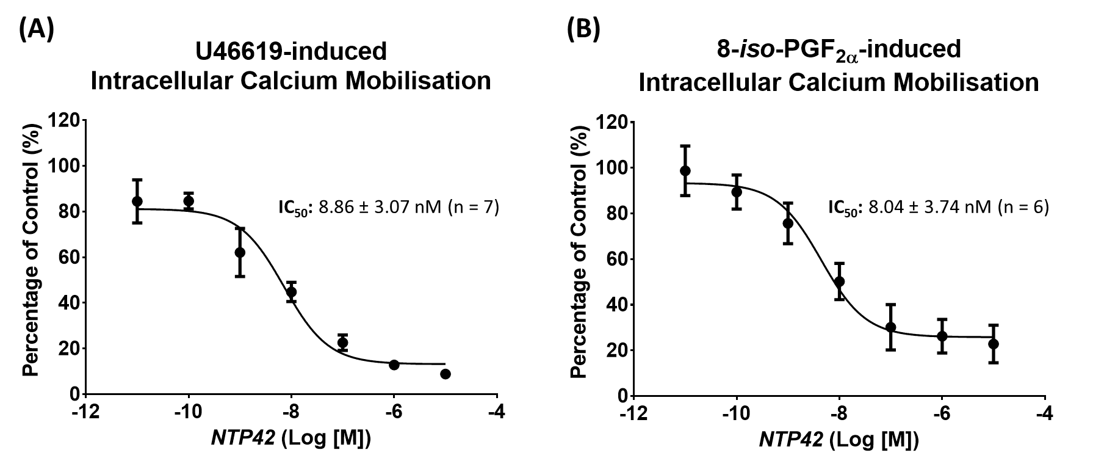

Supplemental Figure 1. Effect of NTP42 on intracellular calcium mobilisation following U46619 or 8-iso-PGF_{2α} stimulation.
HEK.TPβ cells, preloaded with Fluo-4, were incubated with NTP42 (0.00001 - 10 µM), prior to stimulation with the TP agonists (A) 1 μM U46619 or (B) 10 μM 8-iso-PGF_{2α}. In both panels, dose inhibition curves show the effect of NTP42 on intracellular Ca²⁺ mobilisation following stimulation with the respective TP agonist. Data is presented as the mean (± SEM) percentage of the respective agonist-induced response in vehicle-treated cells (Percentage of Control; %) and represents data from at least 6 independent experiments (n ≥ 6). Calculated IC₅₀ values for NTP42 are shown alongside the respective dose inhibition curve.

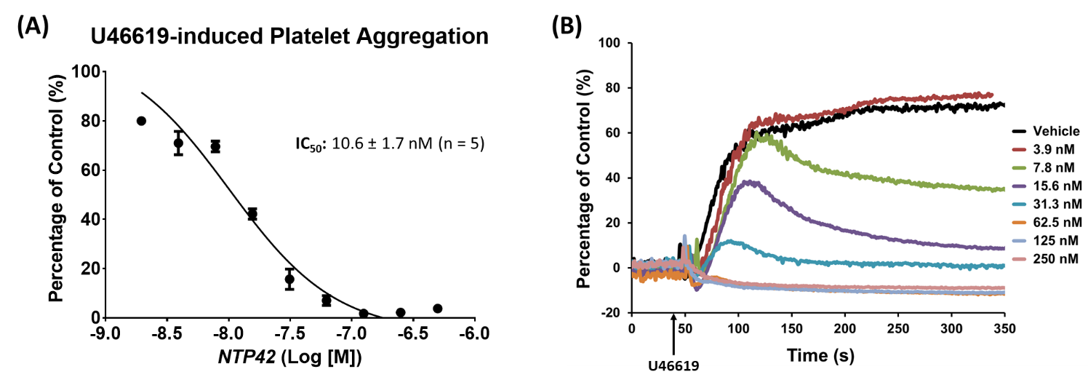

Supplemental Figure 2. Effect of NTP42 on human platelet aggregation following U46619 stimulation.
(A) Dose inhibition curve showing the effect of NTP42 (3.9 - 250 nM) on platelet aggregation following stimulation with 1 μM U46619. Data is presented as the mean (± SEM) changes in percentage aggregation (Percentage of Control; %), as determined by changes in light transmission over time using the PAP-8E Platelet Aggregation Profiler and are representative of at least 7 independent experiments (n = 5). The calculated IC₅₀ value for NTP42 is shown alongside the dose inhibition curve. (B) Representative experimental traces showing the effect of NTP42 (3.9 - 250 nM, as indicated) on platelet aggregation following stimulation with 1 μM U46619.
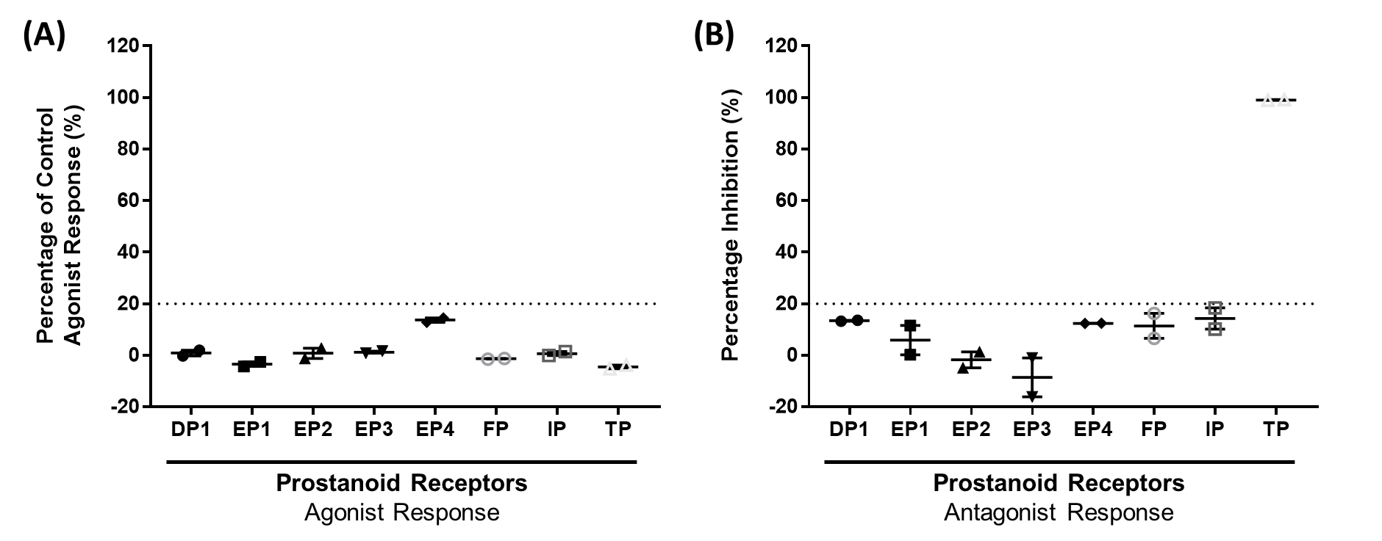
Supplemental Figure 3. Specificity of NTP42 as agonist or antagonist at prostanoid GPCRs.
NTP42 (1 µM) was evaluated as an agonist (A) or antagonist (B) of the TP and 7 other prostanoid receptors, where the mammalian cell line used as source of the given test receptor, along with the assay type and method of detection used is specified in Supplemental Table 2. (A) As a reference control, the specific cell type was stimulated with a given concentration of a recognised agonist necessary to bring about a maximal response at the given/target receptor (e.g. for the TP with 0.3 μM U46609). Results were calculated and are presented as percentage of the agonist-response following stimulation of cells with NTP42 (1 µM) relative to the agonist-response following stimulation of cells with the given concentration of the recognised agonist known to bring about a maximal response, set at 100%. (B) For assays of receptor antagonism, the specific cell type used for the given receptor was co-stimulated with the test compound (NTP42; 1 µM) in the presence of a given concentration of a recognised agonist necessary to bring about a sub-maximal response at the given/target receptor (e.g. for the TP with 10 nM U46609). Results were calculated and are presented as percentage of inhibition of the response generated in the presence of the test drug NTP42 (1 µM) relative to the agonist-response following stimulation of cells with the given concentration of the recognised agonist known to bring about a sub-maximal response, set at 100%.

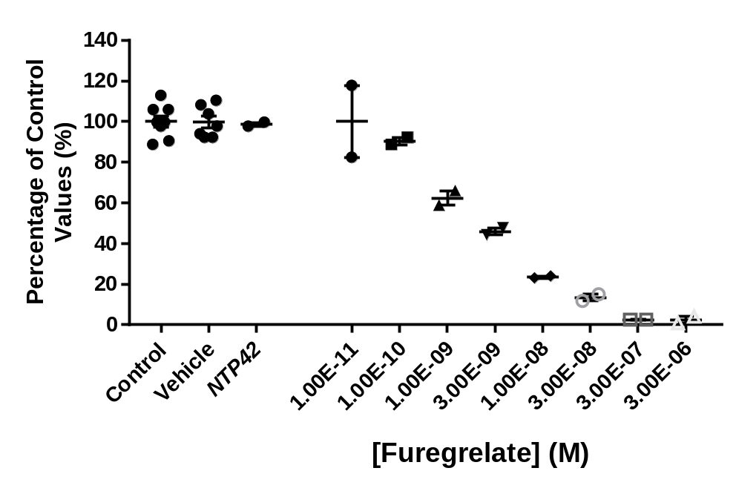

Supplemental Figure 4. Effect of NTP42 on Thromboxane A₂ Synthase Activity.
NTP42 (1 µM), the reference compound Furegrelate (10 pM to 3 µM), the drug vehicle (1% DMSO) or water (Control) were preincubated in duplicate for 15 min at 22°C with the thromboxane (TX) A₂ synthase enzyme preparation from human platelets (15 µg) in a buffer containing 50 mM Tris-HCl (pH 7.5), 70 µg/ml PMSF, 10 µg/ml trypsin inhibitor, 1 µg/ml leupeptin and 1 µM pepstatin. The reaction was initiated by adding 10 µM PGH₂ and the mixture was incubated for 2 min at room temperature (22°C). For basal control measurements, the enzyme preparation was omitted from the reaction mixture. Following incubation, the reaction was stopped by adding 1 M HCl and the pH neutralised by adding 1 M Tris/HCl at pH 8. The amount of TXB₂, the stable hydration product of TXA₂ generated during reaction, was quantified using the EIA (enzyme immunoassay) detection kit (R&D Systems) and the measurements were made with a microplate reader (EnVision, Perkin Elmer). Results were expressed as the percentage of TXB₂ levels generated in the control reaction, in the absence of an TXA₂S inhibitor.

Supplementary References

1. Turner EC, Mulvaney EP, Reid HM, Kinsella BT. Interaction of the Human Prostacyclin Receptor with the PDZ Adapter Protein PDZK1: Role in Endothelial Cell Migration and Angiogenesis. Mol Biol Cell 2011;22:2664-2679.
2. Wikstrom K, Kavanagh DJ, Reid HM, Kinsella BT. Differential regulation of RhoA-mediated signaling by the TPalpha and TPbeta isoforms of the human thromboxane A2 receptor: independent modulation of TPalpha signaling by prostacyclin and nitric oxide. Cell Signal 2008;20:1497-1512.
3. Bankhead P, Loughrey MB, Fernandez JA, Dombrowski Y, McArt DG, Dunne PD, McQuaid S, Gray RT, Murray LJ, Coleman HG, James JA, Salto-Tellez M, Hamilton PW. QuPath: Open source software for digital pathology image analysis. Sci Rep 2017;7:16878.
4. Schermuly RT, Dony E, Ghofrani HA, Pullamsetti S, Savai R, Roth M, Sydykov A, Lai YJ, Weissmann N, Seeger W, Grimminger F. Reversal of experimental pulmonary hypertension by PDGF inhibition. J Clin Invest 2005;115:2811-2821.
5. Walsh MT, Foley JF, Kinsella BT. The alpha, but not the beta, isoform of the human thromboxane A2 receptor is a target for prostacyclin-mediated desensitization. J Biol Chem 2000;275:20412-20423.
6. Kassack MU. Quantitative comparison of functional screening by measuring intracellular Ca2+ with radioligand binding at recombinant human dopamine receptors. AAPS PharmSci 2002;4:E31.

