Supplementary Material

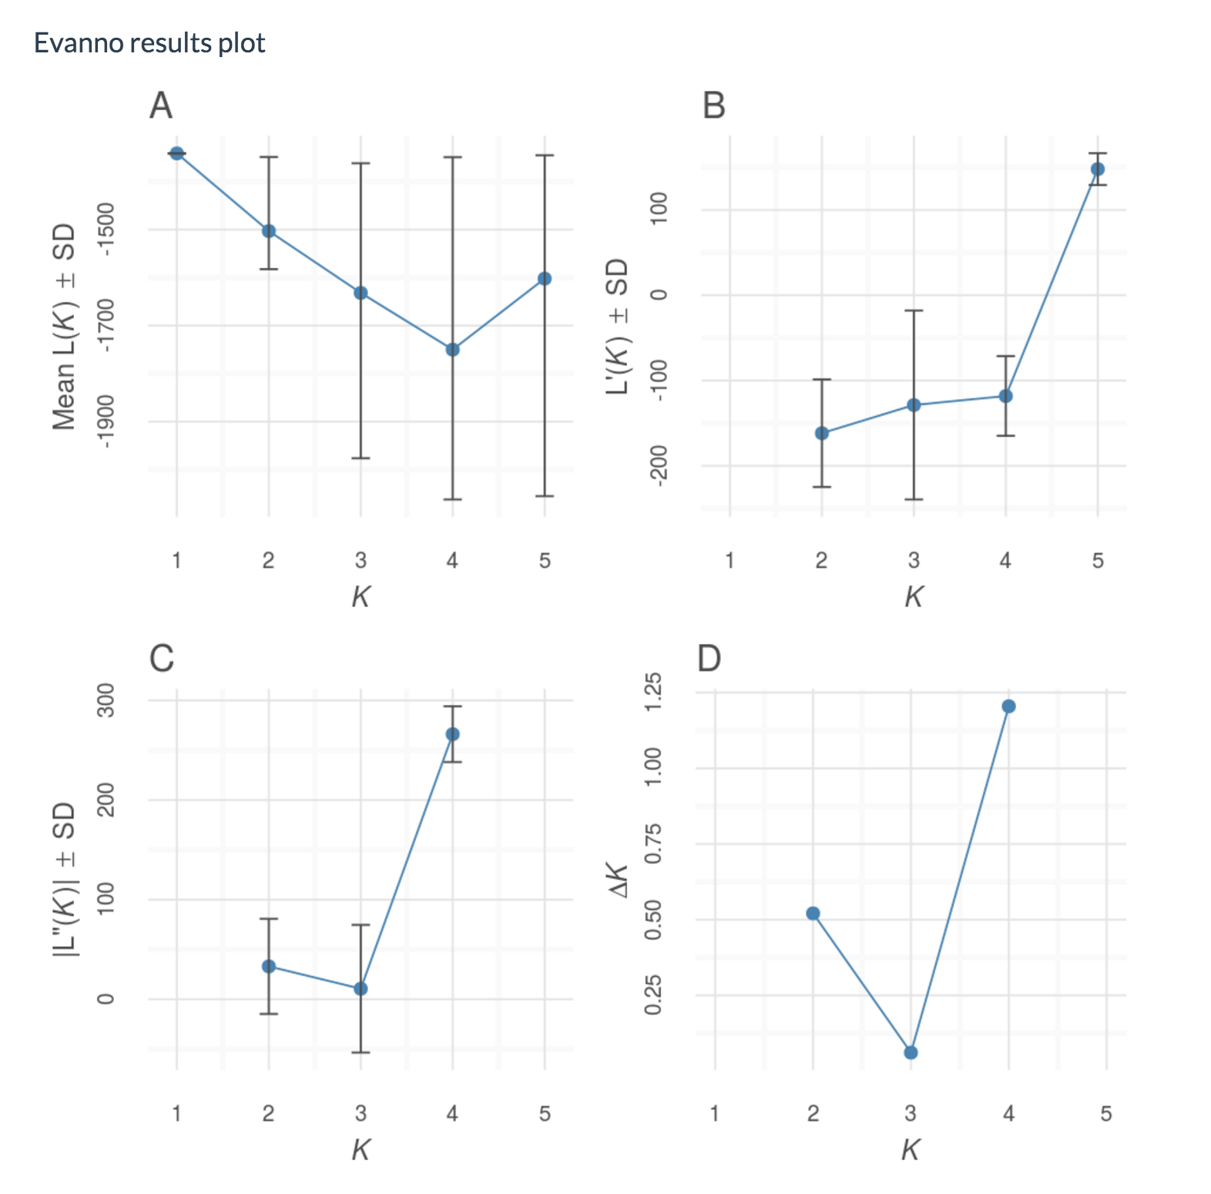
Figure S1. Probability graphs of K as calculated by Evanno et al.2005. The plots show the Evanno analysis with (A) estimated log probability of data of runs over increasing values of K, (B) first derivative, (C) second derivative and (D) DK over values of K.

a) b)
Figure S2. (a) Box plot, and (b) density plot of relatedness values for simulated pairs of individuals of known relatedness. Full siblings (Full); Half siblings (Half); Parent-Offspring (PO); and Unrelated. Based on the estimator of Wang (2002).

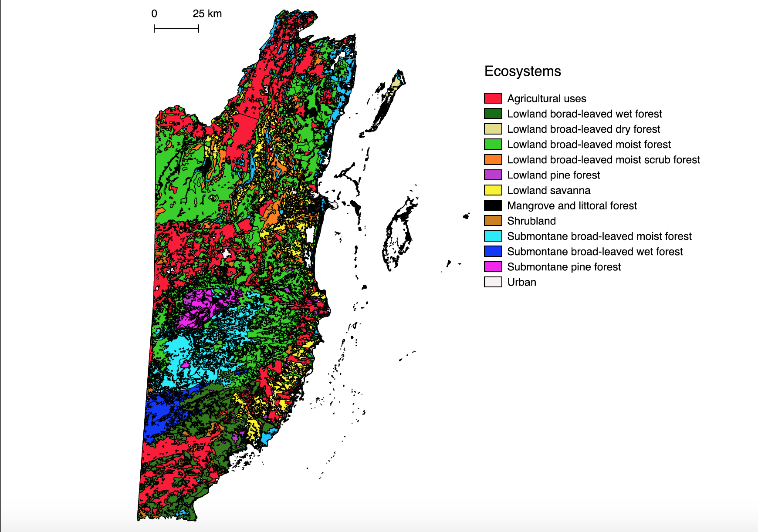
Figure S3. Map of ecosystem types in Belize according to the Biodiversity and Environmental Resource Data System of Belize (BERDS, 2017).

Table S2. Results from MICROCHECKER. This population is possibly in Hardy Weinberg equilibrium with loci FCA212, FCA229, FCA075, showing signs of a null allele. For all loci with null alleles: No evidence for scoring error due to stuttering and no evidence for large allele dropout.

Locus | Null Present | Oosterhout |  | Chakraborty |  | Brookfield 1 |  | Brookfield 2
FCA032 | no | 0.073 | 0.076 |  | 0.055 |  | 0.055
FCA100 | no | 0.056 | 0.069 |  | 0.049 |  | 0.049
FCA124 | no | 0.066 | 0.067 |  | 0.049 |  | 0.113
FCA126 | no | -0.063 | -0.039 |  | -0.033 |  | 0.125
FCA212 | yes | 0.155 | 0.252 |  | 0.086 |  | 0.168
FCA229 | yes | 0.093 | 0.101 |  | 0.077 |  | 0.201
FCA096 | no | -0.040 | -0.032 |  | -0.028 |  | 0.182
FCA132 | no | -0.044 | -0.022 |  | -0.003 |  | 0.232
FCA275 | no | 0.080 | 0.094 |  | 0.068 |  | 0.204
FCA075 | yes | 0.138 | 0.159 |  | 0.126 |  | 0.166
FCA208 | no | -0.046 | -0.041 |  | -0.037 |  | 0.241
FCA225 | no | 0.037 | 0.055 |  | 0.039 |  | 0.331

