Additional files
Additional file 1: ROC Plot for classification accuracy of this model.

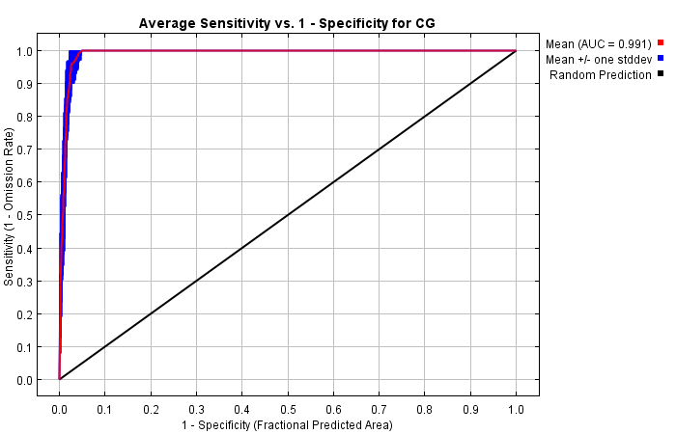

Additional file 2: Predicted distribution of Chinese Grouse in different periods: a, LIG; b, LGM; c, Mid-Holocene’ d, Present day. The grey area represent the distribution in different time and the color bar represent altitude. Map data was from WorldClim-Global Climae Data, which is free data for ecological modeling and GIS.

