Table 1: Peak-callers used for comparison in this study along with their key features and output formats.
Tool | Key feature | Output
MACS, 2008 [21] | - Uses bimodal distribution of reads to model fragment length.  - Uses dynamic Poisson distribution to compare test and control samples | - Peak position  - p-value (based on pileup height at peak summit) and q value (against random Poisson distribution with local lambda)
GEM, 2012 [15] | - Uses a generative probabilistic model to assign positions to the reads after each iteration  - Reciprocally links binding event discovery and motif discovery  - Resolves closely spaced binding events | - Binding events file (including location, IP strength, fold enrichment, p-value is computed from the Binomial test when control data is available, p-value computed from Poisson test in the absence of control data, divergence of the IP reads from the empirical read distribution, fraction of noise, KmerGroup and p-value associated to the K-mer and strand)  - Motif files  - K-mer set memory motifs  - HTML output  - Read distribution file  - The spatial distribution between primary and secondary motifs
Peakzilla, 2013 [18] | - Estimates all parameters from the data itself  - Uses bimodal distribution of reads to calculate fragment length and predict binding sites  - Resolves closely spaced binding events | - Peak file with exact position, summit, score (based on read distribution in peaks that fits bimodal tag distribution and chi-square test), FDR, fold enrichment.  - Negative peaks in the presence of control.
Genetrack, 2008 [16] | - Rapid data smoothing using Gaussian smoothing  - Peak detection by selecting the highest peak in a local maximum with an exclusion zone of up to a few hundred bp  - Combines strand information in a composite value  - Requires manual pairing of border peaks | - Gff file with chromosome, peak exclusion zone, tag sum, strand information and standard deviation of reads in the peak exclusion zone
MACE, 2014 [17] | - Normalizes and corrects sequencing data for any biases  - Consolidates signal to noise ratio by reducing noise  - Detects border peaks using the Chebyshev Inequality and pairs them using Gale-Shapley stable matching algorithm | - BED file containing border pairs of the binding event, the method for detecting each border pair and corresponding p-value (composite p-value of two borders in a pair)
Exoprofiler, 2015 [10] | - Useful to detect different types of footprints  - The peaks are scanned against the motif database to find the highest scoring peaks  - High scoring peaks are then used to calculate 5’ ChIP-exo coverage of reads relative to the TFBS center to find the protein-DNA crosslink boundaries | - Heat map of 5’ ChIP-exo coverage  - Footprint profile of 5’ coverage of all reads  - Footprint profile of the 5’ coverage of reads on both strands matching the scanned motif (output of motif permutation)
ChExMix, 2018 [11] | - Probabilistic mixture model for characterizing different modes of DNA-protein interactions  - Expectation Maximization (EM) algorithm for estimating binding subtype probability for each binding event | - Event subtype file (reports total read count, signal fraction, binding coordinate, fold enrichment, event subtype, binding sequence, log[2]p-value(log likelihood score of subtype specificity for a motif hit))  - Motif file  - Peak-peak distance histogram  - Peak-motif distance histogram
Table 2. MEME output for MACE, MACS, Genetrack and Peakzilla and motifs reported directly by ChExMix and GEM

Dataset | First Motif hit reported by MEME | Match to reported binding sites
IMR90 | ChExMix  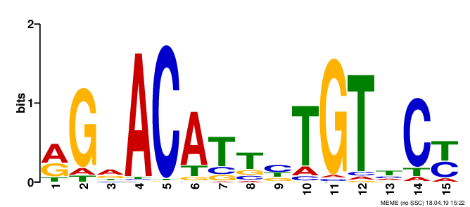 | GBS
IMR90 | GEM  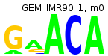 | Half site of GBS
IMR90 | MACE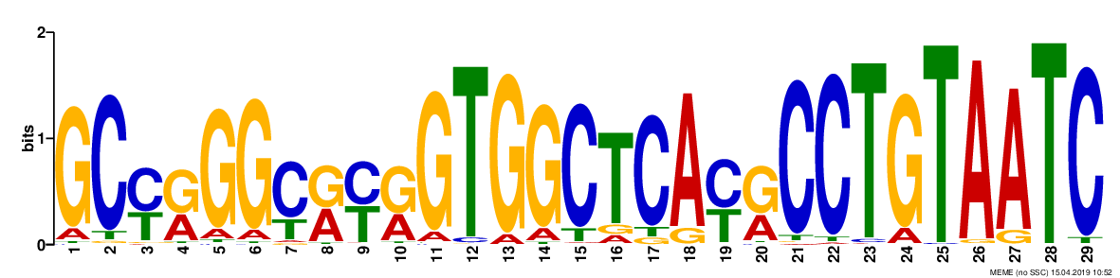 | FOSL1
IMR90 | MACS | HSF1
IMR90 | Peakzilla | GBS
K562 | ChExMix   | GATA
K562 | GEM  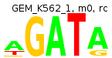 | GATA
K562 | MACE  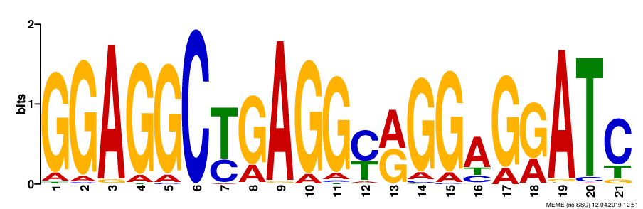 | SP1-like
K562 | MACS  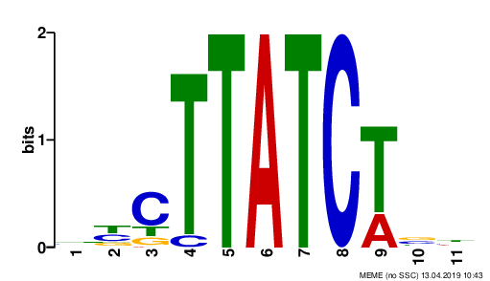 | GATA
K562 | Peakzilla  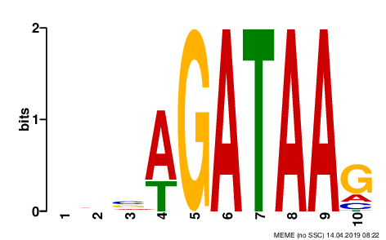 | GATA
U2OS | ChExMix | GBS
U2OS | GEM   | Half site of GBS
U2OS | Genetrack | GBS
U2OS | MACE | GBS
U2OS | MACS | GBS
U2OS | Peakzilla  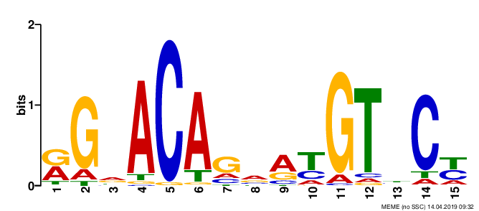 | GBS

