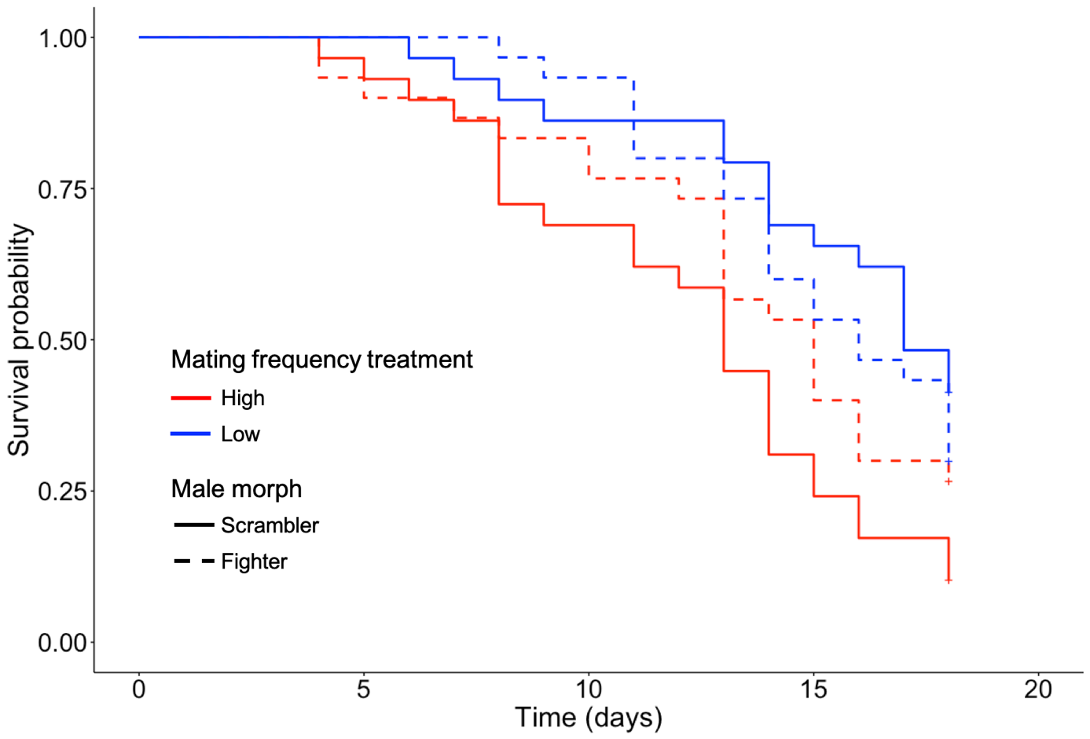
Fig. S1. Effect of mating frequency and male morph on female lifespan. Kaplan-Meier survival plots for females maintained in high mating frequency or low mating frequency treatment and mated with scrambler or fighter male morphs.

Female mated with: | Scrambler |  |  |  |  |  |  |  |  | Fighter
Female mated with: | coef | s.e |  | z | p |  |  |  |  |  |  |  |  | coef | s.e |  | z | P
Fixed effects
Treatment | -1.30 | 0.35 |  | -3.74 | <0.001 |  |  |  |  |  |  |  |  | -0.28 | 0.31 |  | -0.91 | 0.36
Mating with more than one male | -0.99 | 0.47 |  | -2.11 | 0.035 |  |  |  |  |  |  |  |  | 0.48 | 0.39 |  | 1.21 | 0.22
Random effect | Variance |  | Std. Dev. |  |  |  |  |  |  |  |  | Variance |  |  |  | Std. Dev.
Male identity | 0.508 |  | 0.713 |  |  |  |  |  |  |  |  |  | 0.153 |  |  | 0.39

Table S1. Results of a mixed-effect Cox model of female survival probability as a function of mating with a scrambler or fighter in high mating frequency and low mating frequency groups, with experimental treatment and number of mated males as fixed effects and male identity as a random factor..

