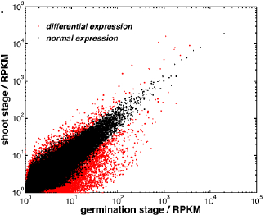
Fig. S1 Different gene expression in two underground development stages of moso bamboo

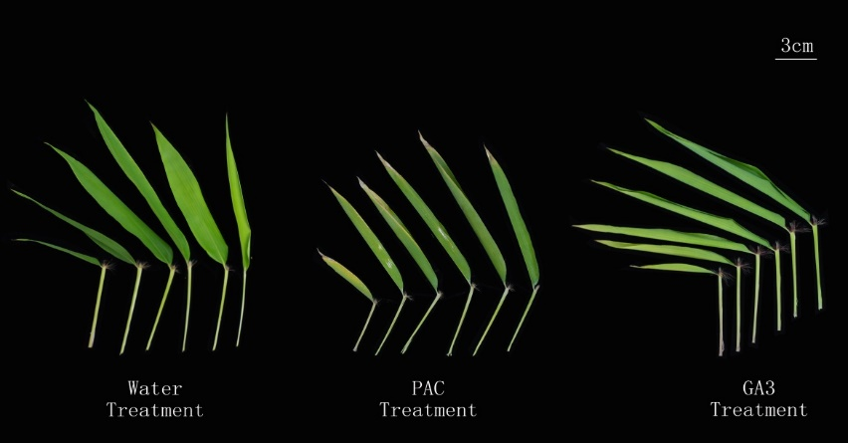
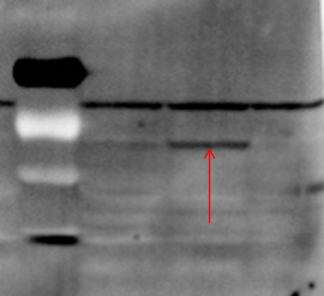
C
B
A
Marker col ga3 rga
Fig. S2 Effects of GA treatment on bamboo seedlings. (A) Illustration of leave and sheath of seedling under water (left), PAC (middle) and GA (right) treatment. Bar, 3 cm. (B) Comparisons of leave length (LL), leave width (LW), sheath length (SL) and internode length (IL) during growth test. (C) AtDELLA detection in Arabidopsis strains through western blotting. Col, wildtype; ga3, GA synthesis deficient mutant; rga, DELLA mutant. Red arrow, protein visualized in western blot.

Table S1 Primer used in quantitative PCR
Unigene | Forward primer 5’- 3’ | Reverse primer 5’- 3’
Pe-Actin | GGTGTGAGCCATACTGTGCCCAT | TTTCCCGTTCAGCAGAGGTTGTG
AMI | TTCTGAGGCTACCTTATGCTGAT | TTTGAGTCCCCATTCTTGTGTC
CYP79B2 | TCAAGACTATTGTCAACAACGGG | TCTGAGAGTGAAAAGTGCATCCA
CYP79B | CTTCCAAAACCTCCCCTACC | CCCACACGTTCACCATGAC
TAA1 | GGACGACATCTTCGCCTTC | CCTCTCGCATTTCACCCAC
YUCC | GCTTCCCCTTGTGCCTTTC | TCCACTTCCTCCCCCATTC
GA3ox1 | ATCACTCGGATACTTCCTCGGCC | CCGTGGAGACCATCTTGAGCG
DELLA | GTGTGATGAGATGGACAATGGA | AAGAGCAGGGAGCAGCATTC
BRI1 | GGGACTCTTGTTCTCGCTGTT | TTGCCTCTTCATCCTTCTGCT
BSK1 | GTGCGATTAGCTTCAAGGTG | CCATCAGTTCGTAAGAGGGAG
BSU1 | CTCGCCATACAGCACTAACAGC | CCAAGGGTGGGAAATCAAAA
BIN2 | CATGAACCAAAGGATGCCACT | CTCCAGGTACAGTATGAATGTAAGC

