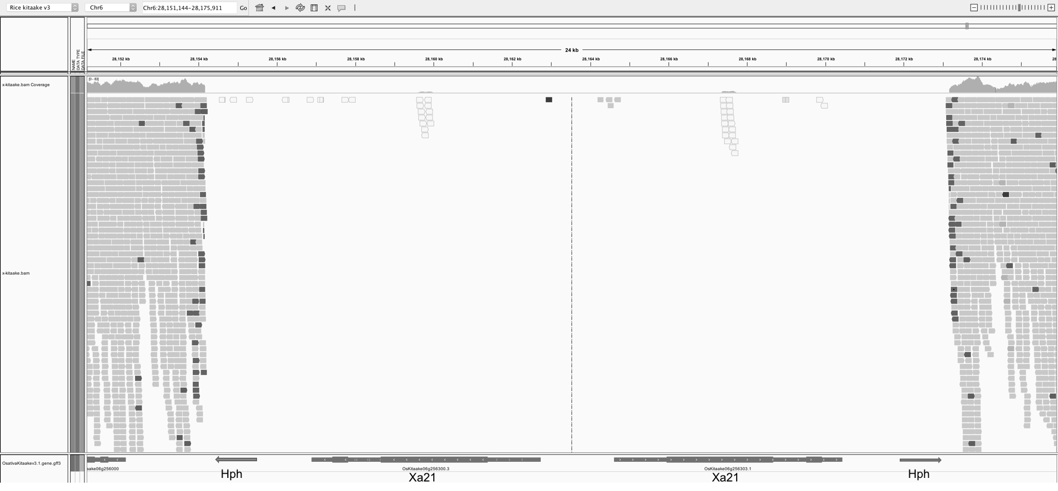

Figure S17: Integrative genomics viewer (IGV) snapshot showing presence of XA21 transgene and selectable marker encoding a hygromycin B phosphotransferase on chromosome 6 of KitaakeX.

