Table 1. Westra et al. eQTLs compared with hand-grip strength GWAS SMR output
agenda
probID: Id of the probe
probeChr: chromosome of the probe
probe_BP: base pair of the probe
topSNP: top SNP that came up in said probe
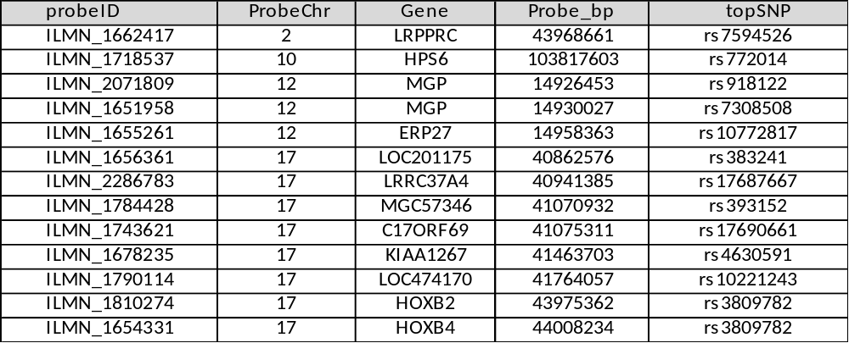
Table 2. Westra et al. eQTLs compared with appendicular lean mass GWAS metal (meta-analysis) SMR output
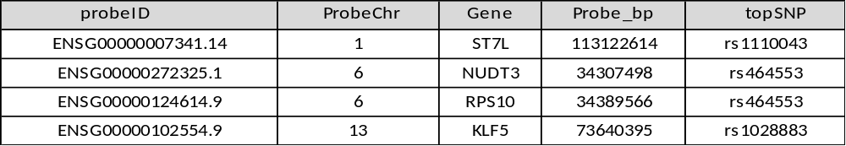
Table 3. Westra et al. eQTLs compared with whole body lean mass GWAS metal SMR output
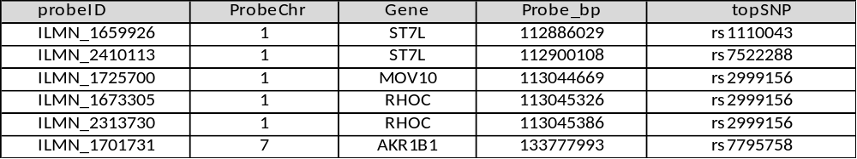
Table 4. GTEx V7 eQTLs compared with appendicular lean mass GWAS metal SMR , results for all tissue types.
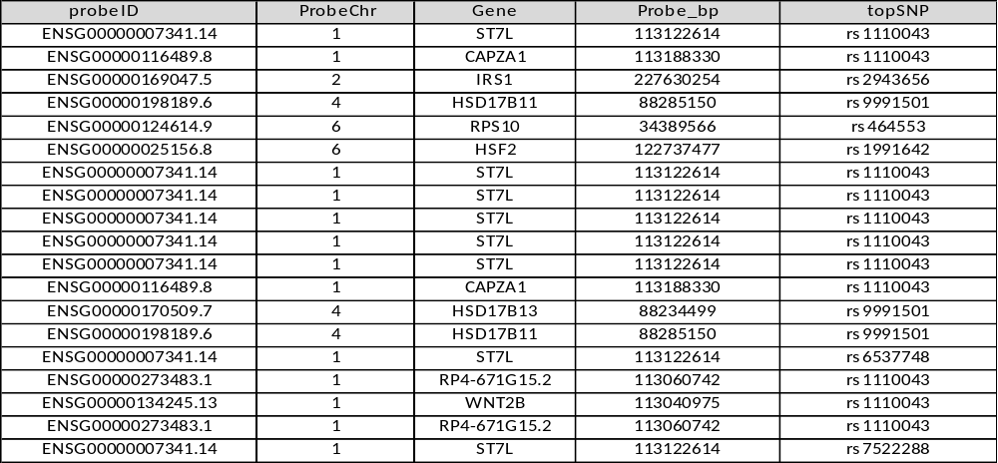

Table 5. GTEx eQTLs compared with appendicular lean mass GWAS in SMR, prioritization for skeletal muscle only.
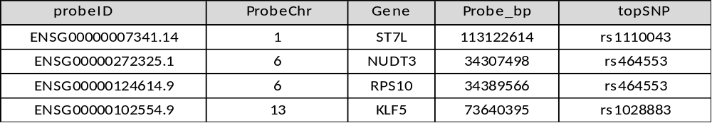

Table 6. GTEx eQTLs compared with lean mass GWAS in SMR, results for all tissue types.
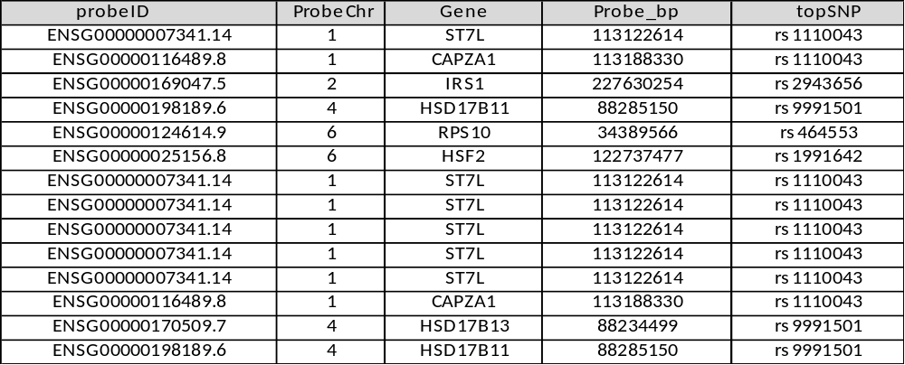

Table 7. GTEx V7 eQTLs compared with lean mass GWAS SMR, results for skeletal muscles.
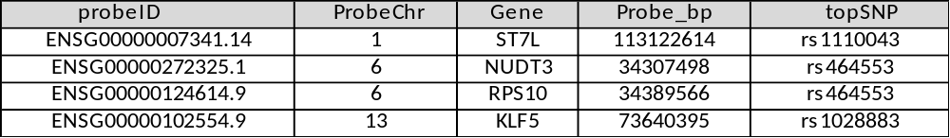

Table 8. GTEx V7 Skeletal muscle eQTLs SMR compared with Handgrip GWAS
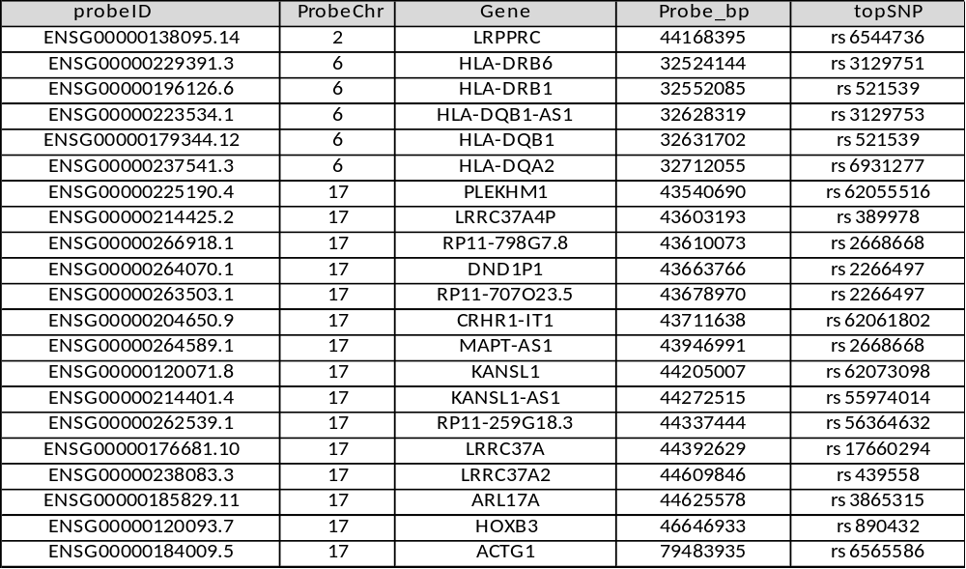

Table 9. GTEx V7 Handgrip GWAS data with eQTL aggregated SMR.

