Title
A benchmarked in-silico driven pipeline capable of complete trifecta protein analysis

Authors
D.D.B.D. Perera¹*, L.D.C Peiris¹*

Affiliations
¹Department of Zoology (Centre for Biotechnology), University of Sri Jayewardenepura, Gangodawila, Sri Lanka.

*Equal Corresponding author: D.D.B.D. Perera¹* (desh.02236@gmail.com), Peiris, L.D.C¹* (dinithi@sci.sjp.ac.lk)

Fig. 1: JPred secondary structure prediction server result. The ‘H’ represents a helix, ‘E’ represents a beta sheet.
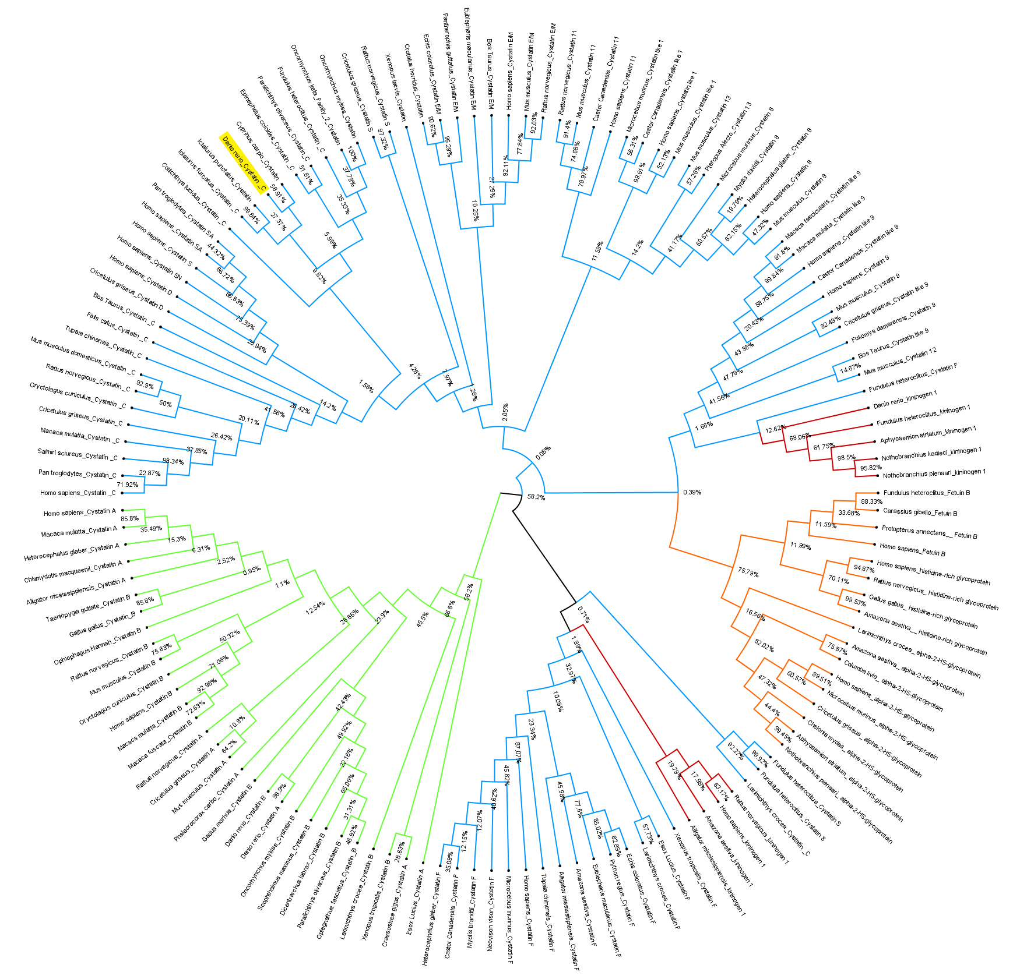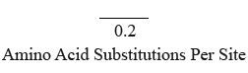
Fig. 2: Phylogenetic tree. Type 1 Cystatins in Green, Type 2 Cystatins in Blue, Type 3 Cystatins in Red and Type 4 Cystatins in Orange. The Danio rerio amino sequence highlighted yellow.
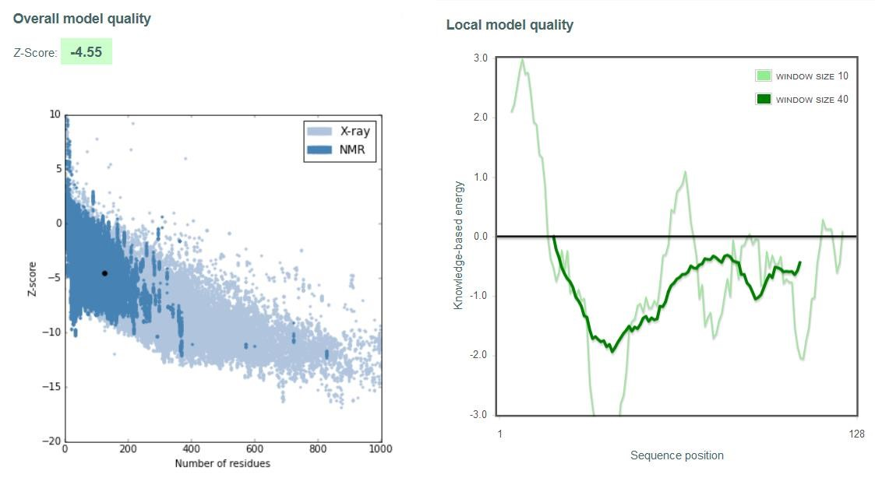
Fig. 3: ProSA-web service quality assessment plots for the I-Tasser generated model
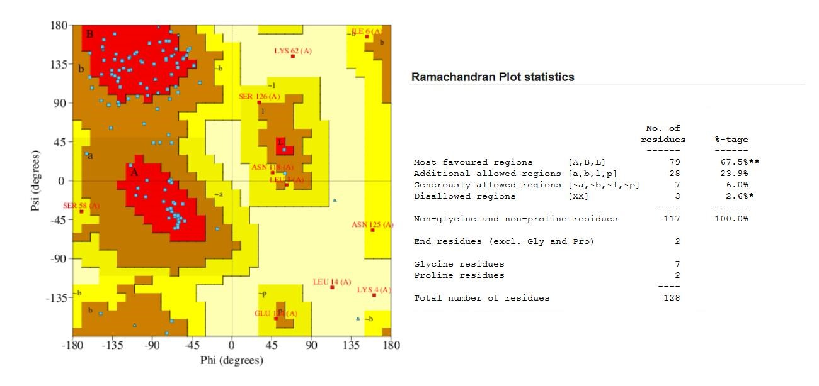
Fig. 4: Validation of the I-TASSER predicted protein structure using the Ramachandran plot.

Table 1: Detailed description of the electrostatic charge and hydrophobic residue distribution on the protein surface.
Patch | Type | Size (Å²) | Score | Intensity  (Score / Size)
1 | Positive | 1024.2 | 866.788 | 0.846
2 | Positive | 43.4 | 38.615 | 0.89
3 | Positive | 15.4 | 0 | 0
4 | Positive | 672.4 | 597.782 | 0.889
5 | Positive | 21.5 | 17.476 | 0.811
6 | Positive | 18.4 | 7.222 | 0.393
7 | Negative | 120.9 | 115.675 | 0.957
8 | Negative | 60.1 | 77.194 | 1.284
9 | Negative | 86.8 | 105.921 | 1.221
10 | Negative | 251.3 | 281.105 | 1.119
11 | Negative | 79.9 | 80.66 | 1.01
12 | Negative | 104.4 | 154.691 | 1.482
13 | Negative | 23.4 | 24.225 | 1.035
14 | Negative | 206.6 | 253.733 | 1.228
15 | Negative | 41.3 | 34.583 | 0.837
16 | Negative | 29.9 | 21.893 | 0.732
17 | Negative | 25.6 | 12.23 | 0.477
18 | Negative | 17.9 | 13.604 | 0.76
19 | Negative | 176.2 | 251.095 | 1.425
20 | Negative | 25 | 32.309 | 1.294
21 | Hydrophobic | 1223.1 | 858.725 | 0.702
22 | Hydrophobic | 104.5 | 75.331 | 0.721
23 | Hydrophobic | 51.1 | 35.154 | 0.688
24 | Hydrophobic | 84.9 | 43.78 | 0.516
25 | Hydrophobic | 143 | 92.19 | 0.645
26 | Hydrophobic | 112.5 | 62.656 | 0.557
27 | Hydrophobic | 107.4 | 53.777 | 0.501
28 | Hydrophobic | 53.9 | 43.302 | 0.803

Table 2: Protein Surface Analysis of the interacting surfaces between Cystatin C (A) and Papain (B). Details regarding the types of bonding including Hydrogen Bonding (HB), Salt Bridges (SB), Pi Stacking (Pi), Disulfide bonding (DS) and Vander Waal interactions (VW).
Residue | Closest | Distance (Å) | HB | SB | Pi | DS | VW
A:53:Tyr |  |  | 0 | 0 | 0 | 0 | 0
A:58:Ser |  |  | 0 | 0 | 0 | 0 | 0
A:59:Lys |  |  | 0 | 0 | 0 | 0 | 1
A:78:Asp | B:156:Lys | 2.7 | 0 | 1 | 0 | 0 | 11
A:80:Ala |  |  | 0 | 0 | 0 | 0 | 0
A:83:Thr | B:64:Asn | 2.1 | 0 | 0 | 0 | 0 | 9
A:84:Cyx |  |  | 0 | 0 | 0 | 0 | 0
A:85:Arg |  |  | 0 | 0 | 0 | 0 | 0
A:90:Glu |  |  | 0 | 0 | 0 | 0 | 0
A:92:Leu | B:61:Tyr | 2.2 | 0 | 0 | 0 | 0 | 1
A:93:Cyx |  |  | 0 | 0 | 0 | 0 | 0
A:94:Ala |  |  | 0 | 0 | 0 | 0 | 0
A:95:Ile | B:158:Asp | 2.4 | 0 | 0 | 0 | 0 | 15
A:96:His | B:158:Asp | 2.9 | 0 | 0 | 0 | 0 | 0
A:97:Glu | B:25:Cys  B:159:His  B:158:Asp  B:66:Gly | 2.3  2.3  2.7  3.0 | 1 | 0 | 0 | 0 | 9
A:98:Asn | B:19:Gln | 2.2 | 0 | 0 | 0 | 0 | 2
A:99:Pro | B:177:Trp B:142:Gln | 1.8  2.5 | 0 | 0 | 0 | 0 | 20
A:100:Glu |  |  | 0 | 0 | 0 | 0 | 0
A:101:Ile |  |  | 0 | 0 | 0 | 0 | 0
A:102:Ala |  |  | 0 | 0 | 0 | 0 | 0
A:103:Gln |  |  | 0 | 0 | 0 | 0 | 0

Table 3: Protein Surface Analysis of interacting surfaces between Cystatin C (A), Cathepsin B (B). Details regarding the types of bonding including Hydrogen Bonding (HB), Salt Bridges (SB), Pi Stacking (Pi), Disulfide bonding (DS) and Vander Waal interactions (VW).
Residue | Closest | Distance (Å) | HB | SB | Pi | DS | VW
A:2:Phe |  |  | 0 | 0 | 0 | 0 | 0
A:3:Leu | B:65:Ser | 3.0 A | 0 | 0 | 0 | 0 | 1
A:4:Lys |  |  | 0 | 0 | 0 | 0 | 0
A:9:Phe |  |  | 0 | 0 | 0 | 0 | 0
A:12:Val |  |  | 0 | 0 | 0 | 0 | 0
A:43:Ala |  |  | 0 | 0 | 0 | 0 | 0
A:44:Gln | B:196:Met | 2.4 A | 1 | 0 | 0 | 0 | 0
A:45:Tyr |  |  | 0 | 0 | 0 | 0 | 0
A:47:Arg | B:196:Met | 2.2 A | 0 | 0 | 0 | 0 | 5
A:48:Gln |  |  | 0 | 0 | 0 | 0 | 0
A:49:Ser |  |  | 0 | 0 | 0 | 0 | 0
A:50:Asn |  |  | 0 | 0 | 0 | 0 | 0
A:86:Lys |  |  | 0 | 0 | 0 | 0 | 0
A:87:Gly |  |  | 0 | 0 | 0 | 0 | 0
A:105:Lys |  |  | 0 | 0 | 0 | 0 | 0
A:108:Lys |  |  | 0 | 0 | 0 | 0 | 0

Table 4: Protein Surface Analysis of interacting surfaces between Cystatin C (A), Cathepsin H (B). Details regarding the types of bonding including Hydrogen Bonding (HB), Salt Bridges (SB), Pi Stacking (Pi), Disulfide bonding (DS) and Vander Waal interactions (VW).
Residue | Closest | Distance (Å) |  | HB | SB | Pi | DS | VW
A:1:Met | B:21:Ser B:63:Cyx | 1.3  2.6 A | A | 0 | 0 | 0 | 0 | 21
A:2:Phe |  |  |  | 0 | 0 | 0 | 0 | 0
A:3:Leu |  |  |  | 0 | 0 | 0 | 0 | 4
A:4:Lys | B:142:Leu | 1.9 A |  | 0 | 0 | 0 | 0 | 21
A:7:Val |  |  |  | 0 | 0 | 0 | 0 | 0
A:8:Ala | B:63:Cyx B:23:Gly | 2.0  2.8 A | A | 0 | 0 | 0 | 0 | 9
A:9:Phe | B:23:Gly B:158:Asn | 2.7  2.9 A | A | 0 | 0 | 0 | 0 | 13
A:10:Leu |  |  |  | 0 | 0 | 0 | 0 | 0
A:12:Val |  |  |  | 0 | 0 | 0 | 0 | 1
A:13:Ile |  |  |  | 0 | 0 | 0 | 0 | 0
A:25:Pro |  |  |  | 0 | 0 | 0 | 0 | 0
A:66:Gln |  |  |  | 0 | 0 | 0 | 0 | 0
A:72:Lys |  |  |  | 0 | 0 | 0 | 0 | 0
A:74:Ile |  |  |  | 0 | 0 | 0 | 0 | 0
A:108:Lys |  |  |  | 0 | 0 | 0 | 0 | 0
A:110:Val |  |  |  | 0 | 0 | 0 | 0 | 0
A:124:Glu |  |  |  | 0 | 0 | 0 | 0 | 0
A:125:Asn |  |  |  | 0 | 0 | 0 | 0 | 0
A:126:Ser |  |  |  | 0 | 0 | 0 | 0 | 0
A:127:Cyx |  |  |  | 0 | 0 | 0 | 0 | 0
A:128:Leu |  |  |  | 0 | 0 | 0 | 0 | 0

Table 5: Protein Surface Analysis of interacting surfaces between Cystatin C (A), Cathepsin L1 (B). Details regarding the types of bonding including Hydrogen Bonding (HB), Salt Bridges (SB), Pi Stacking (Pi), Disulfide bonding (DS) and Vander Waal interactions (VW).
Residue | Closest | Distance (Å) |  | HB | SB | Pi | DS | VW
A:1:Met |  |  |  | 0 | 0 | 0 | 0 | 0
A:2:Phe | B:66:Asn | 2.1 A |  | 0 | 0 | 0 | 0 | 5
A:3:Leu | B:66:Asn  B:65:Cyx  B:67:Gly | 2.0 A  2.8 A  2.9 A |  | 0 | 0 | 0 | 0 | 22
A:4:Lys | B:19:Gln | 2.7 A |  | 0 | 0 | 0 | 0 | 6
A:5:Ile |  |  |  | 0 | 0 | 0 | 0 | 0
A:9:Phe | B:162:Asp | 2.5 A |  | 0 | 0 | 0 | 0 | 17
A:10:Leu |  |  |  | 0 | 0 | 0 | 0 | 0
A:11:Ala |  |  |  | 0 | 0 | 0 | 0 | 0
A:12:Val |  |  |  | 0 | 0 | 0 | 0 | 0
A:13:Ile | B:21:Gln | 2.0 A |  | 0 | 0 | 0 | 0 | 6
A:14:Leu |  |  |  | 0 | 0 | 0 | 0 | 0
A:16:Val |  |  |  | 0 | 0 | 0 | 0 | 0
A:17:Ser |  |  |  | 0 | 0 | 0 | 0 | 0
A:44:Gln |  |  |  | 0 | 0 | 0 | 0 | 0
A:45:Tyr |  |  |  | 0 | 0 | 0 | 0 | 0
A:48:Gln |  |  |  | 0 | 0 | 0 | 0 | 0
A:72:Lys |  |  |  | 0 | 0 | 0 | 0 | 0
A:110:Val |  |  |  | 0 | 0 | 0 | 0 | 0
A:121:Lys |  |  |  | 0 | 0 | 0 | 0 | 0
A:122:Val |  |  |  | 0 | 0 | 0 | 0 | 0
A:123:Thr |  |  |  | 0 | 0 | 0 | 0 | 0
A:124:Glu |  |  |  | 0 | 0 | 0 | 0 | 2
A:125:Asn |  |  |  | 0 | 0 | 0 | 0 | 0
A:126:Ser |  |  |  | 0 | 0 | 0 | 0 | 0

Table 6: Protein Surface Analysis of interacting surfaces between Cystatin C (A), Cathepsin S (B). Details regarding the types of bonding including Hydrogen Bonding (HB), Salt Bridges (SB), Pi Stacking (Pi), Disulfide bonding (DS) and Vander Waal interactions (VW).
Residue | Closest | Distance (Å) | HB | SB | Pi | DS | VW
A:1:Met | B:57C:Lys | 2.5 A | 0 | 0 | 0 | 0 | 5
A:2:Phe |  |  | 0 | 0 | 0 | 0 | 0
A:3:Leu |  |  | 0 | 0 | 0 | 0 | 0
A:8:Ala |  |  | 0 | 0 | 0 | 0 | 0
A:9:Phe | B:113:Tyr | 2.3 A | 0 | 0 | 0 | 0 | 4
A:25:Pro |  |  | 0 | 0 | 0 | 0 | 1
A:45:Tyr |  |  | 0 | 0 | 0 | 0 | 0
A:48:Gln |  |  | 0 | 0 | 0 | 0 | 0
A:61:Thr |  |  | 0 | 0 | 0 | 0 | 0
A:62:Lys |  |  | 0 | 0 | 0 | 0 | 0
A:64:Gln |  |  | 0 | 0 | 0 | 0 | 0
A:66:Gln |  |  | 0 | 0 | 0 | 0 | 0
A:72:Lys |  |  | 0 | 0 | 0 | 0 | 0
A:74:Ile | B:61:Lys | 2.2 A | 0 | 0 | 0 | 0 | 12
A:75:Phe |  |  | 0 | 0 | 0 | 0 | 0
A:76:Thr |  |  | 0 | 0 | 0 | 0 | 1
A:105:Lys |  |  | 0 | 0 | 0 | 0 | 0
A:106:Glu |  |  | 0 | 0 | 0 | 0 | 0
A:108:Lys | B:61:Lys | 2.8 A | 0 | 0 | 0 | 0 | 13
A:124:Glu | B:67:Phe | 2.4 A | 0 | 0 | 0 | 0 | 3
A:125:Asn |  |  | 0 | 0 | 0 | 0 | 0
A:126:Ser |  |  | 0 | 0 | 0 | 0 | 0
A:127:Cyx |  |  | 0 | 0 | 0 | 0 | 1
A:128:Leu |  |  | 0 | 0 | 0 | 0 | 2

