Random Forest 3-dimensional multivariate analysis

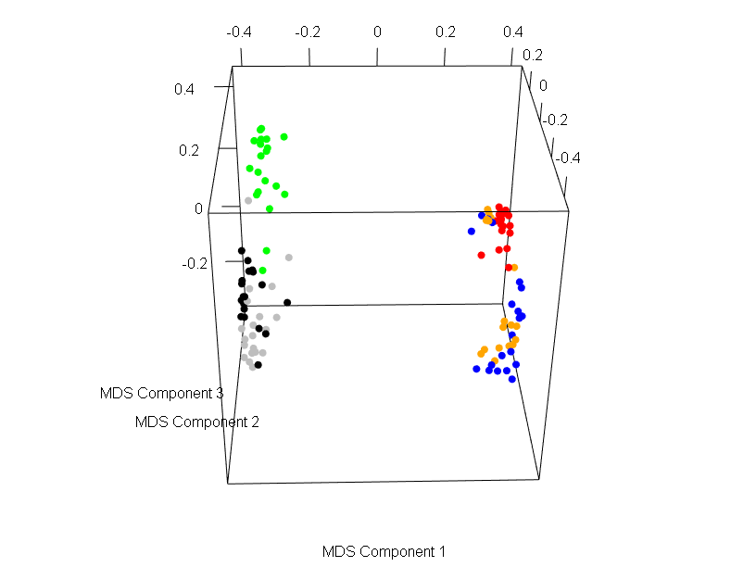 SI Figure 6 A 3-dimensional scatterplot derived from multi-dimensional scaling (MDS) of the proximity matrix of C individuals (red = C₁ females, green = C₁ males, blue = C₂ females, black = C₂ males, orange = C₃ females, grey = C₃ males).
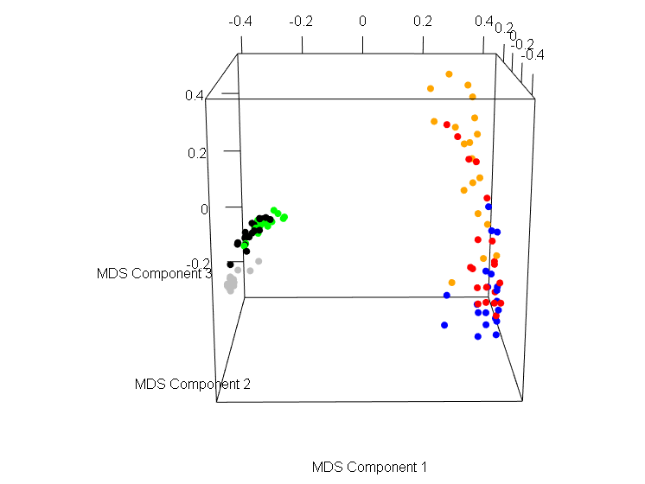 SI Figure 7 A 3-dimensional scatterplot derived from multi-dimensional scaling (MDS) of the proximity matrix of M individuals (red = M₁ females, green = M₁ males, blue = M₂ females, black = M₂ males, orange = M₃ females, grey = M₃ males).
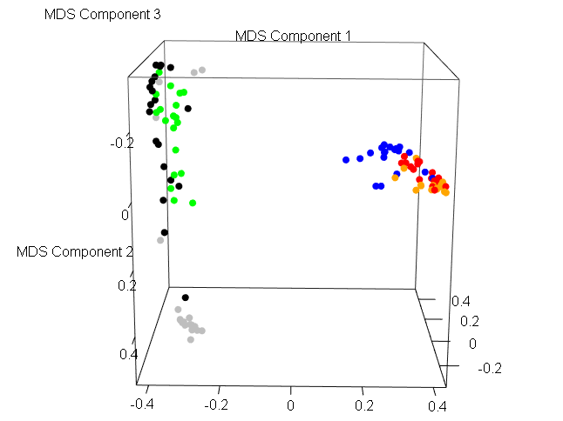 SI Figure 8 A 3-dimensional scatterplot derived from multi-dimensional scaling (MDS) of the proximity matrix of F individuals (red = F₁ females, green = F₁ males, blue = F₂ females, black = F₂ males, orange = F₃ females, grey = F₃ males).

