Supplementary material
A.
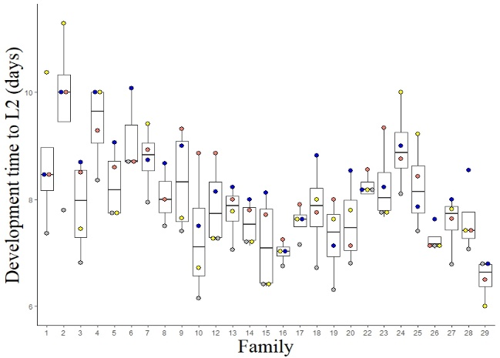
B.
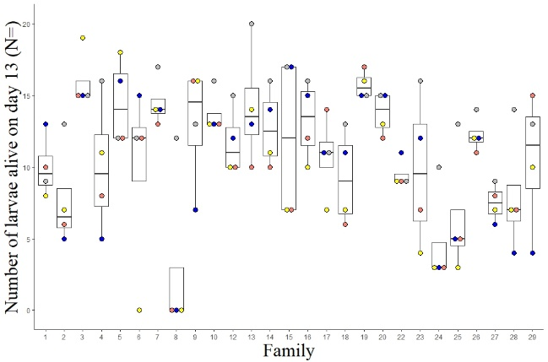

Figure S1: Between family variations of the effect of microbial depletion through antibiotic treatment on the (A.) development rate to L2 and (B.) survival to L3 of pre-diapause larvae. Data include larvae from 27 families under four different treatments (blue): antibiotic-treated, (salmon): antibiotic-treated even during re-infected, (gray): control, and (yellow): antibiotic-treated followed by re-infection by L7 larval frass.

Figure S2: The plant-contaminated gut fungal community of pre-diapause larvae of the Glanville fritillary butterfly. Data include three larvae from each of 13 families, and under four different treatments (A): antibiotic-treated, (AR): antibiotic-treated even during re-infected, (C): control larvae, and (R): antibiotic-treated followed by re-infection by frass from L7 larvae of the same families. Note the large contamination of the fungal analysis with DNA from Streptophyta.
A.
B.
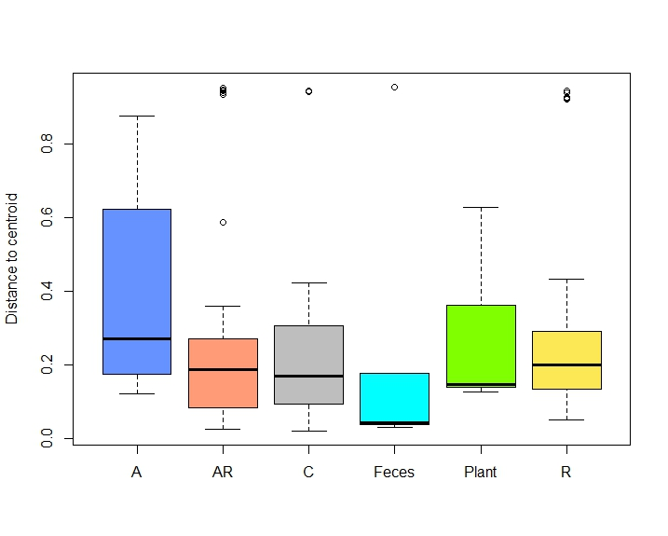
C.
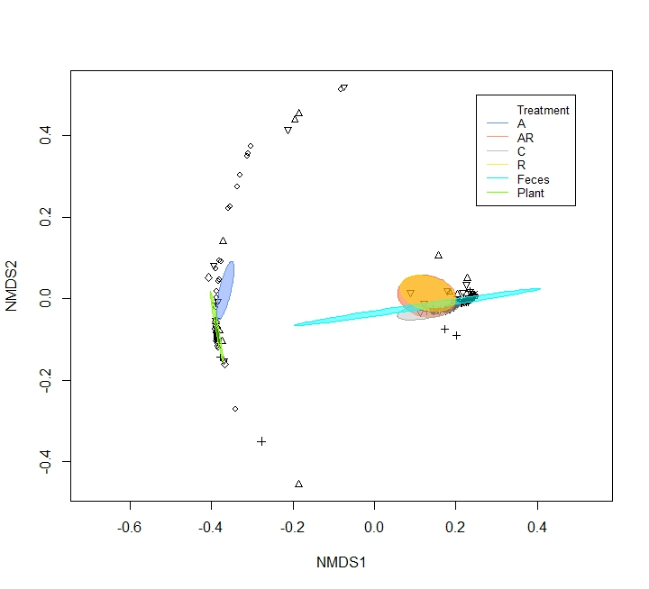
Figure S3. Effects of antibiotic treatments on the (A.) α-diversity (Shannon index), (B.) heterogeneity (Distance to centroid), and (C.) β-diversity of the bacterial gut communities of pre-diapause larvae and frass of the Glanville fritillary butterfly, and of the larval host plant Plantago lanceolata. Data include three larvae from each of 13 families, and under four different treatments: (A-blue- squares): antibiotic-treated, (AR-orange-circles): antibiotic-treated even during re-infected, (C-gray-triangles): control larvae, and (R-yellow-+): antibiotic-treated followed by re-infection by frass from L7 larvae of the same families. (turquoise-x): frass, and (green-diamond shapes): plant samples.

A. B.
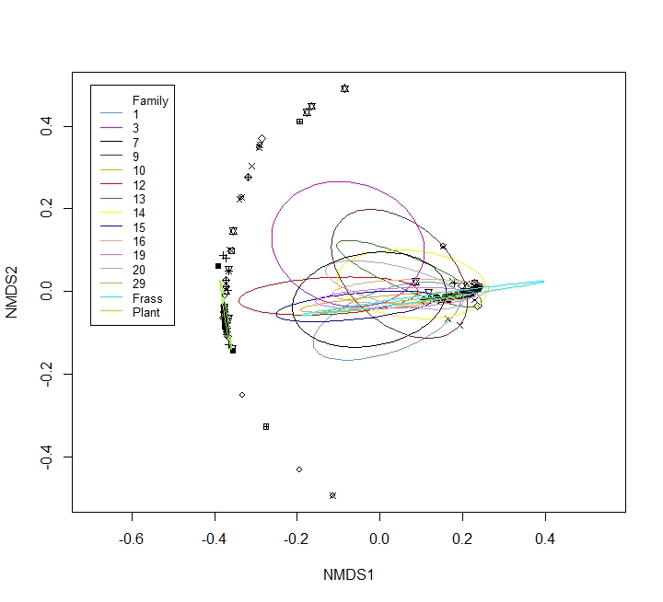

Figure S4: Effects of family on the (A.) α-diversity (Shannon index) and (B.) β-diversity of the gut bacterial communities of pre-diapause larvae, frass and host plant (Plantago lanceolata) of the Glanville fritillary butterfly. Data include larvae from 13 families. Bacterial communities of five larval frass samples and five host plants (1cm² leave piece/plant) were added to the analysis for comparison. There is no difference between families in the bacterial community of the gut.

A. B.
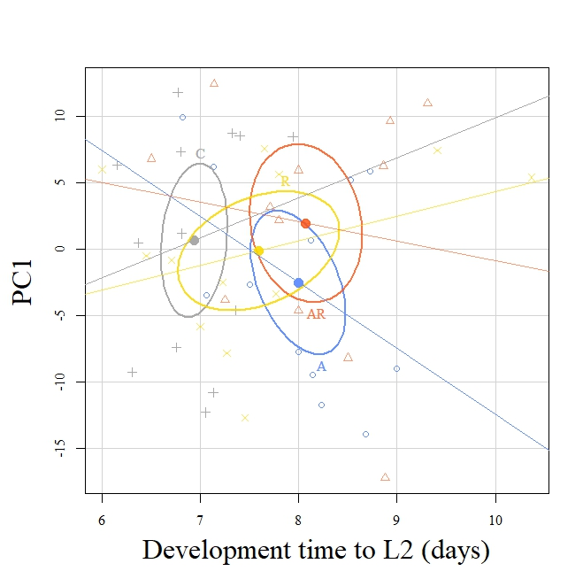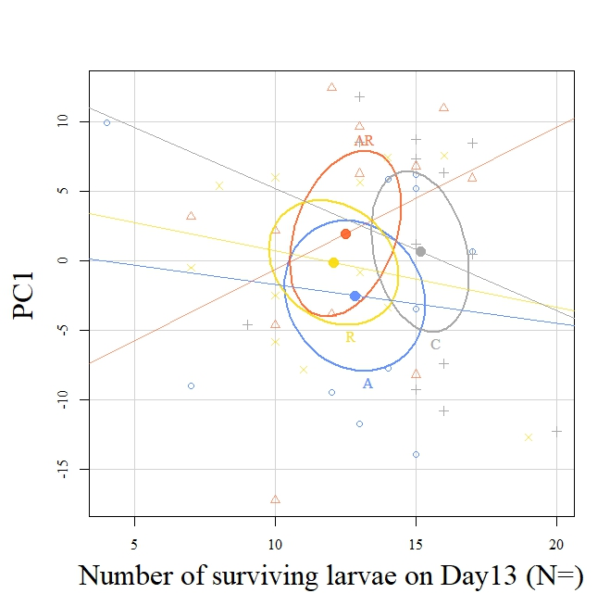
Figure S5: PC1 values from the metabolite study according to (A) development time to L2 and (B) survival to L3 of pre-diapause larvae for each treatment group. Average data from up to three larvae from 13 families reared under four treatment groups: (A-Blue): antibiotic-treated, (AR-Orange): antibiotic-treated even during re-infected, (C-Gray): control, and (R-Yellow): antibiotic-treated followed by re-infection by L7 larval frass. Ellipses give the 2% confidence interval for respective treatment group.

