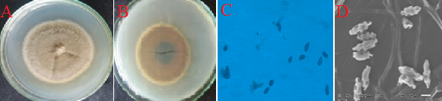
S11: Curvularia sp.1, A. Front view in PDA, B. Reverse view in PDA, C. Fluorescent microscopic image at 40X magnification, D. SEM image

