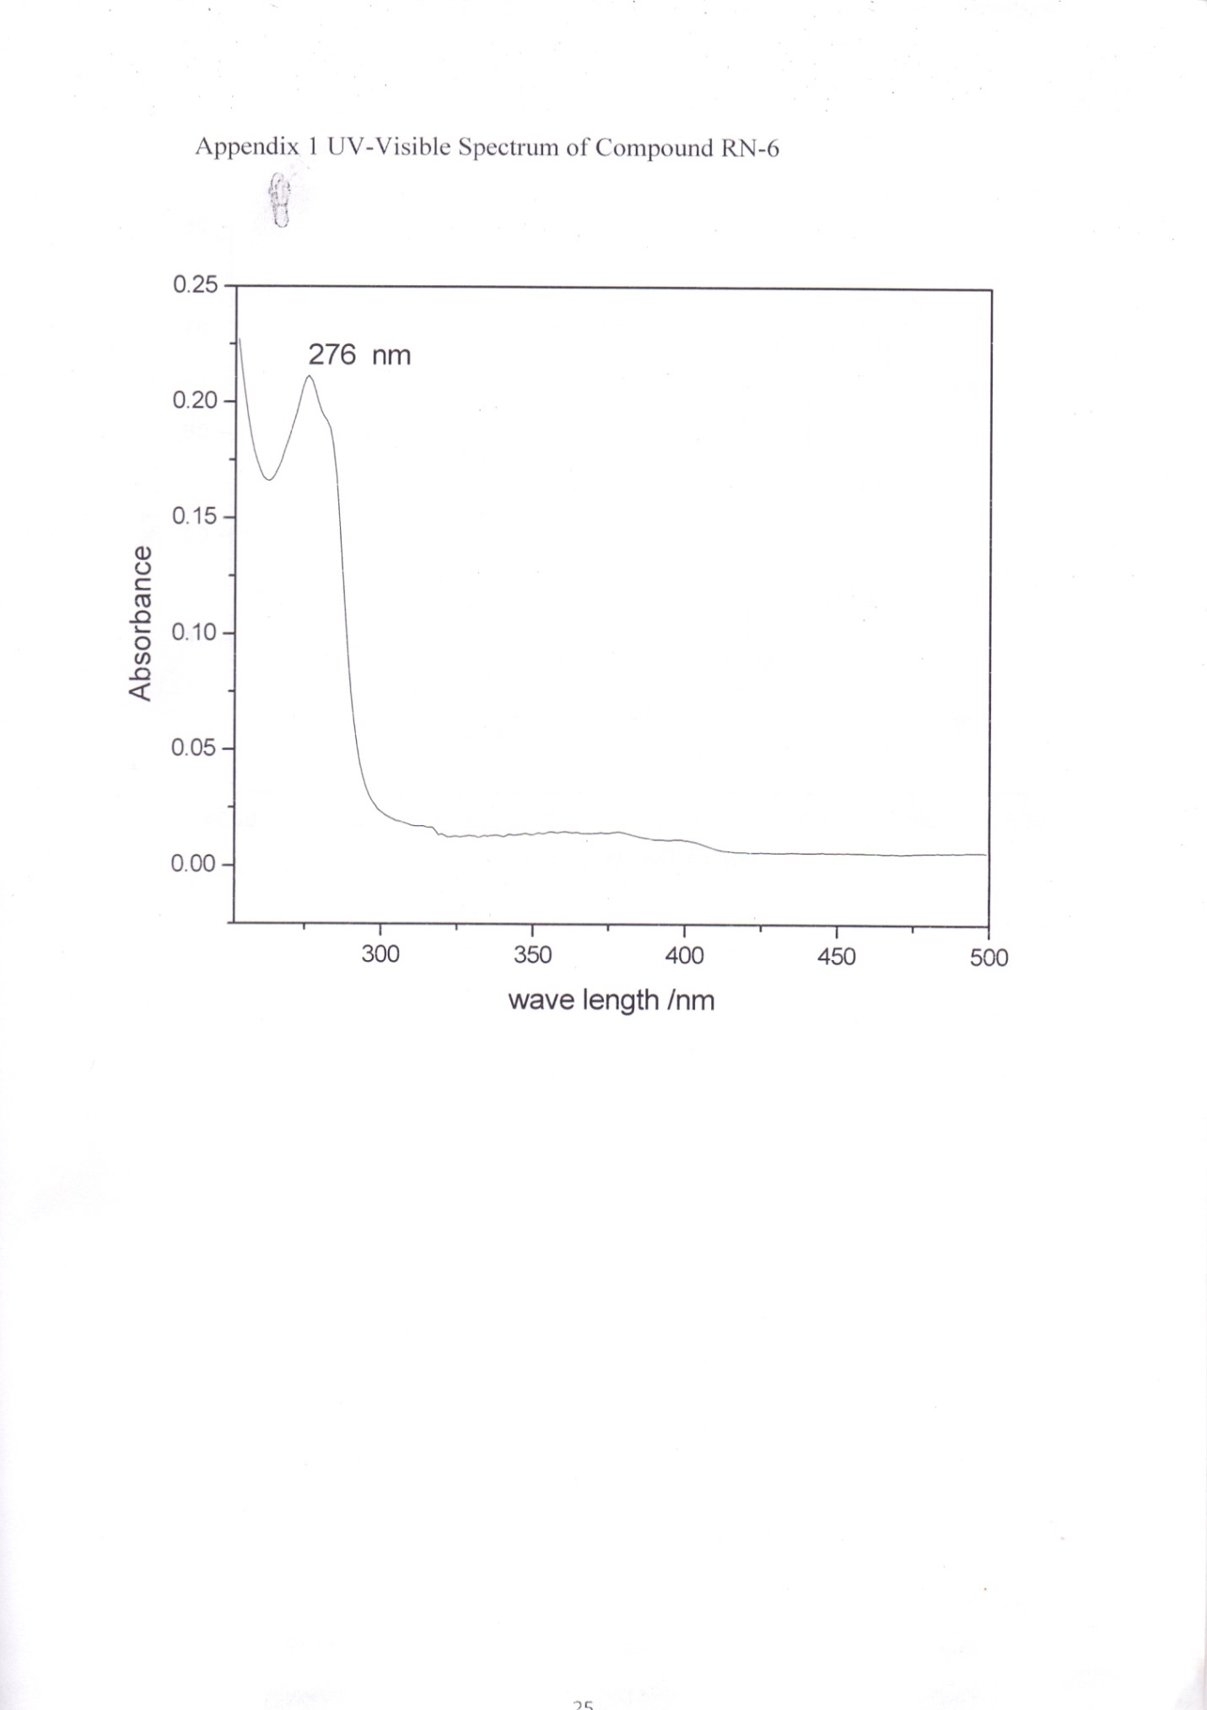
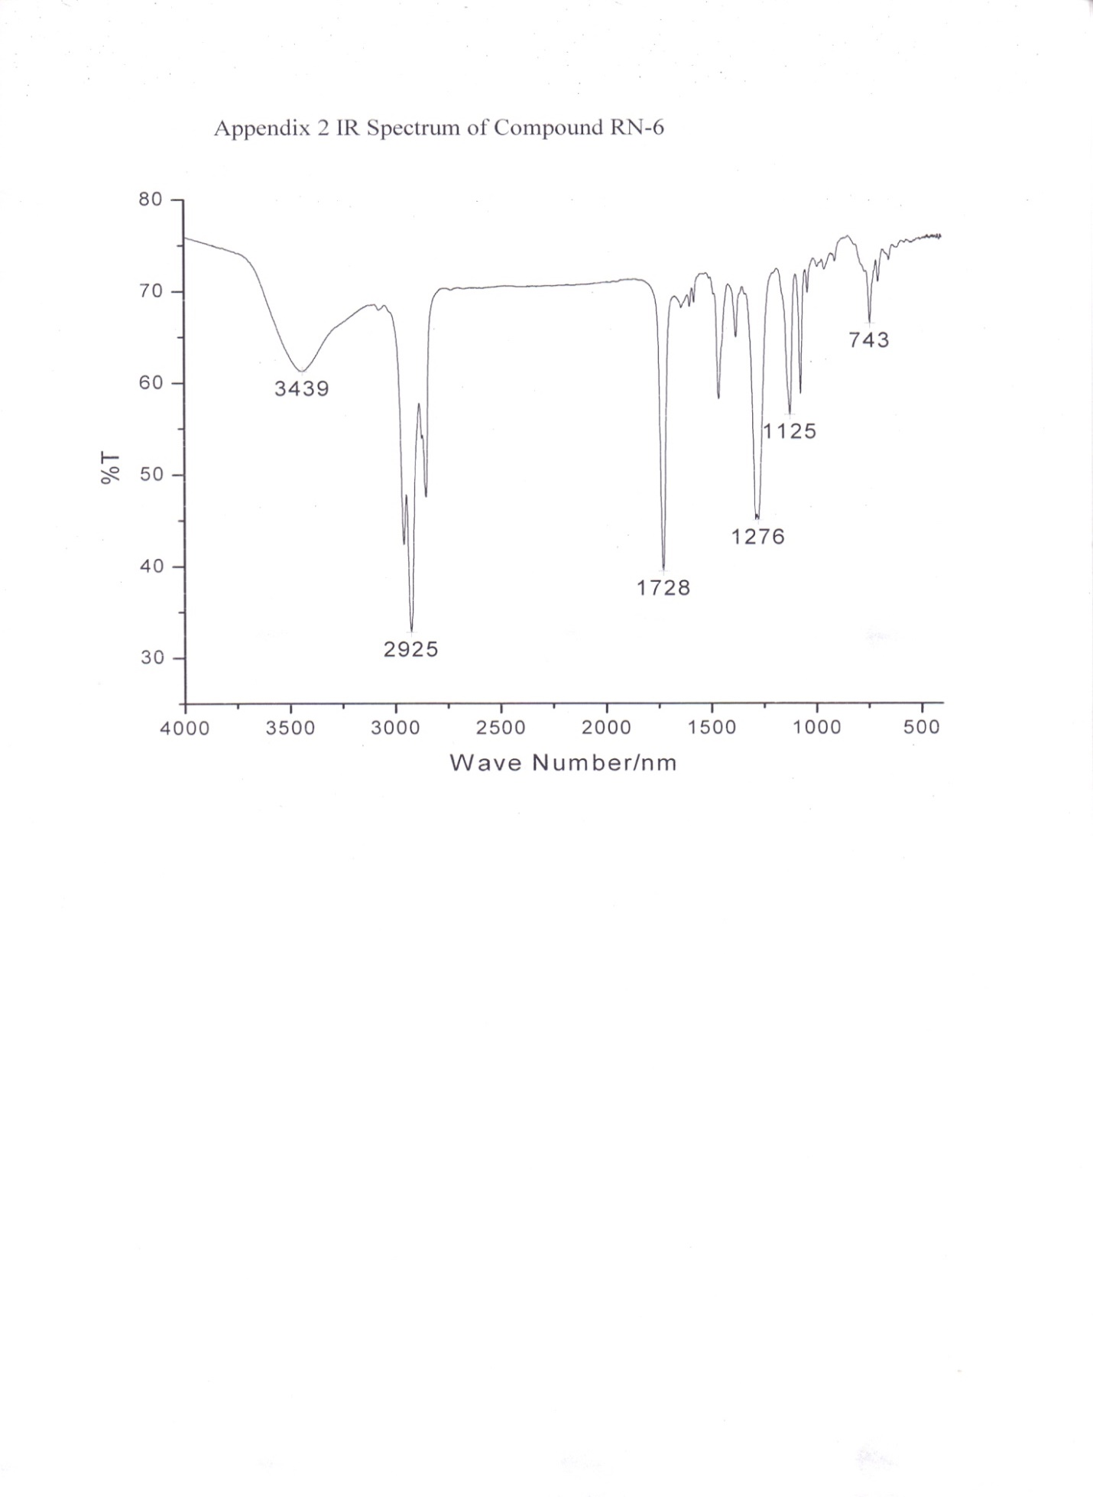
Appendix 3 ¹H-NMR of compound RN-6
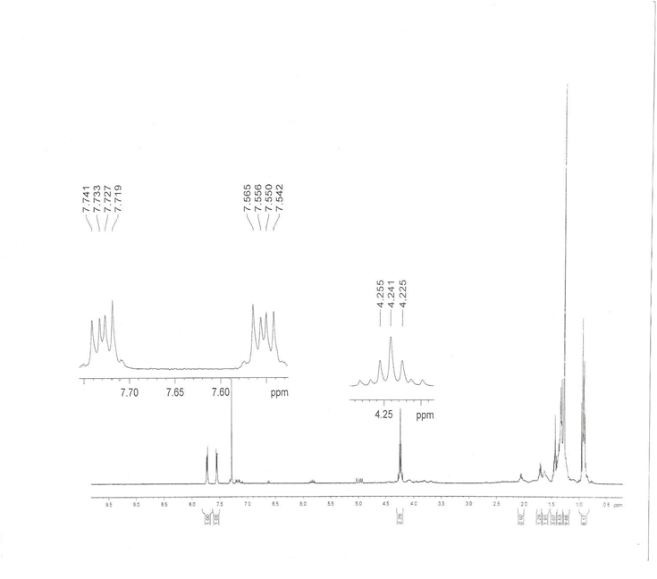

Appendix 4 ¹³C-NMR of compound RN-6
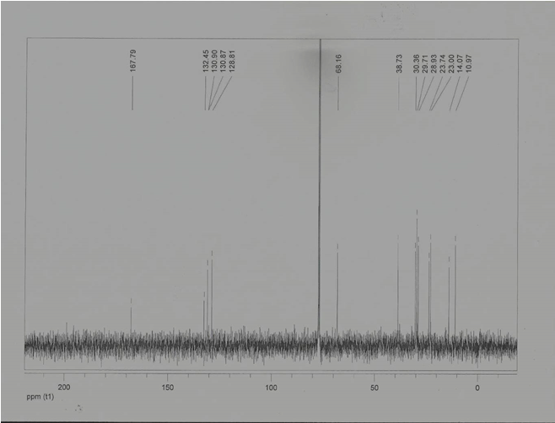

Appendix 5 DEPT-135 Spectra of Compound RN-6
