Supplementary Information

A genomic view of trophic and metabolic diversity in clade-specific Lamellodysidea sponge microbiomes

Sheila Podell, Jessica M. Blanton, Aaron Oliver, Michelle A. Schorn, Vinayak Agarwal, Jason S. Biggs, Bradley S. Moore, Eric E. Allen

Contents
Supplementary Figures S1-S13 2
Supplementary Tables S1-S8 16
References 26

Supplementary Figure 1. Cyanobacteria MAGs classified taxonomically. A) PhyloPhlAn multi-locus concatenated tree [1], with Crinalium epipsammum as an outgroup. B) 16S rRNA gene/and average amino acid identity matrix with closest database relatives. Guidelines for assigning species, genus, family, and order-level taxonomic granularity were based on [2, 3] for AAI and [4] for 16S rRNA gene percent nucleotide identity.
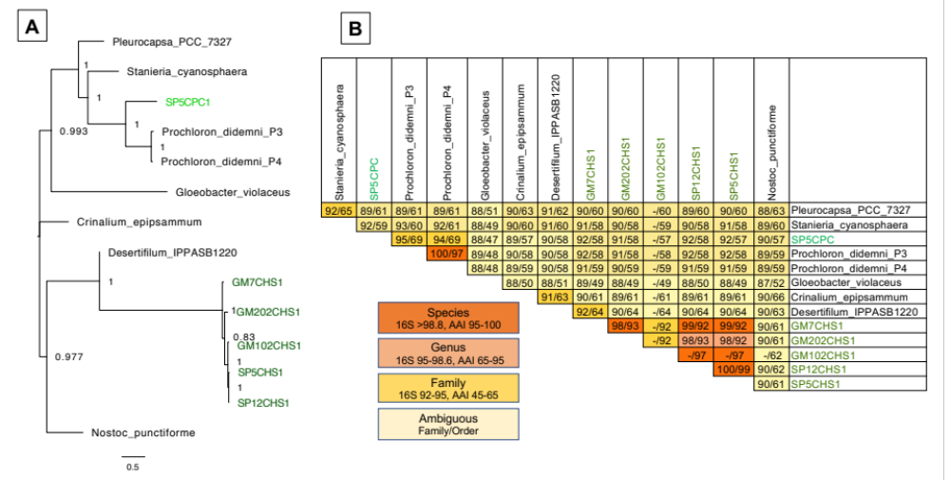

Supplementary Figure 2. Bacteroidetes MAGs classified taxonomically. A) PhyloPhlAn multi-locus concatenated tree [1], with SP5OBV1 as an outgroup. B) 16S rRNA gene/and average amino acid identity matrix with closest database relatives.
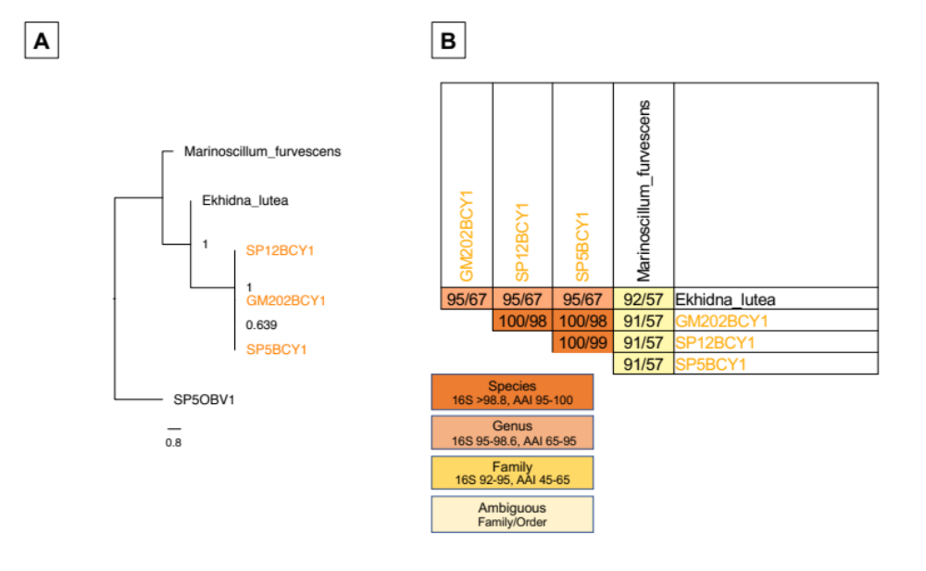

Supplementary Figure 3. Alphaproteobacteria MAGs classified taxonomically. A) PhyloPhlAn multi-locus concatenated tree [1], with SP5OBV1 as an outgroup. B) 16S rRNA gene/and average amino acid identity matrix with closest database relatives.

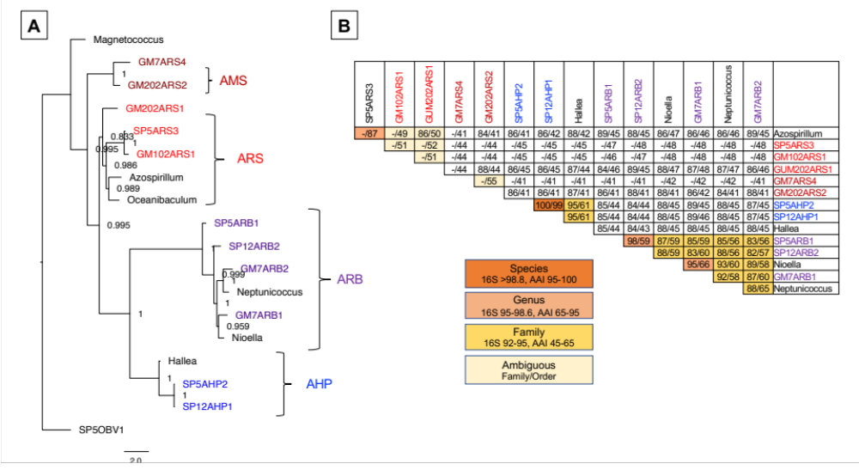
Supplementary Figure 4. Gammaproteobacteria MAGs classified taxonomically. A) PhyloPhlAn multi-locus concatenated tree [1], with SP5OBV1 as an outgroup. B) 16S rRNA gene/and average amino acid identity matrix with closest database relatives.

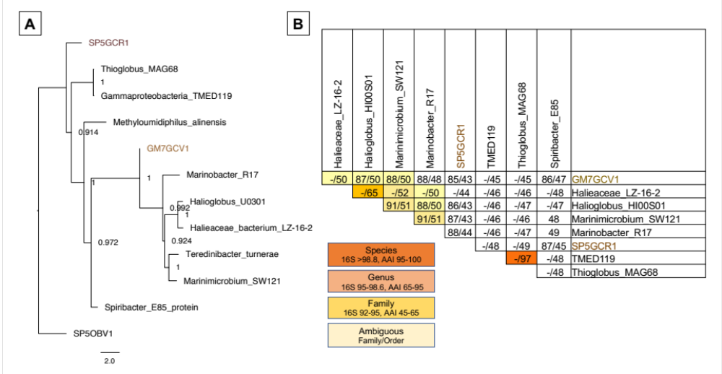

Supplementary Figure 5. Oligoflexia MAG classified taxonomically. A) PhyloPhlAn multi-locus concatenated tree [1], with Oceanobaculum indicum as an outgroup. B) 16S rRNA gene/and average amino acid identity matrix with closest database relatives.
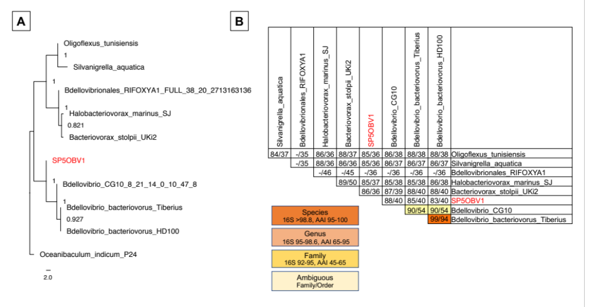

Supplementary Figure 6. Relative abundance of metagenomically assembled sequences in 16S rRNA gene amplicon data sets. Amplified 16S rRNA gene sequences were recruited by blastn search at 97% identity to metagenomically assembled 16S rRNA genes and pooled into taxonomic groups as shown in Figure 3. Relative abundances in this chart are normalized to compensate for differences in total number of 16S rRNA reads obtained for each sponge sample (see Supplementary table 2 for total numbers of cleaned, merged amplicon reads). Metagenomically assembled genomes GM102CHS1, GM7ARS4, SP5ARS3, and GM102ARS1 could not be included in this table because they did not contain any sequences overlapping the amplified region of the 16S rRNA gene.

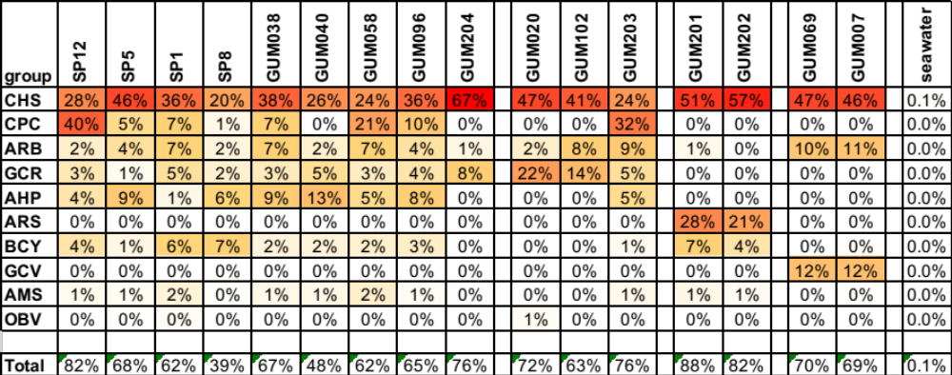

Supplementary Figure 7. Relative abundance of raw metagenomic reads mapping to assembled MAGS. Percentages are based on Bowtie read recruitment at 100% identity. MAGs were pooled into taxonomic groups as shown in Figure 3. A) Relative abundances for all classified reads; B) read recruitment percentages, including unclassified reads. All percentages have normalized for number of reads per sample, but not adjusted for potential differences in genome size.
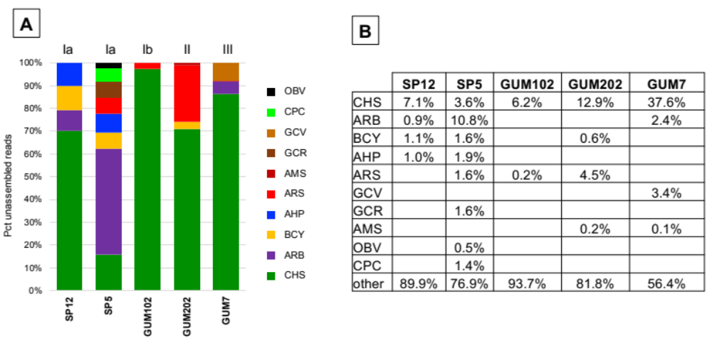

Supplementary Figure 8. Host associations of Type III secretion protein YscR homologs. A) Highlighted YscR homologs from MAGs of this study are shown in the context of a phylogenetic tree annotated with host types as described in [5]. B) Position of YscR homolog in Yersinia Type III secretion structure, adapted from [6].
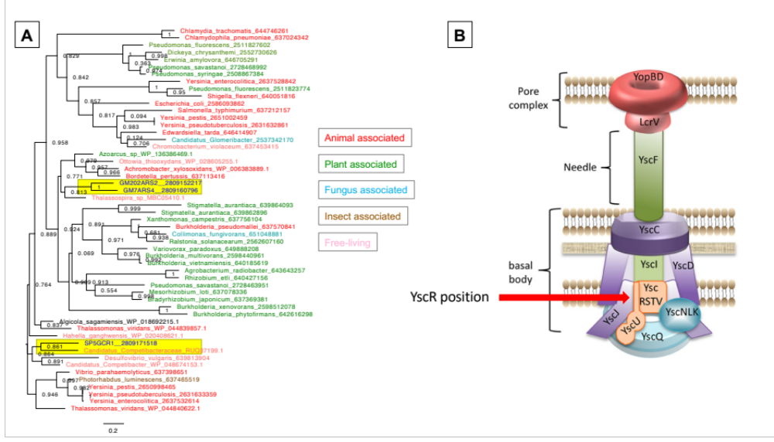

Supplementary Figure 9. VirSorter candidate scaffolds in holobiont assemblies. Virus taxonomic groups were obtained by DarkHorse assignment based on blastx matches to a custom database containing all viral sequences in GenBank nr as of Jaunuary 2, 2019.
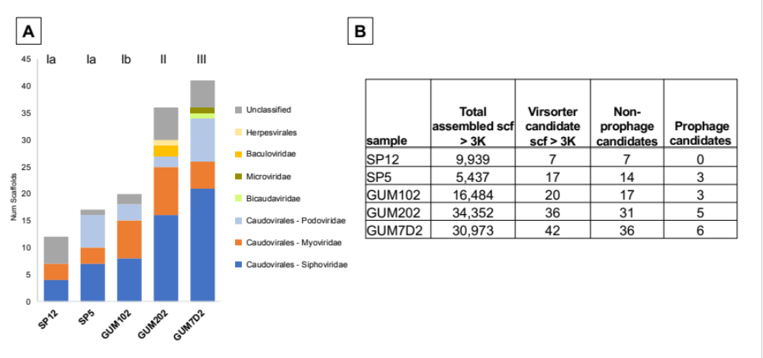

Supplementary Figure 10. Flavin-dependent aromatic halogenases from SP12AHP1 and SP5AHP2. A) Operon structure map from IMG-MER [7] showing relative positions of tandem repeats in red. B) Phylogenetic tree of protein sequences, showing positions of putative halogenase sequences from this study relative to experimentally characterized database examples described in [8]. The tree is rooted with the bmp5 gene of Pseudoalteromonas putida [9]. PDBE pathway halogenases from Hormoscilla strains SP5, SP12, GUM102, and GUM202 clade with the bmp5 outgroup.
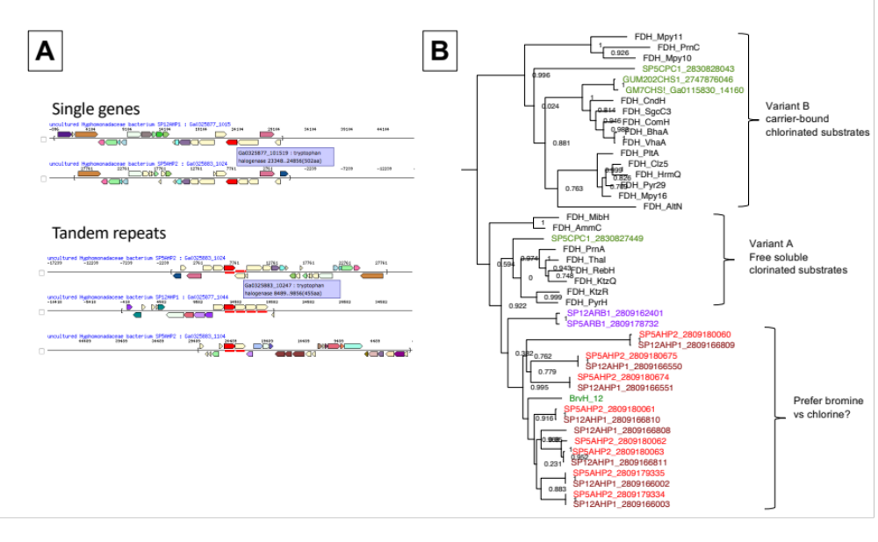
Supplementary Figure 11. Comparison of candidate haloaromatic degradation gene neighborhoods. A) Gene neighborhood maps with halocatechol dioxygenase genes indicated in red. Maps and tables of predicted genes for B) SP12AHP1, C) SP5AHP2 and D) Altererythrobacter marensis were obtained using the automated IMG-ER annotation pipeline [7]

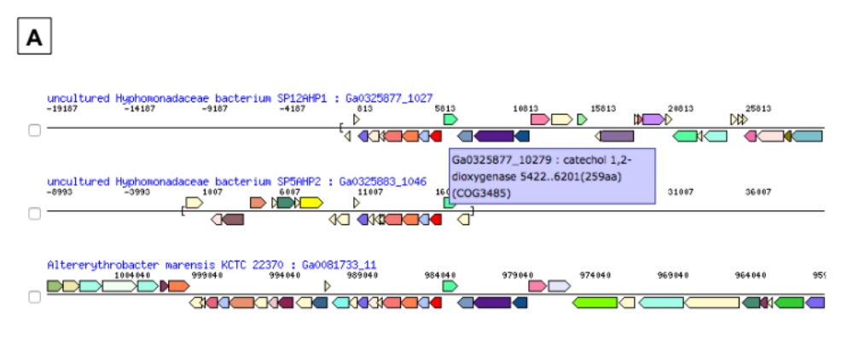
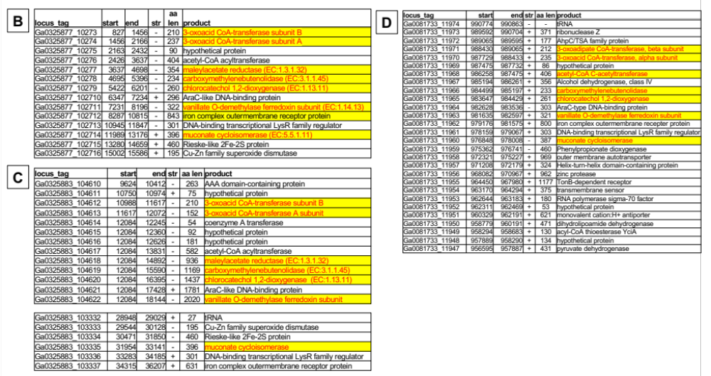
Supplementary Figure 12. Phylogenetic tree of halocatechol 1,2 dioxygenases. Tree shows SP12AHP1 and SP5AHP1 halocatechol 1,2-dioxygenases, highlighted in red, compared to closest GenBank nr protein relatives. Chemically characterized chlorocatechol 1,2-dioxygenases are highlighted in blue.
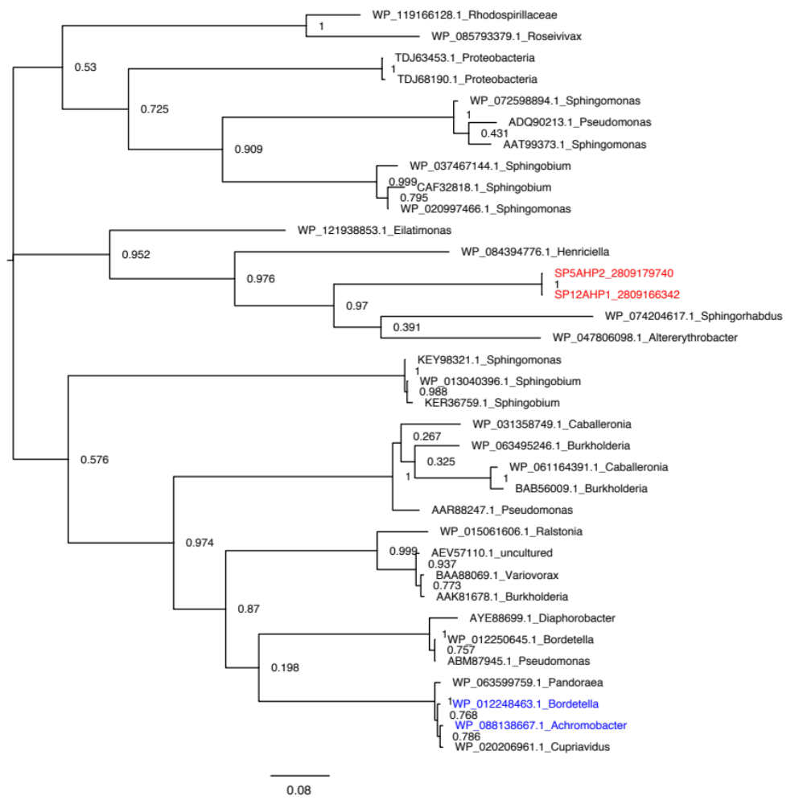
Supplementary Figure 13. MySQL schema for extracting sample metadata and abundance statistics from the Sponge Microbiome Database. Tables were populated using data in Supplementary tables 3,4, and 5 from [10].

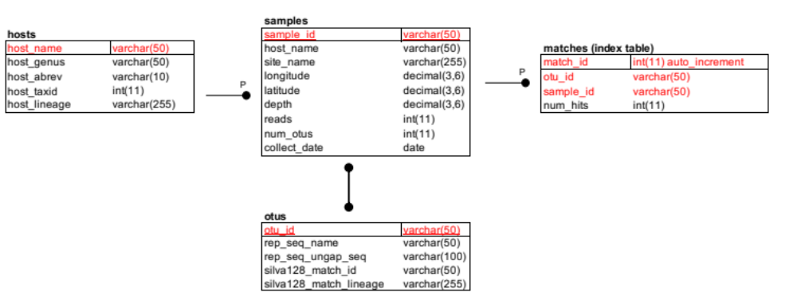

Supplementary Table 1. Lamellodysidea sponge sampling metadata.
Host clade (ITS) | Sample name | Location | Collect  date | Description | NCBI Biosample ID | 16S amplicon merged seqs | Illumina metagenomic reads | PacBio metagenomic reads
Ia | SP12 | Anae Island | June 2014 | lime green, purple patches, flat | SAMN04939363 | 227,847 | 45,810,804 | -
Ia | SP5 | Piti Bomb Holes | June 2014 | lime green, purple base, lettuce leaf | SAMN04939377 | 126,418 | 46,496,996 | -
Ia | SP1 | Piti Bomb Holes | June 2014 | lime green, purple base, lettuce leaf | SAMN04939374 | 97,761 | - | -
Ia | SP8 | Piti Bomb Holes | June 2014 | lime green, purple base, lettuce leaf | SAMN04939378 | 112,399 | - | -
Ia | GUM038 | Anae Island | July 2015 | white/gray, flat | SAMN04939360 | 114,867 | - | -
Ia | GUM040 | Anae Island | July 2015 | white/gray, flat | SAMN04939361 | 213,095 | - | -
Ia | GUM058 | Piti Bomb Holes | July 2015 | lime green, lettuce leaf | SAMN04939368 | 84,608 | - | -
Ia | GUM096 | Piti Bomb Holes | July 2015 | lime green, lettuce leaf | SAMN04939369 | 114,282 | - | -
Ia | GUM203 | Piti Bomb Holes | Dec. 2016 | lime green, purple base, lettuce leaf | SAMN12982864 | 3,280 | - | -
Ib | GUM020 | Piti Bomb Holes | July 2015 | green with white ridged fingers | SAMN04939367 | 123,293 | - | -
Ib | GUM102 | Piti Bomb Holes | July 2015 | green with white ridged fingers | SAMN04939373 | 195,184 | 148,726,466 | -
Ib | GUM204 | Tumon Bay | Dec. 2016 | green with white ridged fingers | SAMN12982865 | 6,503 | - | -
II | GUM201 | Anae Island | Dec. 2016 | green flat with delicate fingers | SAMN12982858 | 5,096 | - | -
II | GUM202 | Anae Island | Dec. 2016 | white/gray flat with delicate fingers | SAMN10266269 | 4,237 | 100,368,352 | 31,034
III | GUM069 | Pago Bay | July 2015 | dark green ridged, fleshy fingers | SAMN04939366 | 128,996 | - | -
III | GUM7D2 | Pago Bay | July 2015 | dark green ridged, fleshy fingers | SAMN04939364 | 79,191 | 178,947,320 | -
III | GUM007 | Pago Bay | July 2015 | trichome enrichment of sample GUM7D2 | SAMN04939365 | - | 82,554,626 | 180,838
na | GUM61 | Anae Island | July 2015 | seawater | SAMN12983225 | 1,405,063 | - | -

Supplementary Table 2. Sponge holobiont and trichome metagenomic assembly statistics.
Sample name | Sample type | pct reads assembled | Read type | Avg read length | Assembled reads | scf >3K | Max scf len
SP12 | holobiont tissue | 32% | Illumina | 90 | 14,534,232 | 9,939 | 75,936
SP5 | holobiont tissue | 37% | Illumina | 90 | 17,349,474 | 5,437 | 235,084
GUM102 | holobiont tissue | 46% | Illumina | 135 | 68,102,612 | 16,294 | 75,068
GUM202 | holobiont tissue | 75% | Illumina | 150 | 75,290,051 | 34,352 | 442,614
GUM7D2 | holobiont tissue | 33% | Illumina | 150 | 27,376,842 | 30,974 | 325,242
GUM202 | trichome enrichment | nd | PacBio | 3852 | 31,034 | 67* | 304,029*
GUM007 | trichome enrichment | 40% | PacBio | 4445 | 71,965 | 6 | 3,147,220

*GUM202 trichome enrichment reads were assembled in combination with Illumina GUM202 holobiont sequences, as previously described in [11].

Supplementary Table 3. MIMAG parameters for assembled genomes.
Host clade | Assembly Name | Organism name | analysis project type | assemb. software | Multi-marker taxonomy | MIMAG qual | Completeness score | Contamination score | Completeness software
Ia | SP12AHP1 | Hyphomonadaceae bacterium SP12AHP1 | MAG | idba-ud  v. 1.1.1 | Alphaproteobacteria;Rhodobacterales;  Hyphomonadaceae | high | 91.4 | 0.0 | CheckM
Ia | SP12ARB1 | Rhodobacteraceae bacterium SP12ARB1 | MAG | idba-ud  v. 1.1.1 | Alphaproteobacteria;Rhodobacterales;  Rhodobacteraceae | med | 69.1 | 0.0 | CheckM
Ia | SP12BCY1 | Ekhidna sp. SP12BCY1 | MAG | idba-ud  v. 1.1.1 | Bacteroidetes;Cytophagia;Cytophagales;  Cytophagaceae;Ekhidna | high | 100.0 | 0.0 | CheckM
Ia | SP12CHS1 | Hormopscilla sp. SP12CHS1 | MAG | idba-ud  v. 1.1.1 | Cyanobacteria;Oscillatoriophycideae;  Oscillatoriales;Gomontiellaceae;Hormoscilla | high | 96.6 | 0.2 | CheckM
Ia | SP5AHP2 | Hyphomonadaceae bacterium SP5AHP1 | MAG | Celera Assem. v.8.3 | Alphaproteobacteria;Rhodobacterales;  Hyphomonadaceae | med | 87.8 | 0.0 | CheckM
Ia | SP5ARB1 | Rhodobacteraceae bacterium SP5ARB1 | MAG | idba-ud  v. 1.1.1 | Alphaproteobacteria;Rhodobacterales;  Rhodobacteraceae | med | 82.4 | 3.4 | CheckM
Ia | SP5ARS3 | Rhodospirllales bacterium SP5ARS3 | MAG | idba-ud  v. 1.1.1 | Alphaproteobacteria:Rhodospirillales | med | 94.8 | 0.0 | CheckM
Ia | SP5BCY1 | Ekhidna sp. SP5BCY1 | MAG | idba-ud  v. 1.1.1 | Bacteroidetes;Cytophagia;Cytophagales;  Cytophagaceae;Ekhidna | high | 96.4 | 0.5 | CheckM
Ia | SP5CHS1 | Hormopscilla sp. SP5CHS1 | MAG | idba-ud  v. 1.1.1 | Cyanobacteria;Oscillatoriophycideae;  Oscillatoriales;Gomontiellaceae;Hormoscilla | high | 96.6 | 0.2 | CheckM
Ia | SP5CPC1 | Pochlorn sp SP5CPC1 | MAG | idba-ud  v. 1.1.1 | Cyanobacteria;Synechococcales;Prochloraceae;Prochloron | med | 77.4 | 0.0 | CheckM
Ia | SP5GCR1 | Chromatiales bacterium  SP5GCR1 | MAG | idba-ud  v. 1.1.1 | Gammaproteobacteria;Chromatiales | high | 98.3 | 0.0 | CheckM
Ia | SP5OBV1 | Bdellovibrionales bacterium SP5)BV1 | MAG | idba-ud  v. 1.1.1 | Oligoflexia;Bdellovibrionales | high | 91.2 | 0.0 | CheckM
Ib | GM102ARS1 | Rhodospirillales bacterium GM102ARS1 | MAG | idba-ud  v. 1.1.1 | Alphaproteobacteria:Rhodospirillales | low | 41.2 | 0.8 | CheckM
Ib | GM102HS1 | Hormopscilla sp. GM102CHS1 | MAG | idba-ud  v. 1.1.1 | Cyanobacteria;Oscillatoriophycideae;  Oscillatoriales;Gomontiellaceae;Hormoscilla | med | 95.7 | 1.8 | CheckM
II | GM202ARS1 | Rhodospirillales bacterium GM202ARS1 | MAG | Celera Assem.  v.8.3 | Alphaproteobacteria:Rhodospirillales | high | 100.0 | 0.0 | CheckM
II | GM202ARS2 | Candidatus Methylospongiales bacterium GM202ARS2 | MAG | idba-ud  v. 1.1.1 | Alphaproteobacteria:Candidatus Methylospongiales | med | 85.3 | 0.8 | CheckM
II | GM202BCY1 | Ekhidna sp. GM202BCY1 | MAG | Celera Assem.  v.8.3 | Bacteroidetes;Cytophagia;Cytophagales;  Cytophagaceae;Ekhidna | high | 94.9 | 0.5 | CheckM
II | GM202CHS1 | Hormoscilla sp. GM202CHS1 | MAG | SPAdes  v. 3.10.1 | Cyanobacteria;Oscillatoriophycideae;  Oscillatoriales;Gomontiellaceae;Hormoscilla | high | 97.4 | 2.0 | CheckM
III | GM7ARB1 | Rhodobacteraceae bacterium GM7ARB1 | MAG | Celera Assem.  v.8.3 | Alphaproteobacteria;Rhodobacterales;  Rhodobacteraceae | high | 96.6 | 0.0 | CheckM
III | GM7ARB2 | Rhodobacteraceae bacterium GM7ARB2 | MAG | Celera Assem.  v.8.3 | Alphaproteobacteria;Rhodobacterales;  Rhodobacteraceae | high | 93.7 | 0.9 | CheckM
III | GM7ARS4 | Candidatus Methylospongiales bacterium GM7ARS2 | MAG | idba-ud  v. 1.1.1 | Alphaproteobacteria:Candidatus Methylospongiales | med | 91.0 | 0.8 | CheckM
III | GM7CHS1pb | Hormopscilla sp. GM7CHS1 | MAG | CANU  v. 1.8 | Cyanobacteria;Oscillatoriophycideae;  Oscillatoriales;Gomontiellaceae;Hormoscilla | high | 100.0 | 1.8 | CheckM
III | GM7GCV1 | Cellvibrionales bacterium GM7GCV1 | MAG | Celera Assem.  v.8.3 | Gammaproteobacteria;Cellvibrionales | med | 89.1 | 0.0 | CheckM

Supplementary Table 4. Closest environmental matches from GenBank nr to 16S rRNA genes obtained from MAGs. GM102CHS1, GM7ARS4, SP5ARS3, GM102ARS1 are not included in this table because they did not include any 16S rRNA genes of 300 nt or longer.
Tax group | MAG | Environ 16S tophit | Env. 16S pct ident | Aln len | Environ tophit habitat | Ref. | Lineage
CHS | GM202CHS1 | AY615507.1 | 99% | 1410 | Sponge - Lamellodysidea | [12] | Cyanobacteria;Oscillatoriophycideae;Oscillatoriales;  Gomontiellaceae;Hormoscilla
CHS | GM7CHS1 | AY615501.1 | 100% | 1410 | Sponge - Lamellodysidea | [12] | Cyanobacteria;Oscillatoriophycideae;Oscillatoriales;  Gomontiellaceae;Hormoscilla
CHS | SP12CHS1 | AY615505.1 | 99% | 1410 | Sponge - Lamellodysidea | [12] | Cyanobacteria;Oscillatoriophycideae;Oscillatoriales;  Gomontiellaceae;Hormoscilla
CHS | SP5CHS1 | AY615505.1 | 100% | 1410 | Sponge - Lamellodysidea | [12] | Cyanobacteria;Oscillatoriophycideae;Oscillatoriales;  Gomontiellaceae;Hormoscillaa
CPC | SP5CPC1 | DQ357958.1 | 99% | 1443 | Tunicates - Lissoclinum | [13] | Cyanobacteria;Synechococcales;Prochloraceae;Prochloron
AMS | GM202ARS2 | AY845234.1 | 99% | 1425 | Sponge - Lamellodysidea | [12] | Alphaproteobacteria:Candidatus Methylospongiales
AMS | GM202ARS1 | AY845233.1 | 100% | 1468 | Sponge - Lamellodysidea | [12] | Alphaproteobacteria:Rhodospirillales
ARB | SP5ARB1 | AY845235.1 | 99% | 1384 | Sponge - Lamellodysidea | [12] | Alphaproteobacteria;Rhodobacterales;Rhodobacteraceae
ARB | SP12ARB2 | AY845235.1 | 98% | 1379 | Sponge - Lamellodysidea | [12] | Alphaproteobacteria;Rhodobacterales;Rhodobacteraceae
ARB | GM7ARB1 | KM051808.1 | 97% | 1448 | Basaltic Crust Borehole biofilm | Un-published | Alphaproteobacteria;Rhodobacterales;Rhodobacteraceae
ARB | GM7ARB2 | CP016093.1 | 88% | 1474 | Biocathode biofilm | Un-published | Alphaproteobacteria;Rhodobacterales;Rhodobacteraceae
AHP | SP12AHP1 | JF769570.1 | 96% | 1467 | seawater near algae (sea lettuce) | Un-published | Alphaproteobacteria;Rhodobacterales;Hyphomonadaceae
AHP | SP5AHP2 | JF769570.1 | 96% | 1467 | seawater near algae (sea lettuce) | Un-published | Alphaproteobacteria;Rhodobacterales;Hyphomonadaceae
BCY | GM202BCY1 | AM259890.1 | 96% | 1460 | sponge - Tethya | [14] | Bacteroidetes;Cytophagia;Cytophagales;Cytophagaceae
BCY | SP5BCY1 | AM259890.1 | 96% | 1460 | sponge - Tethya | [14] | Bacteroidetes;Cytophagia;Cytophagales;Cytophagaceae
BCY | SP12BCY1 | AM259890.1 | 96% | 1460 | sponge - Tethya | [14] | Bacteroidetes;Cytophagia;Cytophagales;Cytophagaceae
GCR | SP5GCR1 | JX391667.1 | 91% | 1514 | PBDE contam marine sediment | Un-published | Gammaproteobacteria;Chromatiales
GCV | GM7GCV1 | JQ062844.1 | 90% | 1500 | sponge- Stylissa | [15] | Gammaproteobacteria;Cellvibrionales;Cellvibrionaceae
OVB | SP5OBV1 | EF092260 | 96% | 1442 | sponge - Axinella | Un-published | Oligoflexia;Bdellovibrionales

Supplementary Table 5. Assembled MAG 16S rRNA gene matches to Sponge Microbiome Database samples at 97% nucleotide identity. Database sequences were 99 bp segments amplified from the V4 region of the 16S rRNA gene [10]. Sponge Microbiome Database samples with the maximum number of matches to each MAG-associated 16S rRNA gene from this study were selected to determine the number and percent of matched sequences, and reported here along with host genus and geographical collection site. GM102CHS1, GM7ARS4, SP5ARS3, GM102ARS1 are not included in this table because they did not include any sequences overlapping the V4 region of the 16S rRNA gene.
Tax group | MAGs | 16S len | All host genera | Host with max pct | total OTU in sample | max num  OTU matches | max pct  OTU matches | site name | sample_id
CHS | SP12CHS1, SP5CHS1, GM202CHS1, GM7CHS1 | 1486 | Xestospongia, Cliona | Xestospongia bocatorensis | 647 | 57 | 16.7% | Panama | P10X53.1020516
BCY | GUM202BCY1,  SP5BCY1,  SP12BCY1 | 1524 | Carteriospongia, Cymbastela, Dysidea, Ectyoplasia, Mycale, marine sediment | Cymbastela coralliophila | 304 | 4 | 1.3% | Davies  Reef | Webster.1.E1.49.1019860
ARB | GM7ARB2 | 1243 | Dysidea | Dysidea avara | 336 | 15 | 4.5% | Limski  Canal | GC.4.2.1019709
ARB | GM7ARB1 | 1470 | Chondrilla, Cinachyrella, Cliona, Dysidea, Ectyoplasia, Lissodendoryx, Mycale, seawater, marine sediment | Lissodendoryx colombiensis | 237 | 1 | 0.4% | Panama | P12x59.1019532
ARB | SP5ARB1, SP12ARB1 | 1497 | Dysidea, Xestospongia | Xestospongia bocatorensis | 678 | 1 | 0.1% | Panama | SI06.11.1019752
ARS | GM202ARS2 | 1504 | Dysidea | Dysidea avara | 336 | 2 | 0.6% | Limski  Canal | GC.4.2.1019709
ARS | GUM202ARS1 | 1507 | Cymbastela. Xestospongia | Cymbastela coralliophila | 1341 | 3 | 0.2% | Davies  Reef | SS.9.2.1019758
AHP | SP12AHP1  SP5AHP2 | 1479 | Ircinia | Ircinia strobilina | 2940 | 1 | 0.04% | Banco  Chinchorros | 17.1020038
DBV | SP5DBV1 | 1517 | Cymbastela, Ircinia, Mycale | Cymbastela | 1085 | 3 | 0.3% | Sponge  Farm | ZA.44.1020227
GCR | SP5GCR1 | 1548 | Carteriospongia, Cymbastela, Cliona, Xestospongia | Carteriospongia foliascens | 953 | 4 | 0.4% | Kimberley, Western  Australia | Webster.3.H4.276.1019944
GCV | GM7GCV1 | 1517 | no matches above threshold | nd | nd | nd | nd | nd | nd
CPC | SP5CPC1 | 1442 | no matches above threshold | nd | nd | nd | nd | nd | nd

Supplementary Table 6. Tally of membrane-associated gene products in MAGs. Values for adhesive genes, signal sequences, and transporter types were tallied based on keyword searches of MAG annotations at IMG-MER [7].
tax group | Genome name | num CDS | num trans-porters | pct CDS as trans-porter | chemo-taxis proteins (Che/Mot) | motility type | cadherin domain proteins | ankyrin domain proteins | Type IV pili genes | num signal peptide genes | pct signal peptide genes | signal proteases | signal glycosidases
CHS | SP12CHS1 | 5961 | 195 | 3.3% | 6 | twitching |  | 2 | 12 | 74 | 1.2 | 5 | 0
CHS | SP5CHS1 | 5738 | 176 | 3.1% | 4 | twitching |  | 2 | 11 | 80 | 1.4 | 7 | 0
CHS | GM102CHS1 | 6390 | 172 | 2.7% | 2 | twitching | 1 | 2 | 16 | 78 | 1.2 | 6 | 0
CHS | GM7CHS1 | 7441 | 196 | 2.6% | 5 | twitching | 2 | 3 | 13 | 111 | 1.4 | 6 | 1
CHS | GM202CHS1 | 6160 | 247 | 4.0% | 6 | twitching |  | 5 | 15 | 113 | 1.5 | 7 | 0
CPC | SP5CPC1 | 3413 | 122 | 3.6% | 24 | twitching |  | 5 | 8 | 83 | 2.4 | 4 | 1
AMS | GM7ARS4 | 1377 | 76 | 5.5% | 0 | none |  | 3 | 8 | 57 | 4.0 | 4 | 0
AMS | GM202ARS2 | 1836 | 91 | 5.0% | 0 | none |  | 18 | 11 | 88 | 4.7 | 6 | 0
ARS | GM202ARS1 | 2858 | 251 | 8.8% | 1 | none |  | 14 | 2 | 136 | 4.7 | 5 | 2
ARS | SP5ARS3 | 2570 | 312 | 12.1% | 0 | none |  | 22 |  | 146 | 5.6 | 2 | 2
ARS | GM102ARS1 | 1161 | 102 | 8.8% | 1 | none |  | 8 |  | 47 | 4.0 | 2 | 1
ARB | GM7ARB1 | 2449 | 247 | 10.1% | 2 | none |  | 14 |  | 124 | 5.0 | 4 | 0
ARB | GM7ARB2 | 2505 | 234 | 9.3% | 1 | none |  | 8 | 1 | 129 | 5.1 | 5 | 3
ARB | SP12ARB1 | 3273 | 263 | 8.0% | 1 | none | 1 | 6 | 2 | 121 | 3.7 | 5 | 1
ARB | SP5ARB1 | 2628 | 237 | 9.0% | 1 | none |  | 6 | 2 | 130 | 4.9 | 1 | 1
AHP | SP12AHP1 | 2275 | 113 | 5.0% | 0 | none |  | 30 |  | 152 | 6.5 | 7 | 7
AHP | SP5AHP2 | 2292 | 107 | 4.7% | 0 | none |  | 32 |  | 135 | 5.8 | 6 | 6
BCY | SP12BCY1 | 2828 | 128 | 4.5% | 12 | gliding | 29 | 10 | 1 | 147 | 5.1 | 12 | 4
BCY | SP5BCY1 | 2774 | 126 | 4.5% | 12 | gliding | 31 | 8 | 1 | 142 | 5.1 | 9 | 4
BCY | GM202BCY1 | 2879 | 125 | 4.3% | 12 | gliding | 30 | 11 | 1 | 134 | 4.6 | 9 | 3
GCR | SP5GCR1 | 1474 | 91 | 6.2% | 0 | none | 13 |  | 8 | 70 | 4.6 | 4 | 2
GCV | GM7GCV1 | 1744 | 109 | 6.3% | 1 | twitching |  | 2 | 10 | 123 | 6.9 | 5 | 3
OVB | SP5OBV1 | 1744 | 66 | 3.8% | 0 | twitching |  | 31 | 13 | 60 | 3.9 | 1 | 0
Supplementary Table 7. Viral defense genes in assembled MAGs. Values were tallied based on keyword searches of MAG annotations at IMG-MER [7].
tax group | MAG | CRISPR loci (Minced) | integrated prophage recovered | IMG  trans-posases | IMG restriction endo-nuclease | IMG DNA-modiification methylase | toxin/anti-toxin genes
CHS | SP12CHS1 | 5 | 0 | 60 | 7 | 6 | 81
CHS | SP5CHS1 | 14 | 0 | 50 | 51 | 16 | 78
CHS | GM102CHS1 | 8 | 2 | 117 | 67 | 20 | 67
CHS | GM202CHS1 | 4 | 1 | 318 | 51 | 11 | 93
CHS | GM7CHS1 | 5 | 2 | 226 | 113 | 6 | 91
CPC | SP5CPC1 | 0 | 0 | 73 | 12 | 8 | 29
AMS | GM202ARS2 | 5 | 3 | 38 | 6 | 7 | 10
AMS | GM7ARS4 | 6 | 0 | 1 | 4 | 5 | 1
ARS | GM202ARS1 | 11 | 0 | 4 | 6 | 3 | 3
ARS | SP5ARS3 | 14 | 0 | 1 | 7 | 3 | 2
ARS | GM102ARS1 | 10 | 1 | 0 | 1 | 1 | 1
ARB | SP5ARB1 | 6 | 0 | 15 | 9 | 0 | 0
ARB | SP12ARB1 | 12 | 0 | 11 | 4 | 15 | 3
ARB | GM7ARB1 | 16 | 0 | 0 | 5 | 21 | 7
ARB | GM7ARB2 | 27 | 0 | 7 | 5 | 23 | 4
AHP | SP12AHP1 | 15 | 0 | 34 | 7 | 7 | 6
AHP | SP5AHP2 | 13 | 0 | 66 | 117 | 8 | 7
BCY | GM202BCY1 | 8 | 0 | 33 | 9 | 24 | 14
BCY | SP5BCY1 | 5 | 0 | 20 | 9 | 27 | 16
BCY | SP12BCY1 | 9 | 0 | 19 | 7 | 30 | 16
GCR | SP5GCR1 | 11 | 0 | 9 | 3 | 7 | 2
GCV | GM7GCV1 | 14 | 1 | 6 | 6 | 21 | 6
OVB | SP5OBV1 | 24 | 0 | 28 | 4 | 14 | 1

Supplementary Table 8. Biosynthetic gene clusters predicted by AntiSmash [16], supplemented with aromatic halogenases predicted by Pfam database model PF04820 [17].
tax group | genome | Type I PKS | NRPS | Type III PKS | terpene-phosphonate | terpene carotenoid | terpene other | bacter-iocin  (RiPP) | beta-lactone | PDBE | Aromatic halogenases (PF04820) | cyano-bactin (RiPP) | Lanthi-peptide | Lasso-peptide (RiPP)
CHS | SP12CHS1 | 1 | 1 |  |  |  | 1 | 1 |  | 1 |  | 1
CHS | SP5CHS1 |  | 2 |  |  |  |  | 1 |  | 1 |  | 1
CHS | GM102CHS1 | 1 |  |  |  |  | 1 | 1 |  | 1
CHS | GM7CHS1pb | 3 | 5 |  |  |  | 2 | 1 |  |  | 1 | 1 | 1
CHS | GM202CHS1 | 4 | 7 |  |  |  | 2 | 1 |  | 1 | 1 | 1
CPC | SP5CPC1 |  | 2 |  |  |  | 4 | 2 |  |  | 1 |  |  | 1
AMS | GM202ARS2 |  |  |  | 1 |  | 1
AMS | GM7ARS4 |  |  |  | 1
ARS | SP5ARS3 |  |  |  |  |  | 1 | 1
ARS | GM202ARS1 |  |  |  |  |  | 1
ARS | GM102ARS1 |  |  |  |  |  | 1 | 1
ARB | GM7ARB1 |  |  |  |  | 1 | 1 | 1
ARB | GM7ARB2 |  |  |  |  | 1 |  | 1
ARB | SP12ARB1 |  |  |  |  | 1 | 1 | 1 |  |  | 1
ARB | SP5ARB1 |  |  |  |  | 1 | 1 | 1 |  |  | 1
AHP | SP5AHP2 |  |  |  |  | 1 | 1 |  |  |  | 11
AHP | SP12AHP |  |  |  |  | 1 | 1 |  |  |  | 8
BCY | SP12BCY1 |  |  | 1 |  | 1 | 1
BCY | GM202BCY1 |  |  | 1 |  | 1 | 1
BCY | SP5BCY1 |  |  | 1 |  | 1 | 1
GCR | SP5GCR1 |  |  |  |  |  |  | 2
GCV | GM7GCV1 |  |  |  |  |  |  | 1 | 1
OVB | SP5OVB1

References
1. Segata, N., et al., PhyloPhlAn is a new method for improved phylogenetic and taxonomic placement of microbes. Nat Commun, 2013. 4: p. 2304.
2. Rodriguez-R, L. and K. Konstantinidis, The enveomics collection: a toolbox for specialized analyses of microbial genomes and metagenomes. PeerJ Preprints, 2016. 4: p. e1900v1.
3. Rodriguez-R, L.M., and Konstantinos T. Konstantinidis, Bypassing Cultivation To Identify Bacterial Species. Microbe, 2014. 9(3): p. 111-8.
4. Yarza, P., et al., Uniting the classification of cultured and uncultured bacteria and archaea using 16S rRNA gene sequences. Nat Rev Microbiol, 2014. 12(9): p. 635-45.
5. Nazir, R., et al., The Ecological Role of Type Three Secretion Systems in the Interaction of Bacteria with Fungi in Soil and Related Habitats Is Diverse and Context-Dependent. Front Microbiol, 2017. 8: p. 38.
6. Dewoody, R.S., P.M. Merritt, and M.M. Marketon, Regulation of the Yersinia type III secretion system: traffic control. Front Cell Infect Microbiol, 2013. 3: p. 4.
7. Chen, I.A., et al., IMG/M: integrated genome and metagenome comparative data analysis system. Nucleic Acids Res, 2017. 45(D1): p. D507-D516.
8. Neubauer, P.R., et al., A flavin-dependent halogenase from metagenomic analysis prefers bromination over chlorination. PLoS One, 2018. 13(5): p. e0196797.
9. Agarwal, V., et al., Biosynthesis of polybrominated aromatic organic compounds by marine bacteria. Nat Chem Biol, 2014. 10(8): p. 640-7.
10. Thomas, T., et al., Diversity, structure and convergent evolution of the global sponge microbiome. Nat Commun, 2016. 7: p. 11870.
11. Schorn, M.A., et al., Comparative Genomics of Cyanobacterial Symbionts Reveals Distinct, Specialized Metabolism in Tropical Dysideidae Sponges. MBio, 2019. 10(3): p. e00821-19.
12. Ridley, C.P., D. John Faulkner, and M.G. Haygood, Investigation of Oscillatoria spongeliae-dominated bacterial communities in four dictyoceratid sponges. Appl Environ Microbiol, 2005. 71(11): p. 7366-75.
13. Donia, M.S., et al., Complex microbiome underlying secondary and primary metabolism in the tunicate-Prochloron symbiosis. Proc Natl Acad Sci U S A, 2011. 108(51): p. E1423-32.
14. Thiel, V., et al., Spatial distribution of sponge-associated bacteria in the Mediterranean sponge Tethya aurantium. FEMS Microbiol Ecol, 2007. 59(1): p. 47-63.
15. Giles, E.C., et al., Bacterial community profiles in low microbial abundance sponges. FEMS Microbiol Ecol, 2013. 83(1): p. 232-41.
16. Blin, K., et al., antiSMASH 5.0: updates to the secondary metabolite genome mining pipeline. Nucleic Acids Res, 2019. 47(W1): p. W81-W87.
17. Finn, R.D., et al., The Pfam protein families database: towards a more sustainable future. Nucleic Acids Res, 2016. 44(D1): p. D279-85.

