Supplementary Material
Supplementary Table 1. Primers used in gene amplification
Gene names | Primers
Gene names | Sense (5’-3’) | Anti-sense (5’-3’)
Mouse NCAM-180 | AGCCCCTTAGCAGCAGTAGCCG | CTGCCTCAGGTGGGTTCTTCACG
Mouse NCAM-140 | GCTGACAGAACCCGAAAAGG | CCCATCATGCTTTGCTCTCAT
Mouse NCAM-120 | GGCACCCGTCATTCTACCTA | GCAAAGGCTTGTCTTTGAGC
Human NCAM | TTGTTTTTCCTGGGAACTGC | TATCTTTGGCATCTCCTGCC
Mouse STX | TCAGAATCAGAACCCCGTCA | CGACAGTCAGTTTCAATGCC
Mouse PST | ACTGAAAGTGCGAACTGCCT | GAGAAGACCTGTGCTGGGTC
Human STX | TCAGAACCAGAACCCAGTCA | CGACAGTCAGTTTCAAAGCC
Human PST | ACTGAAAGTGCGAACTGCCT | GAGAAGACCTGTGCTGGGT
Mouse c-Myc | AGAGCTCCTCGAGCTGTTTG | ACGGAGTCGTAGTCGAGGTC
Mouse Wnt3a | ACTACGTGGAGATCATGCCC | GGTGGCTTTGTCCAGAACAG
Mouse slug | ATCTGTGGCAAGGCTTTCTC | GATGTGCCCTCAGGTTTGAT
Mouse GSK-3β | GCAGCCTTCAGCTTTTGGTA | AACTGACTTCCTGTGGCCTG
Mouse Fzd7 | CCAGCGGTCAAGACAATCA | CCGATGAAGAGGTAGACGAACA
Mouse cyclin D1 | AGACCTTTGTGGCCCTCTGT | GCAGGAGAGGAAGTTGTTGG
Mouse CK1α | CATCCCCAGTTGCTGTACG | GTCCCAGGAGATCCATGACT
Mouse axin2 | TATGTCTTTGCACCAGCCAC | TGCATCTCTCTCTGGAGCTG
Mouse APC | GCCAGCTTTTACAGTCCCAG | GTGTTGCTTTCTGCCACTCC
Human β-actin | CTTCCTGGGCATGGAGTC | GCCGATCCACACGGAGTA
Mouse γ-tubulin | ATCTACCTGTCGGAGCATGG | GCCTCCCGATCTATGATGTC

Supplementary Table 2. NCAM levels in normal and malignant breast tissue samples
 | Diagnosis | Age(y) | LN(P) | LN | Stage | D | NCAM(fd)
1 | N | 36 | - | - | - | - | 0.81±0.02
2 | N | 49 | - | - | - | - | 1.13±0.10
3 | N | 35 | - | - | - | - | 0.50±0.07
4 | N | 54 | - | - | - | - | 1.00±0.00
5 | IDC | 54 | 28 | 33 | T2N3M0 IIIc | U | 1.2±0.32
6 | IDC | 50 | 22 | 24 | T1N3M0 IIIc | 2 | 5.6±0.05
7 | IDC | 32 | 16 | 16 | T2N3M0 IIIc | 2.1 | 13.00±0.21
8 | IDC | 60 | 3 | 14 | T4N1M0 IIIb | 6 | 3.98±0.14
9 | IDC | 65 | 2 | 25 | T4N1M0 IIIb | 6.5 | 2.45±0.06
10 | IC | 73 | U | U | T2N2M0 IIIa | 3.4 | 7.11±0.43
11 | SMC | 57 | 1 | 28 | T2N1M0 IIb | 4 | 3.21±0.03
12 | IDC | 35 | 2 | 18 | T2N1M0 IIb | 2.3 | 1.51±0.02
13 | ILC | 42 | 3 | 22 | T2N1M0 IIb | 2.5 | 1.50±0.03
14 | IDLC | 57 | 0 | 23 | T2N0M0 IIa | 2.5 | 0.50±0.01
15 | MC | 51 | 0 | 19 | T2N0M0 IIa | 2.3 | 1.42±0.06
16 | IDC-NS | 33 | 1 | 25 | T1N1M0 IIa | 2 | 5.00±0.11
17 | IDLC | 72 | 1 | 24 | T1N1M0 IIa | 2 | 0.98±0.02
18 | IDC | 54 | 0 | 20 | T2N0M0 IIa | 2.8 | 0.81±0.03
19 | IDC | 39 | 0 | 12 | T1N0M0 I | 1.6 | 1.45±0.04
20 | IDC | 54 | 0 | U | T1N0M0 I | 1.2 | 1.04±0.00
21 | IDC | 32 | 0 | U | T1N0M0 I | U | 1.92±0.01
22 | IDC | 65 | 0 | U | T1N0M0 I | 1.0 | 1.10±0.01
23 | IDC | 35 | 0 | U | T1N0M0 I | 1.5 | 0.66±0.02
24 | IDC | 39 | 0 | U | T1N0M0 I | U | 0.74±0.05
LN(P), lymph node positivity; D, diameter (cm); fd, fold change; N, normal; IDC, infiltrating ductal carcinoma; IC, infiltrating carcinoma; SMC, squamous metaplastic carcinoma; ILC, infiltrating lobular carcinoma; IDLC, infiltrating ductal-lobular carcinoma; MC, mucinous carcinoma; IDC-NS, infiltrating ductal carcinoma with neural secretion; U, unknown. NCAM level was determined by quantitative RT-PCR and normalized relative to sample 4 (fold change) (see M&M). Values are mean±s.e.m.
Supplementary Table 3. Association of disease characteristics with NCAM gene expression in malignant BC patients
 |  |  | TNM Stage
 |  | Characteristics | I | II | III | Total
No. of patients |  |  | 6 | 8 | 6 | 20
Site: | Left |  | 2 | 2 | 3 | 7
Site: | Right |  | 4 | 6 | 3 | 13
Histology | Invasive/Infil. Ductal |  | 6 | 2 | 5 | 13
Histology | Invasive/Infil. Lobular |  | 0 | 1 | 0 | 1
Histology | Invasive/Infil. Ductal-lobular |  | 0 | 2 | 0 | 2
Histology | Others |  | 0 | 3 | 1 | 4
Lymph node involvement | Absent |  | 6 | 3 | 0 | 9
Lymph node involvement | Present |  | 0 | 5 | 6 | 11
Lymph node involvement | Unknown |  | 0 | 0 | 0 | 0
NCAM positive |  |  | 1/6(17%) | 4/8(50%) | 5/6(83%) | 10/20(50%)
fd=fold change；fd>1.5=NCAM positive.

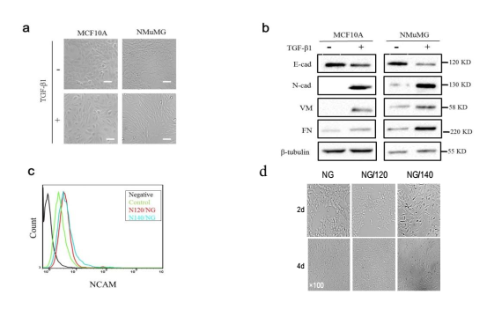
Supplementary Figure 1. Verification of EMT cell model and NCAM overexpressing cell lines. (a) Morphological change induced by TGF-β1. MCF10A and NMuMG cells were treated (+) or not treated (-) with TGF-β1 (5 ng/ml) for 48 h, and phase-contrast images were taken. Scale bars: 20 μm. (b) Western blotting of EMT markers. Aliquots from control cells or TGF-β1 treated cells were immunoblotted with specific antibodies. (c) Testing of NCAM overexpressing cell lines by flow cytometric analysis using anti-NCAM antibody. 10000 cells were accounted. (d) Morphological changes induced by NCAM. Cells were cultured for 2 or 4 days and photos were taken. Magnification: 200×.

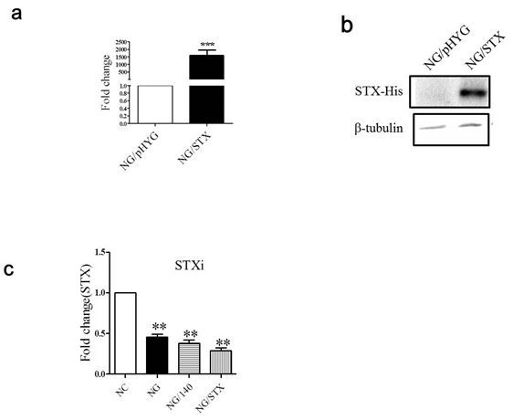
Supplementary Figure 2. Verification of PSA-NCAM overexpressing cell lines. (a) mRNA levels of STX genes in transfected cell lines were assessed by RT-qPCR, with γ-tubulin as control. ***, p < 0.001. (b) Western blot analysis of STX expression using anti-His-tag antibody for selection of transfected cells and β-tubulin as loading control. (c) Down-regulation of STX by siRNA. Cultured NMuMG and transfected cells were transfected with siRNA-targeting mouse STX or with negative control RNA (NC). Total RNA was isolated as described in M&M and quantitative RT-PCR was performed for STX.

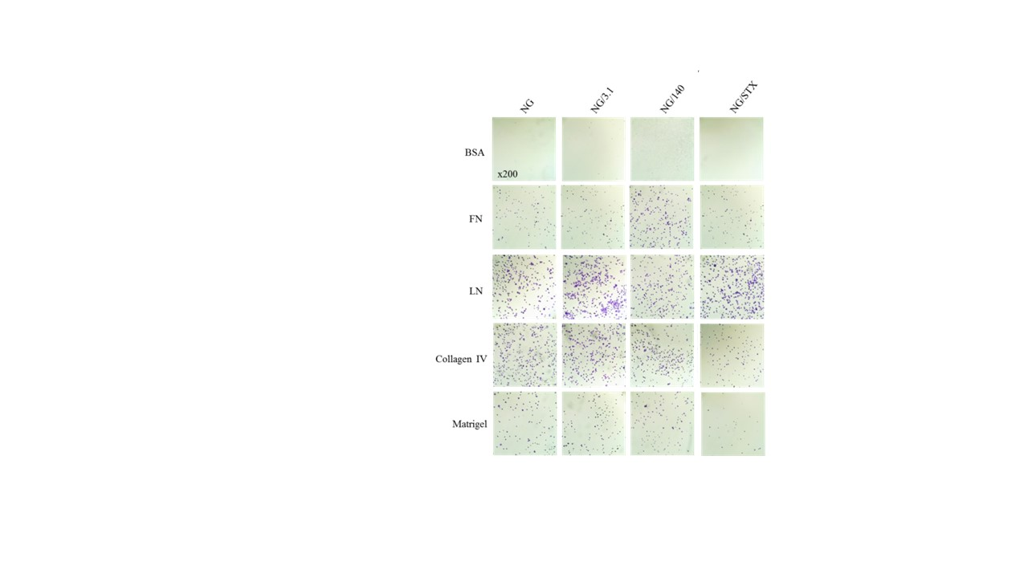
Supplementary Figure 3. Cell adhesion assay. Transfected cells were cultured for 48 h. Cell adhesion to FN, LN, collagen IV, matrigel or BSA solution was determined as described in Materials and Methods, and phase-contrast images were taken.

